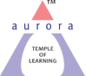
Aurora’s Degree & PG College
(ACCREDITED BY NAAC WITH 'B++' GRADE)
Chikkadpally, Hyderabad 500020

EVENT / ACTIVITY DETAILED REPORT

NAME OF THE EVENT / ACTIVITY | Tulsidas Jayanthi
TYPE OR TITLE OF EVENT / ACTIVITY | Tulsidas Jayanthi
FACULTY INCHARGE | R.Heena
DEPARTMENT/CELL/COMMITTEE/CLUB | Languages
DATE | 23 rd August 2023
VENUE | MAIN BLOCK
TARGET AUDIENCE | UG Students

- PROGRAM SCHEDULE 23 rd August 2023
- 10.00 a.m WelCome speech
10.10 a,m introduction speech
10.20 a.m Elocution
10.40 a.m Poster Presentation
11.10 a.m Vote of Thanks

- LIST OF FACULTY COORDINATORS (DEPARTMENT)
      - Dr. Shivhar Biradar (Languages)
      - R.Heena (Languages)

3. LIST OF THE STUDENT COORDINATORS (NAME, ROLL NO, CLASS & SECTION)
1..V.S. Hariharan Mpcs 1 1051-22-468-037

- LIST OF THE PARTICIPANTS (NAME, ROLL NO, CLASS & SECTION, NO OF GIRLS, BOYS, CASTE)
STUDENTS ATTENDED
BOYS: -

S.No |  | Roll No. | Name | Class & Section
1 |  | 1051-21-468-001 | Sai Deepak Singh | MPCS 3
2 |  | 1051-21-468-002 | Ratnesh Thakur | MPCS 3
3 |  | 1051-21-468-003 | Bhosle Abhijith | MPCS 3
4 |  | 1051-21-468-005 | Thakur Pranav Singh | MPCS 3
5 |  | 1051-21-474-001 | Basavaraj Sajjan | MECS3
6 |  | 1051-21-474-002 | Mohammed Ghouse Pasha | MECS3
7 |  | 1051-21-474-003 | Siddula Satish Netha | MECS3
8 |  | 1051-21-474-004 | Syed Adnan Hussain | MECS3
9 |  | 1051-21-474-006 | Mohammed Parvez | MECS3
10 |  | 1051-21-471-002 | Sumanth Venkata Sai Ayancha | MIBIC 3
11 |  | 1051-22-488-005 | Ravishanker Jha | Bt.bic 2
12 |  | 1051-22-468-018 | Mohammed Atif Ansari | Mpcs 2
13 |  | 1051-22-468-013 | Sahil Singh | Mpcs 2
14 |  | 1051-22-468-037 | Viswanathan Suresh Hariharan | Mpcs 2
15 |  | 1051-22-488-001 | Aditya Koyalkar | Bt. Bic 2
16 |  | 1051-22-488-005 | Ravishanker Jha | Bt. Bic 2
17 |  | 1051-22-488-007 | Syed Shah Kareemuddin | Bt. Bic 2
18 |  | 1051-22-474-001 | Dodla Hari Koushik | Mecs 2
19 |  | 1051-22-474-002 | Katke Aditya Arunkumar | Mecs 2
20 |  | 1051-22-474-010 | Rasala Vignesh | Mecs 2
21 |  | 1051-21-488-001 | Kachchhi Rahil | BT.BIC 3
22 |  | 1051-21-488-008 | Abdul Waheed Khan | BT.BIC 3
23 |  | 1051-21-488-009 | Dalugari Sathyanarayana Reddy | BT.BIC 3
24 |  | 1051-21-488-011 | Tumbalam Kureshi Azaharuddin | BT.BIC 3
25 |  | 1051-21-488-014 | Syed Ansar | BT.BIC 3
26 |  | 1051-21-488-015 | Kandukuri Nagur Basha | BT.BIC 3
27 |  | 1051-22-474-003 | Dodla Hari Koushik | MECS 2
28 |  | 1051-22-474-007 | Katke Aditya Arunkumar | MECS 2
29 |  | 1051-22-471-003 | Thakur Rajneesh Singh | MIBIC 2
GIRLS
S.No |  | Roll No. | Name | Class & Section
1 |  | 1051-21-468-004 | Sheikh Khushi Aslam | MPCS 3
2 |  | 1051-21-471-001 | Sapna Ghosh | MIBIC 3
3 |  | 1051-21-488-002 | Sirigiri Aishwarya | BT.BIC 3
4 |  | 1051-21-488-003 | Kusshika Hemanth | BT.BIC 3
5 |  | 1051-21-488-005 | Neha Anjum | BT.BIC 3
6 |  | 1051-21-488-006 | Kanani Muskan Dilesh | BT.BIC 3
7 |  | 1051-21-488-007 | M Pallavi | BT.BIC 3
8 |  | 1051-22-488-015 | Jyothi Biradar | Bt.bic 2
9 |  | 1051-22-488-003 | Khushi Pratihast | Bt.bic 2
10 |  | 1051-22-488-006 | Saleha Khatoon | Bt.bic 2
11 |  | 1051-22-488-033 | Varsha Adepu | Bt.bic 2
12 |  | 1051-22-488-028 | Ankilla Shiva Kumar Yadav | Bt.bic 2
13 |  | 1051-22-488-029 | Bittu Archana | Bt.bic 2
14 |  | 1051-22-471-001 | Andhagulu Vaishnavi | Mibic 2
15 |  | 1051-22-471-002 | Sakina Ruqsar | Mibic 2
16 |  | 1051-22-459-001 | Afziya Khanam | Migc 2
17 |  | 1051-22-459-002 | Dave Roshni Kamlesh | Migc 2
18 |  | 1051-22-459-029 | poojitha | Migc 2
19 |  | 1051-22-459-026 | Kasani Anusha | Migc 2
20 |  | 1051-22-459-027 | Kulkarni Pavani | Migc 2
21 |  | 1051-22-474-011 | Sheshabattar Sudhanva | Mecs 2
22 |  | 1051-22-539-003 | Kasala Manswi | Msds 2
23 |  | 1051-22-539-035 | Penta Harshitha | Msds 2
24 |  | 1051-21-488-010 | Nishath Farheen | BT.BIC 3
25 |  | 1051-21-488-012 | Alicia Mary Frantz | BT.BIC 3
26 |  | 1051-21-488-013 | P Keerthi Chandana | BT.BIC 3
27 |  | 1051-21-459-001 | Firdous Fatima | MIGC 3
28 |  | 1051-21-459-002 | Swetha Kumari | MIGC 3
29 |  | 1051-22-471-001 | Andhagulu Vaishnavi | MIBIC 2
30 |  | 1051-22-471-002 | Sakina Ruqsar | MIBIC 2

- PARAGRAPH ABOUT THE PROCEEDINGS (TILL THE END OF THE EVENT)
Aurora Degree & PG College Organized activities on “Tulsidas Jayanthi” This enriching and educative event was organized by the Languages Department. The event commenced with the introduction with the convener of the event R. Heena from Department of Languages. She has given an introduction speech about “Tulsidas”
Various Activites like, Elocution, Poster Presentation, where in students participated with full zeal and enthusiasm.

- Activities were organized such as Elocution and Poster Presentation, wherein students participated with full zeal and enthusiasm.
- Nearly 15 students participated in different competitions

Vote of Thanks by R,Heena

“Tulsidas Jayanthi” Utsav is a platform for students to showcase their talent in their Languages and to encourage the students to develop their motherland and for their growth as an Indian Poet. The session was concluded with a collective realization of the importance of literature and the resolve to respect them.
- EVENT PHOTOS (MIN 2 MAX 4)
- 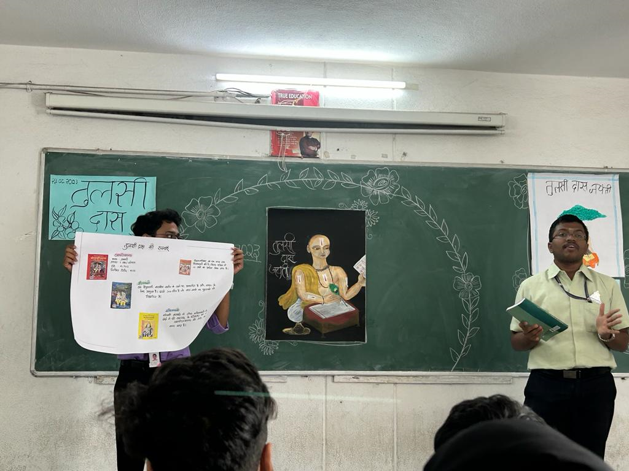

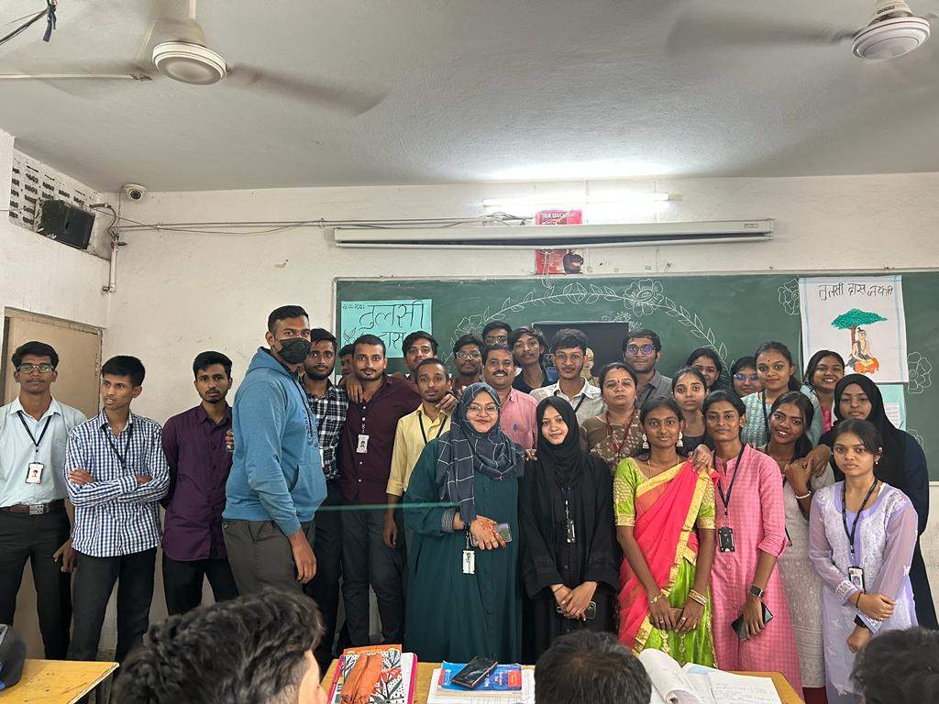
- 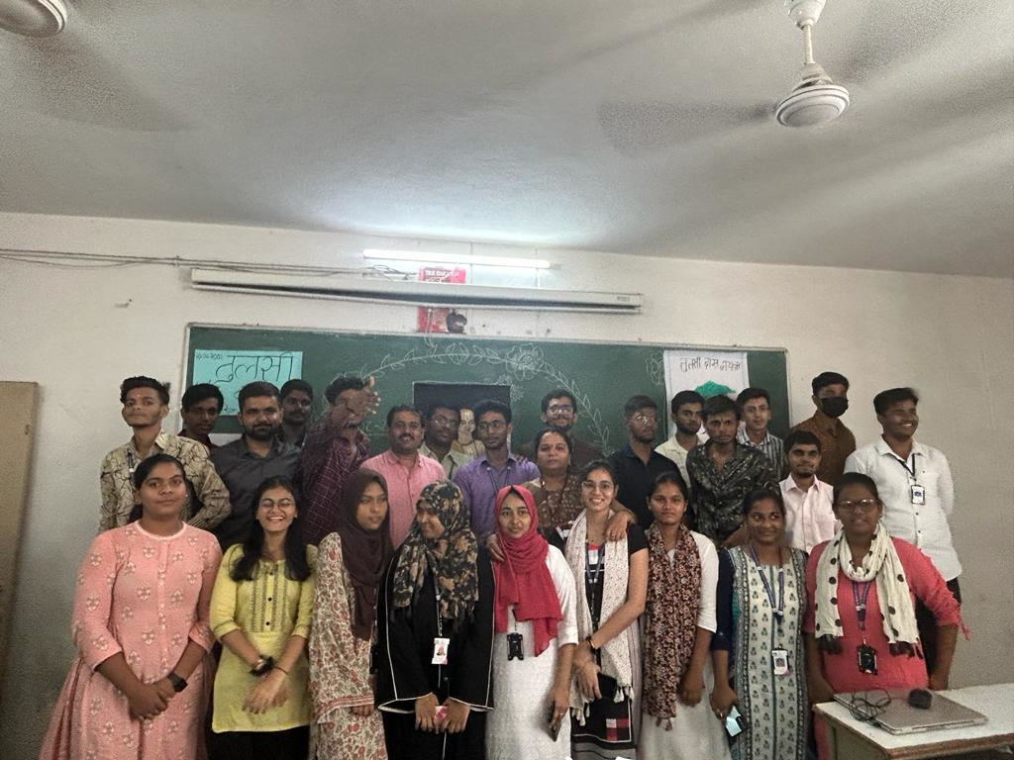
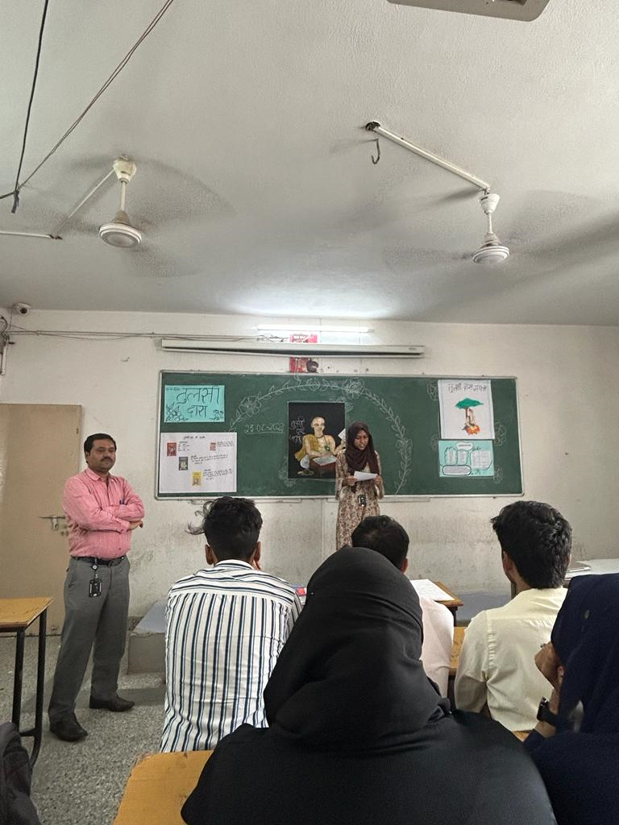

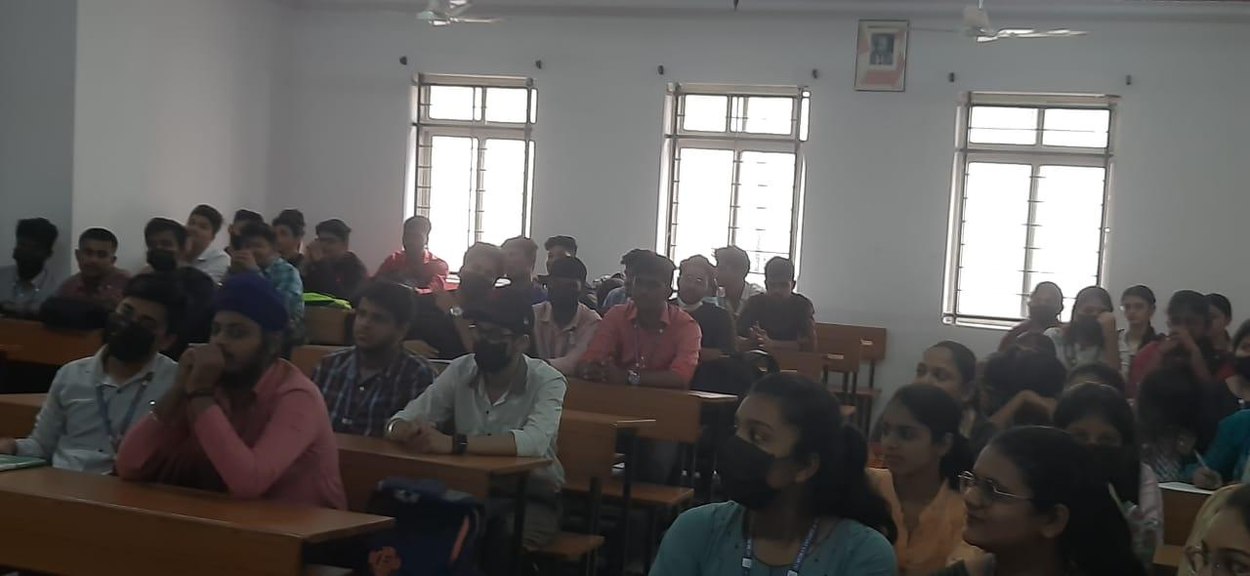

7.EVENT/ACTIVITY PROPOSAL
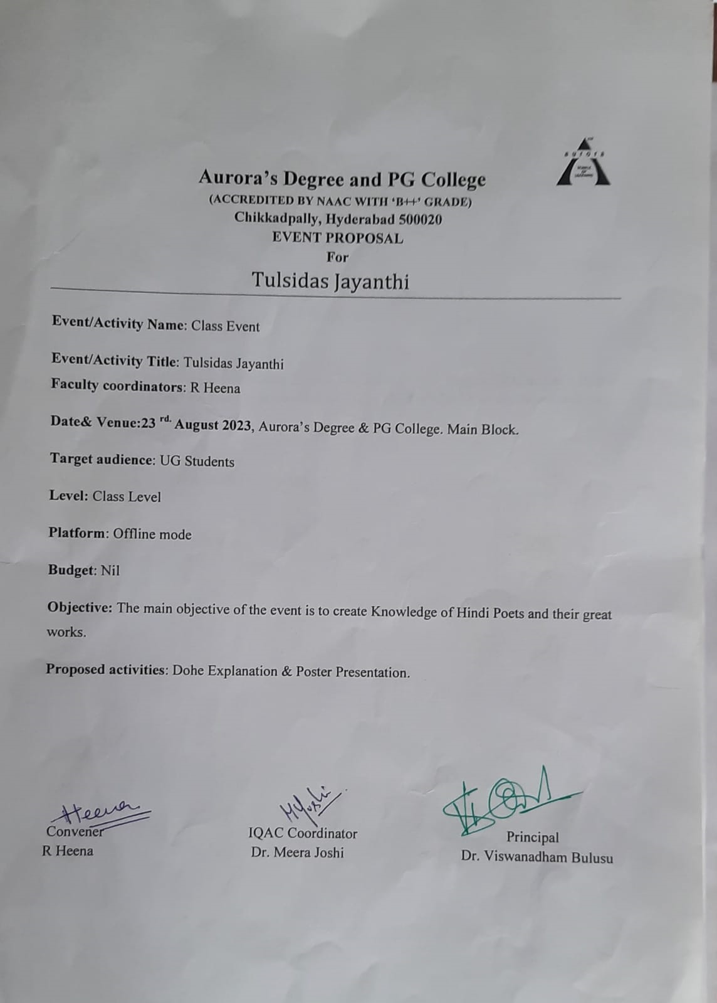
- EVENT / ACTIVITY NOTICE: