Aurora’s Degree & PG College
(ACCREDITED BY NAAC WITH 'B++' GRADE)
Chikkadpally, Hyderabad 500020

EVENT / ACTIVITY DETAILED REPORT

NAME OF THE EVENT / ACTIVITY | Seminar
TYPE OR TITLE OF EVENT / ACTIVITY | Career Goals
FACULTY INCHARGE | Parimala Diana Sudhir. K (Coordinator)
DEPARTMENT/CELL/COMMITTEE/CLUB | Statistics
DATE | 21-08-2023
VENUE | Seminar Hall-Aurora’s Degree and PG College
TARGET AUDIENCE | BBA Final year/ MSCS/MSDS- first year students

- LIST OF FACULTY COORDINATORS (DEPARTMENT): K. Parimala Diana Sudhir (Coordinator)
- LIST OF THE STUDENT COORDINATORS (NAME, ROLL NO, CLASS & SECTION)
- Name: J.Shivani
Roll No: 1051-22-371-0110
Class: BBA-BA2

- LIST OF THE PARTICIPANTS
All BBA final years, BBA-BA2 & 1st year students of MSCS/MSDS participated.

- PARAGRAPH ABOUT THE PROCEEDINGS (TILL THE END OF THE EVENT):
Day : 21-08-2023
Speaker: 1) Praveen Andapalli, Vitel Global,
IT and Technology Leader /Chief Executive Officer)/ Entrepreneur
‘
The seminar talk on “Career Goals” organized by the Department of statistics and Department of Commerce was indeed valuable informative event for the final year BBA & first-year MSCS/MSDs students. Ms. Parimala Diana Sudhir, the coordinator opens the seminar and introduced Mr. Praveen Andapalli, the CEO/ Entrepreneur of Vitel Global Leader, IT and Technology as the guest speaker. Special thanks were given to Ms.Veena Kapoor Head, Department of Commerce & Management for her role in planning and execution.
Ms.Mokshita from first year MSDS program honored Mr. Praveen Andapalli with a bouquet, signifying their appreciation for his presence in the seminar..
Mr. Praveen Andapalli shared information about the work environment and operation at Vitel Global, providing students with a glimpse into the industry.
He highlighted the opportunities available in the market for BBA students, emphasizing the importance of planning a career path while still studying and the significance of internships in shaping a successful career.
Mr. Praveen Andapalli empathized the importance of upskilling and recommended learning Python courses, AI courses which are in high demand in the present job market. He discussed the importance of interview preparation, and suggested alternative career paths.
Mr. Praveen Andapalli expressed his interest in conducting a placement drive for the students during the summer vacation of 2024, which could be a valuable opportunity for the attendees.
Students actively engaged by asking questions regarding business analytics course and sought clarification on various topics related th their career prospects.
Overall, the seminar talk provided practical advice and insights to the students offering them valuable guidance in their pursuit of successful career paths.
Adithi from BBA 3A rendered vote of thanks expressing gratitude to all those involved in organizing the seminar.
The seminar covered a wide range of topics related to career planning and development, with a focus on practicality and industry relevance. The students are likely to benefit greatly from the information and opportunities presented during this event.
- INCOME : Nil
EXPENDITURE : Rs 500/-
- EVENT PHOTOS (MIN 2 MAX 4):
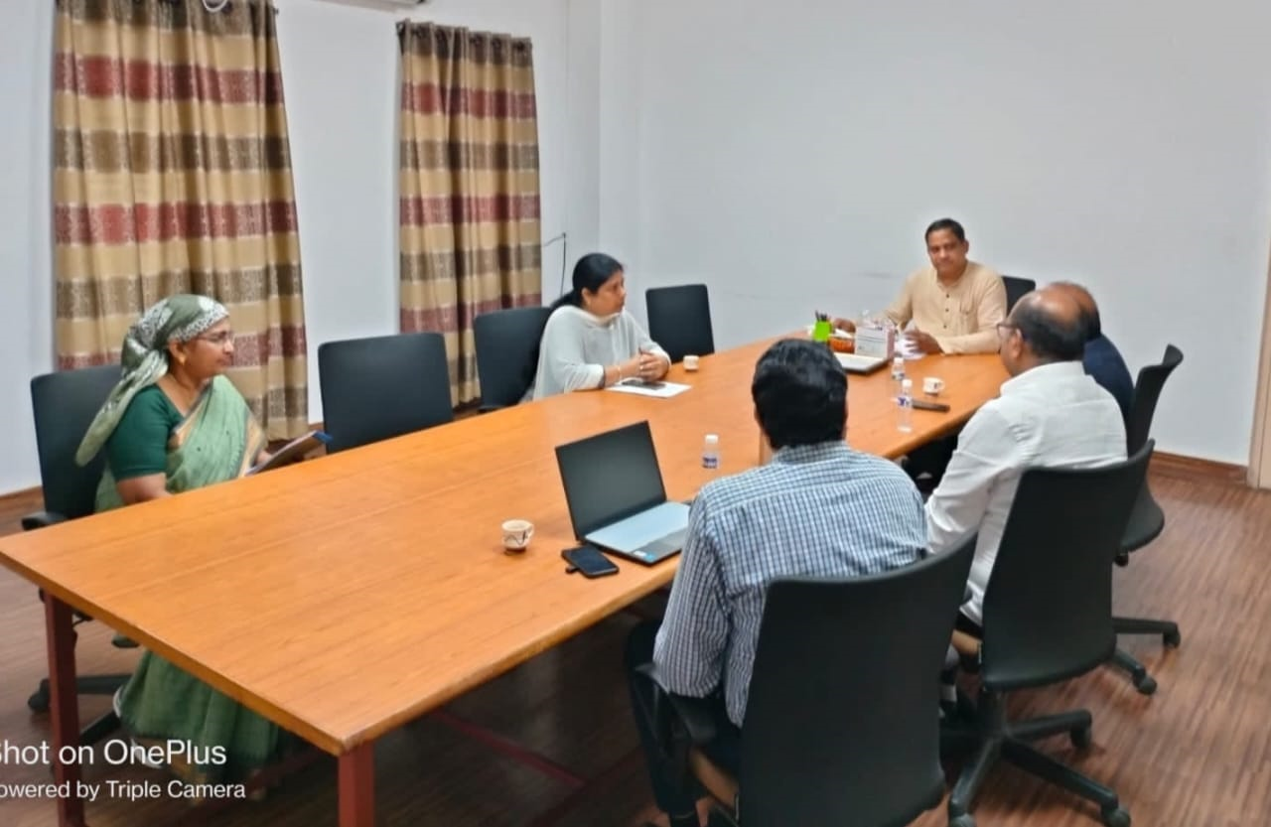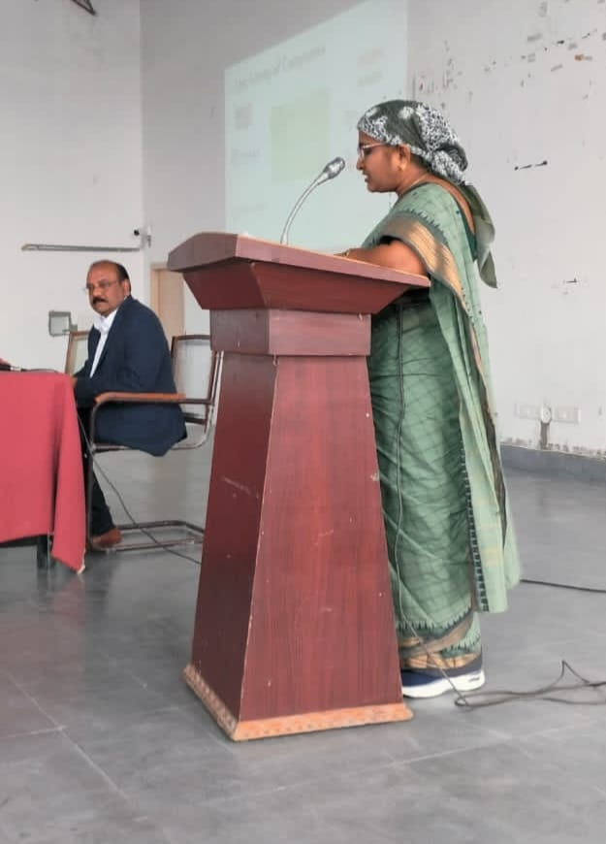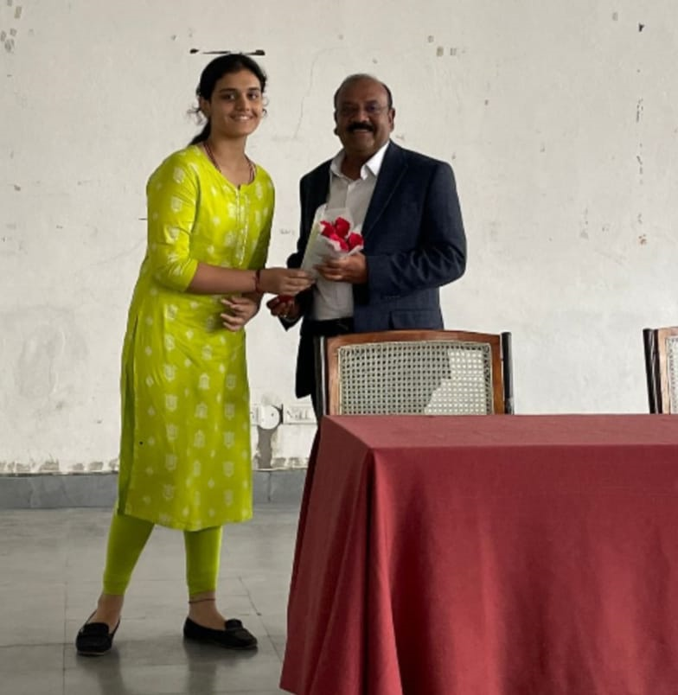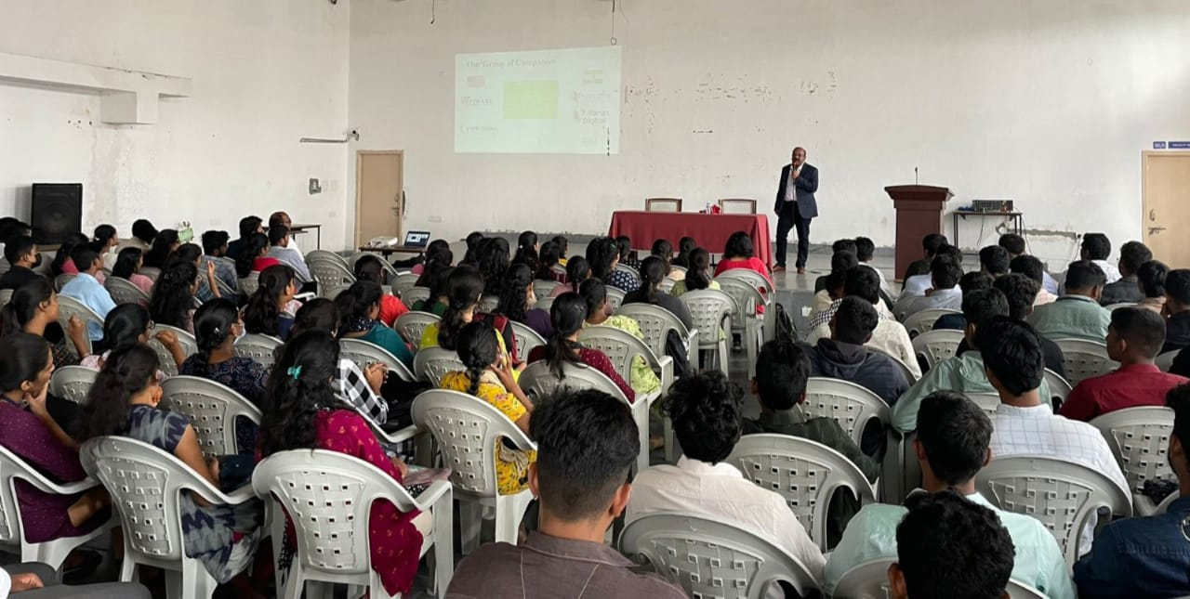

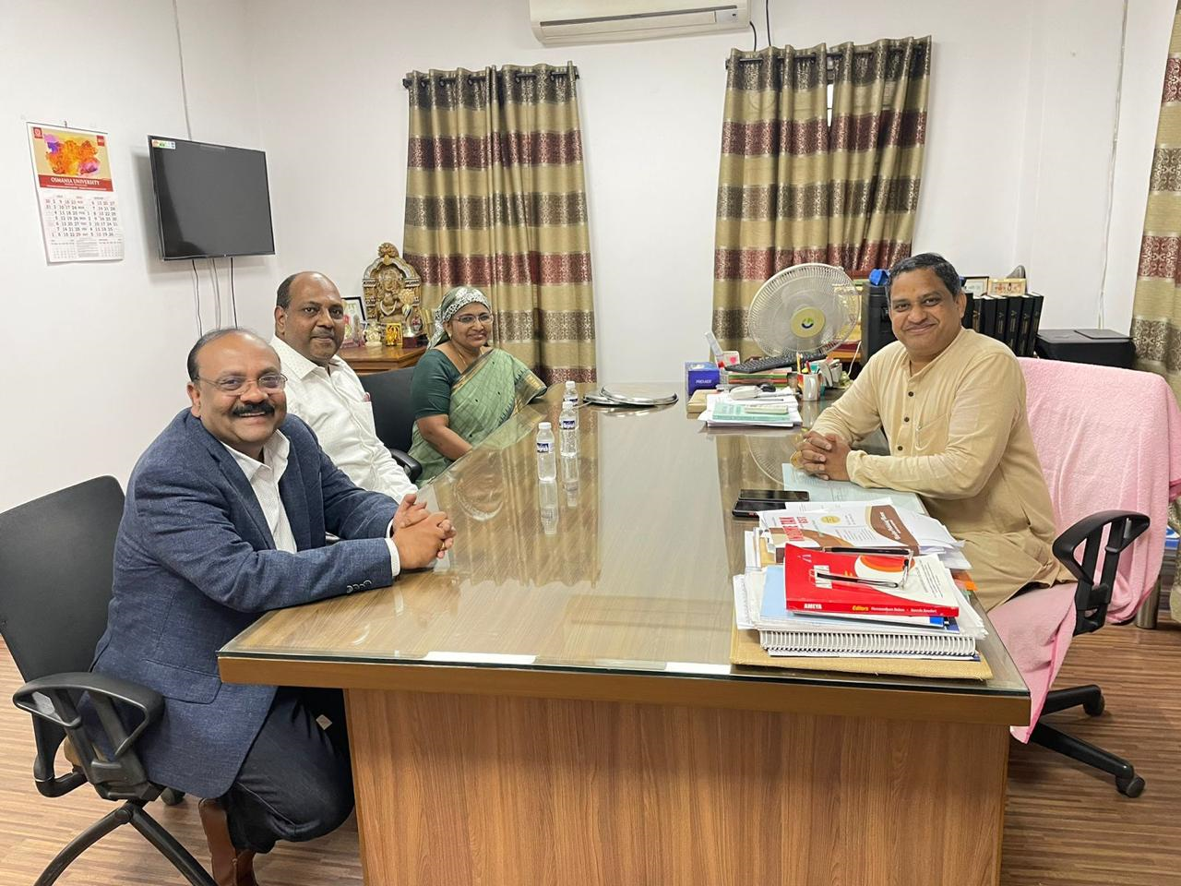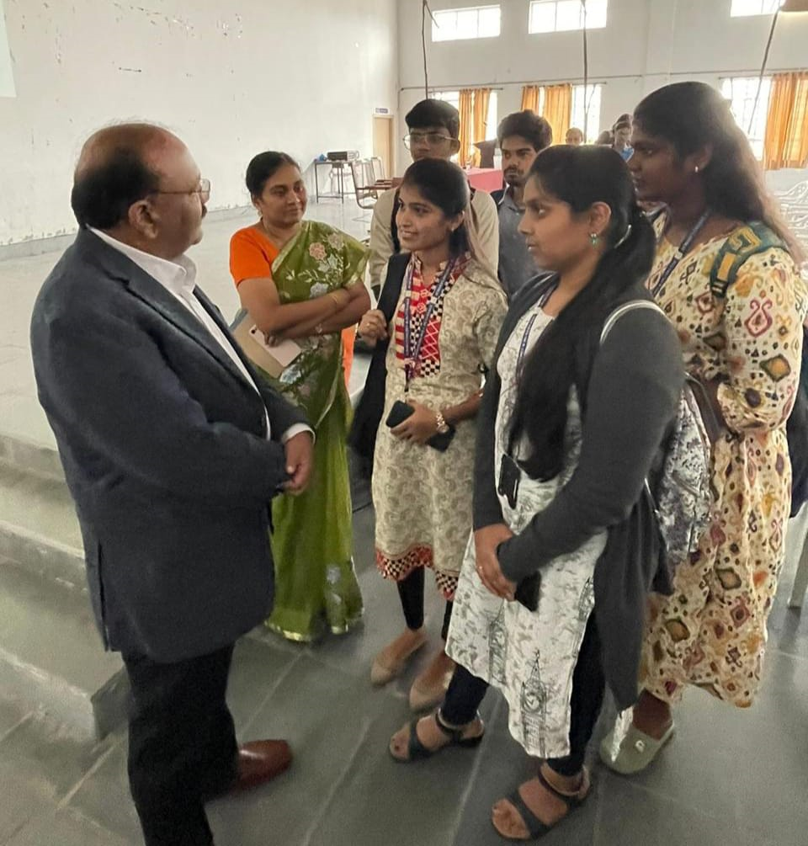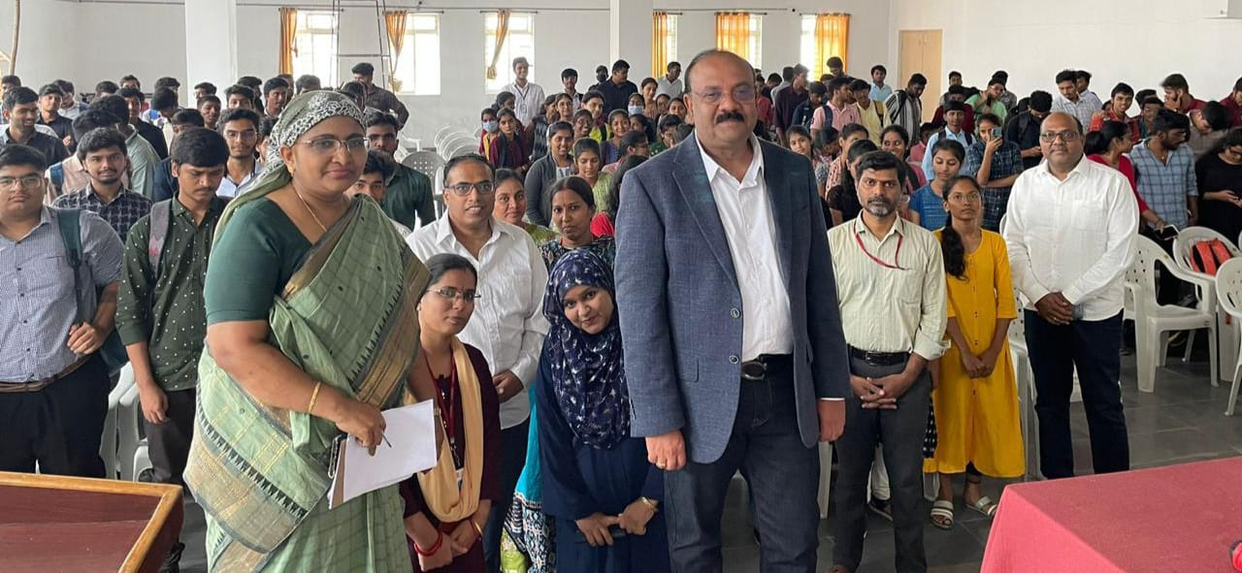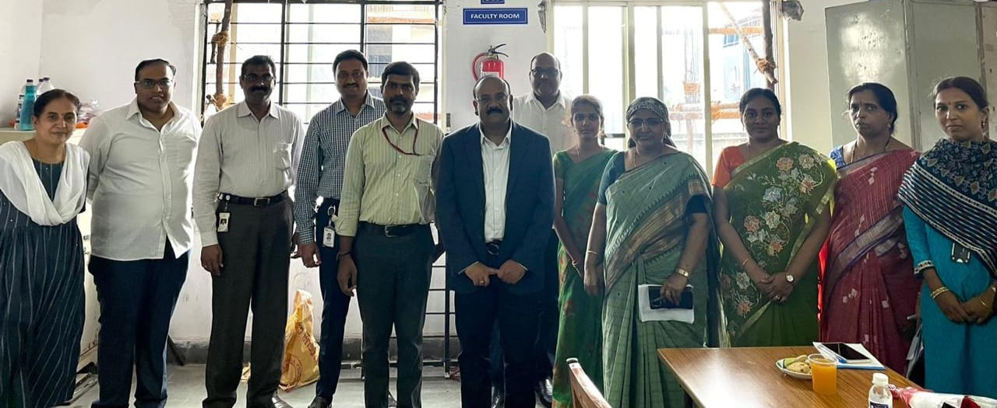
- ATTACHMENTS:
EVENT/ACTIVITY PROPOSAL

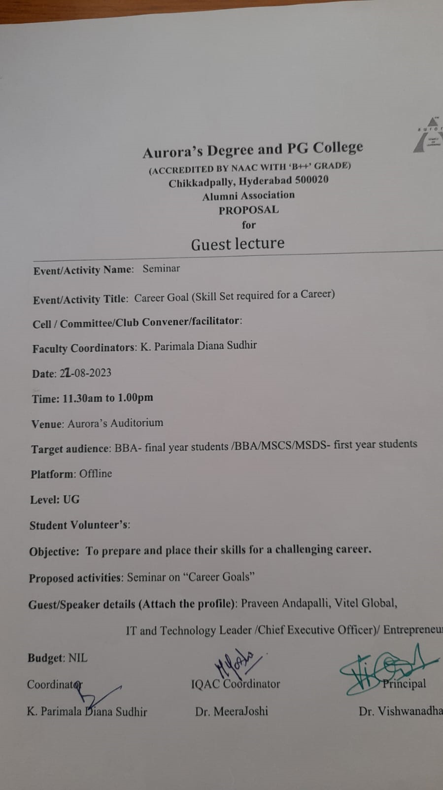

EVENT / ACTIVITY NOTICE
RECEIPTS (IF ANY):
CERTIFICATES (IF ANY):
LETTERS OF COMMUNICATION (IF ANY): (Communicated through WhatsApp.)
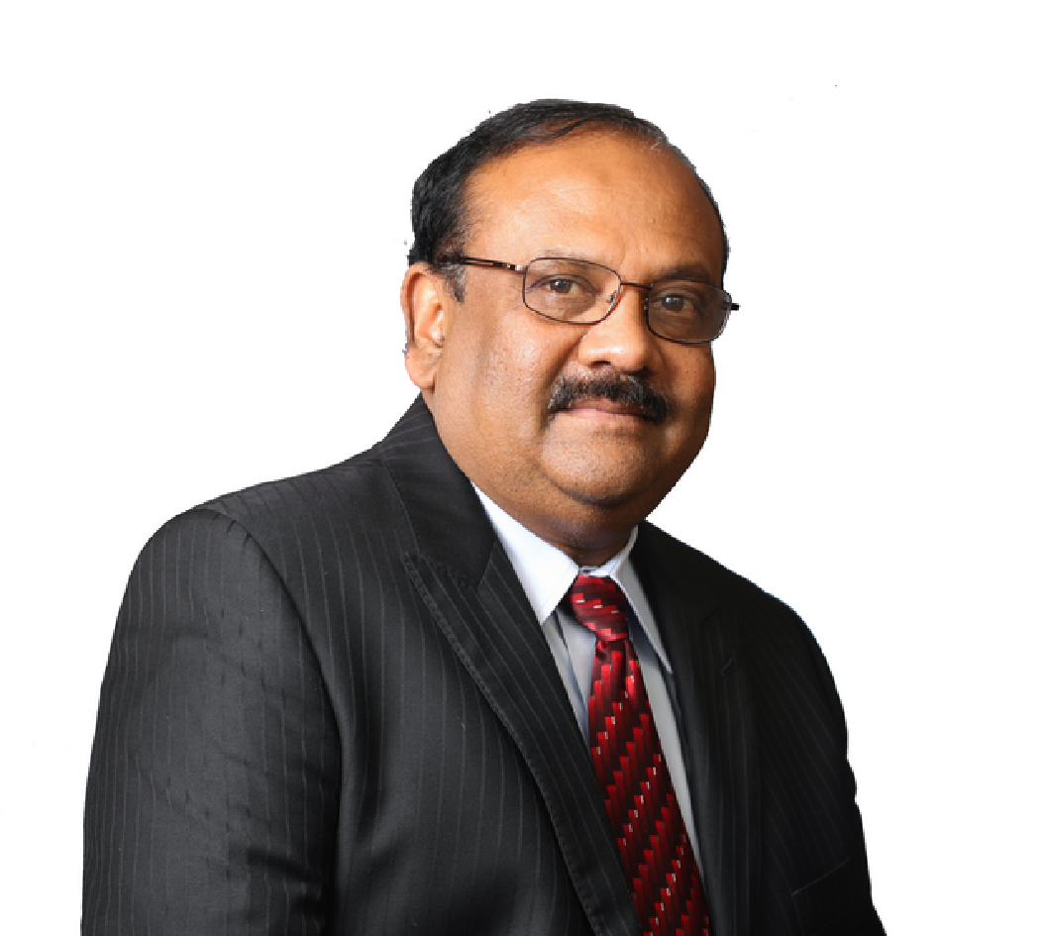

Praveen Andapalli is a distinguished figure in the IT and TechnologySector, recognized for his remarkable accomplishments and leadershipprowess. With a Master’s degree in Applied Statistics from OsmaniaUniversity in Hyderabad, India, he possesses a strong academicfoundation that complements his extensive professional journey.
After the completion of his degree, Praveen Andapalli embarked on ajourney in the Information Technology sector, where he garneredinvaluable expertise as the Vice President of Sales for a well-regardedIT consulting firm. In this pivotal role, he exhibited exceptionalleadership capabilities while overseeing a team of over 300employees. His strategic acumen and proactive approach enabled the company's revenues to soar from $2 million to an impressive $20million between 1998 and 2000.
In 2003, Praveen Andapalli assumed the mantle of Chief ExecutiveOfficer at a leading tech firm headquartered in New Jersey. Under hisadept guidance, the company quickly rose to prominence as one of thefastest-growing IT services companies in the state. His visionaryleadership and unwavering commitment drove the company'srevenues from $1 million to a substantial $10 million over an eight-year period.

Currently, Praveen Andapalli holds the esteemed position of Chief Executive Officer at Vitel Global Communications, a telecommunications firm with a decade of experience in the industry. With operations spanning India, the US, and expanding into Canada, he oversees a workforce of over 300 employees. His remarkable leadership elevated Vitel Global, earning it a place in the coveted Inc5000 list of fastest-growing private companies in both 2021 and 2022.
Beyond his corporate responsibilities, Praveen Andapalli is an active member of the Forbes Tech Council, where he serves as an esteemed IT Advisor. He was also honored by a prominent Telugu organization, which recognized him as the Business Entrepreneur of the Year during their momentous 50th-anniversary celebration.
Notably, Praveen Andapalli is the driving force behind two additional successful ventures in India: Pranathi Software Services and Varun Digital Media. These ventures showcase his entrepreneurial spirit and dedication to innovation.
Balancing his thriving professional journey, Praveen Andapalli is a family man at heart. He finds joy in spending time with his wife, Vijaya, and nurturing his family, including his eldest daughter, Parnathi, who is on the path to becoming a medical professional, and his son, Varun, currently navigating middle school. Their family calls New Jersey home, where they create a harmonious blend of achievement and contentment.

