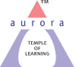
Aurora’s Degree & PG College
(ACCREDITED BY NAAC WITH 'B++' GRADE)
Chikkadpally, Hyderabad 500020

EVENT / ACTIVITY DETAILED REPORT

NAME OF THE EVENT / ACTIVITY | Telugu Workshop
TYPE OR TITLE OF EVENT / ACTIVITY | Telugu kathanika
FACULTY INCHARGE | Dr .N. Suryakanthi
DEPARTMENT/CELL/COMMITTEE/CLUB | Languages
DATE | 08-08- 2023
VENUE | Block 6 Seminar Hall
TARGET AUDIENCE | UG Students

- PROGRAM SCHEDULE
- 08th August, 2023 from 11 am to 1 pm
- Session 1 : Introductory session by students
- Session 2 : Guest Speech
- Session 3 : Student Participation in Telugu Kathanika
- Session 4 : Certificate Distribution
- Session 5 : Photo Session with Guest and Faculty

- LIST OF FACULTY COORDINATORS (DEPARTMENT)
Dr.N.Suryakanthi- Languages Department

- LIST OF THE STUDENT COORDINATORS (NAME , ROLL NO, CLASS & SECTION)
NAME | ROLL NO | CLASS & SECTION
Gadeela Sanjana | 1051-22-371-007 | Bba-Business Analytics 2
Varsha | 1051-22-488-037 | Btbic - 2
Gade Akhil Sai | 1051-22-468-009 | MPCS – 2
Salla Deekshitha | 1051-21-459-025 | MIGC 3 -B
Pannala Abhinaya Sri | 1051-22-684-050 | BBA -2
Vadla Raghunandhan Chary | 1051-22-684-066 | BBA -2

- LIST OF THE PARTICIPANTS (NAME , ROLL NO, CLASS & SECTION, NO OF GIRLS, BOYS, CASTE )
Total Number of Participants | Number of Girls | Number of Boys
250 | 116 | 134

- PARAGRAPH ABOUT THE PROCEEDINGS (TILL THE END OF THE EVENT)
Introduction of the Event:
The Department of Languages organized a One Day Workshop on Telugu Kathanika for all UG Students. The guest speaker was Dr. KNVVS Narayana Murthy, Associate Professor of Telugu, BJRGEC.
The Workshop was designed with the purpose to enable students to learn the art of story writing and storytelling. The speaker spoke about the richness of Telugu Language and how one can utilize this language in the art of story writing and storytelling. He shared many techniques and provided ample examples for the benefit of the students. Through this workshop students gained more knowledge on Telugu Literature and tried to imbibe these techniques in story writing and storytelling. After the session, students were asked to showcase their learning by either writing or telling stories framed by them. After sharing their stories, students were rewarded with a book and an appreciation certificate. This was a learning experience for both the students and faculty alike.

- INCOME AND EXPENDITURE : NIL

- EVENT PHOTOS ( MIN 2 MAX 4)

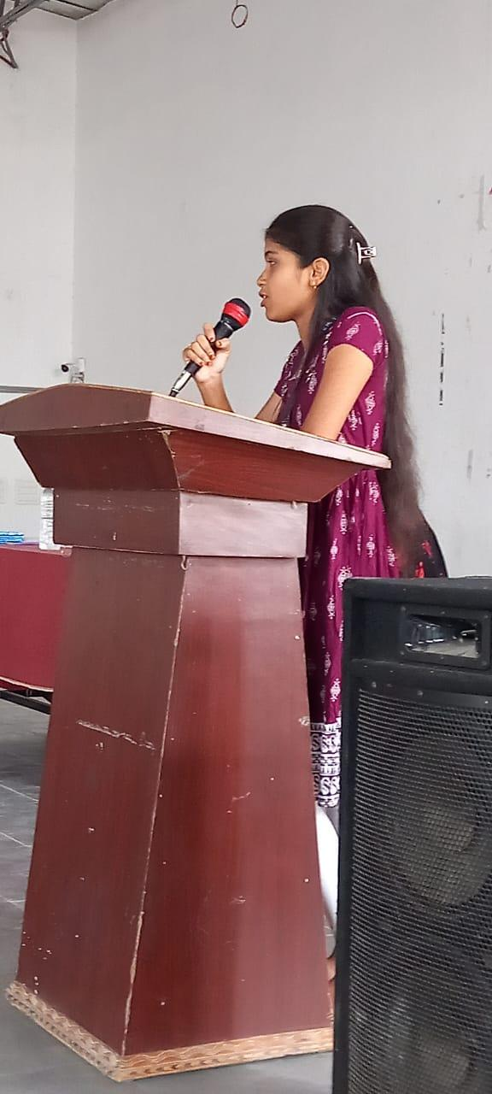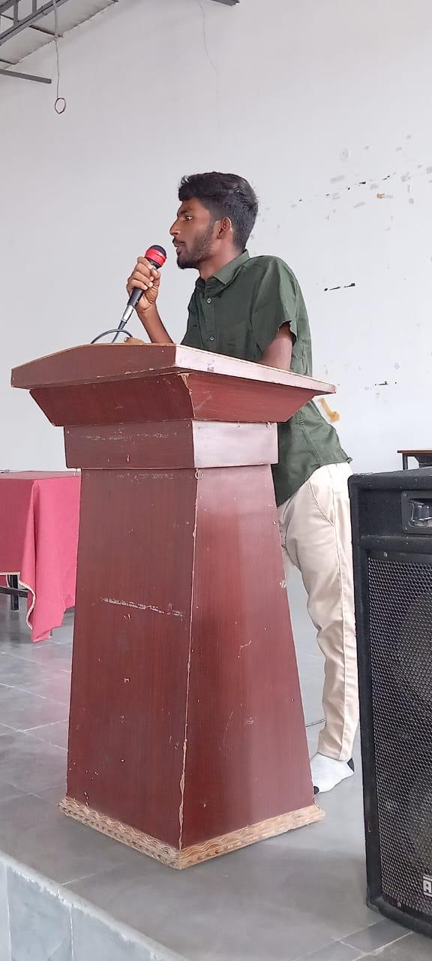

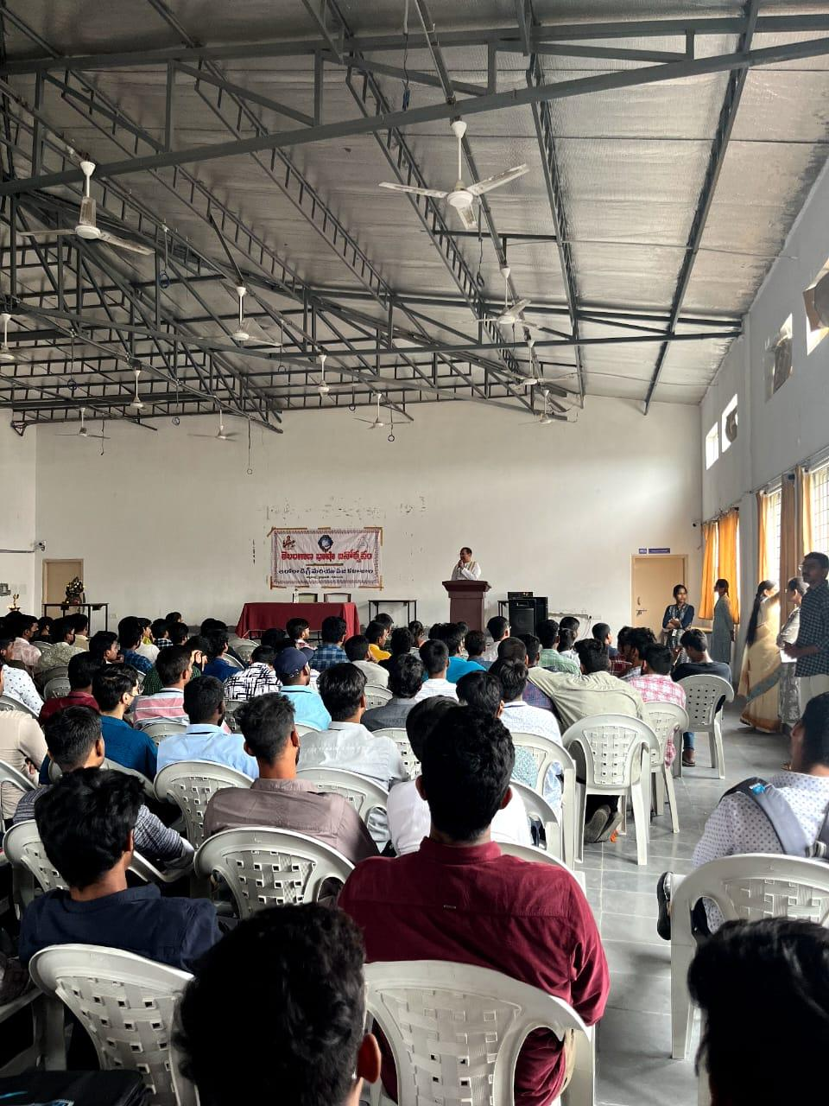
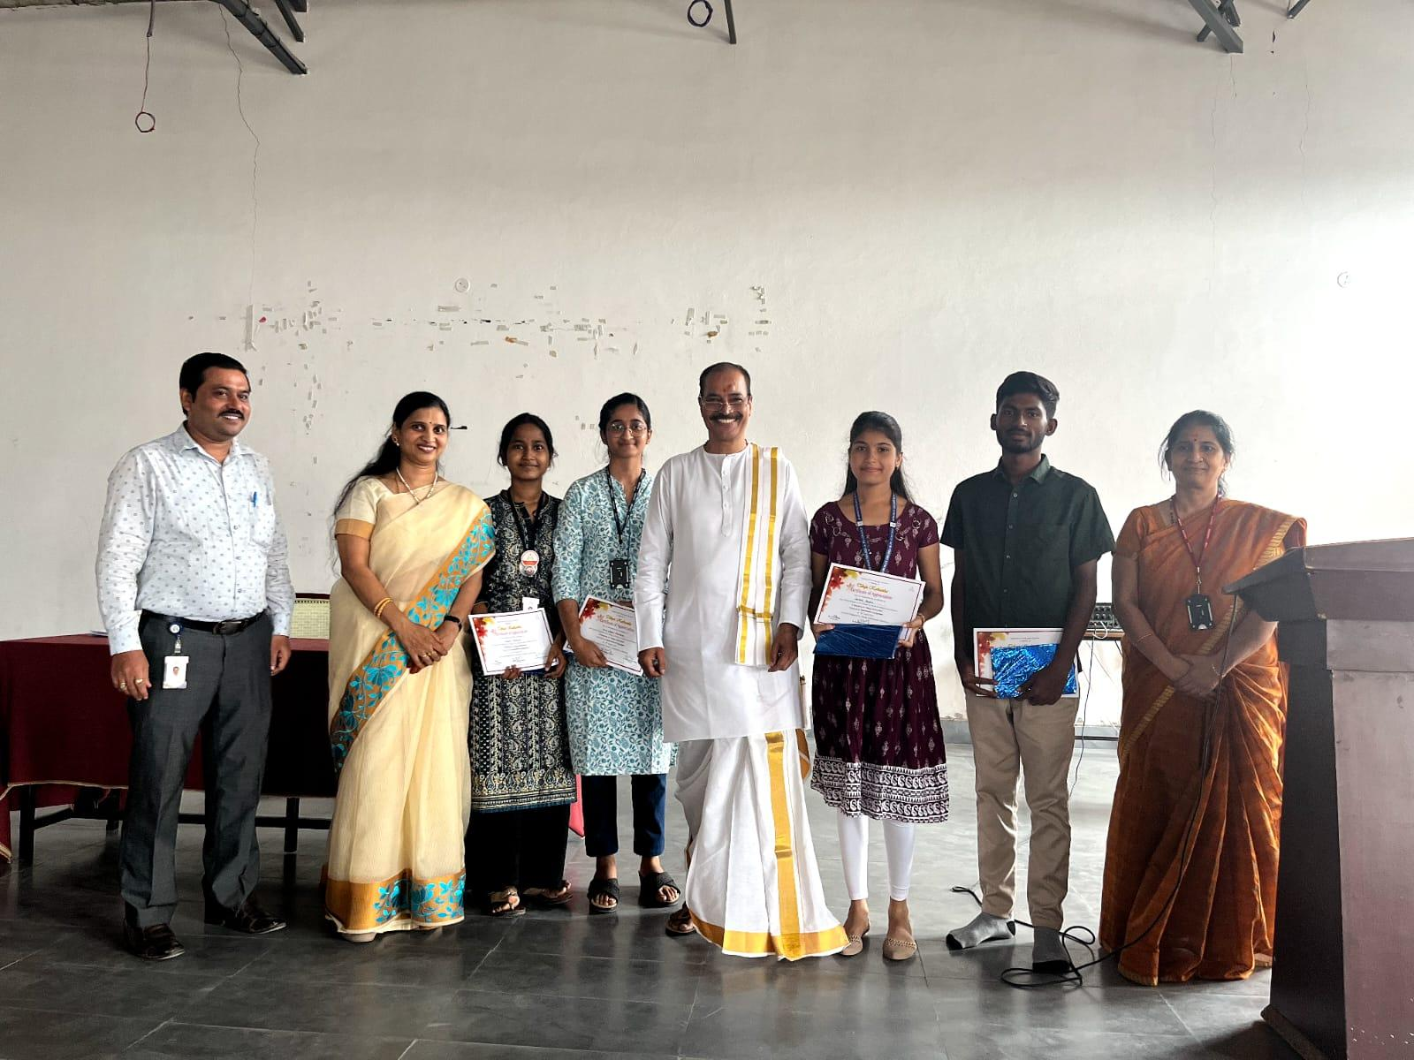
- GUEST PROFILE (IF ANY) : Dr. KNVVS Narayana Murthy, Associate Professor of Telugu, BJRGEC, Narayanaguda, Hyderabad.

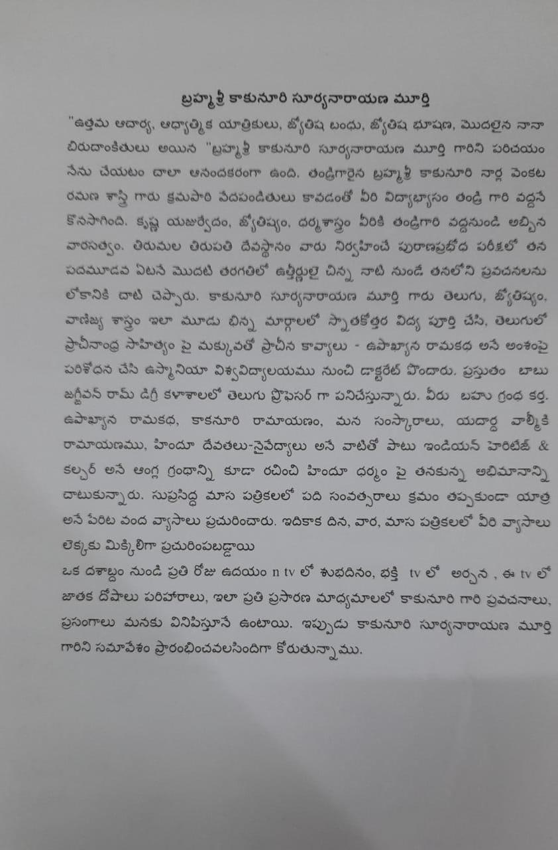
- FEED BACK IF ANY :
The event was very interesting and informative. Students were involved with the speech of the guest and gained knowledge about Telugu kathanika. Respect against Telugu has increased among the audience .

- ATTACHMENTS:
EVENT/ACTIVITY PROPOSAL :
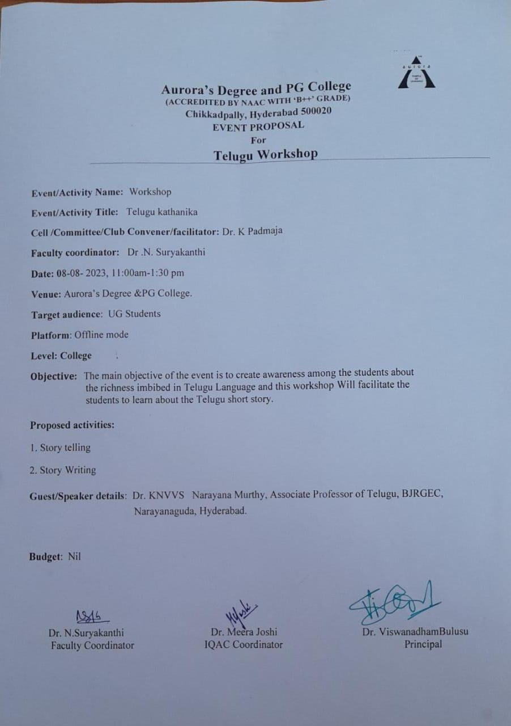

EVENT / ACTIVITY NOTICE :
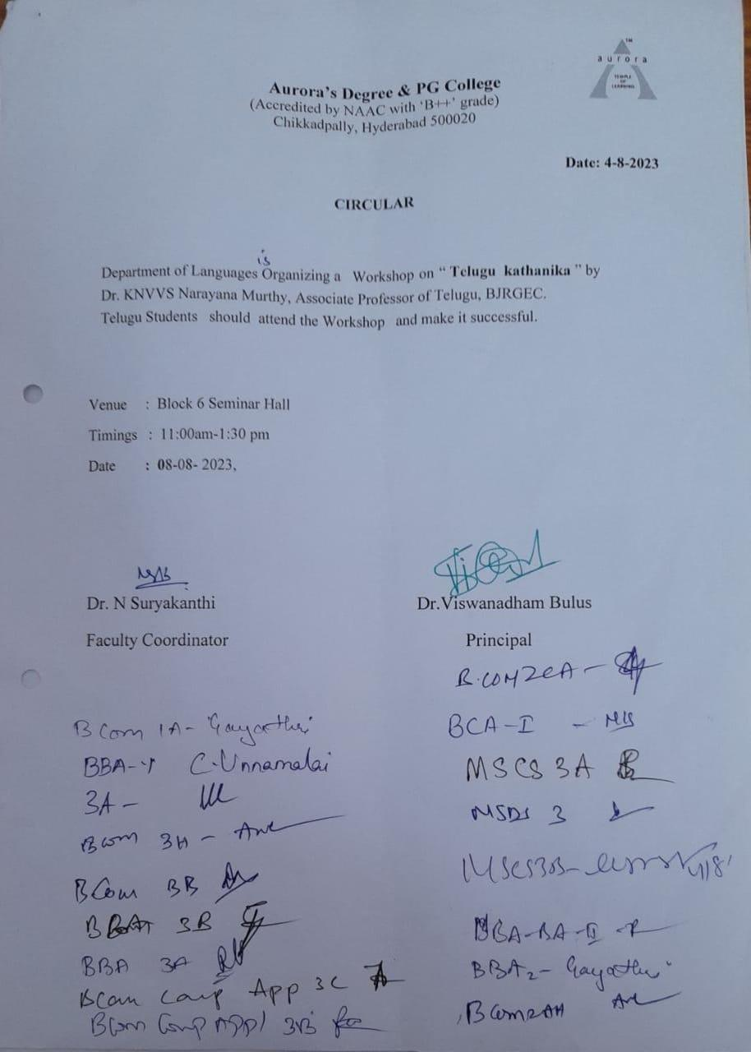

RECEIPTS (IF ANY): NA
CERTIFICATES (IF ANY) :
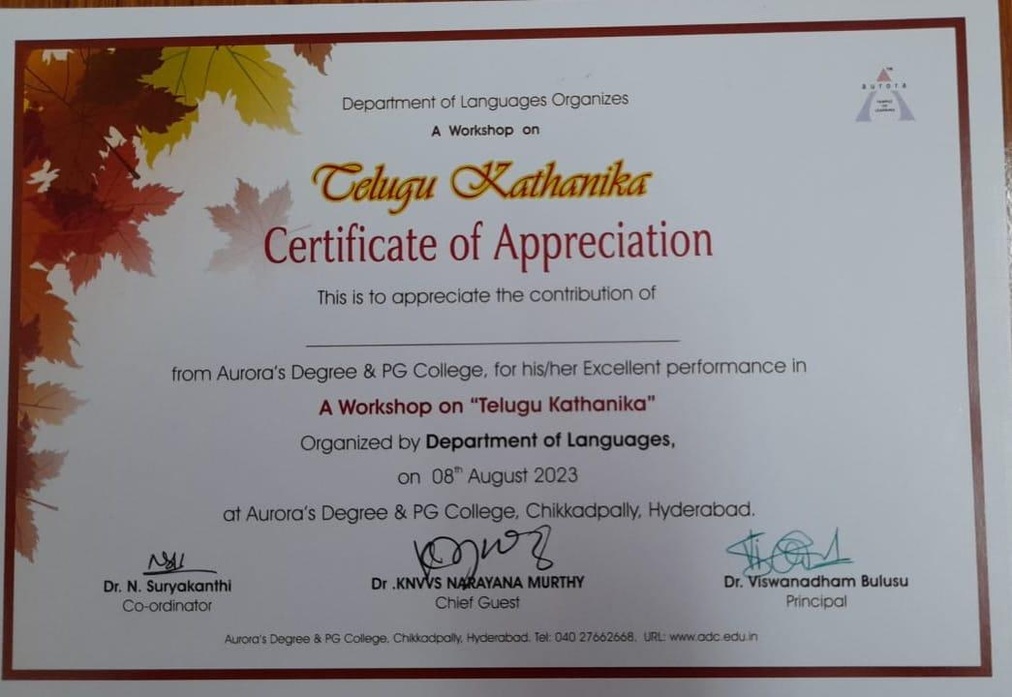

LETTERS OF COMMUNICATION (IF ANY) :

Invitation for Telugu Workshop as Chief Guest & Key note Speaker Reg .
Surya Kanthi <suryakanthin@adc.edu.in> | Tue, Aug 1, 11:26 PM (8 days ago)
to Dr.Kakunuri

Good morning sir

PFA
One attachment • Scanned by Gmail

2 nd August 2023

To
Dr .KNVVS NARAYANA MURTHY,
Associate Professor of Telugu,
BJRGDC, Narayanaguda, Hyd

Respected Sir,

Sub: Invitation for Telugu Workshop as Chief Guest &amp; Key note Speaker Reg .

We are glad to invite you for the Telugu Workshop to be held on 8th August 2023 at our
Aurora’s Degree and PG College, Chikkadpally, Hyderabad as a Guest and Keynote Speaker.
Your presence will be highly beneficial to our students .

Telugu Workshop : Telugu kathanika
Date &amp; Time : 08-08- 2023
Venue : Aurora’s Degree &amp; PG College,
Chikkadpally , Hyderabad.
Target audience : UG Students

PRINCIPAL
Dr. Viswanadham Bulusu
Aurora’s Degree and PG College

