Aurora’s Degree & PG College
(ACCREDITED BY NAAC WITH 'B++' GRADE)
Rtc x roads, Hyderabad 500020

EVENT / ACTIVITY DETAILED REPORT

NAME OF THE EVENT | R.A. FISHER’S BIRTHDAY CELEBRATIONS
TYPE OF EVENT | R.A. FISHER’S BIRTHDAY(Departmental Event)
FACULTY INCHARGE | J Vinita & Y Aruna Rekha
DEPARTMENT | Department of Statistics
DATE | 17th February, 2024
VENUE | Aurora’s Degree and PG college, RTC x road, Hyderabad.
TARGET AUDIENCE | UG & PG Students

- PROGRAM SCHEDULE:
The event scheduled on 17th February,2024 at 10:00 a.m.
The following is the schedule.
- Inaugural address by Y Aruna Rekha.
- Presentation on Life Journey & his achievements of Prof R.A.Fisher.
- Presented the data in best possible way in form of charts/Visualization by the students of Data Exploration activity.
- Closing Comments by J Vinita

- LIST OF FACULTY COORDINATORS (DEPARTMENT):
J Vinita & Y Aruna Rekha

- LIST OF THE STUDENT COORDINATORS (NAME , ROLL NO, CLASS & SECTION)
1. B.Suman Nayak
Roll No. : 1051-21-467-072
Class: MSCs-3B
2. R. Sai Meghana
Roll No: 1051-23-507-007
Class: PG (Statistics) I yr
- LIST OF THE PARTICIPANTS:
The participant students:
      - PG (Statistics & Applied Statistics 1st years)
      - UG Statistics Students

S.No | Roll.No | Section | Name
1 | 1051-21-467-044 | MSCS 3A | Tharun
2 | 1051-21-467-005 | MSCS 3A | Deekshit
3 | 1051-21-467-035 | MSCS 3A | Ashwit
4 | 1051-21-467-039 | MSCS 3A | Sathvik
5 | 1051-21-467-043 | MSCS 3A | Bharadwaj
6 | 1051-21-467-037 | MSCS 3A | Anas
7 | 1051-21-467-014 | MSCS 3A | Vivek
8 | 1051-21-467-038 | MSCS 3A | Sai charan
9 | 1051-21-467-034 | MSCS 3A | Abhishek
10 | 1051-21-467-031 | MSCS 3A | Swetha
11 | 1051-21-467-019 | MSCS 3A | Anusha
12 | 1051-21-467-030 | MSCS 3A | Shailaja
13 | 1051-21-467-029 | MSCS 3A | Bindu
14 | 1051-21-467-064 | MSCS3B | V.Murali
15 | 1051-21-467-074 | MSCS3B | B.Sai varun
16 | 1051-21-467-080 | MSCS3B | Rajput siddhi
17 | 1051-21-467-094 | MSCS3B | J. Anith babu
18 | 1051-21-539-013 | MSDS 3 | N.Shruthi
19 | 1051-21-539-019 | MSDS 3 | D.Vaishnavi
20 | 1051-21-539-038 | MSDS 3 | A.Sanjana
21 | 1051-21-539-005 | MSDS 3 | B.Sanjana
22 | 1051-21-539-018 | MSDS 3 | R.Nithin
23 | 1051-22-539-001 | MSDS-2 | Achal
24 | 1051-23-507-007 | M.Sc Statistics 1 | R.Sai meghana
25 | 1051-23-507-001 | M.Sc Statistics 1 | G.Vyshnavi
26 | 1051-23-507-006 | M.Sc Statistics 1 | B.Vaishbavi
27 | 1051-23-507-002 | M.Sc Statistics 1 | Ch.Bhavana
28 | 1051-23-507-008 | M.Sc Statistics 1 | Ramya sri
29 | 1051-23-507-009 | M.Sc Statistics 1 | Rakesh yadav
30 | 1051-23-539-064 | MSDS 1 | P.Krishna
31 | 1051-23-539-067 | MSDS 1 | P.Mahinder
32 | 1051-23-539-071 | MSDS 1 | S.Vaishnavi
33 | 1051-23-539-072 | MSDS 1 | Deva Krishna
34 | 1051-23-539-074 | MSDS 1 | S.Karthik
35 | 1051-23-539-076 | MSDS 1 | T.Srinath
36 | 1051-23-467-040 | MSCS1 | Varun
37 | 1051-23-467-005 | MSCS1 | Vinod
38 | 1051-23-467-007 | MSCS1 | Adithya
39 | 1051-23-467-018 | MSCS1 | Nithin
40 | 1051-23-467-037 | MSCS1 | Vishnu
41 | 1051-23-467-001 | MSCS1 | Aziz
42 | 1051-23-467-037 | MSCS1 | Vaibhav
43 | 1051-23-539-056 | MSDS 1 | Nameera
44 | 1051-23-539-012 | MSDS 1 | Surya Teja
45 | 1051-23-539-060 | MSDS 1 | Raj kumar
46 | 1051-23-539-023 | MSDS 1 | Durlab
47 | 1051-23-539-016 | MSDS 1 | Gautham
48 | 1051-23-539-035 | MSDS 1 | Srihas
49 | 1051-23-539-015 | MSDS 1 | Harshith
50 | 1051-23-539-048 | MSDS 1 | Mokshitha
51 | 1051-23-539-053 | MSDS 1 | Vaishanvi
52 | 1051-23-539-050 | MSDS 1 | Harika
53 | 1051-23-539-051 | MSDS 1 | Revathi
54 | 1051-23-539-078 | MSDS 1 | Proosana
55 | 1051-23-508-016 | M.Sc Applied Statistics 1 | P.Bhavana
56 | 1051-23-508-010 | M.Sc Applied Statistics 1 | V.Chandhana
57 | 1051-23-508-015 | M.Sc Applied Statistics 1 | Atiya Tasneem
58 | 1051-23-508-013 | M.Sc Applied Statistics 1 | Nameera
59 | 1051-23-508-007 | M.Sc Applied Statistics 1 | B.Harika
60 | 1051-23-508-012 | M.Sc Applied Statistics 1 | A.Deekha
61 | 1051-23-508-019 | M.Sc Applied Statistics 1 | v.Harshitha
62 | 1051-21-539-022 | MSDS 3 | Srinath.S
63 | 1051-23-508-014 | M.Sc Applied Statistics 1 | K.Divya Teja
64 | 1051-23-508-011 | M.Sc Applied Statistics 1 | T.BalaKrishna

- PARAGRAPH ABOUT THE PROCEEDINGS (TILL THE END OF THE EVENT):
The event was organized on 17th February,2024 for Students. This session was started with the introductory speech by J. Vinita, Senior Assistant Professor (HOD), Department of Statistics. She gave a brief applications on the importance of statistics in the MNC companies. Post that, PG Statistics first year student Sai Meghana briefed students about the achievements and importance of Prof. R.A.Fisher.
An activity " Data Exploration – To explore and analyse the data " for PG & UG Statistics students was organized. The students presented their findings using various statistical tools and techniques in the form of charts/visulaization. It helped students to understand the practical aspects of the subject. Followed by vote of thanks by a student volunteer R.Sai Meghana.

- INCOME AND EXPENDITURE: NIL
- EVENT PHOTOS ( MIN 2 MAX 4):
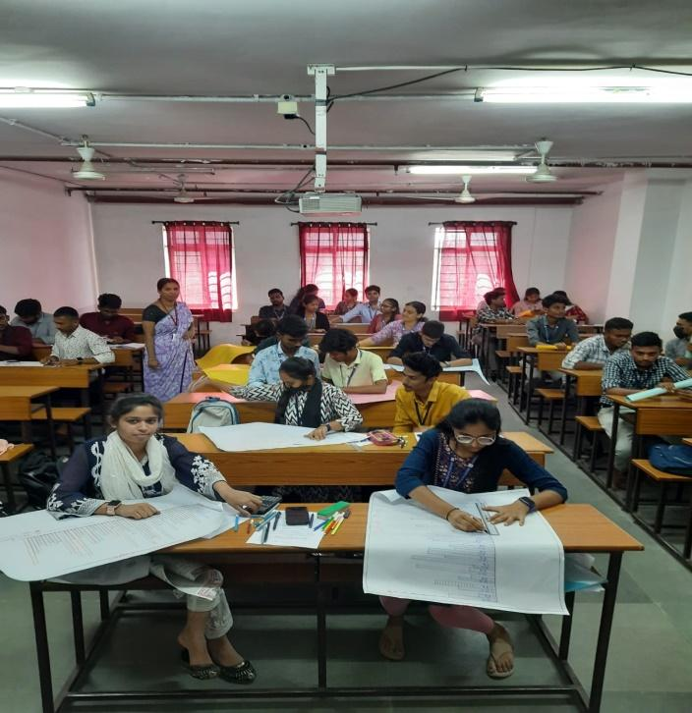

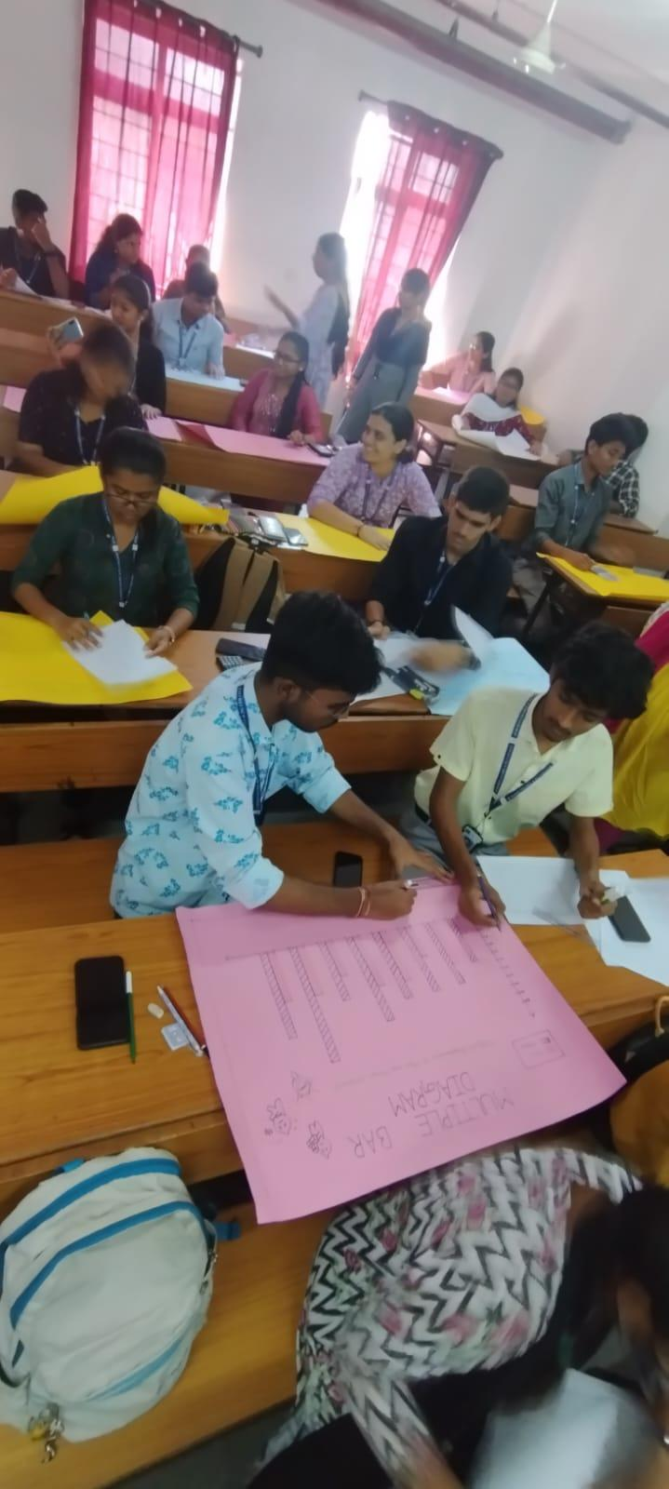

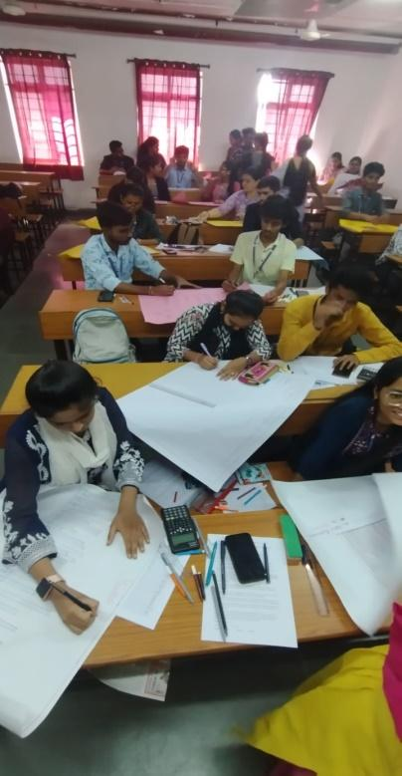

- GUEST PROFILE (IF ANY): NIL

- FEED BACK IF ANY: NIL

- ATTACHMENTS:
EVENT/ACTIVITY PROPOSAL
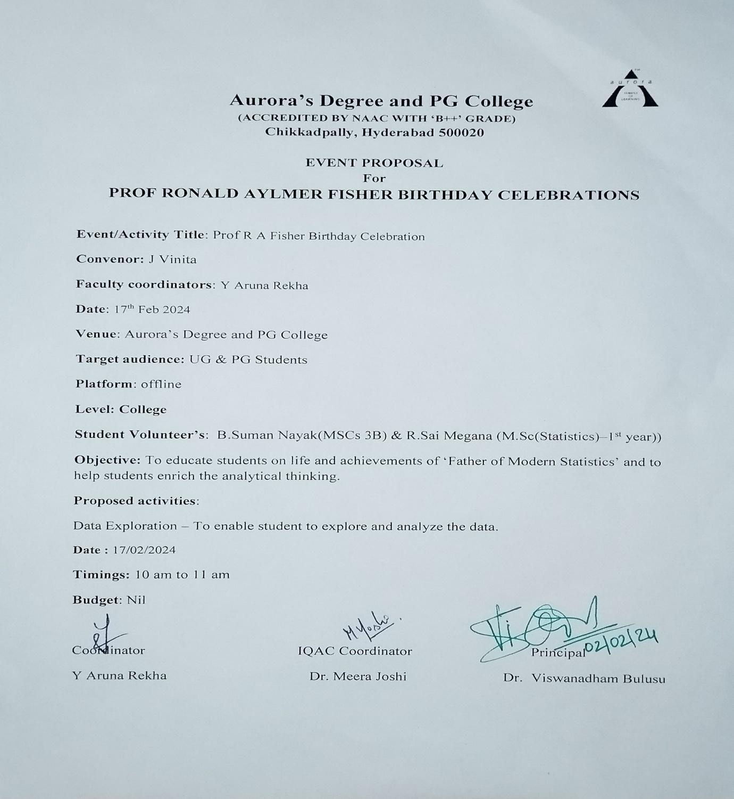

- EVENT / ACTIVITY NOTICE
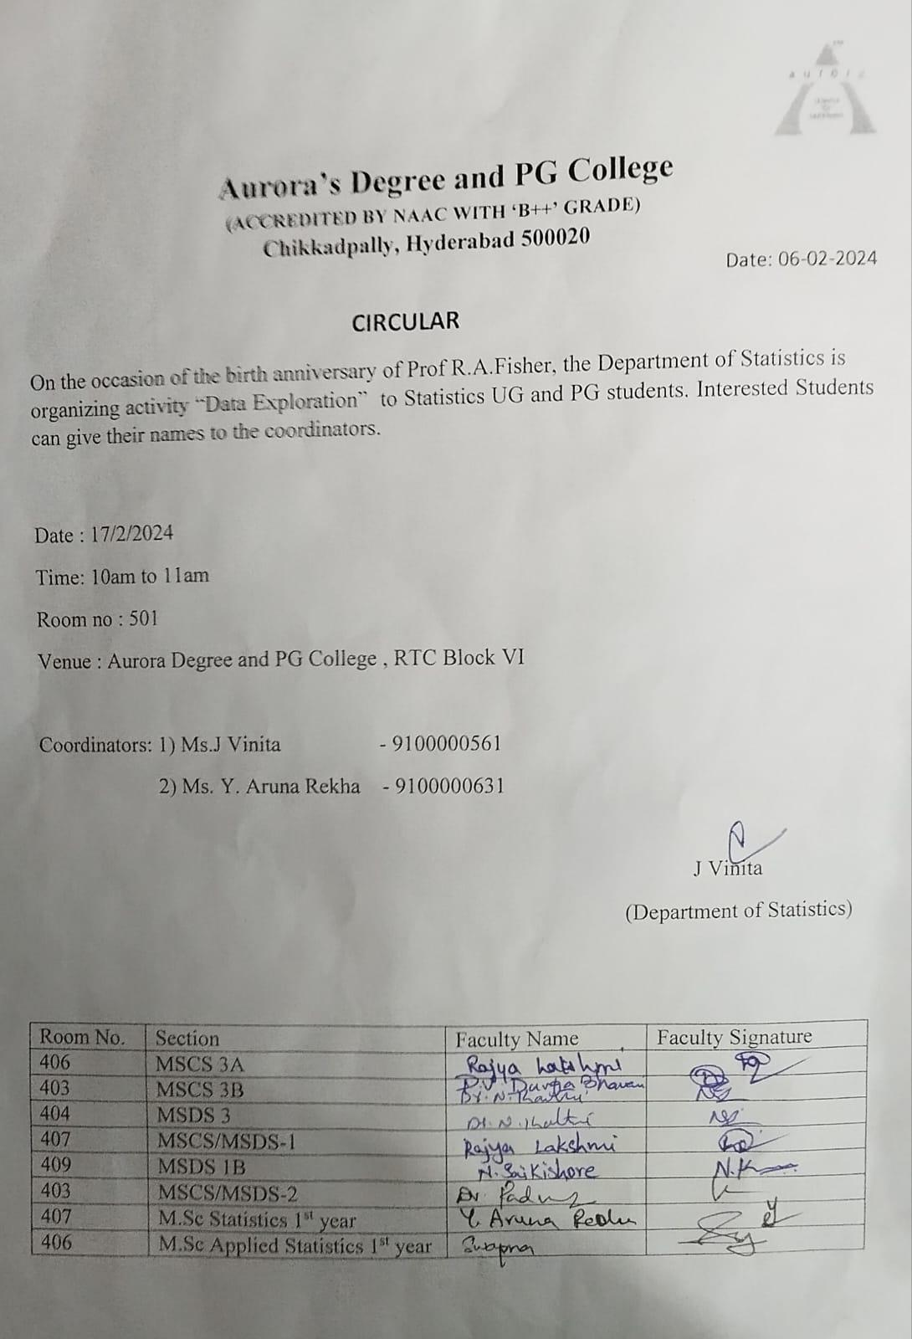

- RECEIPTS (IF ANY): NIL
- CERTIFICATES (IF ANY): NIL
- LETTERS OF COMMUNICATION (IF ANY): NIL

