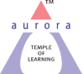
Aurora’s Degree & PG College
(ACCREDITED BY NAAC WITH 'B++' GRADE)
Chikkadpally, Hyderabad 500020

EVENT / ACTIVITY DETAILED REPORT

NAME OF THE EVENT / ACTIVITY | Industrial Visit to T-Hub
TYPE OR TITLE OF EVENT / ACTIVITY | Industrial Visit to T-Hub
FACULTY INCHARGE | C. Deepa
DEPARTMENT/CELL/COMMITTEE/CLUB | Computer Science
DATE | 28-12-2023
VENUE | T-Hub, Raidurgam
TARGET AUDIENCE | PG Students –MS(cs)Computer Science.

- PROGRAM SCHEDULE: Industrial Visit to T-HUB.
- LIST OF FACULTY COORDINATORS (DEPARTMENT): C.Deepa
- LIST OF THE IT Club STUDENT COORDINATORS
Roll No | Name | Stream
1051-22-405-035 | G.Jathin Sai | B.Com compapp-2CA
1051-21-405-001 | N.Neha | B.com compapp-3CA
1051-21-405-009 | K.Shreya | B.com comp app-3CB
1051-21-405-127 | S.Aakanksha | B.com comp app-3CC
1051-22-539-032 | P.Harshan | MSDS-2

4.LIST OF THE STUDENTS PARTICIPATED: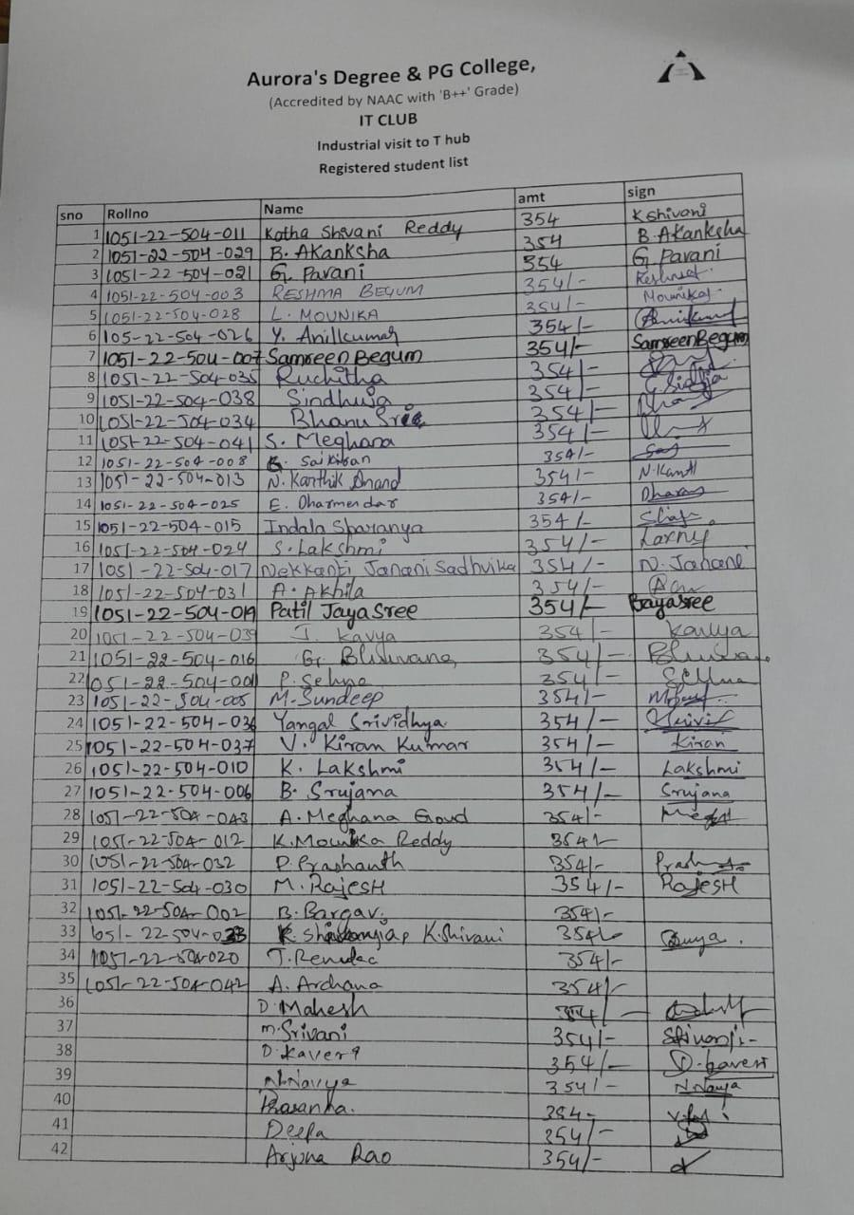
5.PARAGRAPH ABOUT THE PROCEEDINGS (TILL THE END OF THE EVENT):
An Industrial visit to “T-HUB, Gachibowli, Hyderabad Telangana 500032”, was organized by the IT club on Thursday, 28th dec 2023. 40 Msc (computer science) students and two faculty visited to T-HUB , to engage with the software industry and learn about the most recent and in-demand technologies, selection criteria, and market conditions. visit students were very eagerly waiting for listening to industrial higher authorities.
The Technical Head of T-Hub conducted very informative session for the students. Also he motivated to the students to select their domain and area of interest. He also guided the students to select the areas like artificial intelligence, python , web development, & mobile application development etc. and its importance in the current software market. He also guided on New technology which is their working technology
The session was concluded with Question- Answer session. Many of the students asked different questions to the Technical Head on current demanding technologies, market scenarios etc. and he cleared all the doubt and myths which was in students mind about the technologies and IT sector. All students were satisfied after the session.
6.INCOME AND EXPENDITURE :14,868/-

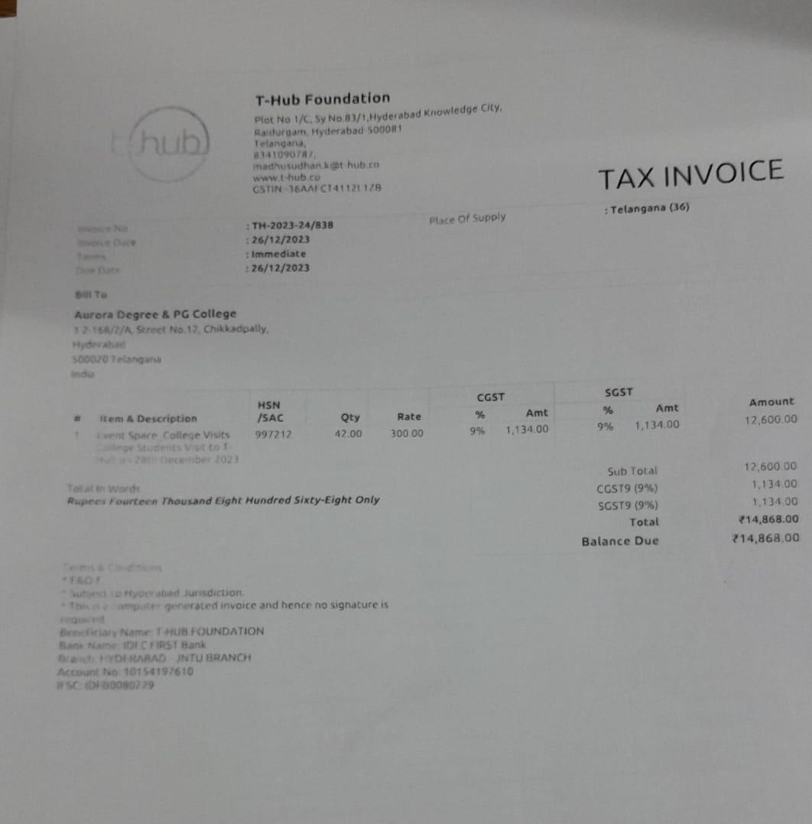

7.EVENT PHOTOS: (MIN 2 MAX 4):

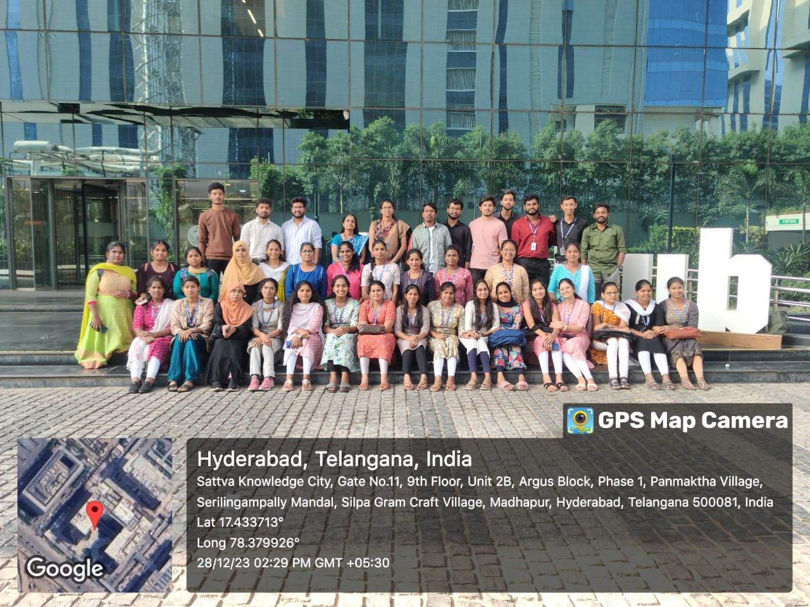
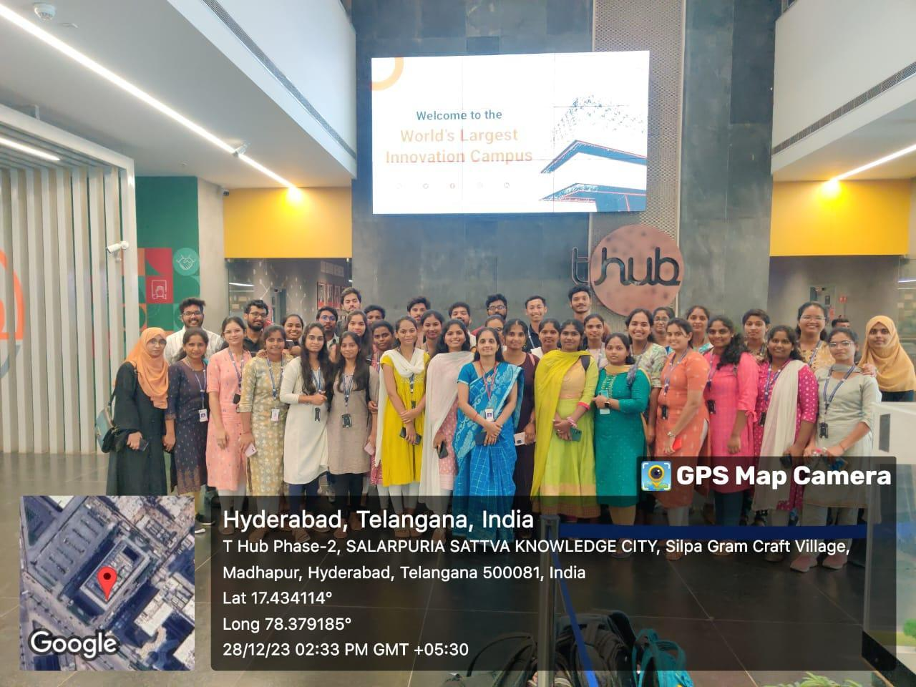

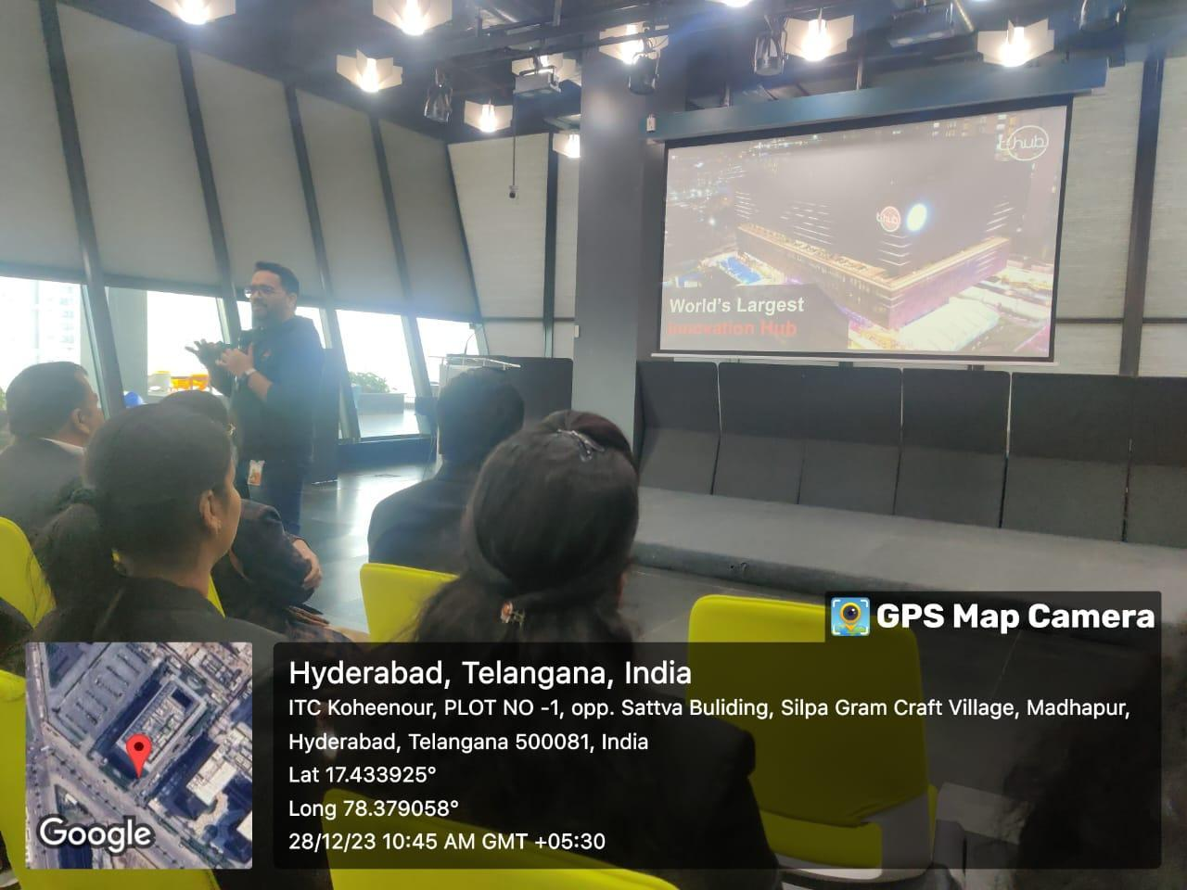
8.GUEST PROFILE (IF ANY)-NA
9.FEED BACK IF ANY-NA
10.ATTACHMENTS:
EVENT/ACTIVITY PROPOSAL: Hardcopy
EVENT / ACTIVITY NOTICE:hardcopy
RECEIPTS (IF ANY):NA
CERTIFICATES (IF ANY):NA
LETTERS OF COMMUNICATION (IF ANY):NA

