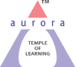
Aurora’s Degree & PG College
(ACCREDITED BY NAAC WITH 'B++' GRADE)
Chikkadpally, Hyderabad 500020

EVENT / ACTIVITY LONG REPORT

NAME OF THE EVENT / ACTIVITY | Guest Lecture on Impact of Artificial Intelligence in IT
TYPE OR TITLE OF EVENT / ACTIVITY | Guest Lecture on Impact of Artificial Intelligence in IT
FACULTY INCHARGE | C.Suvarna Lakshmi
DEPARTMENT/CELL/COMMITTEE/CLUB | Computer Science
DATE | 19-12-2023
VENUE | Aurora’s Degree & PG College, Block VI RTC X ROAD’S, Hyderabad
TARGET AUDIENCEe | M.Sc Computer Science Students
SPEAKER | Dr. B. Suresh Kumar, Associate Professor, School of Computer Science and Engineering, Sanjay Ghodawat University, Kolhapur, Maharashtra

OBJECTIVE:
To make Students aware of better carrier options with latest trends in IT with the scope of Artificial Intelligence.

BRIEF ABOUT THE EVENT
The Event has been scheduled 19-12-23 at 10.00 am at Computer lab 2 Block VI.Students have been informed well a head about the event through a circular. The event has been started at 10.00 am to 12:30 pm , where in about M.Sc Computer Science PG Semester I and Semester 3 around 78 Students have attended the Guest Lecture given by the speaker Dr. B. Suresh Kumar, Associate Professor, School of Computer Science and Engineering, Sanjay Ghodawat University, Kolhapur, Maharashtra, Speaker explained about Key role of various emerging latest technologies in current trend of Information technology and the usage of Artificial intelligence with the use of Python, Machine Learning and Deep Learning concepts. Also he iterated topic discussion on Chat GPT usage and how the Artificial Intelligence playing vital role in predominating the current IT trend, followed with the open discussion with the students stating that “Will AI Replace Human” through Power point presentation and also stated about how AI can work with Input Data but it does lacks emotional Intelligence, Thus its human makes AI work. In the event around 78 students presented, given below Student details:
OUTCOME:
M.Sc Computer Science students got the awareness about various concepts in Artificial Intelligence and Impact of Artificial Intelligence in the current world of Information Technology and Limitations of AI.
EVENT PHOTOS :
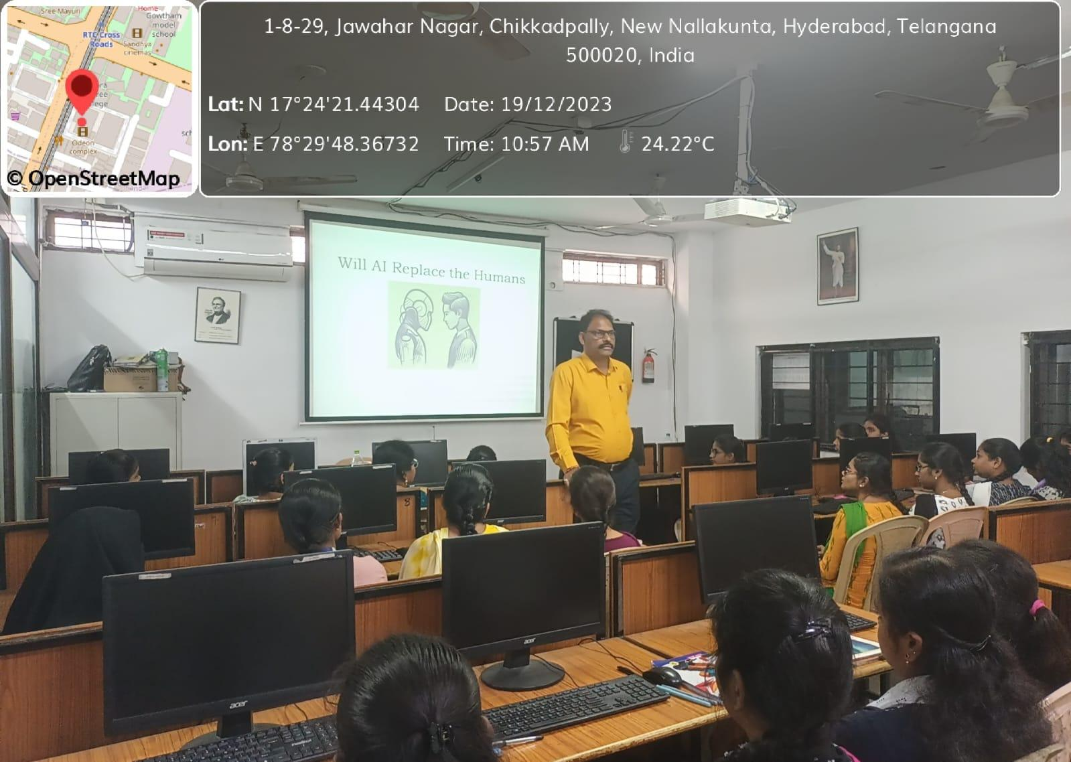
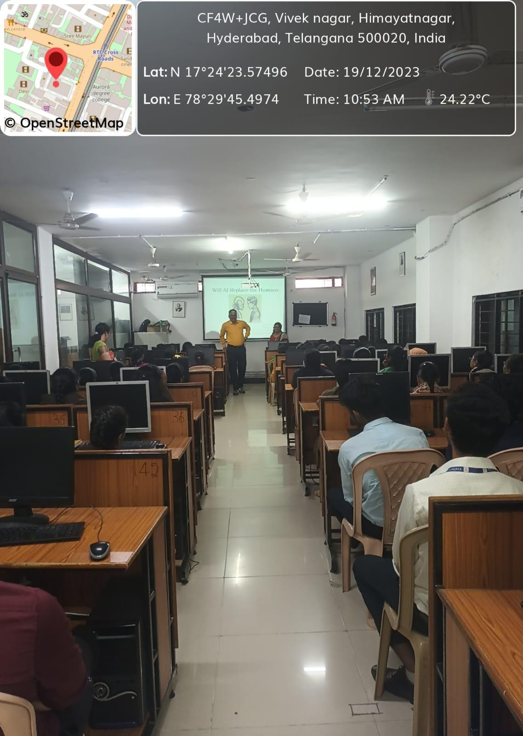
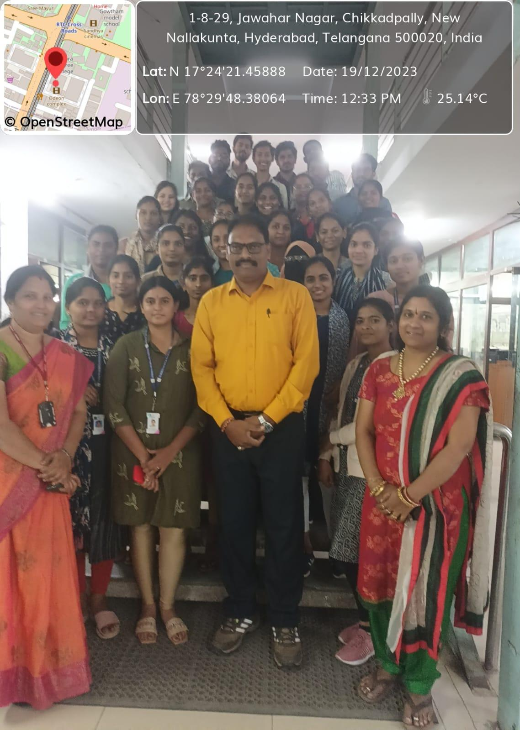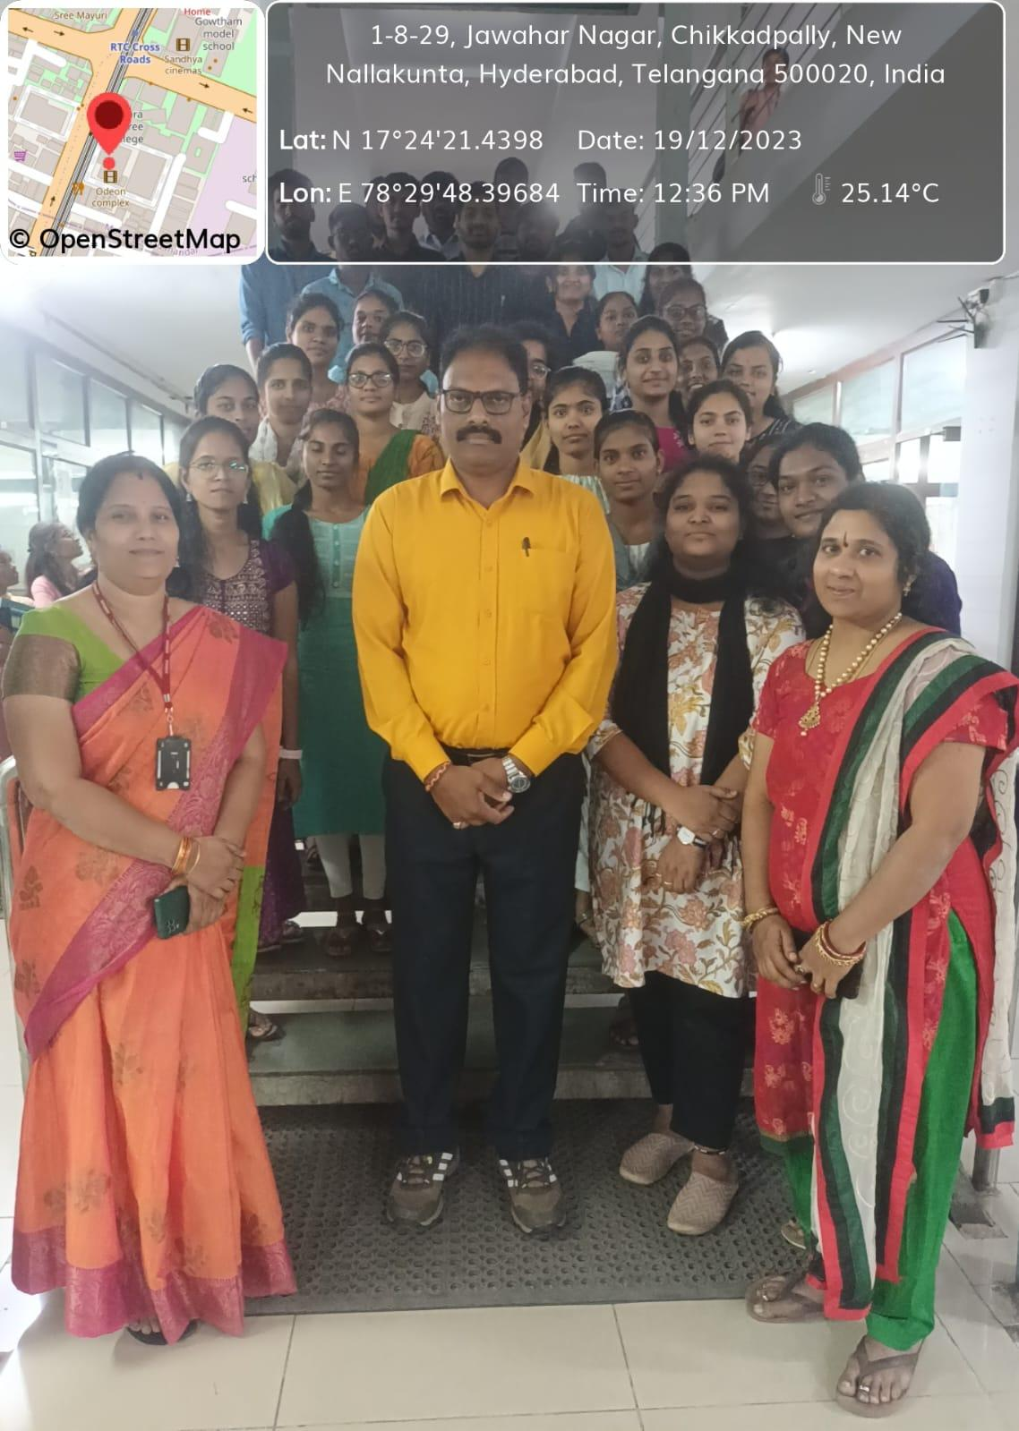
STUDENTS ATTENDED:
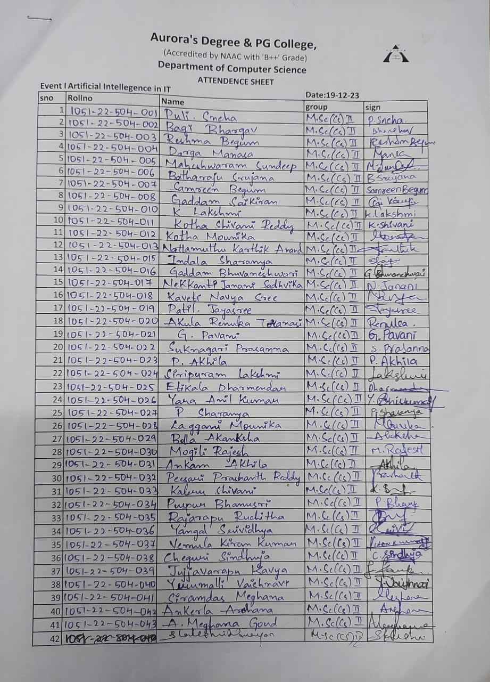
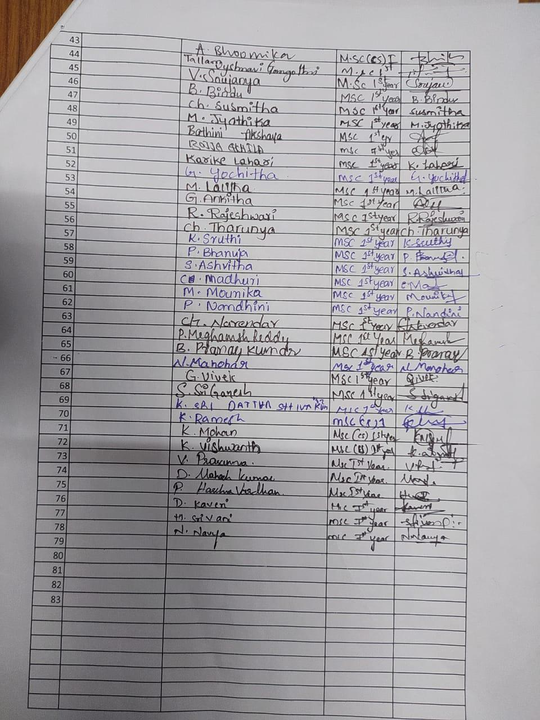
- GUEST PROFILE (IF ANY)-NA
- FEED BACK IF ANY-NA
- ATTACHMENTS:
EVENT/ACTIVITY PROPOSAL: Hardcopy
EVENT / ACTIVITY NOTICE:NA
RECEIPTS (IF ANY):NA
CERTIFICATES (IF ANY):NA
LETTERS OF COMMUNICATION (IF ANY):NA

