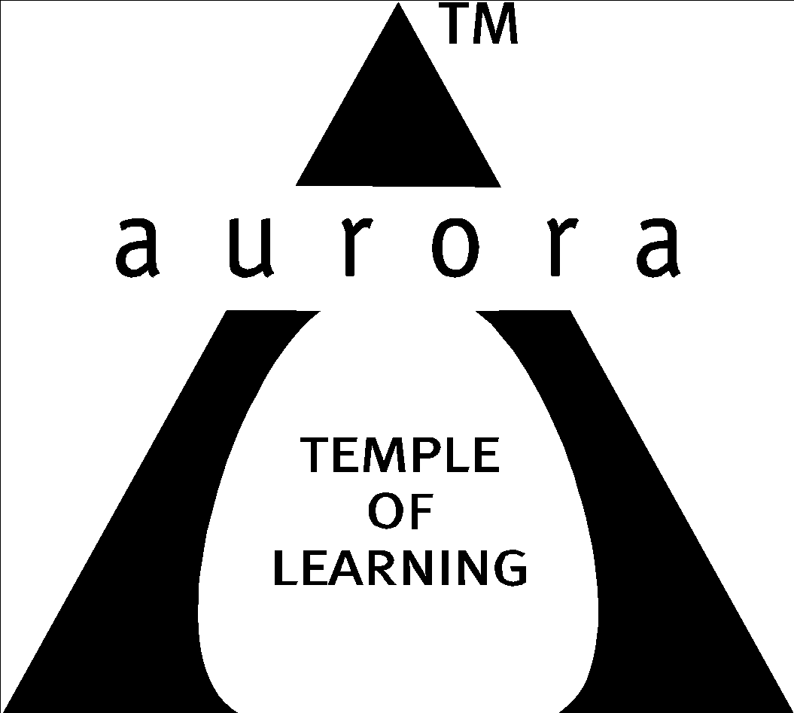

Aurora’s Degree & PG College
(ACCREDITED BY NAAC WITH 'B++' GRADE)
Chikkadpally, Hyderabad 500020

EVENT / ACTIVITY DETAILED REPORT

NAME OF THE EVENT / ACTIVITY | Prof.C.R.Rao Memorial Lecture
TYPE OR TITLE OF EVENT / ACTIVITY | Lecture
FACULTY INCHARGE | Parimala Diana Sudhir. K(Convener)  Anjaneyulu.P & Rajyalakshmi (Coordinators)
DEPARTMENT/CELL/COMMITTEE/CLUB | Statistics
DATE | 10-10-2023
VENUE | Seminar Hall-Aurora’s Degree and PG College
TARGET AUDIENCE | Twin city level (UG & PG Statistics)

- LIST OF FACULTY COORDINATORS (DEPARTMENT): K. Parimala Diana Sudhir (Convener)
Anjaneyulu.P & Rajyalakshmi (Coordinators)

- LIST OF THE STUDENT COORDINATORS (NAME, ROLL NO, CLASS & SECTION)
- Name: Meher Sai
Roll No: 1051-21 467-001
Class: MSCS3A
- Name: Siddi Rajput
Roll No: 1051-21 467-001-080
- Name: Ajay.G
Roll No: 1051-21-467-020
Class: MSDS 3

- LIST OF THE PARTICIPANTS

- PARAGRAPH ABOUT THE PROCEEDINGS (TILL THE END OF THE EVENT):
Day : 10-10-2023
Speaker: Prof. J. Sreenivasa Rao, University of California, Santa Barbara, USA
(C.R. Rao’s Life time achievement awardee in the year 2019)

Program Schedule:
➢ Welcome Address -- 10.00am-10.05am
➢ Documentary Presentation -- 10.05am-10.15am
➢ Inviting Guest to the dais -- 10.15am-10.20am
➢ Address by Dr Viswanatham Bulusu, Principal -- 10.20am-10.25am
➢ Lecture by Prof Sreenivasa Rao Jammalamadaka -- 10.25am-11.25am
➢ Feedback -- 11.25am-11.30am
➢ Felicitation to Prof Sreenivasa Rao Jammalamadaka -- 11.30am-11.40am
➢ Vote of thanks -- 11.40am-11.50am

The Department of Statistics organized a memorial lecture in honor of Prof. C.R. Rao on October 10, 2023, for statistics students from twin city colleges. The event featured Prof. J. Sreenivasa Rao, a notable figure in the field of statistics, who had received the C.R. Rao Lifetime Achievement Award in 2019.
Welcome Address: Ms. Parimala Diana Sudhir, the convener of the event, began with a welcome address, introducing the distinguished speaker, Prof. J.S. Rao, and welcoming the Principal, Dr. Vishwanadham Bulusu, and all the participants.
Honoring the Guest: Mr. Anjaneyulu, the coordinator of the event, honored Prof. J.S. Rao with a bouquet to show respect for the esteemed speaker.
Mr. Rajkumar MSDS1 presented documentation on the activities and events organized by the statistics department, providing an overview of the department's contributions. Ms. Vinita, the head, Department of Statistics, introduced Prof. J.S. Rao by reading his profile, highlighting his accomplishments and contributions to the field.
Prof. Jammalmadaka Srinivasa Rao's Remarks: Prof. Jammalmadaka Srinivasa Rao, the distinguished professor, shared his personal experiences with Prof. C.R. Rao, likely offering insights into the life and work of the late C.R. Rao. He also inspired the participants to make their own contributions to the field of statistics.
Prof. J.S. Rao delivered a lecture titled "A Matter of Direction - An Introduction to Directional Data." In his lecture, he discussed various examples related to directional data, providing valuable insights into the field of statistics. Some of the examples included:

- Measuring Directional Movement of Water Bodies: Exploring how to measure the directional flow of water bodies.
- Migration Patterns of Animals and Birds: Using examples like the Monarch butterflies in Santa Barbara to study animal migration.
- Ozone Levels in Santa Barbara: Investigating how pollution levels in nearby major cities affect the ozone levels in Santa Barbara.
- Random Walk Problem: Discussing the concept of random walks in statistical analysis.
- Sound Waves of Two Violins: Examining sound wave patterns from two violins.
- 2-Dimensional Projection of Flying Paths of Mosquitoes: Using statistics to analyse the flying paths of mosquitoes.

The Principal, Dr. Vishwanadham Bulusu, felicitated Distinguished Professor JS Rao. Ms. Rajyalakshmi coordinated the felicitation ceremony. Ms.Parimala Diana Sudhir rendered vote of thanks. The complete program was telecasted by Alumni Sravani on her YouTube channel, QTV.
There were 180 participants, including 100 students from other colleges, 60 from Aurora, and 12 faculty members from other institutions. Along the organizing teams the department faculty took on different responsibilities
- Ms. Rekha was responsible for providing refreshments to the guests and participants.
- Mr. Sai Kishore handled technical support and also contributed to the refreshments.
- Ms. Swapna was in charge of registration.

All the department faculty members shared responsibilities in conducting the lecture.The organizing committee expressed their gratitude to Principal Dr. Vishwanadham Bulusu for his continuous support, sponsorship of event expenditures gifts for the guest, and lunch for the guest.
Student Volunteers:
- Ms.Praveena - PG Statistics
- Ms.Chavi - PG Applies Statistics
- Ms.Sai Bhavana - MSCs/MSDS2
- Ms.Nammera - MSDS1
- Ms.Siddi Rajput - MSCS3B
- Ms.Ajay.G - MSDS3
- Mr.Sumeeth Singh - MSDS3B
- Mr.Aakash - MSCS3B

- INCOME : NIL
EXPENDITURE :
- Refreshments for participants (Tea& Coffee) - 150/-
- Refreshments for participants (Biscuits) - 444/-
- Refreshment for Guest - 290/-
- Stationery - 30/-
- Bouquei for guest - 150/-
- Banners, Certificates & Momentoo - 2849/-
Total - 5463/-

- EVENT PHOTOS (MIN 2 MAX 4):
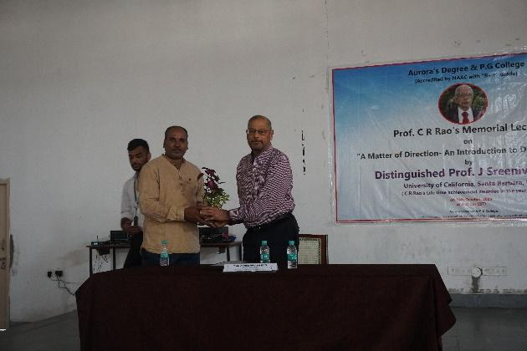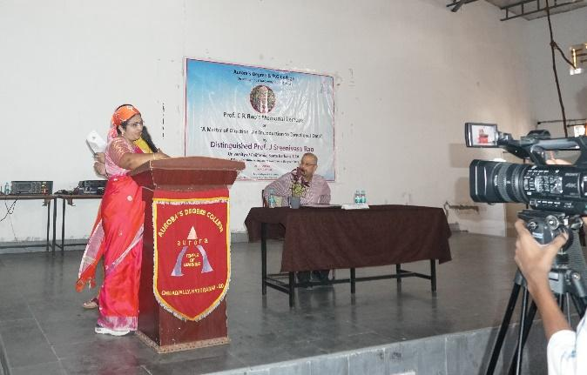
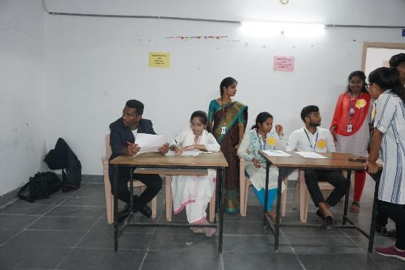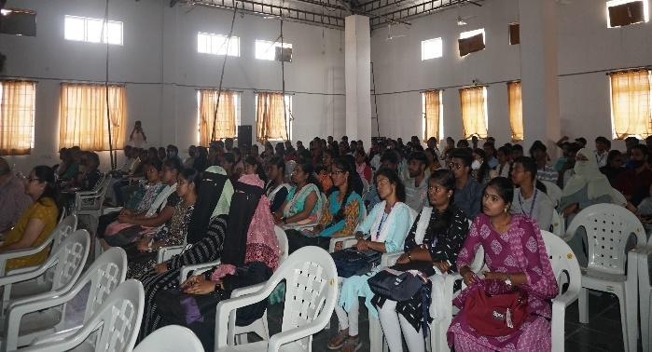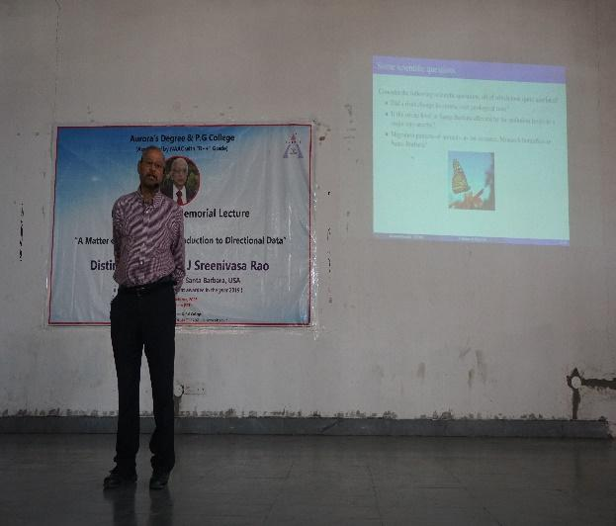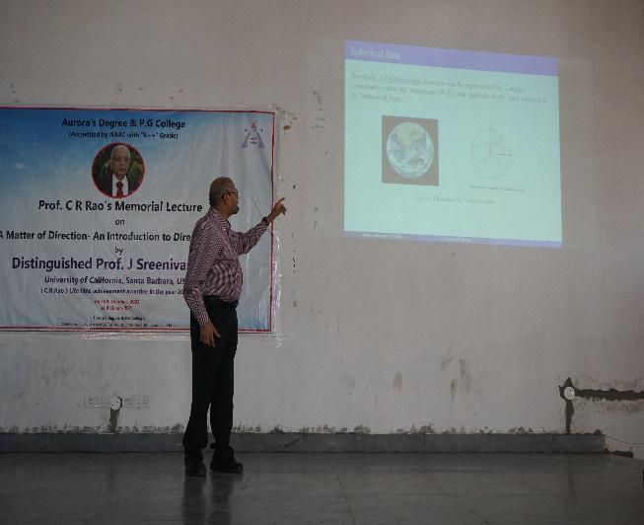
- 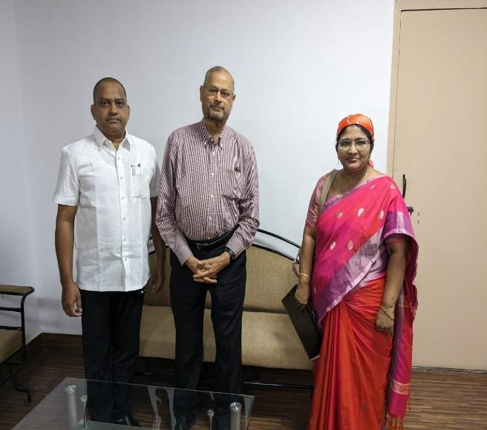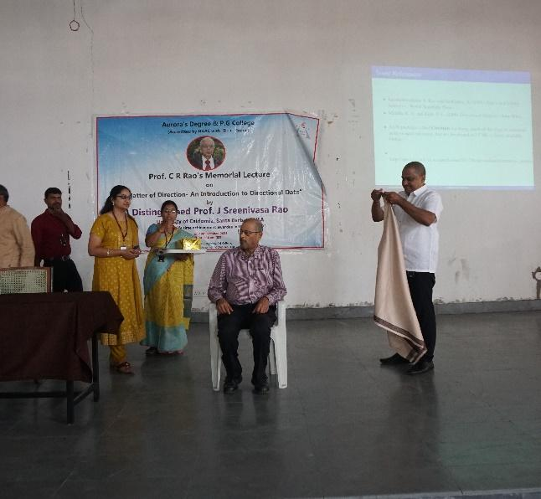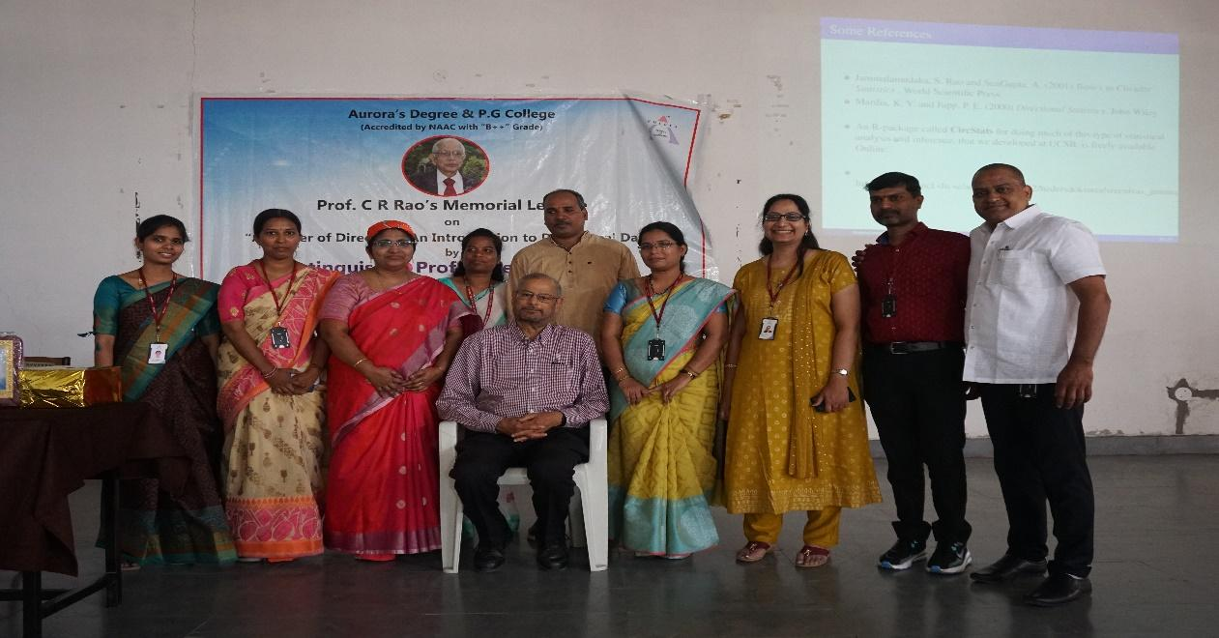

- ATTACHMENTS:
EVENT/ACTIVITY PROPOSAL
. 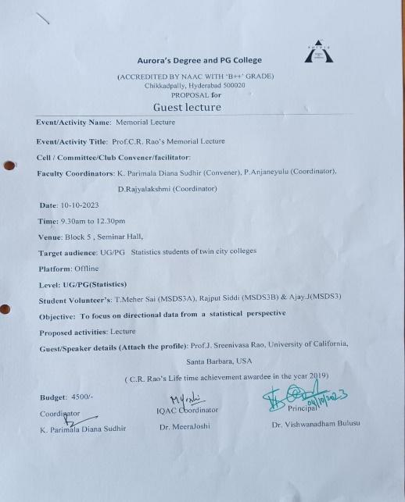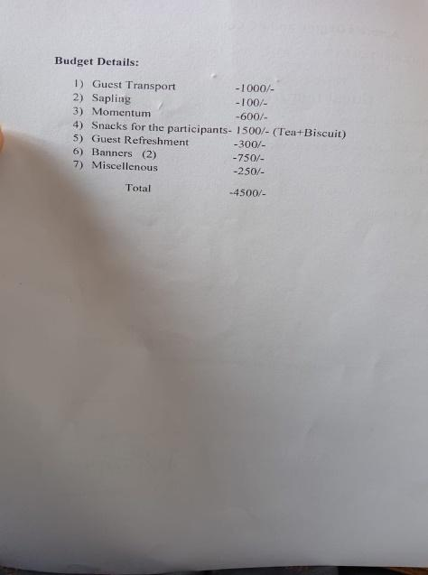

EVENT / ACTIVITY NOTICE – Shared In Whatsapp groups

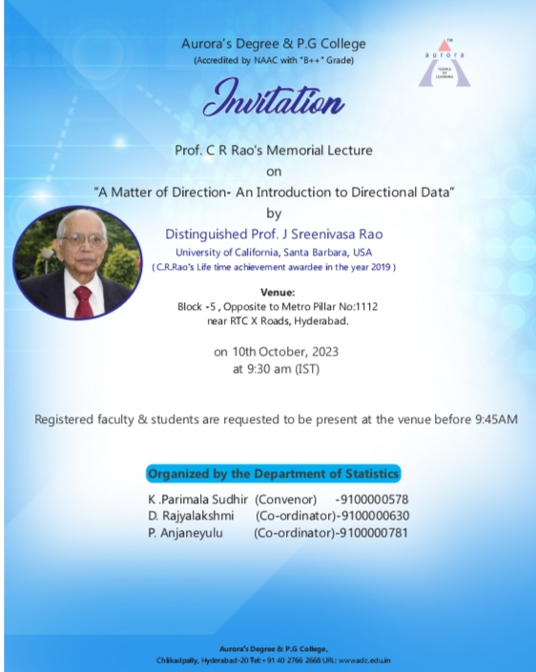

RECEIPTS (IF ANY):
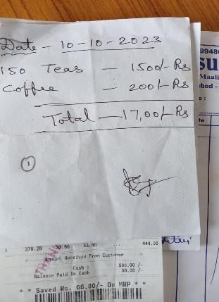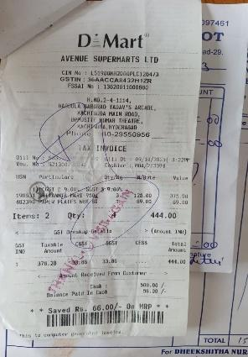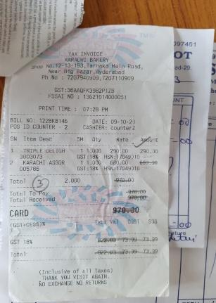

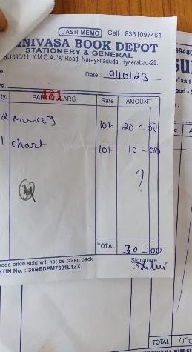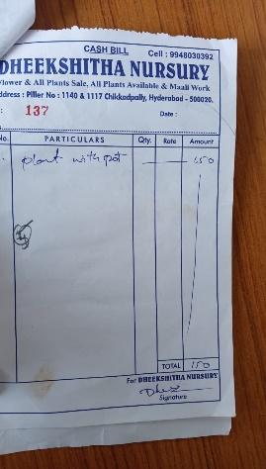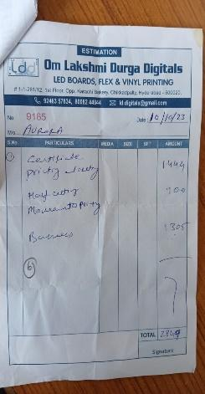

CERTIFICATES (IF ANY):
LETTERS OF COMMUNICATION (IF ANY):
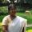
Parimala Sudhir <parimalasudheer@adc.edu.in> | Sep 23, 2023, 11:13 AM
to rao

Good morning sir,
Thank you for accepting our invitation. It's a privilege and honor to
have you, sir. Your presence itself is an inspiration to faculty and
students. I humbly request you to give your date and time between
October 9th to 13th possibly, (because students may have Dussehra
vacation from 14th October), and the topic suitable for the audience.
Participants are statistics students of Undergraduate, Postgraduate,
and Statistics faculty of our college and other colleges.
Looking forward to an opportunity to inspire and engage our faculty
and students.
Thank you,
Regards,
Parimala Diana Sudhir.K
Associate Professor, Department of Statistics.
Aurora's Degree & PG College,
Hyderabad.

S Rao Jammalamadaka | Sep 24, 2023, 11:07 AM
to me

Hi Parimala
I can give a talk on Tuesday the 10th Oct. either on:
1. "Statistics-- Some Excursions" (this is a broad-brush intro to stats and some non-standard sidelights that I call excursions)
or
2. "A Matter of Direction -- an introduction to Directional Data" (this gives examples where directional data occurs and how it is different -- this is the topic of a conference here at Gitam starting tomorrow)
Decide what might interest your audience and let me know. I enclose a brief writeup about me so you don't have to look around too much.
Sreenivas
----------------------------------------------------------------------------------------------------------------------------
S. Rao Jammalamadaka Phone: (805) 893-3119
Distinguished Professor Office: (805) 893-2129
Dept of Statistics & Applied Probability Fax: 805) 893-2334
Univ of California email: rao@pstat.ucsb.edu
Santa Barbara, CA 93106 www.pstat.ucsb.edu/faculty/jammalam/
----------------------------------------------------------------------------------------------------------------------------
One attachment • Scanned by Gmail

