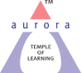
Aurora’s Degree & PG College
(Accredited by NAAC with 'B++' grade)
Chikkadpally, Hyderabad- 500020
Department of Biochemistry

EVENT REPORT

NAME OF THE EVENT / ACTIVITY | World Alzheimer’s Day
TYPE OR TITLE OF EVENT / ACTIVITY | Department Event
FACULTY INCHARGE | Bindu G
DATE | 21/09/2023; 11: 30 AM
VENUE | Main Block
TARGET AUDIENCE | Life science students

Objective:
- To enlighten students about the various causes of dementia
- To create awareness about early warning signs, risk factors and treatment associated with dementia
- PROGRAM SCHEDULE
- Brief introduction about World Alzheimer’s Day
- Poster presentation
- Decipher the terms
- LIST OF FACULTY COORDINATORS (DEPARTMENT): Dr. G. Bindu
LIST OF THE STUDENT COORDINATORS (NAME, ROLL NO, CLASS & SECTION)
Sno | Name | Roll No | Class
1 | Shivani | 1051-21-488-026 | Bt.Bi.C III
2 | Pravali | 1051-21-488-028 | Bt.Bi.C III
3 | Keerthi Chandana | 1051-21-488-013 | Bt.Bi.C III
4 | Namami | 1051-21-459-010 | Mi.G.C III

LIST OF THE PARTICIPANTS IN DECIPHER THE TERMS
SNo | Name | Roll No | Class
1 | Md.Abdul Ahad |  | BT.BI.C 1
2 | M.Tejas |  | BT.BI.C 1
3 | Noor Ali |  | BT.BI.C 1
4 | Shreya |  | BT.BI.C 1
5 | Khaleed |  | BT.BI.C 1
6 | Hari Prasad |  | BT.BI.C 1
7 | B.Rakesh Yadav |  | MI.G.C 1
8 | M.Uday Kumar |  | MI.G.C 1
9 | Dhara Singh |  | MI.G.C 1
10 | Bhagya shree |  | MI.G.C 1
11 | Harshith |  | MI.G.C 1
12 | Dhiren Singh |  | MI.G.C 1
13 | Ch.Shiva |  | MI.G.C 1
14 | Roopa | 1051-21-459-004 | MI.G.C 3
15 | M.Bhargavi | 1051-21-459-032 | MI.G.C 3
16 | S. Shivani | 1051-21-459-028 | MI.G.C 3
17 | S.Deekishitha | 1051-21-459-025 | MI.G.C 3
18 | P.Kavya | 1051-21-459-026 | MI.G.C 3
19 | Raj Kumar | 1051-21-459-029 | MI.G.C 3
20 | Vivek | 1051-21-459-012 | MI.G.C 3
21 | Srinath | 1051-21-459-005 | MI.G.C 3
22 | P. kalayan | 1051-21-459-024 | MI.G.C 3
23 | Swaminathan | 1051-21-459-009 | MI.G.C 3
24 | Akanksha | 1051-21-459-006 | MI.G.C 3
25 | M. Pradeep | 1051-21-459-008 | MI.G.C 3
26 | - Sumanth | 1051-21-471-002 | MI.BI.C 3
27 | Raghuvamsh.V | 1051-21-471-013 | MI.BI.C 3
28 | T.Keerthi Bhargavi | 1051-21-471-011 | MI.BI.C 3
29 | G.Shivani | 1051-21-471-014 | MI.BI.C 3
30 | Shashidhar | 1051-21-471-008 | MI.BI.C 3
31 | Nithish | 1051-21-471-012 | MI.BI.C 3
32 | Sri Kousthub | 1051-21-471-003 | MI.BI.C 3
33 | Sampath | 1051-21-471-010 | MI.BI.C 3
34 | Nishath Farheen | 1051-21-488-010 | BT.BI.C 3
35 | Syed Ansar | 1051-21-488-014 | BT.BI.C 3
36 | R. Varanavi | 1051-21-488-043 | BT.BI.C 3
37 | Laxmi Prasanna | 1051-21-488-047 | BT.BI.C 3
38 | Likisha Reddy | 1051-21-488-041 | BT.BI.C 3
39 | Sai Teja | 1051-21-488-051 | BT.BI.C 3
40 | Dinesh | 1051-21-488-029 | BT.BI.C 3
41 | Vignan Amar | 1051-21-488-042 | BT.BI.C 3
42 | M. Mani Deepak | 1051-21-488-049 | BT.BI.C 3
43 | K. Rahil | 1051-21-488-001 | BT.BI.C 3
44 | V. Srileka | 1051-21-488-040 | BT.BI.C 3
45 | M.Pallavi | 1051-21-488-007 | BT.BI.C 3
46 | S.Aishwarya | 1051-21-488-002 | BT.BI.C 3
47 | V. Sanjeev | 1051-22-488-035 | BT.BI.C 2
48 | Shaik Khaja | 1051-22-488-032 | BT.BI.C 2
49 | Sravani Sree | 1051-22-488-039 | BT.BI.C 2
50 | Varsha | 1051-22-488-037 | BT.BI.C 2
51 | Shreya | 1051-22-471-004 | MI.BI.C 2
52 | Sakina | 1051-22-471-002 | MI.BI.C 2

LIST OF THE PARTICIPANTS IN POSTER PRESENTATION
SNo | Name | Roll No | Class
1 | Harshith |  | MI.G.C 1
2 | Dhiren Singh |  | MI.G.C 1
3 | Bhagya shree |  | MI.G.C 1
4 | Raghuvamsh.V | 1051-21-471-013 | MI.BI.C 3

- PARAGRAPH ABOUT THE PROCEEDINGS (TILL THE END OF THE EVENT):
Globally, dementia is one of the biggest challenges we face, with nearly 50 million people living with dementia worldwide. To tackle this international dementia challenge, we need to work together and share best practice with one another. This is why Alzheimer's Society has committed to work with partners on global research and campaigning, as well as sharing our learning, best practice and experience with one another.
As outlined in our World Alzheimer Report 2019, many people still wrongly believe that dementia is a part of normal ageing. This alone highlights how important public awareness campaigns, like World Alzheimer’s Month, are for changing perceptions and increasing existing public knowledge around Alzheimer’s disease and dementia.
With the number of people living with dementia set to almost triple by 2050, it has never been more important to recognise the risk factors associated with dementia and take proactive steps towards risk reduction. As such, this year’s theme ‘Never too early, never too late’ centres on the key risk factors and risk reduction, aiming to emphasise their crucial role in delaying and potentially preventing the onset of dementia. This also importantly includes on-going risk reduction for those who have already been diagnosed.
We the Department of Biochemistry celebrated World Alzheimer’s Day on 21st September 2023. In this connection competition like Poster presentation and Decipher the terms were conducted. 52 students were participated for the event Decipher the terms and there were 5 participants for Poster presentation with the theme ‘Never too early, never too late’.
The aim of all these competitions was to impart the knowledge about various phases of dementia, causes and treatment. It has also enlightened about the importance of personal attention and healthy diet for maintaining a healthy life.
The event was successful with the participation of students of various streams of life sciences.

- INCOME AND EXPENDITURE: Nil
- EVENT PHOTOS ( MIN 2 MAX 4)

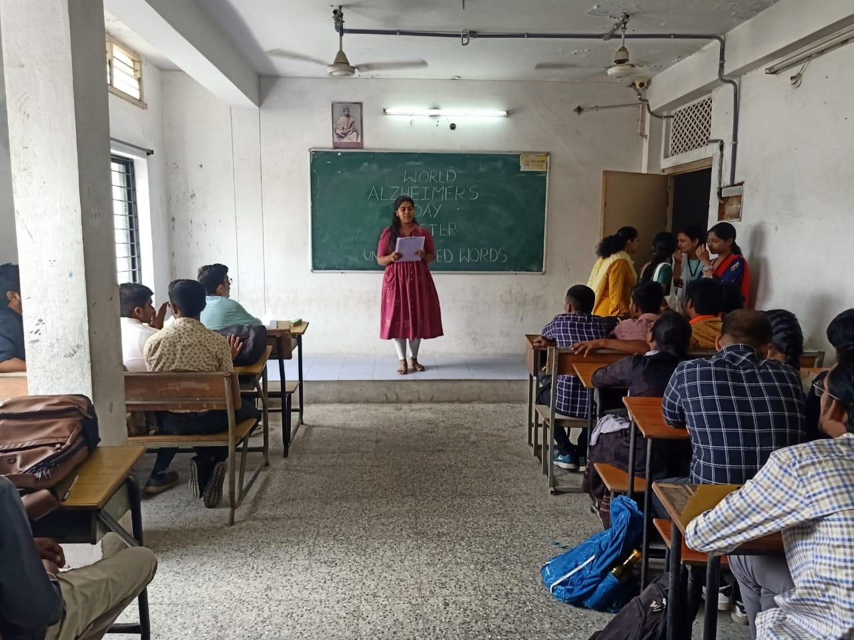
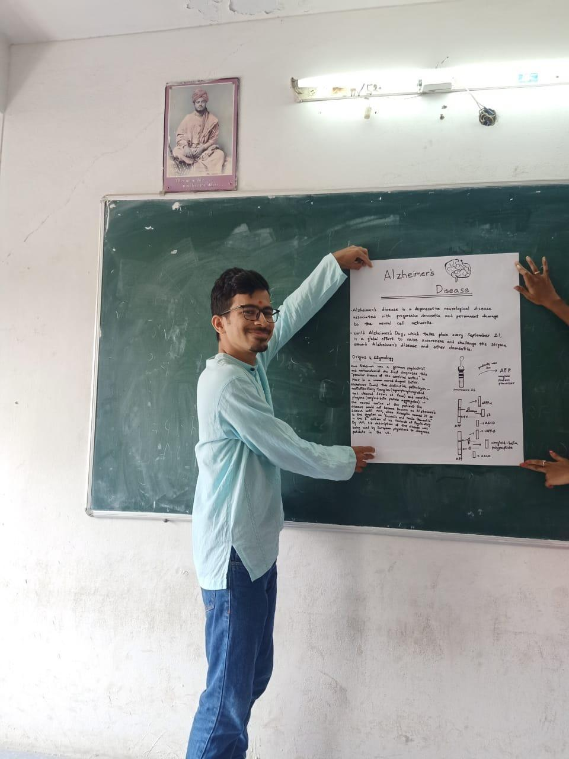
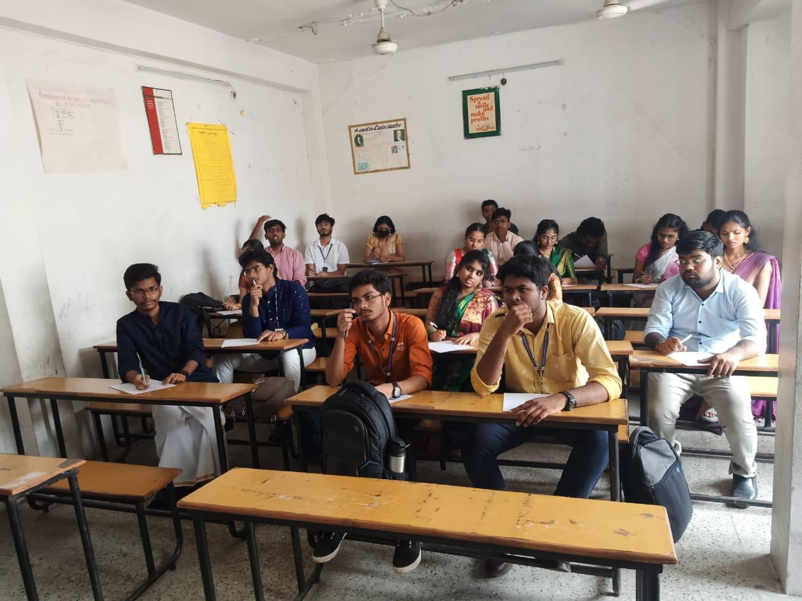
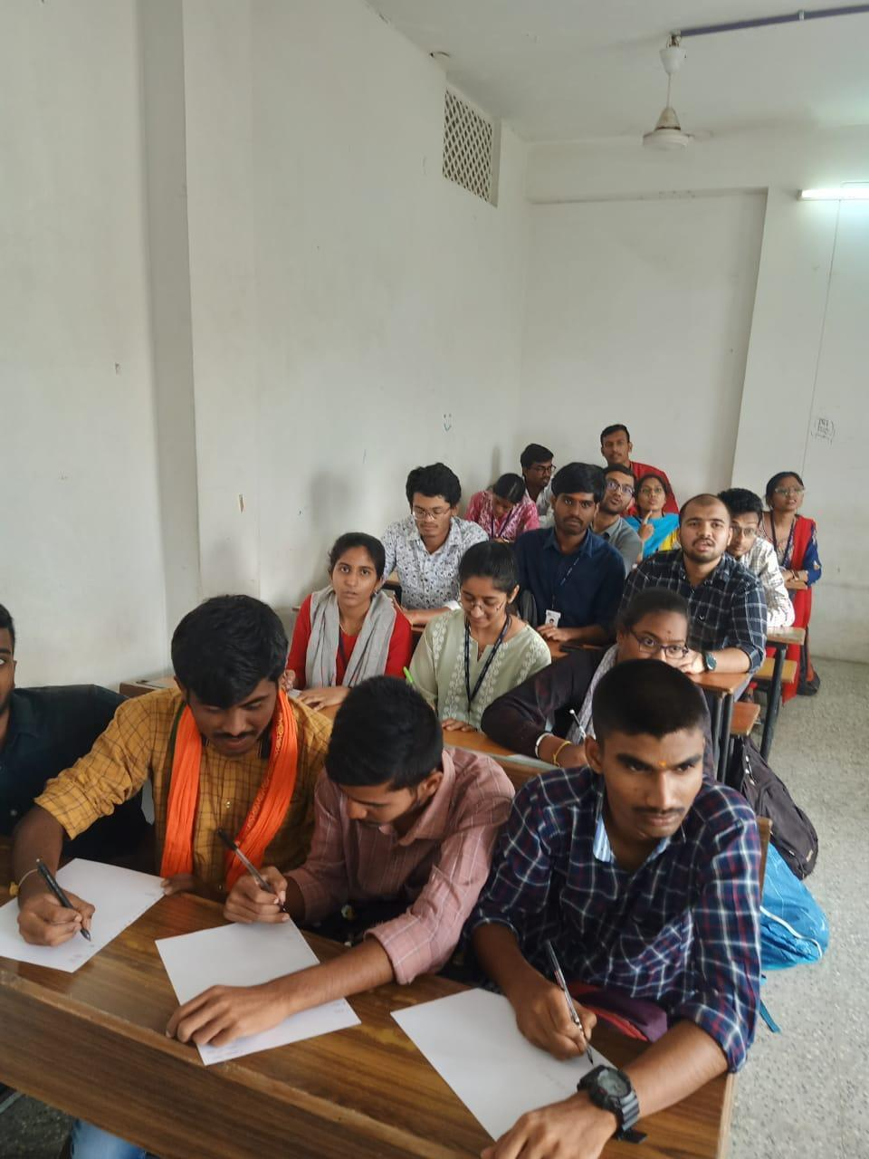

- GUEST PROFILE (IF ANY): Nil
- FEED BACK IF ANY: Nil
- ATTACHMENTS:

EVENT/ACTIVITY PROPOSAL
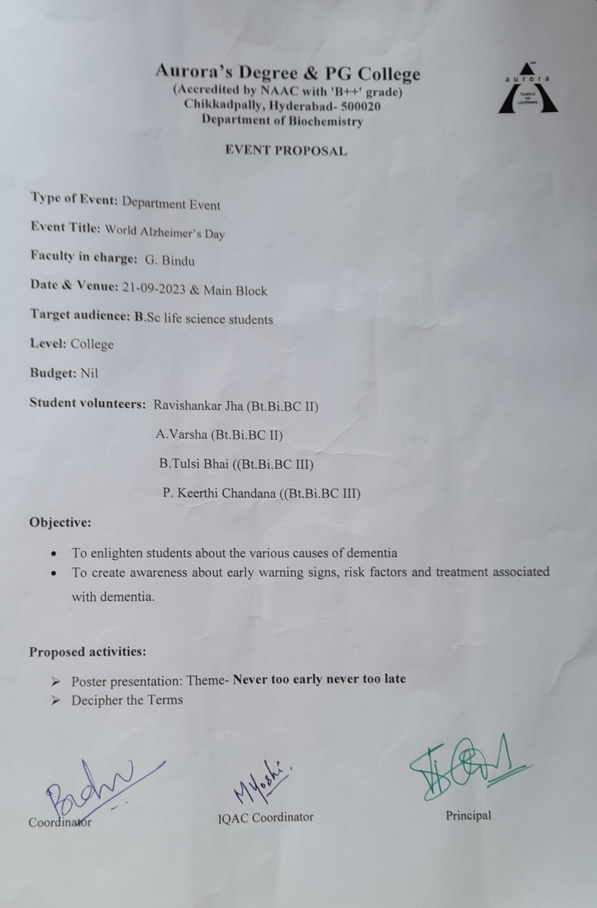

EVENT / ACTIVITY NOTICE
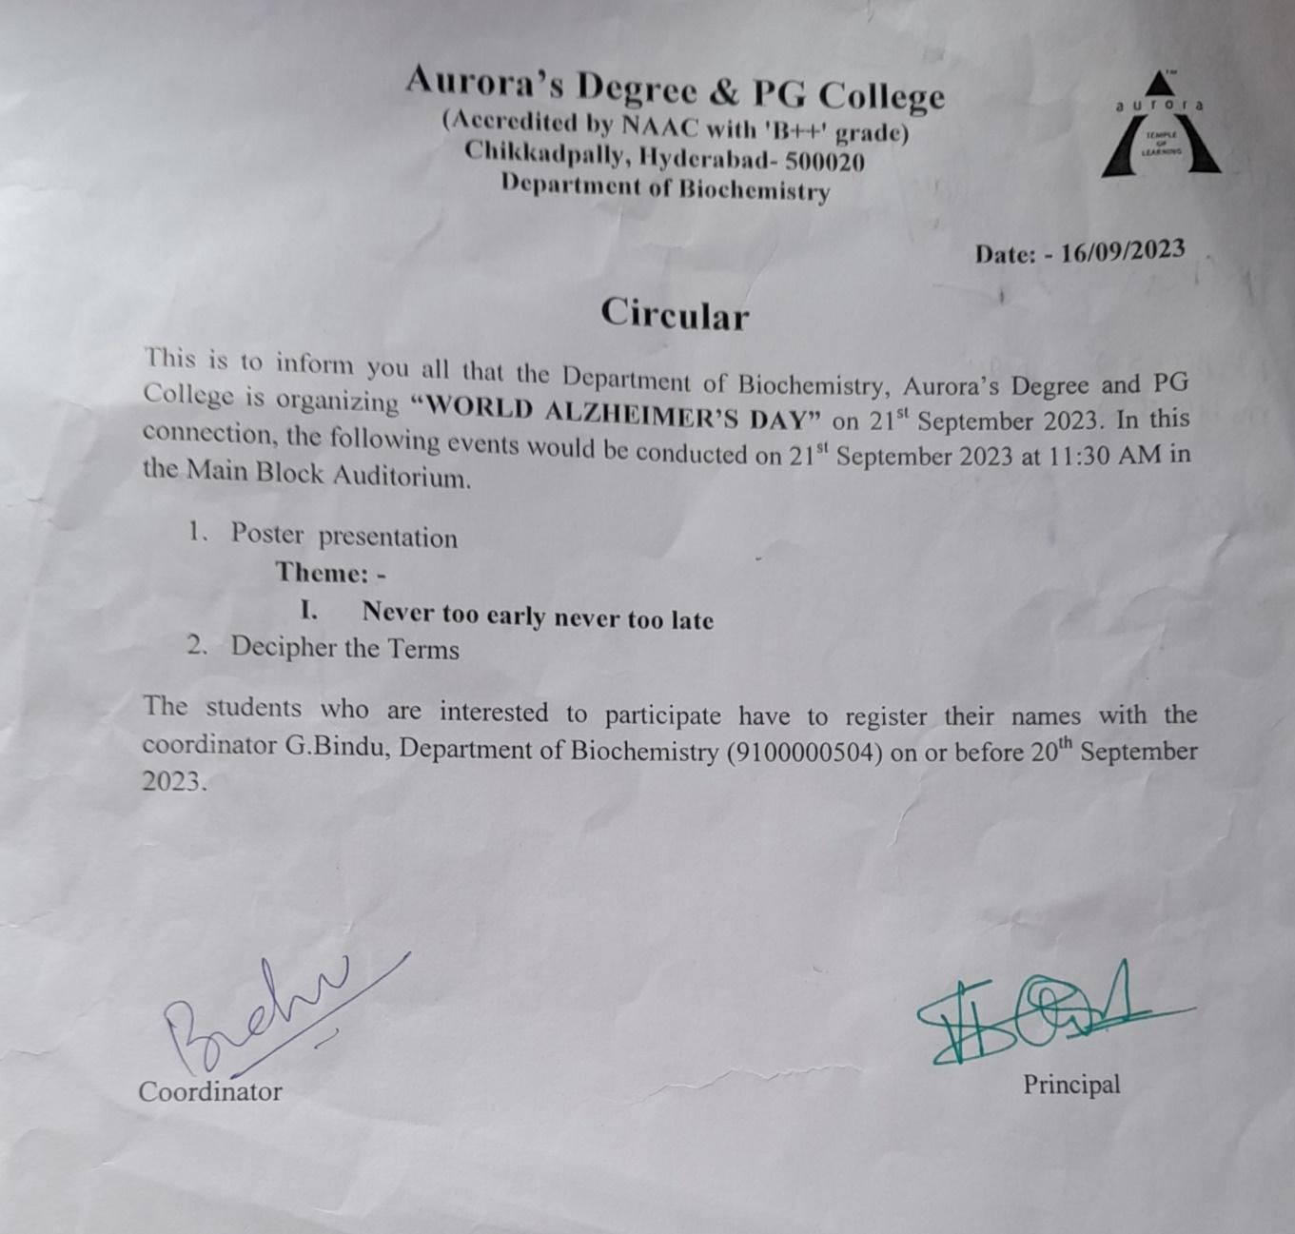
RECEIPTS (IF ANY)
CERTIFICATES (IF ANY)
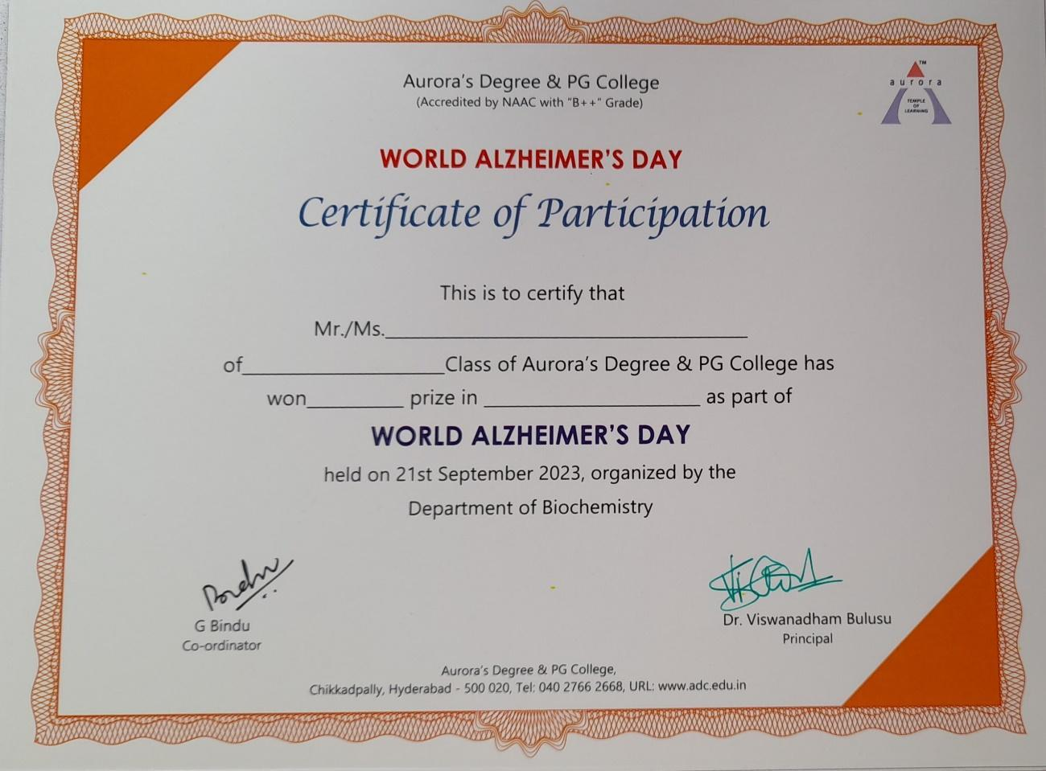

LETTERS OF COMMUNICATION (IF ANY)-NIL

