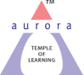
Aurora’s Degree & PG College
(ACCREDITED BY NAAC WITH 'B++' GRADE)
Chikkadpally, Hyderabad 500020

EVENT / ACTIVITY DETAILED REPORT

NAME OF THE EVENT / ACTIVITY | Hindi Diwas
TYPE OR TITLE OF EVENT / ACTIVITY | Hindi Diwas
FACULTY INCHARGE | Dr. Shivhar Biradar,
DEPARTMENT/CELL/COMMITTEE/CLUB | Languages
DATE | 14 to21st September 2023
VENUE | RTC BLOCK 6
TARGET AUDIENCE | Hindi Students

- PROGRAM SCHEDULE 14 to21 st September 2023
11.00 a.m Well Come speech
11.10 a.m lighting of the lamp
11.15 a.m prayer song
11.20 a,m introduction speech
11.30 a.m Poetry Recitation
12.00 noon Hindi Diwas speech
12.30 p.m Story Review
1.00 p.m Vote of Thanks
- LIST OF FACULTY COORDINATORS (DEPARTMENT)
1. Dr. Shivhar Biradar (Languages)
2. R.Heena. (Languages)
3. LIST OF THE STUDENT COORDINATORS (NAME, ROLL NO, CLASS & SECTION)
- Kashish Sharma - 1051-21-684-086 (B.B.A 3 B )
2. Ekambe Anu 1051-21- 401—059 (B. COM 3 B)

- LIST OF THE PARTICIPANTS (NAME, ROLL NO, CLASS & SECTION, NO OF GIRLS, BOYS, CASTE)
STUDENTS ATTENDED
BOYS: -

S.No | Roll No. |  | Name | Class & Section
1 | 1051-21-405-090 |  | Kamlesh Khatri | B.Comp Appl-3B
2 | 1051-21-405-091 |  | Kartick Shee | B.Comp Appl-3B
3 | 1051-21-405-092 |  | Das Aditya | B.Comp Appl-3B
4 | 1051-21-405-093 |  | K Ronit Jaiswal | B.Comp Appl-3B
5 | 1051-21-405-095 |  | Vadlamani Sriman Narayana | B.Comp Appl-3B
6 | 1051-21-405-096 |  | Arjun Venkatesh | B.Comp Appl-3B
7 | 1051-21-405-097 |  | Akash Dileep | B.Comp Appl-3B
8 | 1051-21-405-098 |  | Himanshu Agarwal | B.Comp Appl-3B
9 | 1051-21-405-099 |  | Nehal Saha | B.Comp Appl-3B
10 | 1051-21-405-100 |  | Salla Anirudh | B.Comp Appl-3B
11 | 1051-21-405-101 |  | Shubham Mishra | B.Comp Appl-3B
12 | 1051-21-405-102 |  | Krishna Pandey | B.Comp Appl-3B
13 | 1051-21-405-103 |  | Gurumitkal Sai Chandra | B.Comp Appl-3B
14 | 1051-21-405-104 |  | Easuraj John Paul | B.Comp Appl-3B
15 | 1051-21-405-105 |  | Pratham Goel | B.Comp Appl-3B
16 | 1051-21-405-106 |  | Gadhgay Yogesh | B.Comp Appl-3B
17 | 1051-21-405-107 |  | Kotagiri Vishal | B.Comp Appl-3B
18 | 1051-21-405-108 |  | Pawan Yadav | B.Comp Appl-3B
19 | 1051-21-405-109 |  | Yalamaly Shivani | B.Comp Appl-3B
20 | 1051-21-405-110 |  | Hemanth Kumar Bansiwal | B.Comp Appl-3B
21 | 1051-21-405-111 |  | Karthik Joshi | B.Comp Appl-3B
22 | 1051-21-405-112 |  | Prashant Khatri | B.Comp Appl-3B
23 | 1051-21-405-113 |  | T Yash Singh | B.Comp Appl-3B
24 | 1051-21-405-114 |  | Ashish Singh | B.Comp Appl-3B
25 | 1051-21-405-115 |  | Thote Mahesh Shivaji | B.Comp Appl-3B
26 | 1051-21-405-116 |  | Harsh Thakur | B.Comp Appl-3B
27 | 1051-21-405-117 |  | Krishi Agarwal | B.Comp Appl-3  B
28 | 1051-21-405-118 |  | Anusri Durga Prasad | B.Comp Appl-3B
29 | 1051-21-405-119 |  | Pandiya Premchand | B.Comp Appl-3B
30 | 1051-21-405-120 |  | Gorav Kumar Bardia | B.Comp Appl-3B
31 | 1051-21-401-051 |  | Salman Ahmed | B. Com 3B
32 | 1051-21-401-052 |  | Gaurav Jain | B. Com 3B
33 | 1051-21-401-053 |  | Harsh Jain | B. Com 3B
34 | 1051-21-401-054 |  | Mathupati Abhishek | B. Com 3B
35 | 1051-21-401-055 |  | Surasani Shiva Prasad Reddy | B. Com 3B
36 | 1051-21-401-062 |  | Kirtan Agarwal | B. Com 3B
37 | 1051-21-401-063 |  | Sumeet Jain | B. Com 3B
38 | 1051-21-401-064 |  | Vidish Sharma | B. Com 3B
39 | 1051-21-401-065 |  | Abhishek Sudke | B. Com 3B
40 | 1051-21-401-066 |  | Beedekhane Uday Kiran | B. Com 3B
41 | 1051-21-401-067 |  | M Chetan Yadav | B. Com 3B
42 | 1051-21-401-068 |  | Anurag Singh | B. Com 3B
43 | 1051-21-401-071 |  | Saahil Ramchandani | B. Com 3B
44 | 1051-21-405-121 |  | Konapuram Rahul | B.Comp Appl-3C
45 | 1051-21-405-122 |  | Ramjus Yuvraj Kumar | B.Comp Appl-3C
46 | 1051-21-405-123 |  | Mohammed Abdul Raheem | B.Comp Appl-3C
47 | 1051-21-405-124 |  | Jammula Vijay Ramchandra Reddy | B.Comp Appl-3C
48 | 1051-21-405-125 |  | Pawan Singh | B.Comp Appl-3C
49 | 1051-21-405-126 |  | Kanduluri Jai Sri Datta | B.Comp Appl-3C
50 | 1051-21-538-002 |  | Sumeet Kumar Jaiswal | Buss Anly-3
51 | 1051-21-538-004 |  | Dev Joshi | Buss Anly-3
52 | 1051-21-538-005 |  | Ashish Pandiya | Buss Anly-3
53 | 1051-21-538-006 |  | Ramawat Harsh | Buss Anly-3
54 | 1051-21-538-007 |  | Sujal Sirvi | Buss Anly-3
55 | 1051-21-538-008 |  | Sujal Chowdary | Buss Anly-3
56 | 1051-21-538-010 |  | Eshanth Suri | Buss Anly-3
57 | 1051-21-538-012 |  | Manav Singh | Buss Anly-3
58 | 1051-21-684-073 |  | Rajput Alok Arun Singh | BBA-3B
59 | 1051-21-684-075 |  | Anirudh Singh | BBA-3B
60 | 1051-21-684-076 |  | Chintapalli Akhila | BBA-3B
61 | 1051-21-684-077 |  | Rakesh Chandra Rout | BBA-3B
62 | 1051-21-684-078 |  | Sohaib Khan | BBA-3B
63 | 1051-21-684-079 |  | Mamillapally Sowrabh | BBA-3B
64 | 1051-21-684-080 |  | Aditya Upadhyay | BBA-3B
65 | 1051-21-684-081 |  | Asawa Saloni | BBA-3B
66 | 1051-21-684-082 |  | Madhav Upadhyay | BBA-3B
67 | 1051-21-684-083 |  | Harshit Gupta | BBA-3B
68 | 1051-21-684-084 |  | Vishnu Aasat | BBA-3B
69 | 1051-21-684-085 |  | Ankush Khalkho | BBA-3B
70 | 1051-21-684-087 |  | Yash Jain | BBA-3B
71 | 1051-21-684-088 |  | Sharma Rajath | BBA-3B
72 | 1051-21-684-089 |  | Keshav Sanghi | BBA-3B
73 | 1051-21-684-092 |  | Advani Manav V | BBA-3B
74 | 1051-21-684-093 |  | Talaviya Gautam Patel | BBA-3B
75 | 1051-21-684-094 |  | Shaik Manzoor Ali | BBA-3B
76 | 1051-21-684-095 |  | Brij Raval | BBA-3B
77 | 1051-21-684-096 |  | Aditya Hiware | BBA-3B
78 | 1051-21-684-098 |  | G Sumith | BBA-3B
79 | 1051-21-684-100 |  | Amol Agnihotri | BBA-3B
80 | 1051-21-684-101 |  | Vaishnav Luv | BBA-3B
81 | 1051-21-684-103 |  | Vaishnav Kush | BBA-3B
82 | 1051-21-684-104 |  | Dhruv Shah | BBA-3B
83 | 1051-21-684-105 |  | Vishal Biradar | BBA-3B
84 | 1051-21-467-078 |  | Mohammed Safwan Aasim | MSCS-3B
85 | 1051-21-467-079 |  | Aravind Kumar Bansiwal | MSCS-3B
86 | 1051-21-467-081 |  | Mohammed Feroz | MSCS-3B
87 | 1051-21-467-083 |  | Kukrethi Harinand | MSCS-3B
88 | 1051-21-467-084 |  | Madnoorkar Yogesh | MSCS-3B
89 | 1051-21-467-085 |  | Roshan Sharma | MSCS-3B
90 | 1051-21-539-002 |  | Aman Rasyani | MSDS-3
91 | 1051-21-539-003 |  | Bhandari Ajay Rajamallu | MSDS-3
92 | 1051-21-539-009 |  | Rahul Pokar | MSDS-3
93 | 1051-21-539-010 |  | More Abhishek | MSDS-3
94 | 1051-21-539-011 |  | Md Asim Maqsood | MSDS-3
S.No | Roll No. |  | Name | Class & Section
1 | 1051-21-401-056 |  | Badegharwale Unnathi | B. Com 3B
2 | 1051-21-401-057 |  | Kumari Neha | B. Com 3B
3 | 1051-21-401-059 |  | Ekambe Anu Baliram | B. Com 3B
4 | 1051-21-401-061 |  | T Gayathri Bai | B. Com 3B
5 | 1051-21-401-069 |  | Sanjana Agarwal | B. Com 3B
6 | 1051-21-401-070 |  | Prathana Vyas | B. Com 3B
7 | 1051-21-405-094 |  | D Nandini | B.Comp Appl-3B
8 | 1051-21-405-117 |  | Krishi Agarwal | B.Comp Appl-3B
9 | 1051-21-405-142 |  | Suguru Sai Priya | B.Comp Appl-3B
10 | 1051-21-538-003 |  | Laxmi | Buss Anly-3
11 | 1051-21-538-009 |  | Angarkar Shreya | Buss Anly-3
12 | 1051-21-538-011 |  | Aliya Tabassum | Buss Anly-3
13 | 1051-21-684-074 |  | Divya Gami | BBA-3B
14 | 1051-21-684-076 |  | Chintapalli Akhila | BBA-3B
15 | 1051-21-684-081 |  | Asawa Saloni | BBA-3B
16 | 1051-21-684-086 |  | Kashish Sharma | BBA-3B
17 | 1051-21-684-090 |  | Nisha Lahoti | BBA-3B
18 | 1051-21-684-091 |  | Divya Khatri | BBA-3B
19 | 1051-21-684-097 |  | Diya Agarwal | BBA-3B
20 | 1051-21-684-099 |  | Pandit Soumya Sharma | BBA-3B
21 | 1051-21-684-102 |  | Mahek Jain | BBA-3B
22 | 1051-21-684-106 |  | Bandhakavi Sri Dhatri | BBA-3B
23 | 1051-21-467-076 |  | Naima Khatoon | MSCS-3B
24 | 1051-21-467-077 |  | Anth Reddy Amrutha | MSCS-3B
25 | 1051-21-467-080 |  | Rajput Siddhi | MSCS-3B
26 | 1051-21-467-082 |  | Karishma | MSCS-3B
27 | 1051-21-539-005 |  | Sanjana Badnale | MSDS-3
28 | 1051-21-539-006 |  | Uzma Nazneen | MSDS-3
29 | 1051-21-539-007 |  | Swetha Kulkarni | MSDS-3
30 | 1051-21-539-008 |  | Nethikar Harshitha | MSDS-3

- PARAGRAPH ABOUT THE PROCEEDINGS (TILL THE END OF THE EVENT)
Aurora Degree & PG College Organized activities on Hindi Diwas from 14th September to 21ST September at RTC Block 6 The convener of the event Dr. Shivhar Biradar (Hindi faculty) from department of languages gave an introduction speech about the importance of Hindi Language. Hindi is recognized as our country’s official language on 14th Sept 1949. Dr. Shivhar Biradar also shared a poem which instilled patriotism in everyone.
- Welcome song to create awareness among students about Hindi Language.
- To make the program more interactive and engaging several competitions and activities were organized like, Elocution, Story review, poem recitation, PPT Presentation, where in students participated with full zeal and enthusiasm.
- Nearly 50 students participated in different competitions and 1st & 2nd
Prizes were given away to winners.

Faculty Volunteer Dr. Shivhar Biradar also shared a poem which instilled patriotism in everyone.
Winner’s list
Elocution: -
1.Shweta Kulkarni MSDS 3
2.Hari Haran MPCS 2
3.Nandini B.COM 2
Story Review: -
1.Sanjana. B MSDS 3
2.Uzma MSDS 3
Poem Recitation: -
1.Kashish Sharma BBA 3C
2.Arpita BBA BA 2
3.Vivaan BBA BA 1

Vote of Thanks by R. Heena
Hindi diwas is a platform for students to showcase their talent in their National Language and to encourage the students to develop their motherhood and for their growth as an Indian. The session was concluded with a collective realization of the importance of Hindi language and the resolve to respect it.
Certificates were distributed.
- INCOME AND EXPENDITURE - 300/-
- EVENT PHOTOS (MIN 2 MAX 4)

- 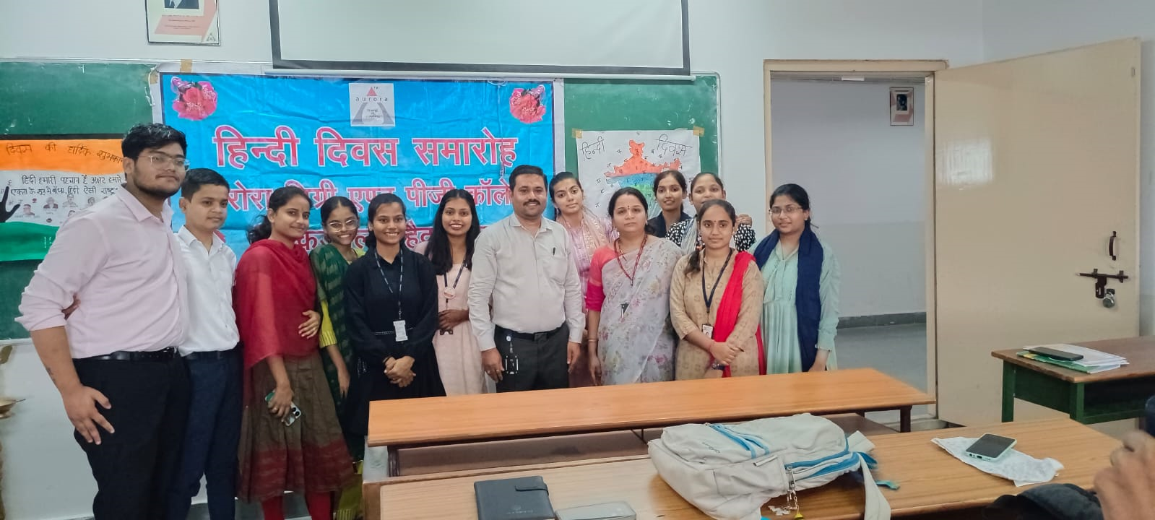

- 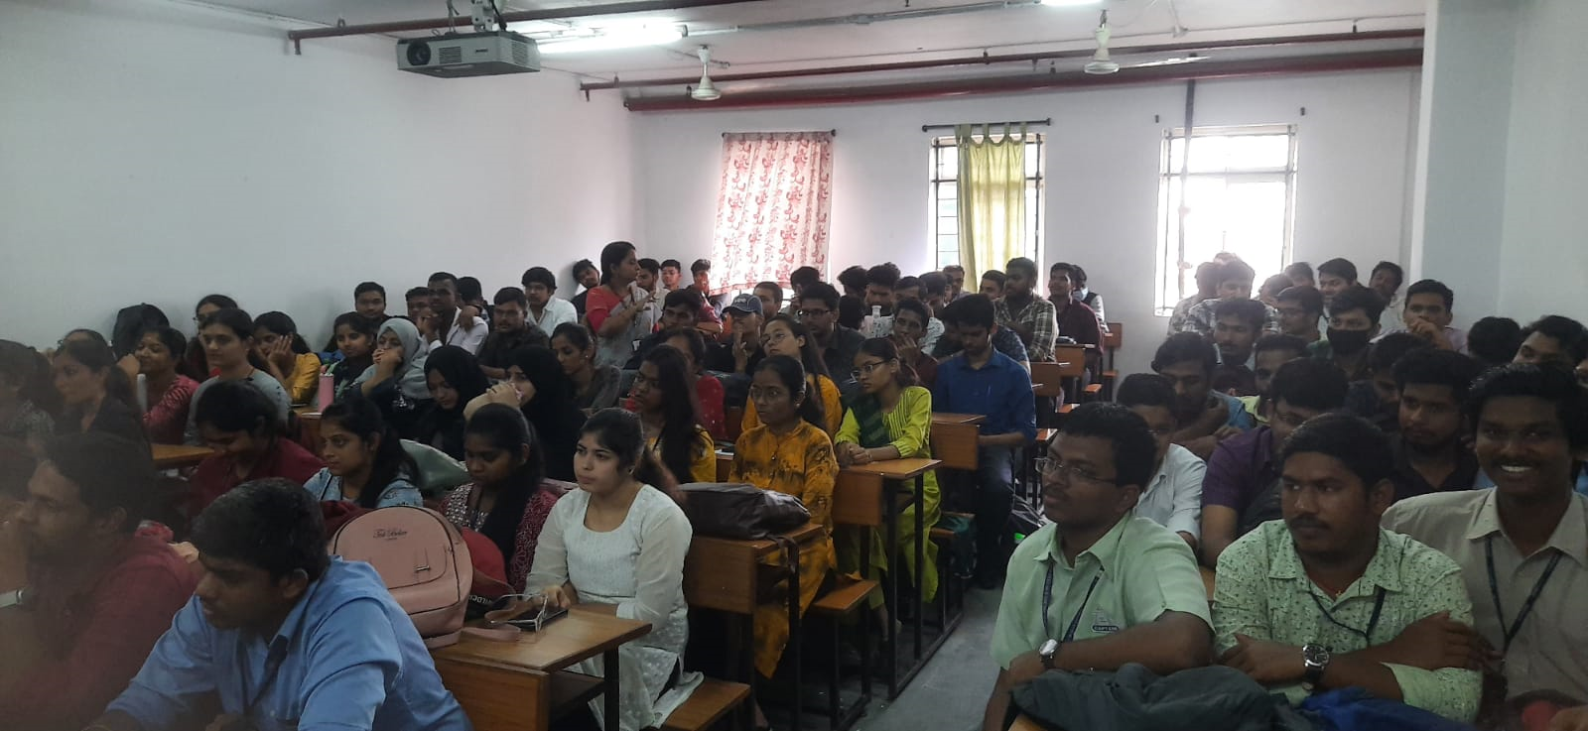
- 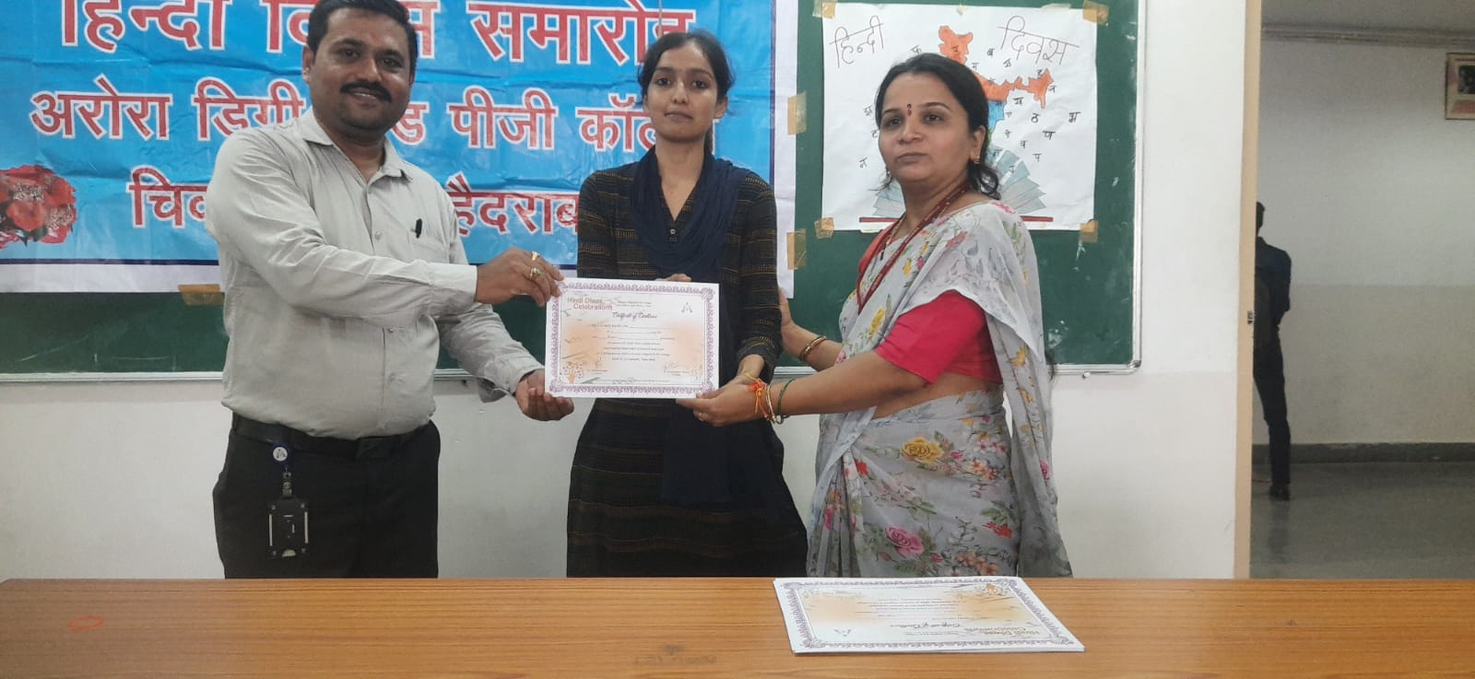

- 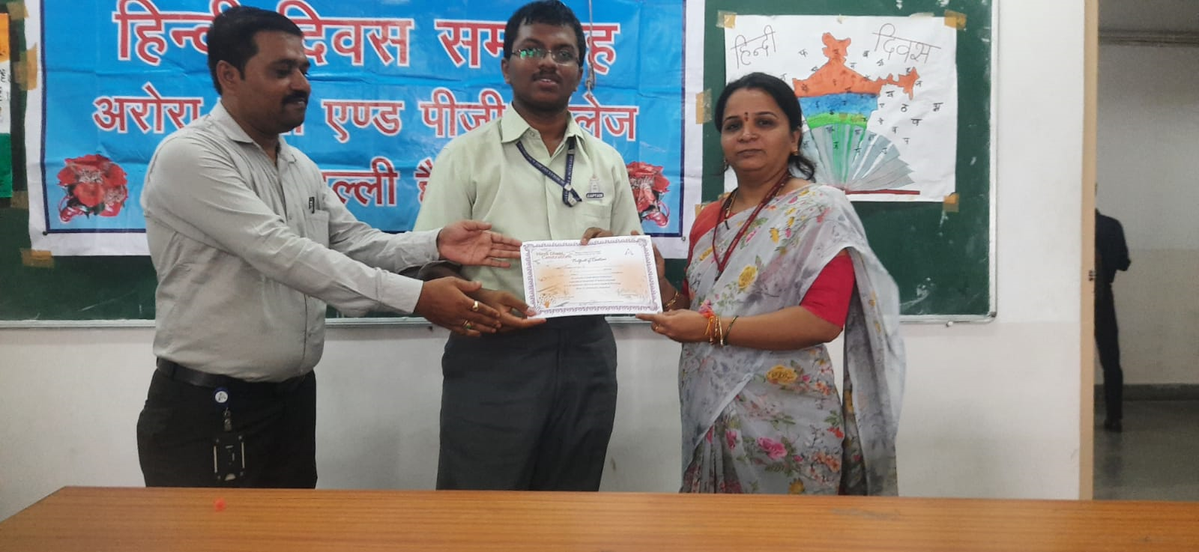

- 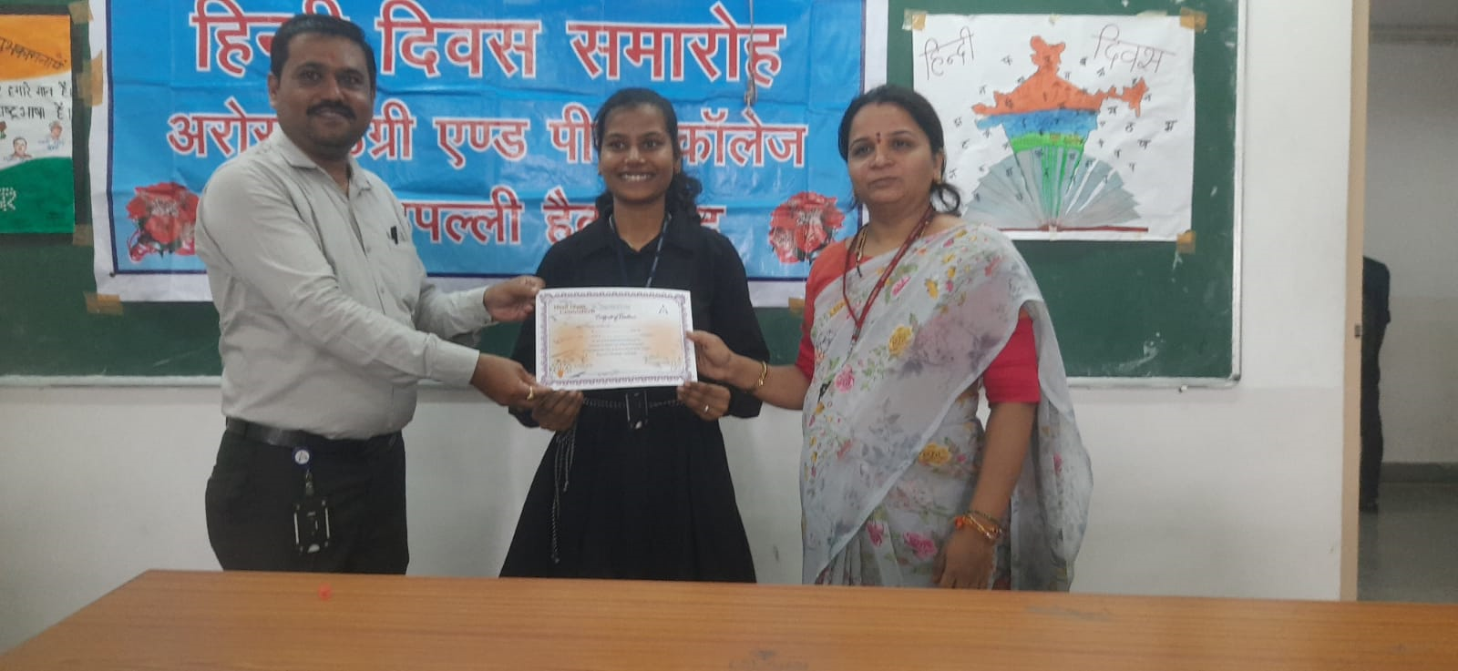
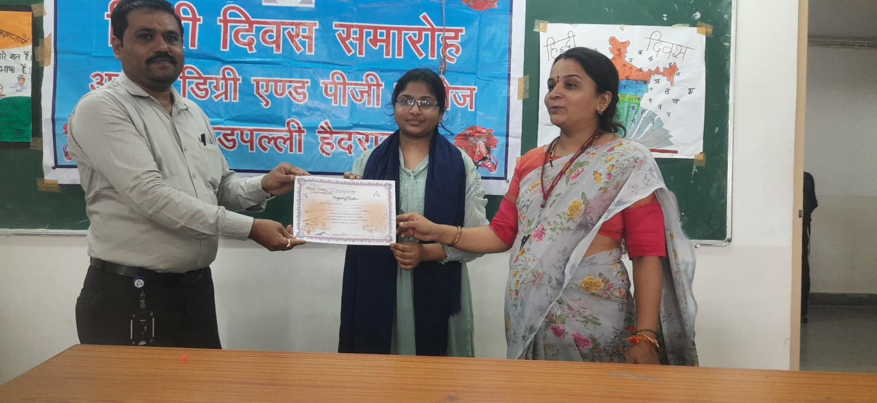

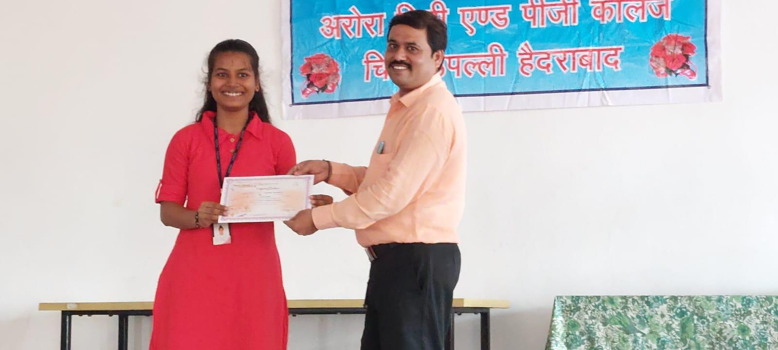
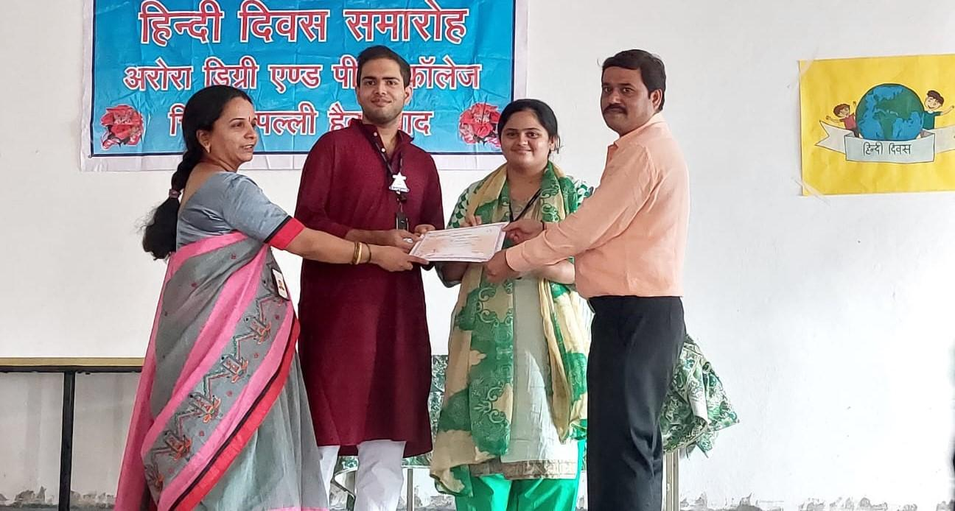
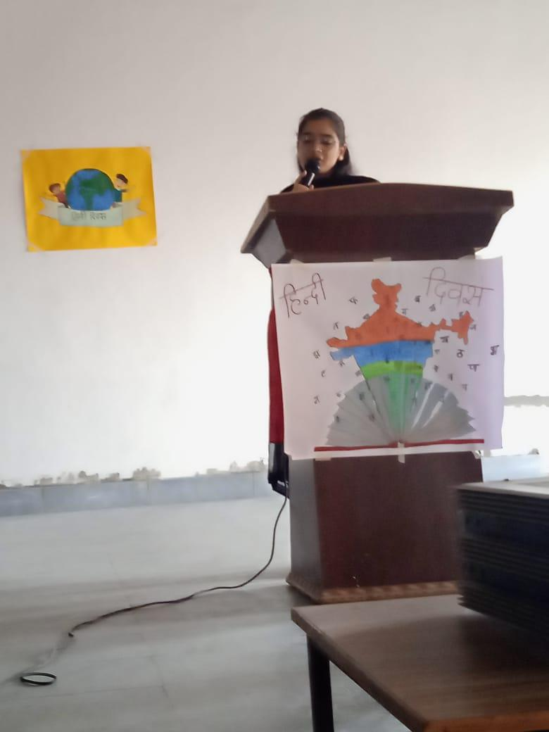
- ATTACHMENTS:
EVENT/ACTIVITY PROPOSAL
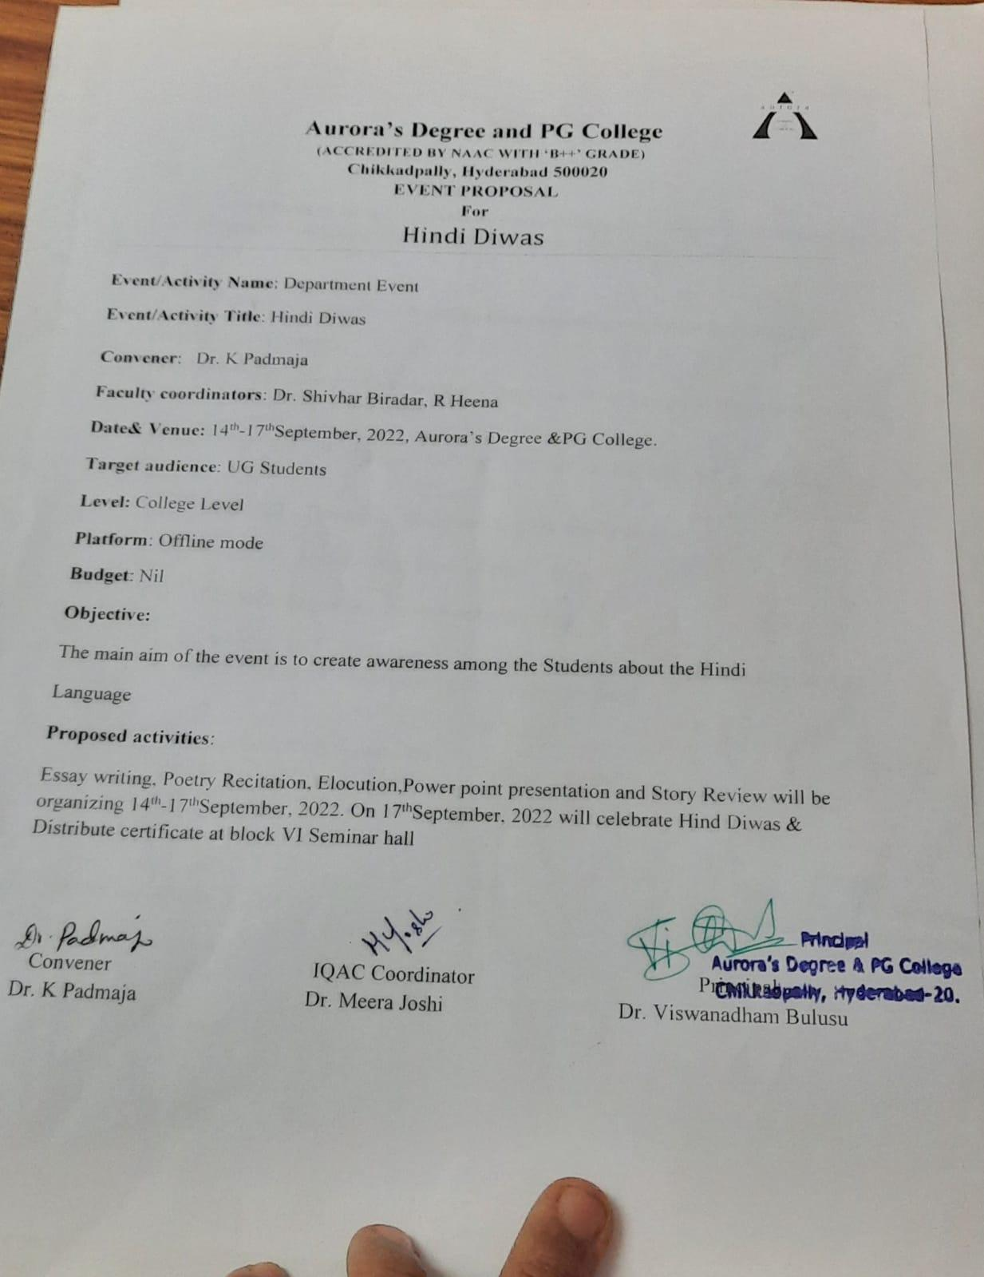
EVENT / ACTIVITY NOTICE
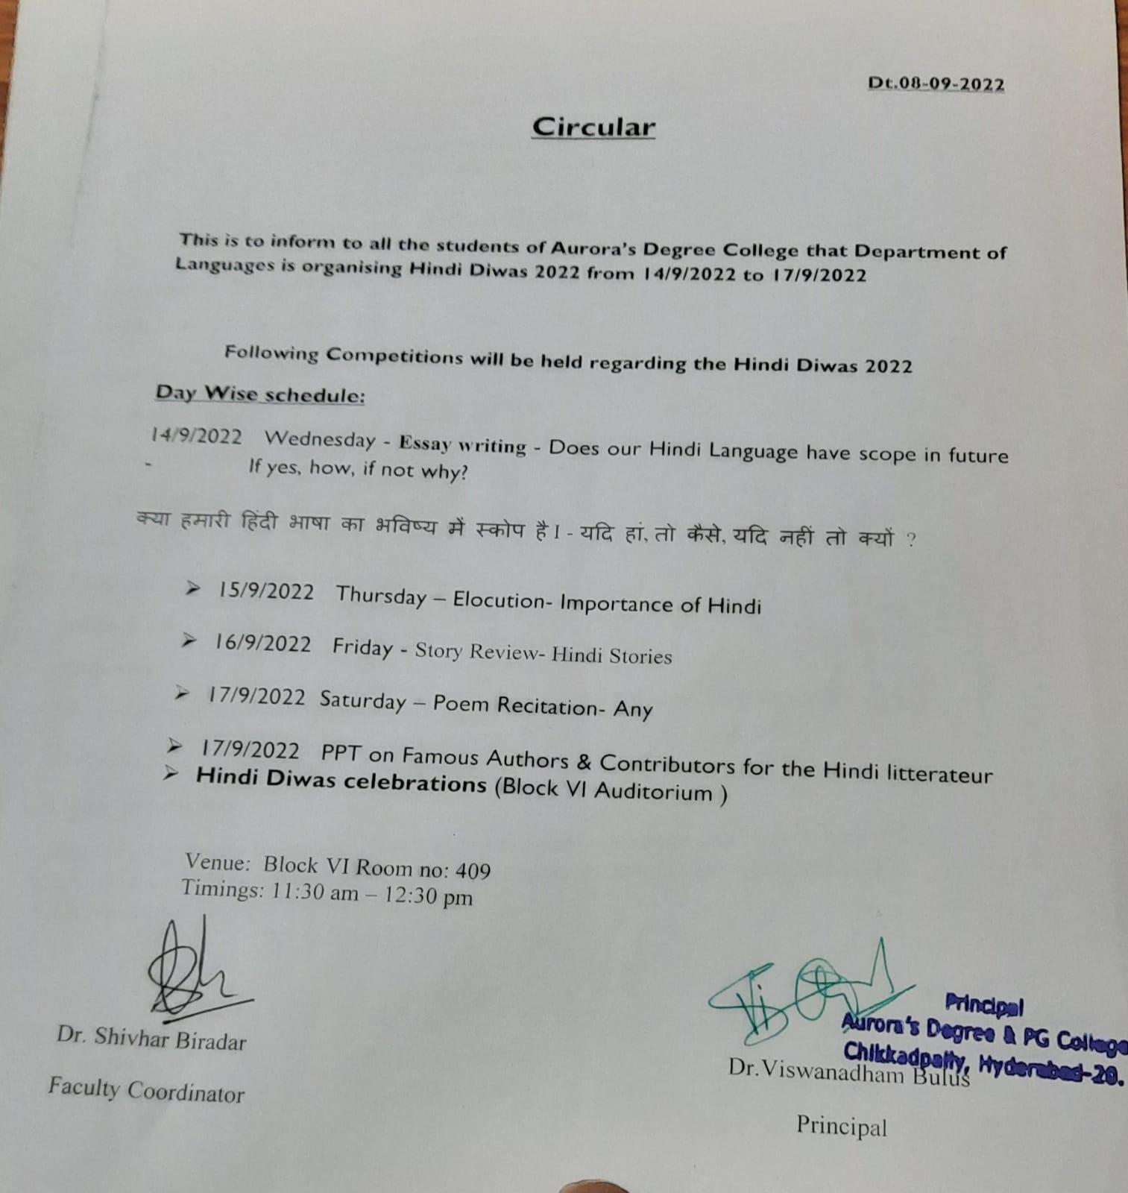

RECEIPTS (IF ANY)

CERTIFICATES (IF ANY)

