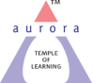
Aurora’s Degree & PG College
(ACCREDITED BY NAAC WITH 'B++' GRADE)
Chikkadpally, Hyderabad 500020

EVENT / ACTIVITY DETAILED REPORT

NAME OF THE EVENT / ACTIVITY | Augustin-Louis Cauchy Birthday observations
TYPE OR TITLE OF EVENT / ACTIVITY | Augustin-Louis Cauchy Birthday observations
FACULTY INCHARGE | Ms.M. Latha Salome
DEPARTMENT/CELL/COMMITTEE/CLUB | Department
DATE | 21-08-2022
VENUE | Aurora’s Degree and PG College
TARGET AUDIENCE | B.Sc. Physical Sciences

- PROGRAM SCHEDULE
The Guest Lecture on the occasion of Augustin-Louis Cauchy Birthday was scheduled at 2:30 pm. The guest was invited at 2:00 pm. Welcome note was given till 2:40pm. Later the profile of the guest speaker was read. The session was handed over to the speaker at 2:50pm. Lecture by guest speaker was carried till 3:40pm. Question and answer interactive session was done by 3:50pm.One speech and two presentations were given by students of MSDs2. till 4:15pm. The program is completed by giving vote of thanks.
- LIST OF FACULTY COORDINATORS
M. Latha Salome, Associate Professor, Dept. of Mathematics
- LIST OF THE STUDENT COORDINATORS :
- 1051-21-467-001 Thammi Meharsai, MSCs2A
- 1051-21-467-021 Sukhine Sandeep MSCs2A
- 1051-21-539-005 Sanjana Badnale MSDs2
- 1051-21-539-045 Hussainpur Mallikarjun MSDs2
- 1051-21-539-022 Salvadi Srinath MSDs 2
- 1051-21-467-010 K. Charan Kumar Reddy, MSCs2a

- LIST OF THE PARTICIPANTS (NAME , ROLL NO, CLASS & SECTION, NO OF GIRLS, BOYS, CASTE )
S.No. | Name | Roll No. | Class & Section | Gender
1 | Thammi Meharsai | 1051-21-467-001 | MSCs2A | Male
2 | C Himabindhu | 1051-21-467-002 | MSCs2A | Female
3 | Jakkareddy Karthik Reddy | 1051-21-467-003 | MSCs2A | Male
4 | Nadimpally Dhana Sai Sumith Varma | 1051-21-467-004 | MSCs2A | Male
5 | Thadvai Deekshith | 1051-21-467-005 | MSCs2A | Male
6 | Kotte Sruthika | 1051-21-467-006 | MSCs2A | Female
7 | Vatsavai Bhargava Sai Raghavendra Varma | 1051-21-467-007 | MSCs2A | Male
8 | Muppadi Omkar | 1051-21-467-008 | MSCs2A | Male
9 | Ragi Rohith | 1051-21-467-009 | MSCs2A | Male
10 | Kancharla Charan Kumar Reddy | 1051-21-467-010 | MSCs2A | Male
11 | M Suresh | 1051-21-467-011 | MSCs2A | Male
12 | Birelli Punyavathi | 1051-21-467-012 | MSCs2A | Female
13 | Arutla Sushma | 1051-21-467-013 | MSCs2A | Female
14 | Birader Vivek Kumar | 1051-21-467-014 | MSCs2A | Male
15 | Roshini Salunki | 1051-21-467-015 | MSCs2A | Female
16 | Peketi Lohit Satya Sai Venkat Reddy | 1051-21-467-016 | MSCs2A | Male
17 | Lakshman Bahadur Budha | 1051-21-467-017 | MSCs2A | Male
18 | Volisetty Balakrishna | 1051-21-467-018 | MSCs2A | Male
19 | Vemula Anusha | 1051-21-467-019 | MSCs2A | Female
20 | Javvaji Vinod Kumar | 1051-21-467-020 | MSCs2A | Male
21 | Sukhine Sandeep | 1051-21-467-021 | MSCs2A | Male
22 | Bandari Praneethkumar | 1051-21-467-022 | MSCs2A | Male
23 | Thakkuri Srivardhan | 1051-21-467-023 | MSCs2A | Male
24 | Merupula Sanjana | 1051-21-467-024 | MSCs2A | Female
25 | Alluri Nithin Reddy | 1051-21-467-025 | MSCs2A | Male
26 | Vengala Suchithra | 1051-21-467-026 | MSCs2A | Female
27 | Mekala Vijay | 1051-21-467-027 | MSCs2A | Male
28 | Erram Harsha Vardhan | 1051-21-467-028 | MSCs2A | Male
29 | Markapudi Bindu | 1051-21-467-029 | MSCs2A | Female
30 | Namile Shailaja | 1051-21-467-030 | MSCs2A | Female
31 | Thakur Swetha | 1051-21-467-031 | MSCs2A | Female
32 | Kunda Shiva Kiran | 1051-21-467-032 | MSCs2A | Male
33 | Gorla Pavan Kumar | 1051-21-467-033 | MSCs2A | Male
34 | Annaboina Abhishek Goud | 1051-21-467-034 | MSCs2A | Male
35 | Motapalukula Ashwiz | 1051-21-467-035 | MSCs2A | Male
36 | Sidhartha Kanjilal | 1051-21-467-036 | MSCs2A | Male
37 | Shaik Anas | 1051-21-467-037 | MSCs2A | Male
38 | Sriram Saicharan | 1051-21-467-038 | MSCs2A | Male
39 | Kannuri Sathvik | 1051-21-467-039 | MSCs2A | Male
40 | Sardar Sukhbeer Singh | 1051-21-467-040 | MSCs2A | Male
41 | Gujjar Narendar | 1051-21-467-041 | MSCs2A | Male
42 | Maddur Hemanth | 1051-21-467-042 | MSCs2A | Male
43 | Manchineela Venkata Rama Bharadwaj Sharma | 1051-21-467-043 | MSCs2A | Male
44 | Jamparapu Tharun | 1051-21-467-044 | MSCs2A | Male
45 | Katakam Varsha | 1051-21-467-045 | MSCs2A | Female
46 | Thakur Srinath Singh | 1051-21-467-046 | MSCs2A | Male
47 | Tula Uday Kumar | 1051-21-467-047 | MSCs2A | Male
48 | Vishal Reddy | 1051-21-467-049 | MSCs2B | Male
49 | D Vamshi | 1051-21-467-049 | MSCs2B | Male
50 | Sangu Upasana | 1051-21-467-051 | MSCs2B | Female
51 | Banoth Suman Nayak | 1051-21-467-072 | MSCs2B | Male
52 | Aravind Kumar Bansiwal | 1051-21-467-079 | MSCs2B | Male
53 | Rajput Siddhi | 1051-21-467-080 | MSCs2B | Female
54 | Mohammed Feroz | 1051-21-467-081 | MSCs2B | Male
55 | A Aakash | 1051-21-467-093 | MSCs2B | Male
56 | Jakkula Anith Babu | 1051-21-467-094 | MSCs2B | Male
57 | B. Dharani | 1051-21-467-095 | MSCs2B | Female
58 | Aman. R | 1051-21-539-002 | MSDs 2 | Male
59 | Sanjana | 1051-21-539-005 | MSDs 2 | Female
60 | uzmanazmeen | 1051-21-539-006 | MSDs 2 | Female
61 | R. Nithin | 1051-21-539-018 | MSDs 2 | Male
62 | S. Srinath | 1051-21-539-022 | MSDs 2 | Male
63 | Mallikarjun.H | 1051-21-539-045 | MSDs 2 | Male
64 | Sannidhi | 1051-21-539-049 | MSDs 2 | Female

- PARAGRAPH ABOUT THE PROCEEDINGS (TILL THE END OF THE EVENT)
The department of Mathematics observed 234th B’ Day of Augustin-Louis Cauchy, who was a French mathematician and made pioneering contributions to mathematical analysis and continuum mechanics. He was one of the first to state and rigorously prove theorems of calculus. More concepts and theorems have been named for Cauchy than for any other mathematician. Cauchy was a prolific writer; he wrote approximately eight hundred research articles and five complete textbooks in the fields of mathematics and mathematical physics. The students displayed charts and participated in quiz competition. Retd. Prof. Satyanarayana, from O.U. addressed the students of MSCs & MSDs students on this occasion. Students have prepared PPTs’ on ‘Careers in Mathematics’ and ‘Competitive Exams in Mathematics’. Students participated in the event enthusiastically and made the event successful.
The department has a culture of celebrating Mathematicians B’ Day, every year. As a part of it this year, Augustin-Louis Cauchy B’Day is celebrated on 21st August 2022. Ms. M. Latha Salome approached Prof. Satyanarayana, Retd. Professor, Dept. of Mathematics,OU, Hyderabad. He accepted our invitation and has given the date and timings of his availability.
A proposal was made for the same and was accepted by the AQAC convener and obtained permission from the Principal Dr.Viswanatham Bulusu. With the continuous guidance and support of our Principal Dr.Viswanatham Bulusu, Aurora’s Degree and PG College the event was organized by the department of Mathematics for the development of students.
Quiz in Mathematics is conducted on 21-08-2022, through online mode. Link of google form is circulated to the students. Students from physical sciences have participated in the quiz. The faculty members of the department encouraged the students to participate in the quiz. The guest lecture is also organized with an intention to motivate the students towards the subject mathematics. It is organized on 30th September 2022. Retd. Prof. Satyanarayana, from O.U. addressed the students of second year MSCs & MSDs. Sir has arrived the venue at 2:15 pm and all arrangements were made for the lecture in Room No. 502 of Block VI. Guest Lecture is started at 2:40 pm. Siddharth, of MSCs2A, gave a welcome speech and introduced sir by reading sir’s profile. Sir used projector and screen for the lecture. He has given a talk on Mathematicians Euclid, Ramanujan and Augustin Louis Cauchy and inspired the students by his words. After the lecture there is a question and answer session, and students interacted with professor. Sir is honored with an honorarium of Rs. 2000/-
Students displayed charts on the occasion of the day throughout the college campus.
Sanjana, of MSDs 2, with Roll No. 1051-21-539-005 has given an inspirational speech to the students.
Srinath, of MSDs 2, with Roll No. 1051-21-539-021 has presented a PPT on Careers in Mathematics to the students.
Mallikarjun, of MSDs 2, with Roll No. 1051-21-539-045 has presented a PPT on Competitive exams in Mathematics to the students.
On behalf of Dept. of Mathematics, vote of thanks is given by Ms. M. Latha Salome,
The program is completed by 4:10pm and students dispersed to their classes.
The students are aware about the biographies of famous mathematicians and are motivated to deal positively with the subject mathematics.
- INCOME AND EXPENDITURE: Rs. 2000/- (as an honorarium)
- EVENT PHOTOS ( MIN 2 MAX 4)
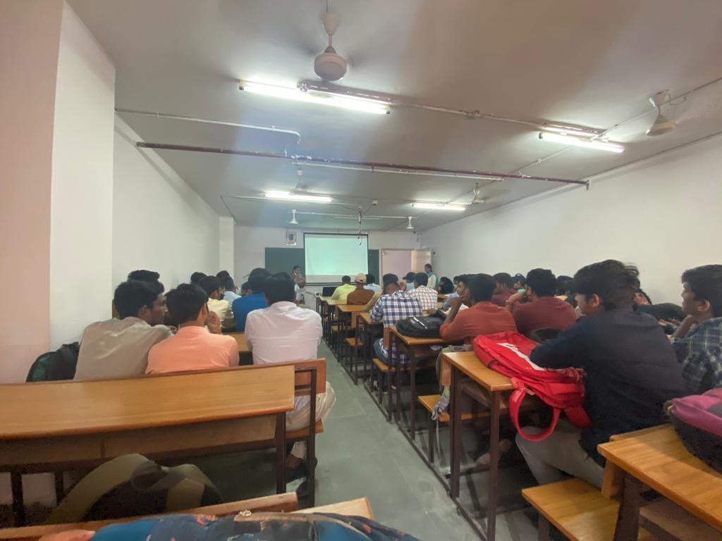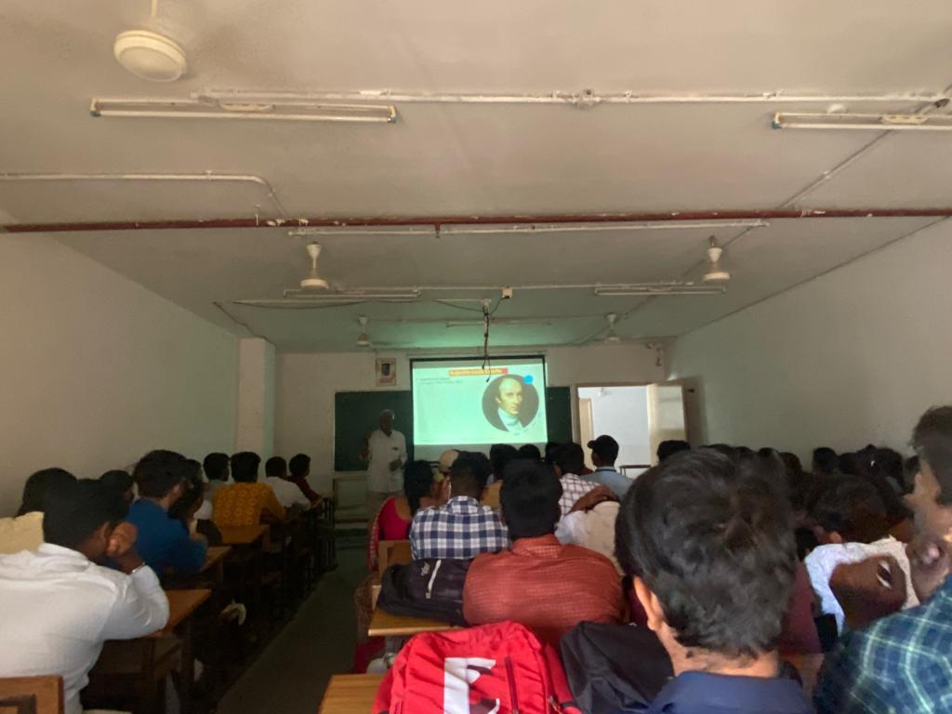
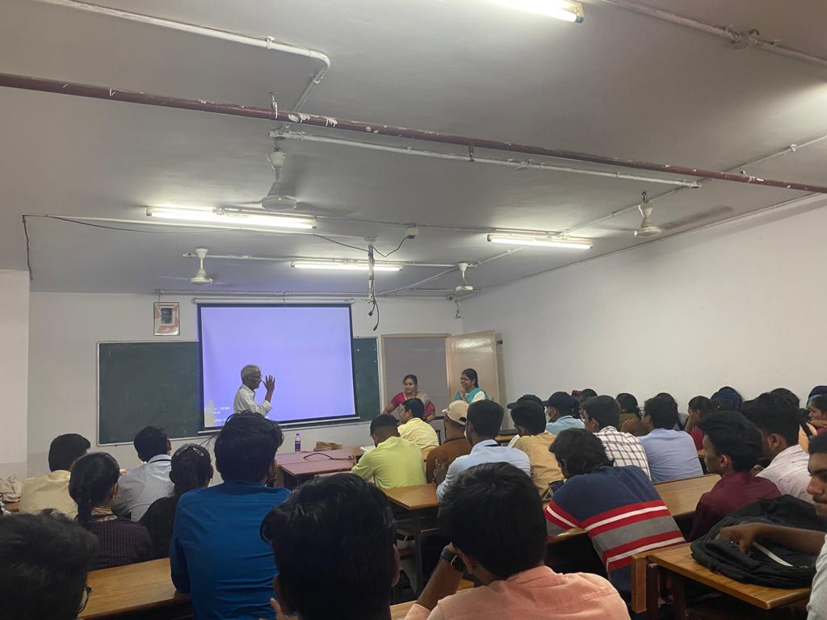
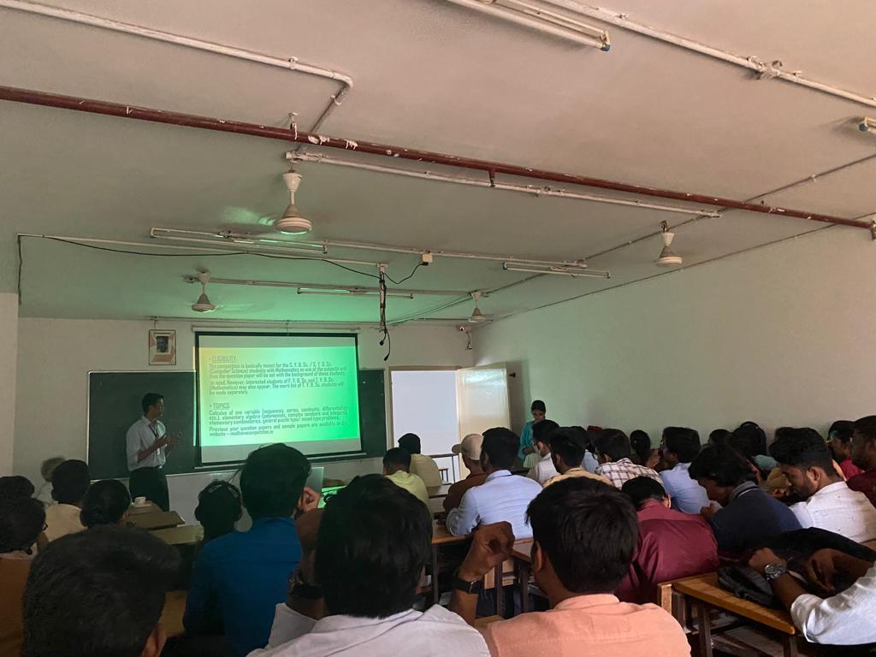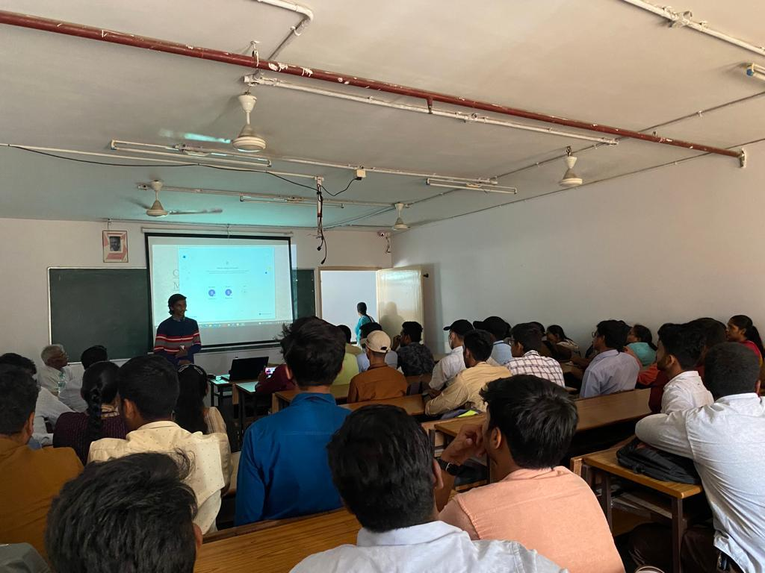
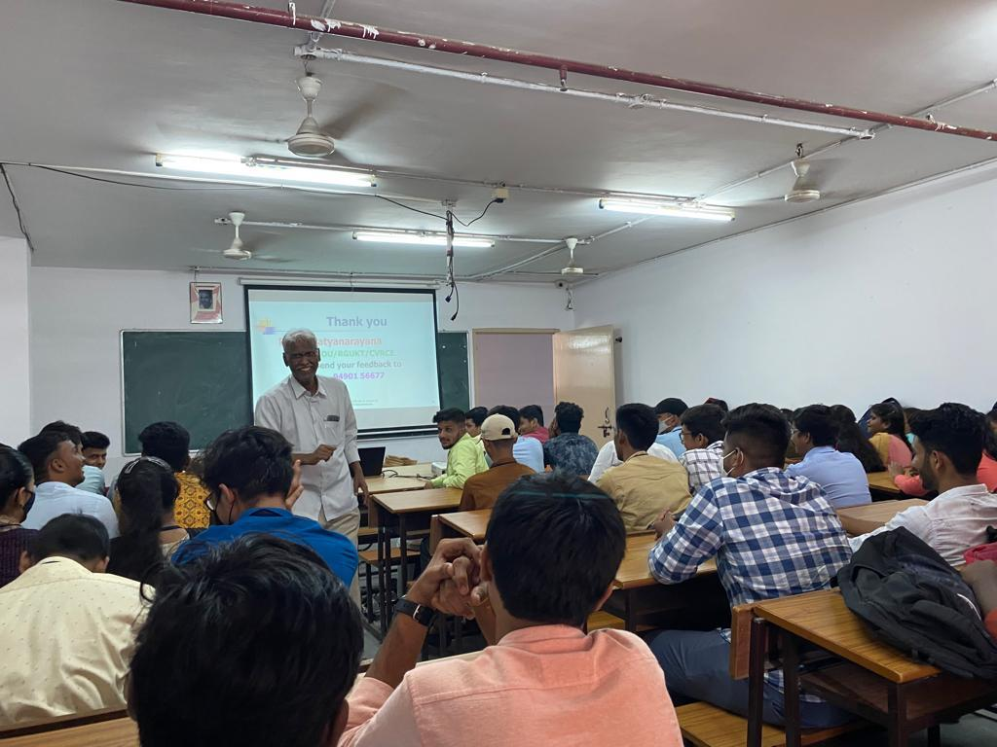
- GUEST PROFILE (IF ANY):
Prof. K. Satyanarayana garu, is a retd. Professor of Mathematics from Osmania University. He served OU for 35 long years1974- 2009. He rendered his services for university as Professor, Head of the Department, Chairman BOS in Mathematics and Chairman BOS in Computer Science. Sir has guided 4 Ph.Ds & 10 M.Phils. He published 20 research papers in Journals of international repute in Algebra aand its applications to finite geometries. Sir also extended his services as visiting pro. Of Mathematics in Rajiv Gandhi University of Knowledge Technologies, Gachibowli from2009 to 2014. Also worked for CVR College of Engineering as a Pro. In Mathematics. As Sir’s passion is teaching and inspiring young brains,since 3 years sir is uploading videos in you tube which are useful and supportive for aspirants of CSIR-UGC-NET, JEE-Mains.
- FEED BACK IF ANY: The students were satisfied by the lecture and are motivated to deal positively with the subject mathematics.

- ATTACHMENTS:
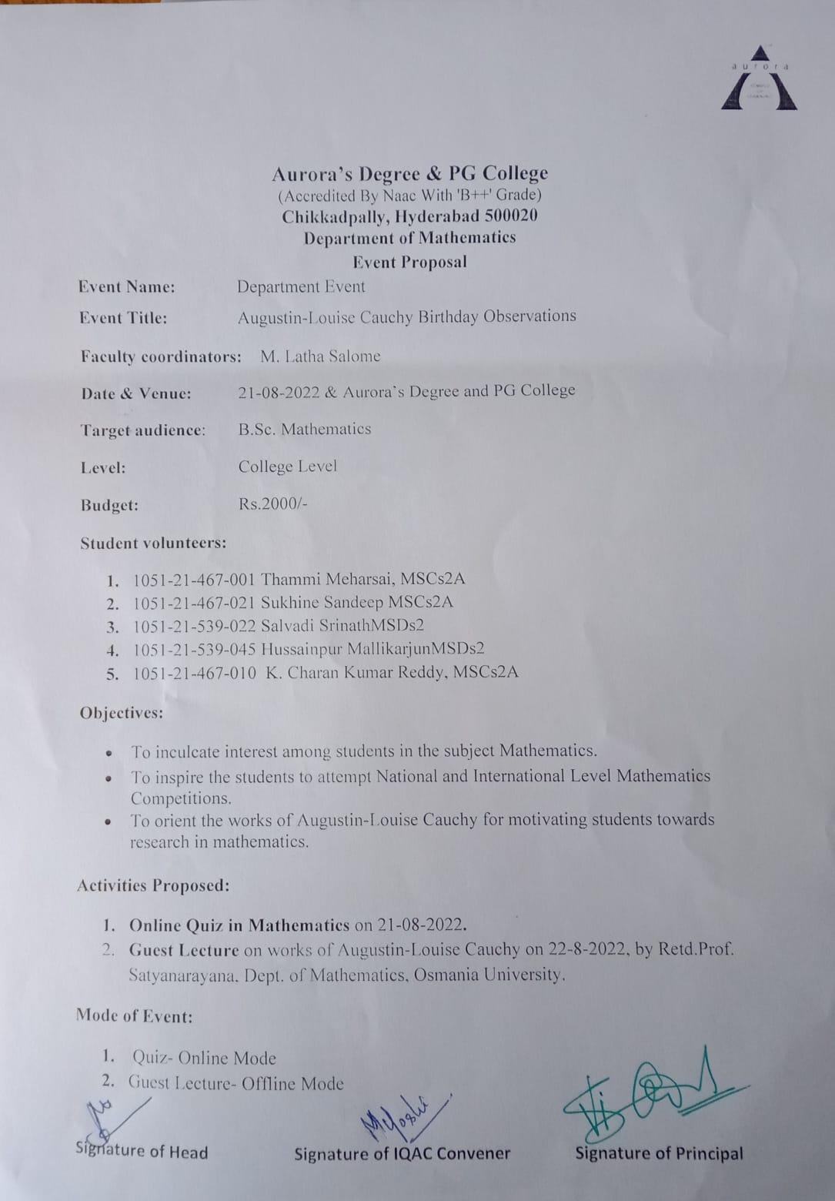

- RECEIPTS (IF ANY): Nil
- CERTIFICATES (IF ANY): Nil

