Aurora’s Degree & PG College
(ACCREDITED BY NAAC WITH 'B++' GRADE)
Chikkadpally, Hyderabad 500020

EVENT / ACTIVITY DETAILED REPORT

NAME OF THE EVENT / ACTIVITY | Prof. Acharya JayaShankar Sir Jayanthhi
TYPE OR TITLE OF EVENT / ACTIVITY | Prof. Acharya JayaShankar Sir Jayanthhi
FACULTY INCHARGE | k.SUNITHA
DEPARTMENT/CELL/COMMITTEE/CLUB | Management
DATE | O6-August-2022
VENUE | Aurora’s Degree & PG college
TARGET AUDIENCE | Students of BBA & COMMERCE DEPT

PROGRAM SCHEDULE
- LIST OF FACULTY COORDINATORS (DEPARTMENT)
K.Sunitha
- LIST OF THE STUDENT COORDINATORS (NAME , ROLL NO, CLASS & SECTION)
NAME | ROLL NO | CLASS
SVSSD.Akanksh | 1051-20-684-149 | BBA 3C
G.Supraja | 1051-20-684-152 | BBA 3C
G.Anusha | 1051-20-684-054 | BBA 3B
SV.Samanvitha | 1051-20-684-150 | BBA 3C

- LIST OF THE PARTICIPANTS (NAME , ROLL NO, CLASS & SECTION, NO OF GIRLS, BOYS, CASTE )
NAME | ROLL NO | CLASS
M.Pranathi | 1051-20-684-132 | BBA 3C
D.Sindhu | 1051-20-684-134 | BBA 3C
Tharun | 1051-20-684 -122 | BBA 3C
P.Rohith | 1051-20-684 -160 | BBA 3C
A.Dhanush | 1051-20-684-159 | BBA 3C
T.Abhishek | 1051-20-684-109 | BBA 3C
A.Mokshith | 1051-20-684 155 | BBA 3C

- PARAGRAPH ABOUT THE PROCEEDINGS (TILL THE END OF THE EVENT)
On the occasion of Acharya Kothapalli jayashankar jayanthi , The 88th birth anniversary of Telangana leader Sri Kothapalli jayashankar,The students of BBA 3rd year has presented about PROF.Jayashankar sir’s life history and his contributions for Telangana formation. This presentation consists of prof.Jayashankar Sir’s,
- BIOGRAPHY
- TEACHING CARRER
- HIS CONTIBUTIONS FOR TELANGANA FORMATION
&
BENEFITS AFTER TELANGANA STATE FORMATION .

- INCOME AND EXPENDITURE - NILL
- EVENT PHOTOS ( MIN 2 MAX 4)
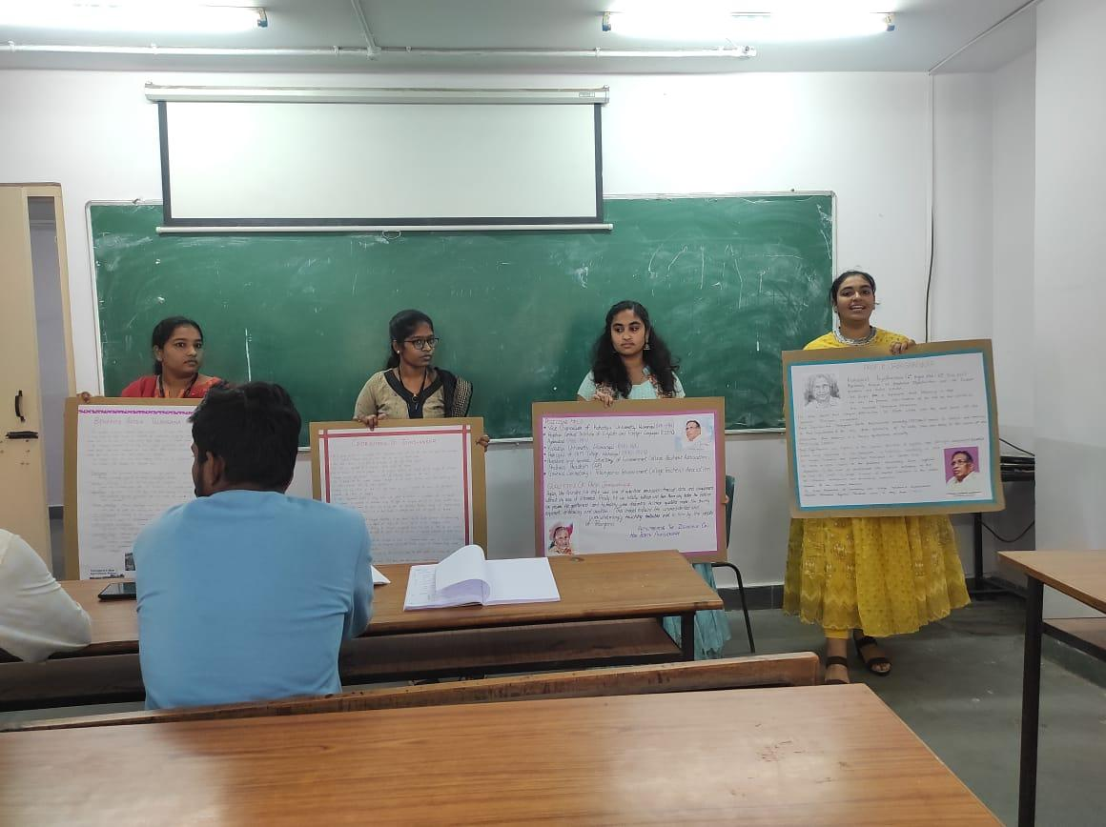
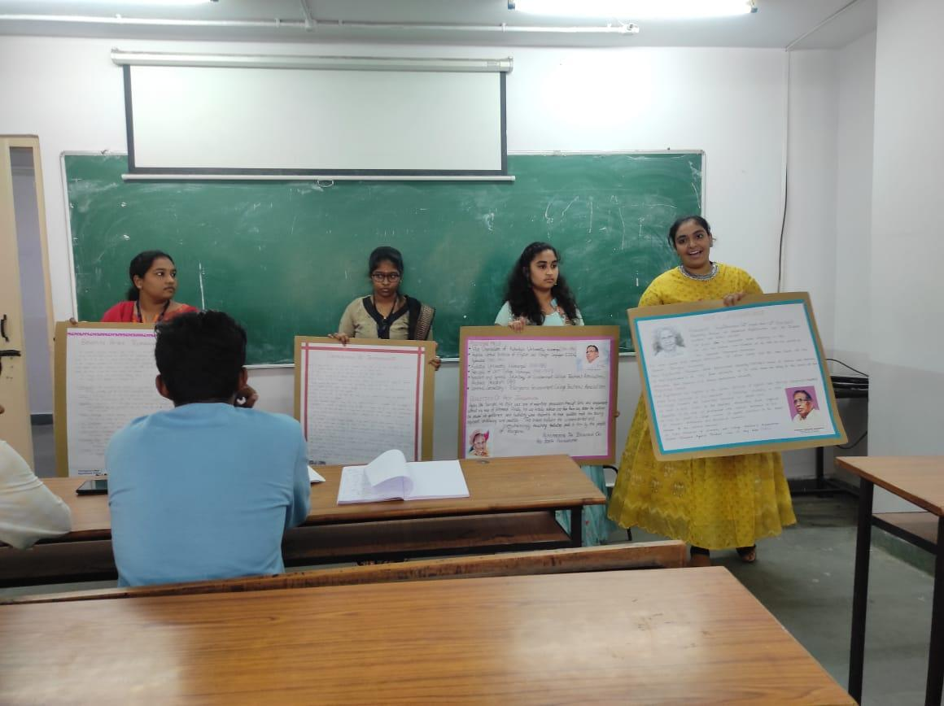
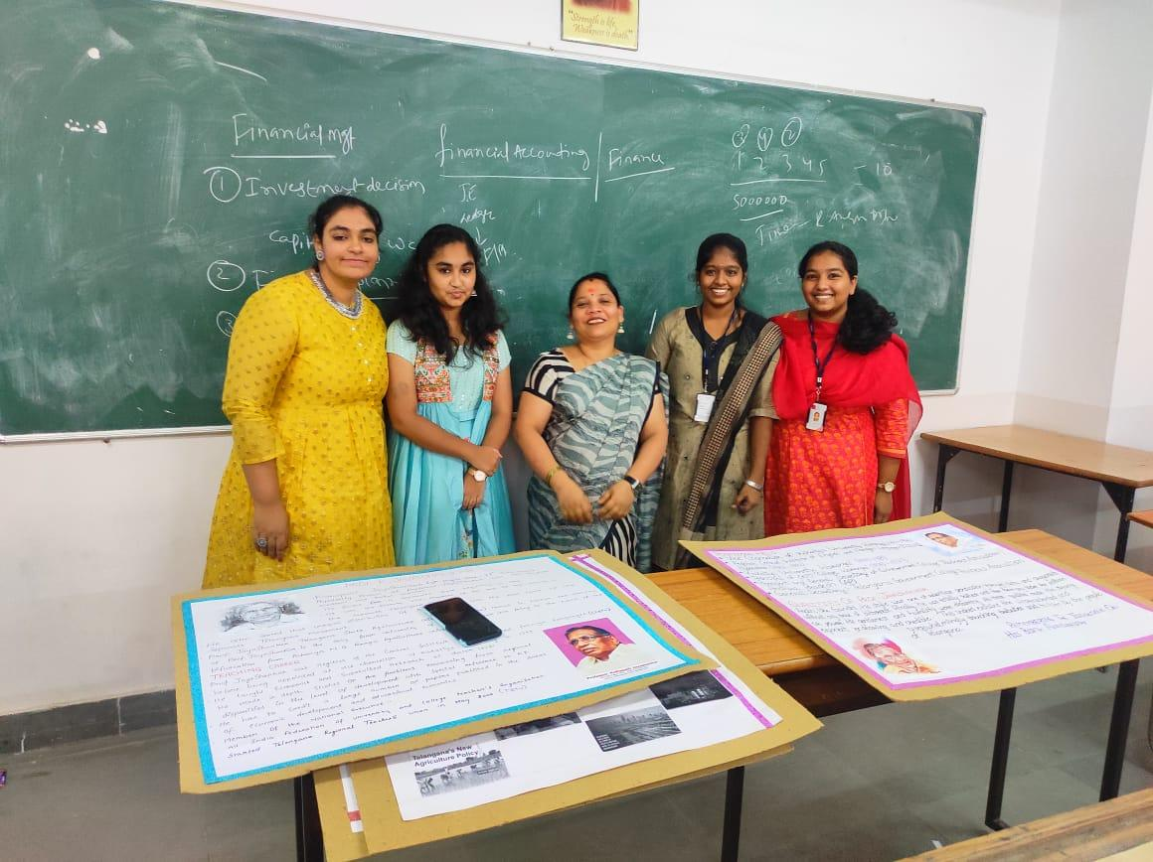

- GUEST PROFILE (IF ANY)
-
- FEED BACK IF ANY
- ATTACHMENTS:
EVENT/ACTIVITY PROPOSAL
EVENT / ACTIVITY NOTICE
RECEIPTS (IF ANY)
CERTIFICATES (IF ANY)
LETTERS OF COMMUNICATION (IF ANY)

