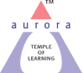
Aurora’s Degree & PG College
(ACCREDITED BY NAAC WITH 'B++' GRADE)
Chikkadpally, Hyderabad 500020

EVENT DETAILED REPORT

NAME OF THE EVENT / ACTIVITY | Android Application Development Workshoop
TYPE OR TITLE OF EVENT / ACTIVITY | Android Application Development Workshoop
FACULTY INCHARGE | Rajani B, Associate Professor  Srinivas U, Associate Professor
DEPARTMENT/CELL/COMMITTEE/CLUB | Computer Science
DATE | 17th & 18th April 2023
VENUE | Computer Lab, Blcok VI, Near RTC ‘X’ Road,Chikkadpally, Hyd
TARGET AUDIENCE | B.Sc Final Year Students
SPEAKER | - Shashank  Corporate Trainer

- PROGRAM SCHEDULE: 9 AM – 4;30 PM
- LIST OF FACULTY COORDINATORS :
Rajani B, Associate Professor
Srinivas U, Associate Professor

- LIST OF THE STUDENT COORDINATORS: NIL
- LIST OF THE PARTICIPANTS 37 PARTICIPANTS
SLNO | ROLL NO. | STUDENT NAME | SECTION
1 | 105120467004 | P SNEHA | MSCS3A
2 | 105120467018 | KARAN RAJ Keshavaboena | MSCS3A
3 | 105120467021 | V AJAY KUMAR | MSCS3A
3 | 105120467030 | NAYAN RAJ YADAV | MSCS3A
5 | 105120467034 | RAJNISH | MSCS3A
6 | 105120467037 | M AKASH | MSCS3A
7 | 105120467042 | ROHIT ANDOL | MSCS3A
8 | 105120467047 | DHANISH | MSCS3A
9 | 105120467048 | MUKESH | MSCS3A
10 | 105120467052 | SAI PRADEEP | MSCS3A
11 | 105120467054 | NAGATEJA | MSCS3A
12 | 105120467057 | NIKHILA | MSCS3A
13 | 105120467064 | P NAVANEETHA | MSCS3A
14 | 105120467073 | ARAVIND REDDY | MSCS3B
15 | 105120467087 | KASHYAP BHARADWAJ | MSCS3B
16 | 105120467089 | KARTHYASH YADAV | MSCS3B
17 | 105120467110 | LIKHITH | MSCS3B
18 | 105120467115 | PARAS RUPANI | MSCS3B
19 | 105120467082 | BHASKAR CHITTURI | MSCS3B
20 | 105120468079 | T BHANU BHARATH | MPCS
21 | 105120468017 | SAI BALAJI PULMADDI | MPCS3A
22 | 105120468048 | LAVANYA | MPCS3B
23 | 105120468052 | VIKKY SHARMA | MPCS3B
24 | 105120468054 | SURESH | MPCS3B
25 | 105120468056 | HARIVATSA RAPARTY | MPCS3B
26 | 105120468061 | SIMMA UPENDRA | MPCS3B
27 | 105120468080 | K MOUNIKA | MPCS3B
28 | 105120474010 | VENKAT RAM REDDY | MECS3A
29 | 105120474015 | B NIRANJAN REDDY | MECS3A
30 | 105120474019 | ABHISHEK METHREE | MECS3A
31 | 105120474024 | INDRA REDDY P | MECS3A
32 | 105120474031 | G DILEEP GOUD | MECS3A
33 | 105120474032 | VARAPRASAD KODIPE | MECS3A
34 | 105120474043 | VIKAS Ch. | MECS3A
35 | 105120474050 | K VARUN KUMAR REDDY | MECS3A
36 | 105120467043 | CH SSSS BADRINADH | MSCS3A
37 | 105120474023 | K SAIGOUTHAM | MECS3A

- AGRAPH ABOUT THE PROCEEDINGS :
In the Two-Day workshop students were trained on the following topics:
- Building Blocks of Android
  - Activity (User Interface / GUI – Graphical User Interface)
  - Service – Background Process. Ex: WhatsApp, Gmail etc.,
  - Intent – Action
  - Broadcast Receiver
  - Content Provider – Database
  - Fragment
- Using of MIT App Inventor Online Tool
- Creation of Toasts or prompts in Android
- Basic Design Manipulation
- Creation of Buttons.
- Insertion of Images.
- Re-direction to other pages.
- Creation of Databases
- Usage of both Implicit and Explicit Applications.

- EXPENDITURE: Rs. 12000/-
- EVENT PHOTOS

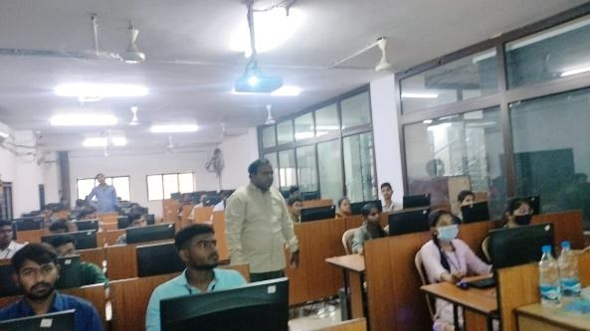 | 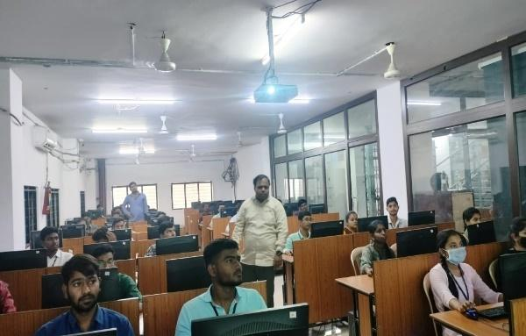
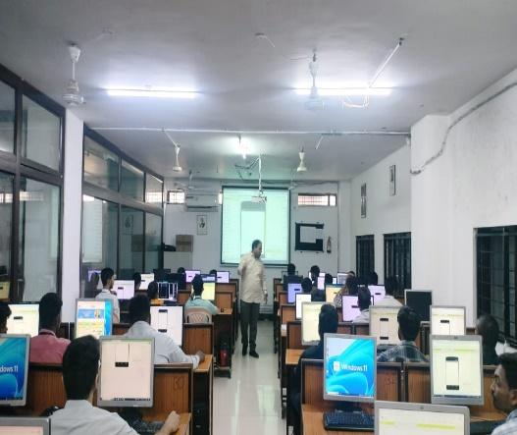 | 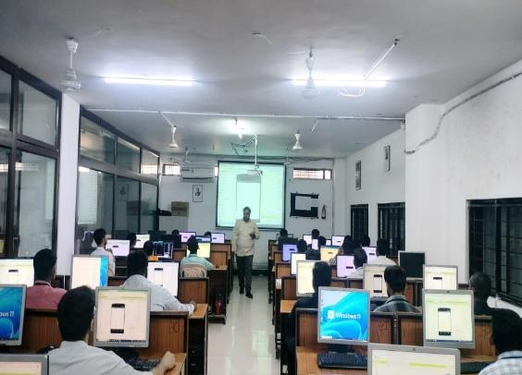

- GUEST PROFILE (IF ANY)
- FEED BACK IF ANY

- ATTACHMENTS:
EVENT/ACTIVITY PROPOSAL
EVENT / ACTIVITY NOTICE
RECEIPTS (IF ANY)
CERTIFICATES (IF ANY)
LETTERS OF COMMUNICATION (IF ANY)

