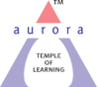
Aurora’s Degree & PG College
(ACCREDITED BY NAAC WITH 'B++' GRADE)
Chikkadpally, Hyderabad 500020

EVENT / ACTIVITY DETAILED REPORT

NAME OF THE EVENT / ACTIVITY | Faculty Development Programme on Writing Skills
TYPE OR TITLE OF EVENT / ACTIVITY | FDP
FACULTY INCHARGE | S.Padmavathi & K.Suresh
DEPARTMENT/CELL/COMMITTEE/CLUB | English, Commerce &Management
DATE | 2nd &4th March 2023
VENUE | Aurora’s Degree & P.G Collage
TARGET AUDIENCE | Faculty members of all the departments of Aurora’s Degree & P.G College

- PROGRAM SCHEDULE:

DATE | TIME
02/03/2023 & 04/03/2023 | 2 pm to 4 pm

2. FACULTY COORDINATOR: S.Padmavathi & K.Suresh
3. LIST OF THE PARTICIPANTS:

Total Number of Participants: 70

4. PARAGRAPH ABOUT THE PROCEEDINGS
A Faculty Development Programme on Writing Skills was organized by the Department of English & Commerce on 2nd & 4th March in Room no. 201, Block 6 at Aurora’s Degree & PG College, Chikkadpally, Hyderabad. The session on the first day began with a briefing in basic grammar skills and common errors often committed. The session on the second day continued with improving communication skills of the faculty members, the correct format to be followed in writing letters and reports and concluded with a worksheet to assess the learning.

5. INCOME AND EXPENDITURE: Nil
6. EVENT PHOTOS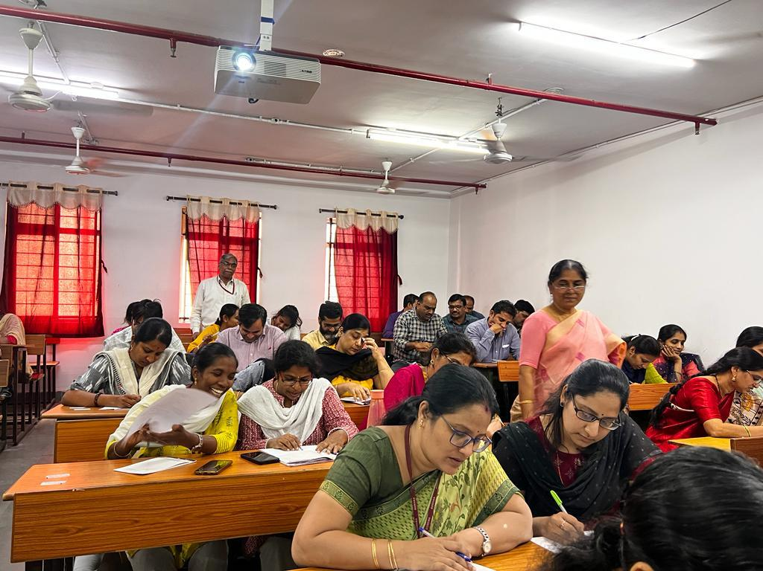

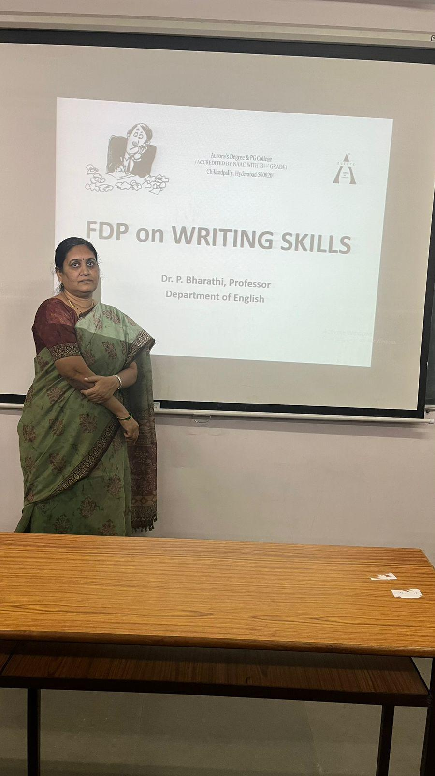
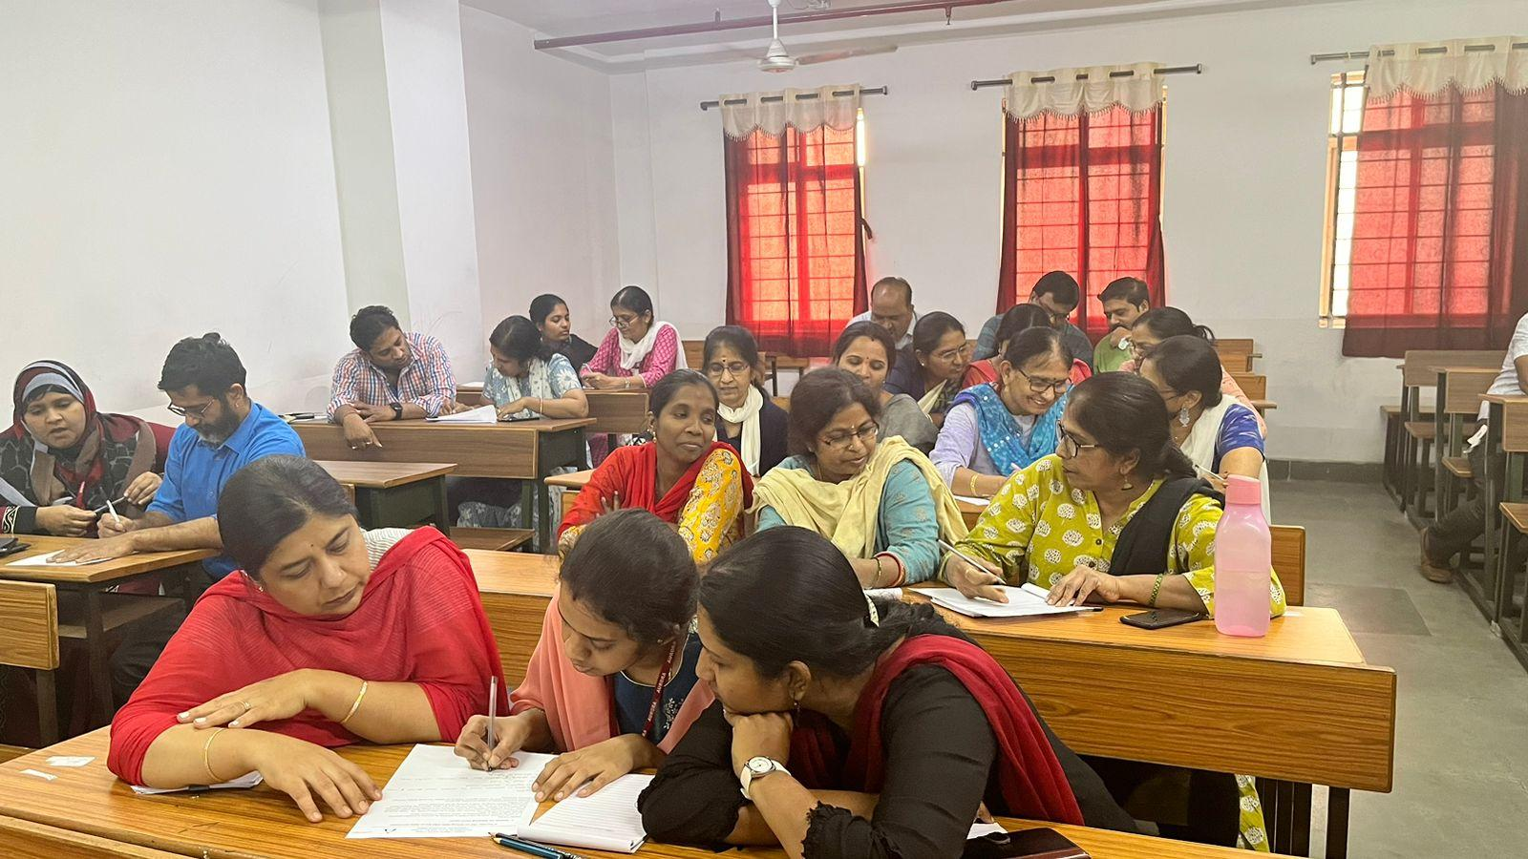
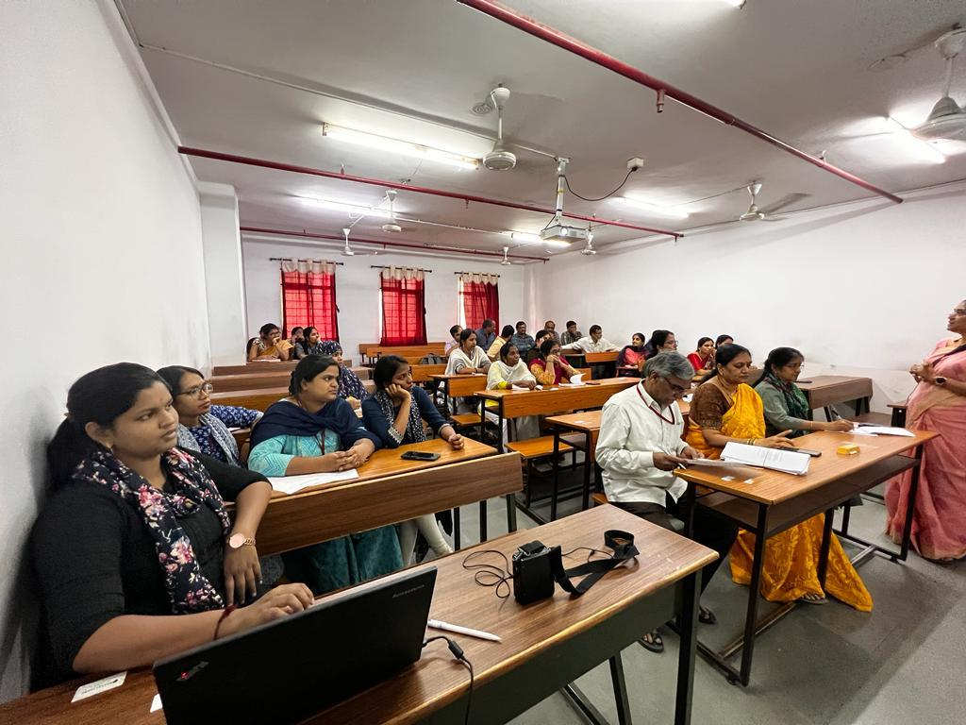
7. FEED BACK
Feedback link: https://forms.gle/e2i2RvHMiVrHPZTT7
8. ATTACHMENTS:
EVENTACTIVITY PROPOSAL: Attached

