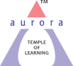
Aurora’s Degree & PG College
(ACCREDITED BY NAAC WITH 'B++' GRADE)
Chikkadpally, Hyderabad 500020

EVENT / ACTIVITY DETAILED REPORT

NAME OF THE EVENT / ACTIVITY | Carl Alexander Neuberg Birthday Celebrations
TYPE OR TITLE OF EVENT / ACTIVITY | Carl Alexander Neuberg Birthday Celebrations
FACULTY INCHARGE | Dr. V. Nagavani
DEPARTMENT/CELL/COMMITTEE/CLUB | Department of Biochemistry
DATE | 29/07/2022
VENUE | Aurora’s Degree & PG College
TARGET AUDIENCE | MSc Biochemistry

- PROGRAM SCHEDULE
- Brief introduction of the Carl Alexander Neuberg
- Quiz and Debate competition conducted for the students
- Announcement of the results

- LIST OF FACULTY COORDINATORS (DEPARTMENT): Dr. V. Nagavani
- LIST OF THE STUDENT COORDINATORS (NAME , ROLL NO, CLASS & SECTION) : Nil
- LIST OF THE PARTICIPANTS IN QUIZ (NAME , ROLL NO, CLASS & SECTION, NO OF GIRLS, BOYS, CASTE )
S.No | Name of the student | Roll No | Class
1 | Adeeba Azeem | 1051-21-514-001 | MSC Biochemistry- Iyr
2 | Nida Fatima | 1051-21-514-002 | MSC Biochemistry- Iyr
3 | Afreen Khatoon | 1051-21-514-023 | MSC Biochemistry- Iyr
4 | T Harshitha Priya | 1051-21-514-027 | MSC Biochemistry- Iyr
5 | Medari Sai Nikitha | 1051-20-514-015 | MSC Biochemistry- IIyr
6 | M Sneha | 1051-20-514-020 | MSC Biochemistry- IIyr
7 | Telu Sonia | 1051-20-514-029 | MSC Biochemistry- IIyr
8 | Nishadham Vindhya | 1051-20-514-033 | MSC Biochemistry- IIyr
9 | Mekala Shashi Rekha | 1051-20-514-003 | MSC Biochemistry- IIyr
10 | Poreddy Sai Soumya | 1051-20-514-007 | MSC Biochemistry- IIyr
11 | Anandamma | 1051-20-514-009 | MSC Biochemistry- IIyr
12 | G Shravya | 1051-20-514-011 | MSC Biochemistry- IIyr
13 | Karampuri Hema | 1051-20-514-004 | MSC Biochemistry- IIyr
14 | Miryala Sreeja | 1051-20-514-016 | MSC Biochemistry- IIyr
15 | Pothana Rasagnya | 1051-20-514-026 | MSC Biochemistry- IIyr
16 | Cycle Srinibha | 1051-20-514-030 | MSC Biochemistry- IIyr
17 | Karrolla Shreya | 1051-20-514-017 | MSC Biochemistry- IIyr
18 | Chiragowni Akansha | 1051-20-514-018 | MSC Biochemistry- IIyr
19 | Regalla Sravanthi | 1051-20-514-034 | MSC Biochemistry- IIyr
20 | G Vineetha | 1051-21-514-009 | MSC Biochemistry- Iyr

LIST OF THE PARTICIPANTS IN DEBATE
S.No | Name of the student | Roll No | Class
1 | A Sai Prasanna Kumar | 1051-21-514-008 | MSC Biochemistry- Iyr
2 | R Sudha Gayathri | 1051-21-514-010 | MSC Biochemistry- Iyr
3 | Kamati Shivani | 1051-21-514-012 | MSC Biochemistry- Iyr
4 | D Sandeep Kumar | 1051-21-514-025 | MSC Biochemistry- Iyr
5 | K Bhanu Sree | 1051-21-514-028 | MSC Biochemistry- Iyr
6 | B V S Yasaswini | 1051-21-514-029 | MSC Biochemistry- IIyr
7 | D Swetha | 1051-20-514-008 | MSC Biochemistry- IIyr
8 | Aisha | 1051-20-514-010 | MSC Biochemistry- IIyr
9 | R Meghana | 1051-20-514-013 | MSC Biochemistry- IIyr
10 | Koneru Jahnavi | 1051-20-514-027 | MSC Biochemistry- IIyr
11 | Ganganboina Krishna | 1051-20-514-031 | MSC Biochemistry- IIyr
12 | Swetha Suprabha | 1051-20-514-035 | MSC Biochemistry- IIyr

- PARAGRAPH ABOUT THE PROCEEDINGS (TILL THE END OF THE EVENT):
Carl Alexander Neuberg (29 July 1877 – 30 May 1956) was an early pioneer in biochemistry, and he is often referred to as the "father of modern biochemistry". His notable contribution to science includes the discovery of the carboxylase and the elucidation of alcoholic fermentation which he showed to be a process of successive enzymatic steps, an understanding that became crucial as to how metabolic pathways would be investigated by later researchers. Neuberg worked on solubility and transport in cells, the chemistry of carbohydrates, photochemistry, as well as investigating and classifying different types of fermentation. He was also a pioneer in the study of the chemistry of amino acids and enzymes.
In 1913, Neuberg was invited to head the biochemistry section of the Kaiser Wilhelm Institute for Experimental Therapy, the director of which was August von Wasserman. Neuberg discovered in 1911 an enzyme "carboxylase" which catalyzed the decarboxylation of pyruvic acid. He also introduced methods for trapping of intermediate metabolites which allowed him to correctly interpret the steps and mechanisms of reactions, and formulate a theory for the alcoholic fermentation of glucose. Support for his theory was bolstered when he helped develop an industrial process that contributed materially to the German war effort in World War I, manufacturing glycerol for the production of explosives by the fermentation of sugar.
Neuberg made a particularly important discovery in 1916: hydrotropy, a solubilization process where the addition of large amounts of a second solute causes an increase in the aqueous solubility of a different solute. He also worked on catalase and the oxidation of fatty acids and amino acids, studied the structure of biochemicals, discovered other enzymes, and synthesized phosphorylated intermediates of carbohydrate metabolism. He is considered one of the founders and leaders of modern dynamic biochemistry.
The Department of Biochemistry has celebrated his birthday on 29/07/2022. As a part of the celebrations PowerPoint presentation with the theme ‘Biochemistry behind Cardiovascular Diseases’ was conducted. Total Thirteen students participated in the event, 23 from MSc Biochemistry (IIyr) and 9 from MSc Biochemistry (Iyr). After the competitions results were announced. In quiz batch 1 (Adeeba Azeem, Nida Fatima, Afreen Khatoon and T Harshitha Priya) and in Debate (Swetha Suprabha, Aisha and Koneru Jahnavi) were declared as winners.

- INCOME AND EXPENDITURE: Nil
- EVENT PHOTOS ( MIN 2 MAX 4)
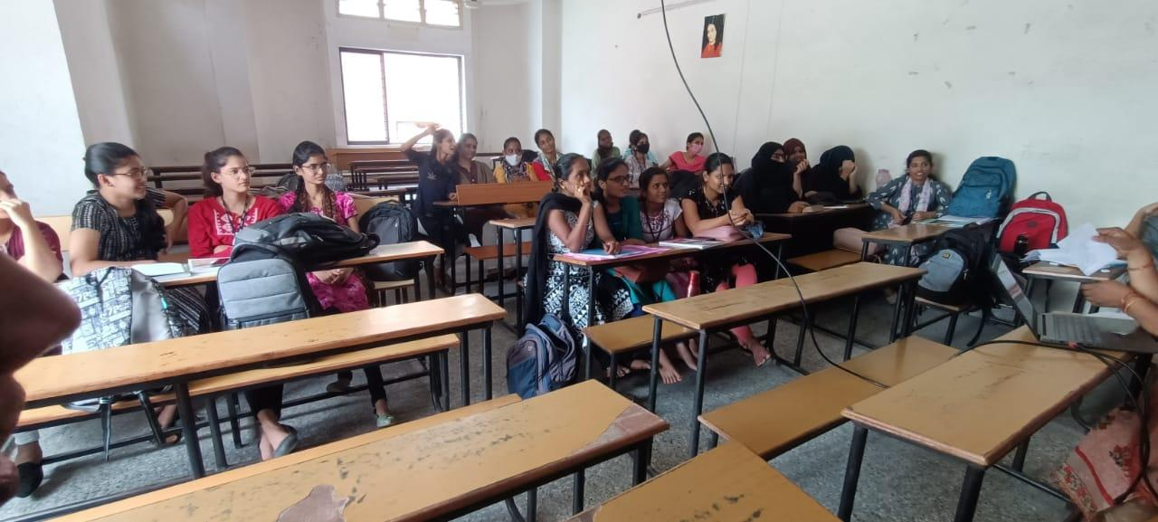
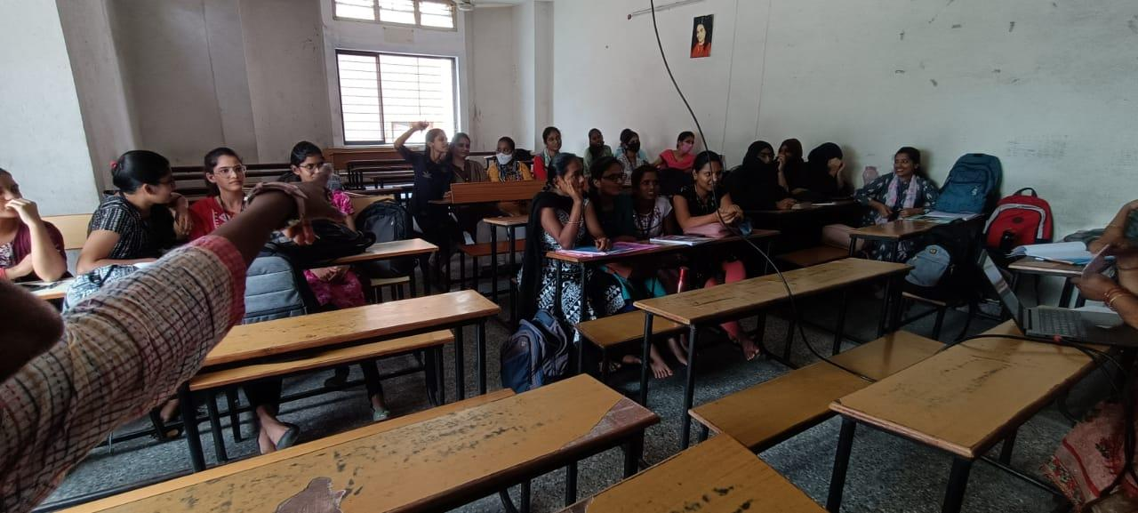

- GUEST PROFILE (IF ANY): Nil
- FEED BACK IF ANY: Nil
- ATTACHMENTS:
EVENT/ACTIVITY PROPOSAL
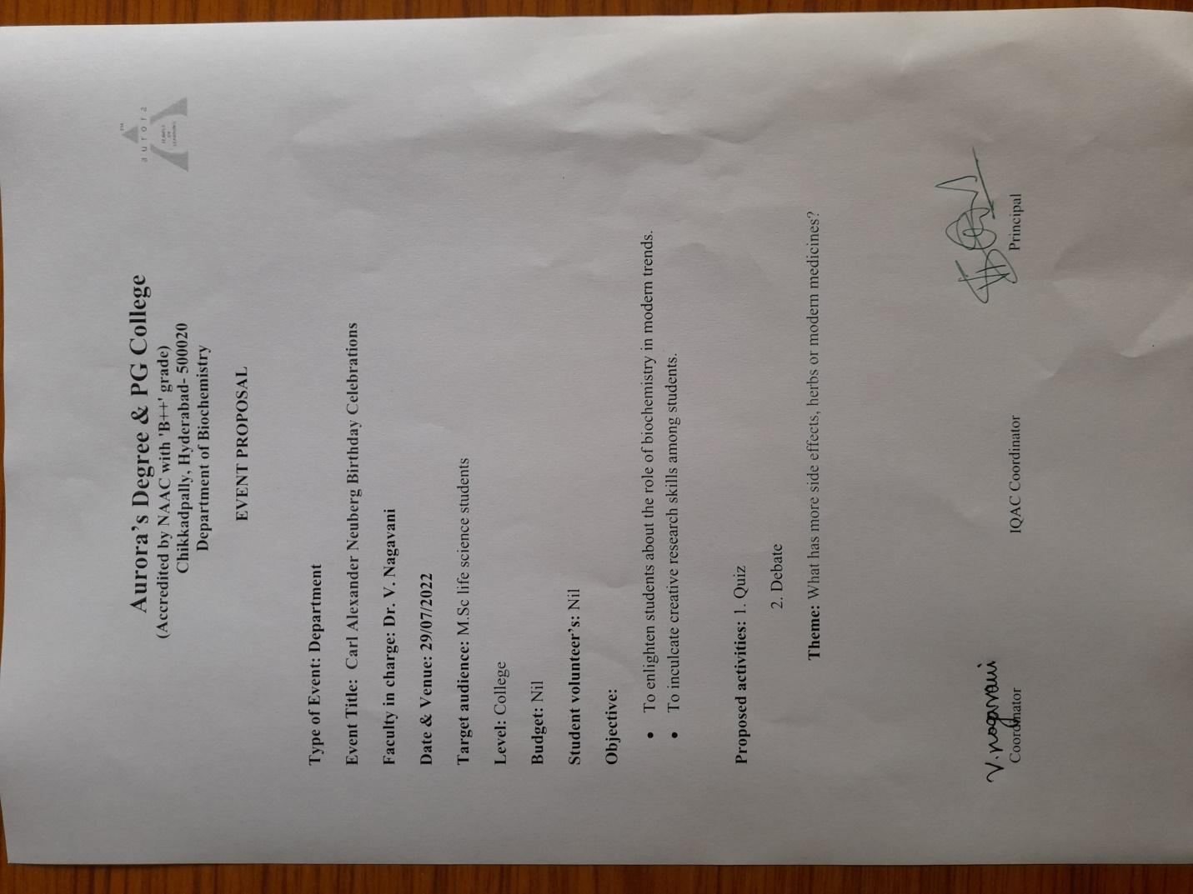
EVENT / ACTIVITY NOTICE
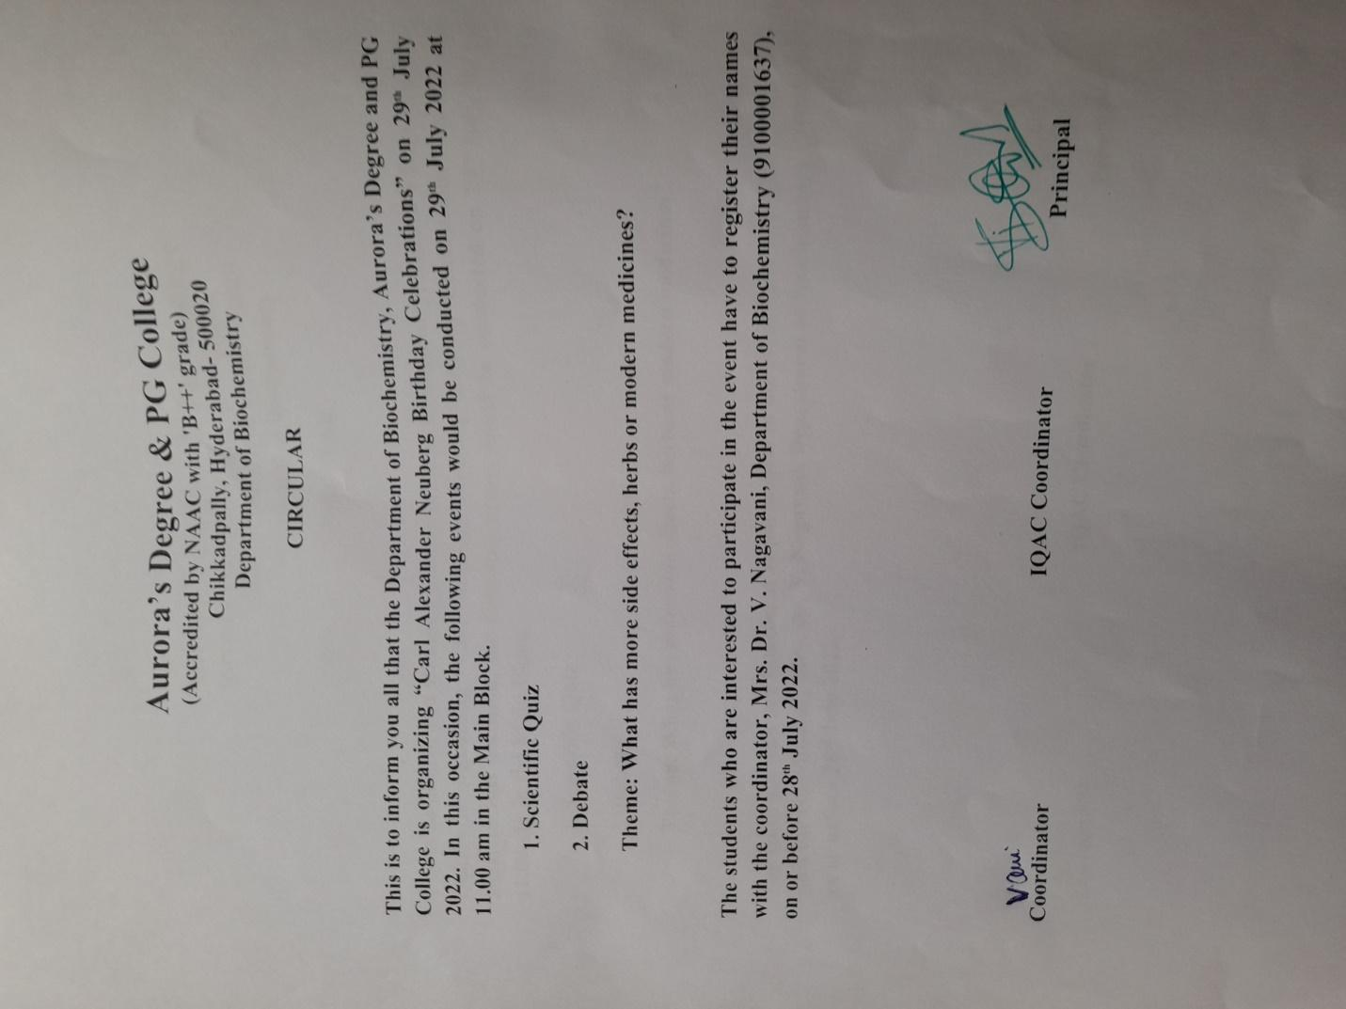
RECEIPTS (IF ANY)
CERTIFICATES (IF ANY)

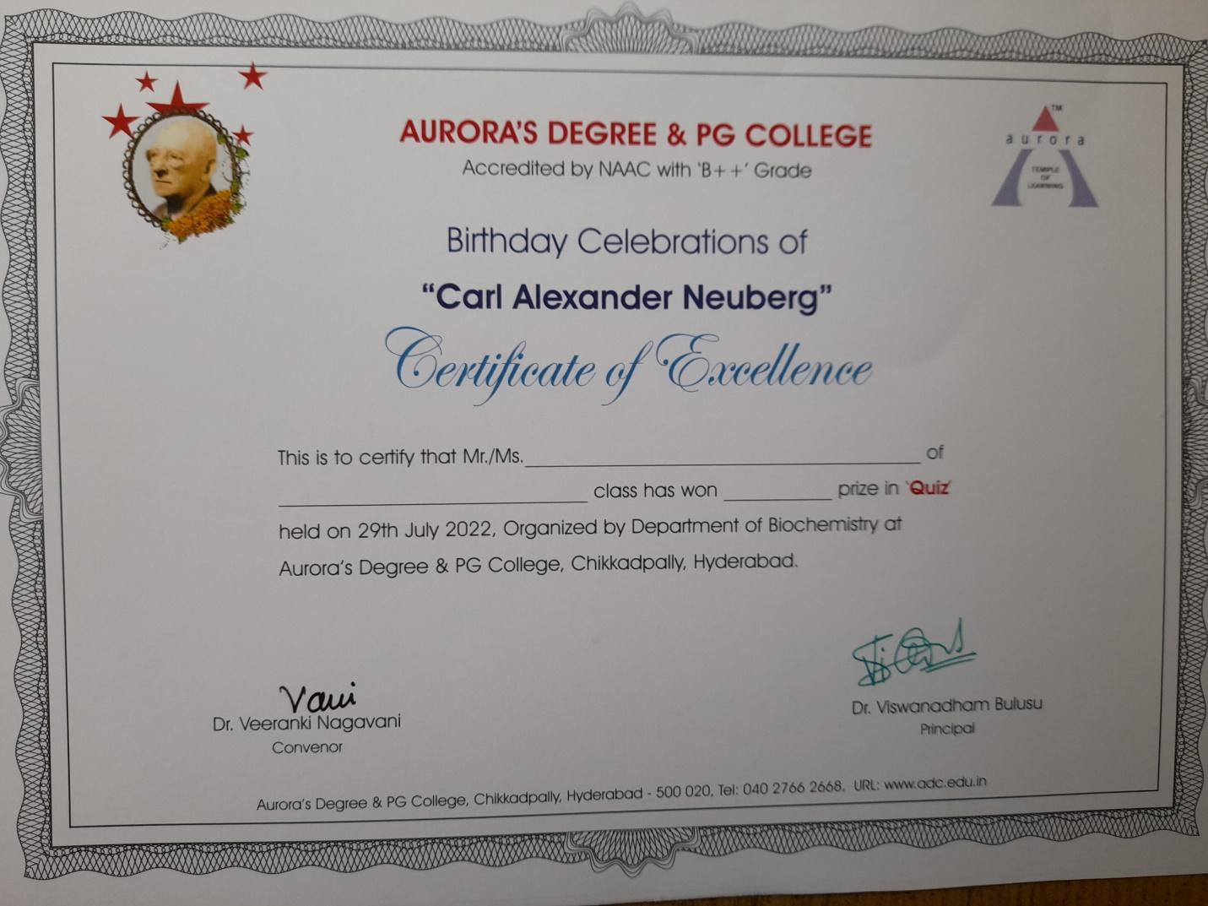
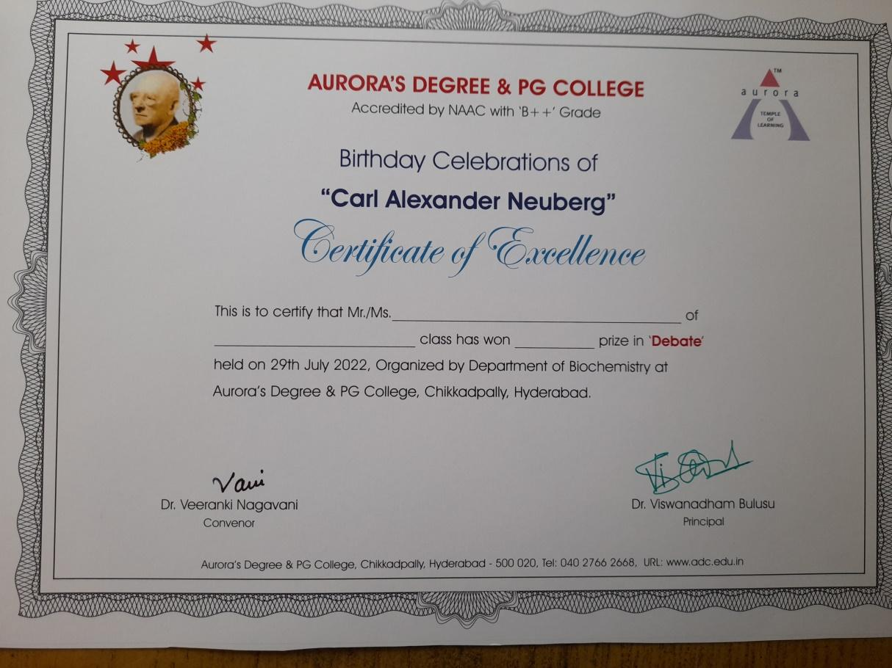
LETTERS OF COMMUNICATION (IF ANY)

