REPUBLIC DAY DETAILED REPORT

Date: 26th January 2023
Time: 9:00 AM onwards
Venue: Block I, Chikkadpally
Target audience: All faculty & Students
Faculty Coordinator: Dr.Padmini S, Dr. Meera Joshi
The day started with our college NCC cadet parade which really ignited a feeling of patriotism. Followed by NCC parade flag hosting ceremony by principal sir Dr.Viswanadham Bulusu and sir has addressed the gathering .
All the faculty, students and non-teaching staff have attended the event. Later certificates were given by our principal sir to the competitions winners & participants. Later vice principal sir along with gave rest of the certificates. There were speeches in English, Telugu, Hindi delivered by students. 2 patriotic songs were sung by Keerthi and Meghana from B.Com Hons. There was a gathering of 150 students. Lastly we winded up the programme with Sweets distribution to the students and the faculty.
PROGRAM SCHEDULE:
S.No | Time | Event
1. | 9:00Am – 9:10 Am | NCC Parade
2. | 9:10 Am - 9:15 Am | Flag hosting, National Anthem
3. | 9:15Am- 9:25 Am | Address by Principal
4. | 9:35Am – 9:40 Am | Song - telugu
5. | 9:45 Am – 9:50 Am | Speech - English
6. | 9:50 Am – 10: 00 Am | Song - hindi
7. | 10:05 Am – 10:10 Am | Speech – Telugu
8 | 10:15 Am – 10: 20 AM | Song -telugu
9. | 10:20 Am – 10: 25 AM | Speech – Hindi
10. | 10:25 Am – 10: 40 AM | Certificates distribution
11. | 10: 40 Am – 10:45Am | Hindi poetry
12. | 10:45Am – 10:50 Am | Vote Of Thanks
13. | 10:50 Am | Announcements followed by refreshments

COMPETITIONS CONDUTED SCHEDULE:
Date | Time | Competition | Faculty concerned
23/1/2019 | 11:00- 12:30 | Essay writing | Ms. P.Vineetha
23/1/2019 | 12:30- 1:30 | PPT presentation | Dr.Meera Joshi & Dr.Padmini
24/1/2019 | 1:30- 3:00 | Rangoli | Ms. P.Madhavi Latha

WINNERS LIST:
S.NO | Competition | 1ST PRIZE | 2ND PRIZE
1 | Essay writing | Priyanka | Jatin Sai
2 | PPT | Aritra & Team | Madhulohit & Team
3 | Rangoli | Roshini | Afiya

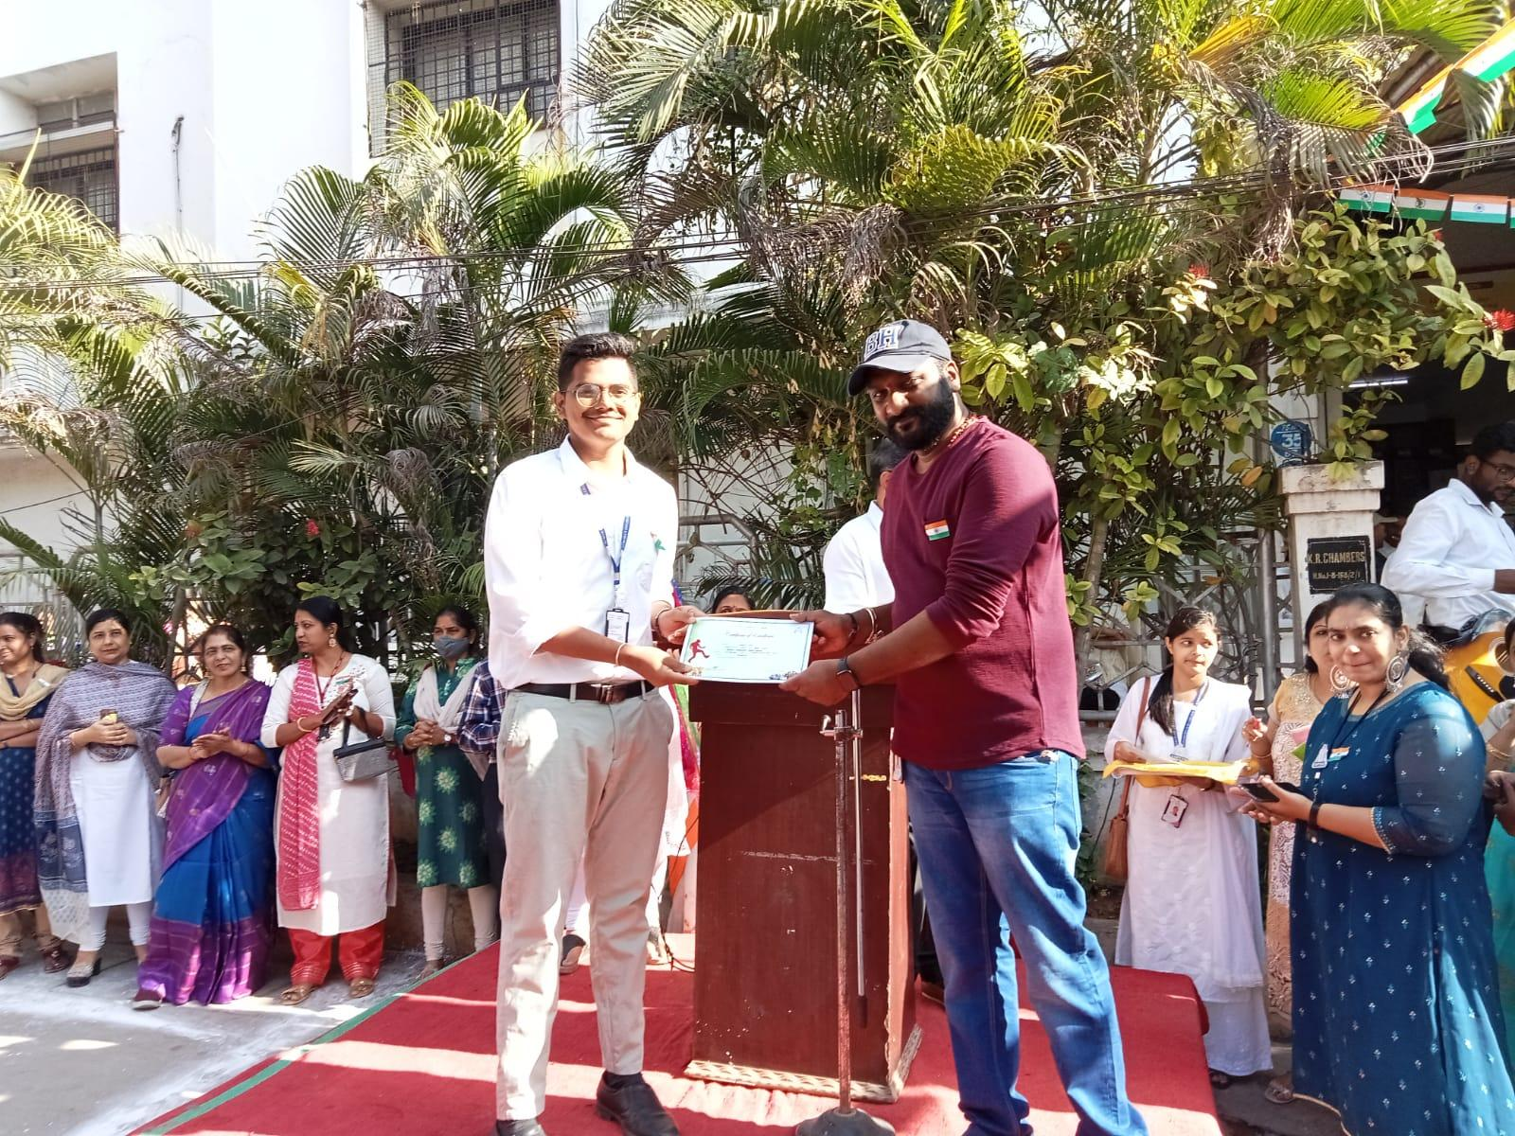

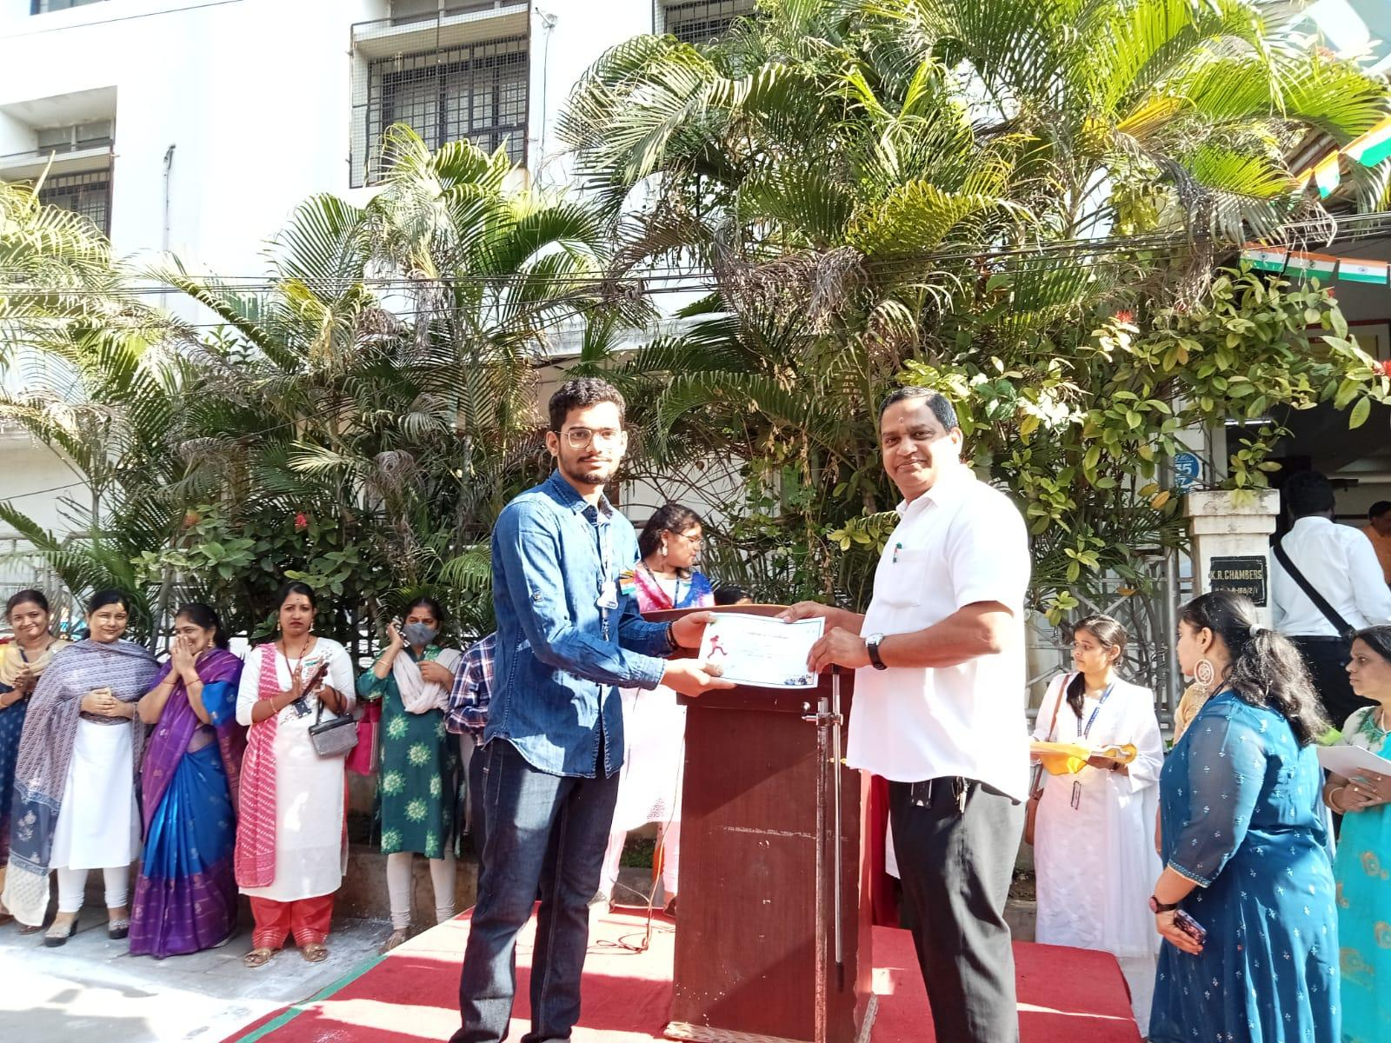

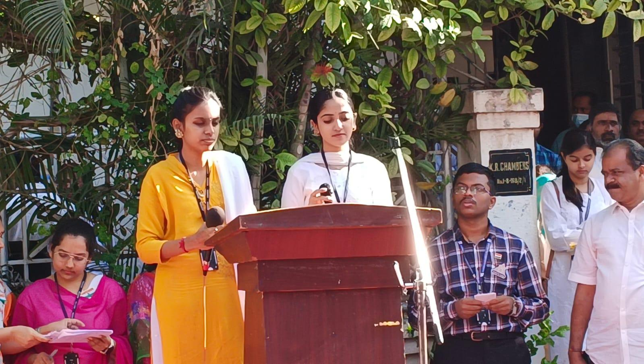

BUDGET REPORT
Decoration | 2778
Refreshment | 24400
Certificates | 500
Miscellaneous | 200
Total | 27878

Thanks & regards
Madhavi.I
KNL Prashanthi

