SNATAKA
Mini Convocation 2022
A Report on

Symbolizing Successful Sojourn

CONVENERS:
1.M.DEVIKA
Associate Professor,
Department of Mathematics.
2.P.MADHAVILATHA
Associate Professor,
Department of Computer Applications.

Convocation – meaning “calling together” from the Latin is a ceremony steeped in a tradition that goes back centuries. It signals a person’s first step into the ‘real world’ – a world where the true strength of character, skills and knowledge are put to test.

Valuing the Indian traditions and culture, Aurora has come up with a Samskaara to applaud its students’ academic achievements. The year 2002 marks the beginning of the Convocation ceremony in Aurora’s Degree College. It has seen a path breaking step in the history of the initiatives taken by the college. The purpose of organizing such a fulfilling and heart rendering event is to recognize the efforts and hard work put up by the students and make them step into the world of harsh reality with courage and indomitable attitude.

This year the Convocation Ceremony attained its new name ‘Snataka’, tracing back to the Vedic times in Indian History, where a student on successful completion of his education is honored in the name of ‘Samavartanam’.

Snataka 2022, was a successful event conducted on 22nd November 2022 Shilpa Kala Vedika Madhapur, along with mother nature showering golden droplets congratulating all the graduating youngsters. The program has started as it was scheduled, with all the guest coming on time and 90% of the students to start with. The session was conducted in two parts – first half is the formal function and the second half was the group photo session followed by individual photographs.
The guest list goes as follows :
1.The President - Prof. R. Limbadri, Chairman, TSCHE
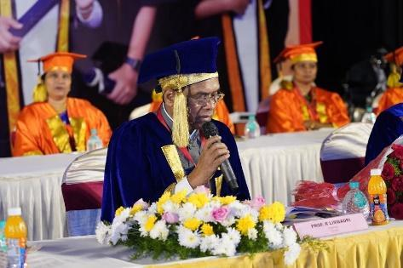
2.Sri Tammareddy Bharadwaja, Indian film Director and Producer

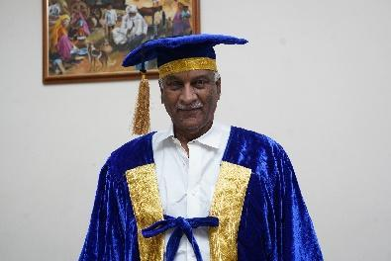

3. Ms. V. Karuna Gopal, President, Futuristic India
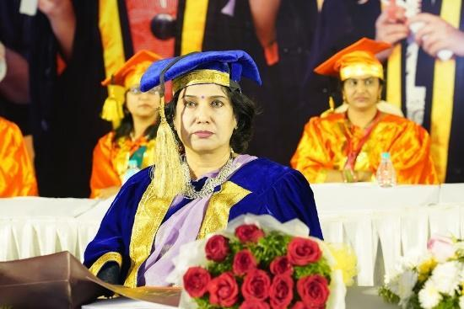

4. Dr.S.Venkataraman Director, C.R.Rao Institute
.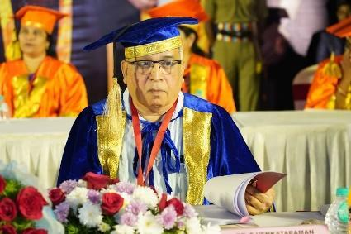
5. Sri Sahadeva Sakhadasa
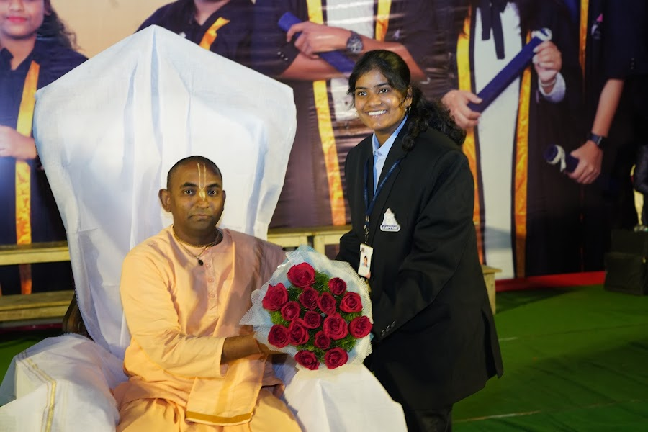

Arrival of the Guests:
The President, Chief Guest, Eminent Guest,Guest of Honour and the Management members arrived at 9:30am and were received by the Principal and led to the dressing room for wearing the robe and badge. The guests dressed formally in appropriate Graduation robes and caps for the Graduation Ceremony – Snataka.

Photo Session:
The Principal, President, Chief Guest, Eminent Guest,Guest of Honour for the Day, Secretary, Chairman, Heads of all Departments assembled for a group photo.

Academic Procession:
The Academic Procession lead by the HODs, Principal, Chairman, Secretary, and Guests started and proceed towards the stage, escorted by the Guard of Honor with the Band. The formal function started once the procession reached the dais and everyone took their seats. The Gold Medals for the College Topper, the Course Toppers and the top ten rankers for the 2017-2020, 2018-2021,2019-2022 batches were presented by the President Prof. R.Limbadri. The certificate of Excellence to the college toppers of Commerce students was given by Sri Tammareddy Bharadwaja. The Certificate of Excellence to the college toppers of BBA, BA and Physical Sciences was given by Smt. V.Karuna Gopal and the Certificate of Excellence to the college toppers of Life Sciences was given by Dr. S.Venkataraman. After the completion of the programme The President, Chief Guests, Eminent Guest, Guest of Honour, Secretary, Chairman, Principal and Heads of all Departments retired with the band.

Commencement of Snataka:

After the lighting of the lamp from the dignitaries, the Principal briefed about Snataka and presented the college report. Principal then by taking permission from the President, declared the
Graduation Ceremony Open.
This was followed by the Oath Administration by the President and presentation of Degree Awardees department wise.
The Gold Medals were awarded to the college topper and course toppers. Certificate of Excellence was awarded to the top ten rankers of the college. Certificate of Excellence was awarded to the top five rankers from each course.
All the guests addressed the gathering and motivated the graduating students to face the world with a positive attitude.
The dignitaries were honored by the chairman, secretary,and principal . Then the vote of thanks was presented by the principal. Principal dissolved the graduation ceremony and the Academic procession departed from the auditorium.

Second session began with Aurora’s Rock Band Followed by the Guest Sri Sahadeva Sakhadasa. He was received well at the reception by Dr. Viswanadham Bulusu, Principal. He delivered motivational speech for the students. Swamiji’s speech attracted all the audience as he inspired and motivated by quoting relevant examples. He was escorted by Dr. Viswanadham Bulusu , and Ms. P.Chandrakala for a sendoff.

In the second session of the ceremony, a group photo of every class was arranged. The students of the class assembled together and marched to the dais along with the Principal and Head of the department. Every presentation of the award was with the band playing in the background. Students and Faculty appreciated it a lot. Next year we will plan for Aurora's band. They were distributed the certificates and after the group photo marched down the dais and were directed for individual photos and refreshment outside the auditorium.
Media coverage was well organized. Complete video coverage and 10 minutes telecast was by Ntv, TV9, Saakshi, 10Tv, V6, Etv, ABN TV, Hmtv , TV5 and T news in the evening. The event report with photograph was published in the daily newspapers like Namaste Telangana, Sakshi, Eenadu, Vartha, Andhra jyothi and Velgu.
All the committees had their respective volunteers apart from the class captains.
The individual reports by all conveners and the expenditure statements are provided separately. The expenditure statement is also included.
This year All the guests were presented with the personalized photo album of the event and a album was printed to be preserved in the college apart from the digital album.
Event Organization:
The Convener, in consultation with the Principal will form different committees. However the committees can be combined or bifurcated as the situation demands. Each committee will have a convener, faculty members, class captains allotted by Student Activity Facilitator and the student volunteers selected by the committee. Once the committees are formed, the organizing committee will finalize the venue based on the proposed date and availability of the venue.

The Committee list:
- Organizing Committee
- Guest Relations Committee
- Reception Committee
- Stage Decoration Committee
- Stage Management Committee
- Refreshment Committee
- Press and Photography Committee
- Prize Distribution Committee
- Gowns Committee
- Material Procurement Committee
- Discipline Committee
- Budget Committee

Basic Protocols for various Committees:
- Every committee convener must submit the budget to the budget committee within 5 days of committee formation approved by the Principal for releasing the funds.
- Every committee must select the volunteers for their committee and the same has to reach the reception and refreshment committee along with all the details like roll no, name, class, contact number, email id etc.
- Make sure that the number of volunteers are nominal as too many cooks spoil the food.
- The works of the committee must be distributed equally among all the members and regular meetings should happen with the members and student volunteers to understand the work properly and keep track of the work status.
- Minutes of Meeting (MoM) have to be recorded and signed by all the members.
- After the completion of the event, within 3 days a detailed report has to be submitted to the convener along with the Minutes of the meeting and expenditure statement with all the original bills.

Reports of various committees
Guest Relations:
Guest relationship committee Members:

S.No | Name | Department | Role
1 | Ms. P. Chandrakala | Mathematics | Convener
2 | Prathiba G | Mathematics | Member
3 | Ms. Parimala Sudheer | Statistics | Member
4 | Mr. R. Arjun Rao | Computer Science | Member
5 | Mr. K. Rahul | BioTechnology | Member

The committee members after deliberations have approached/contacted a few proposed guests and finally the following guests have been finalized and invited for the Event:
- Prof. R. Limbadr, Chairman, TSCHE
- Sri Tammareddy Bhradwaja, Indian film Director
- Ms. V. Karuna Gopal, President, Futuristic India
- Dr.S. Venkararaman Director CRRAO’s Institute
- Swami Sahadeva Sakhadasa, ISKON

- The committee successfully accomplished the task of coordinating with the guests.
- The guests were well received and presented with bouquets and mementos
- The committee has ensured timely pick up of the guests, their reception and their cordial send off after the event.
- The mementos for the Guests were procured and given to the guests.
Expenditure Statement;
Sl.No. | Item | Expenditure(in Rs.)
1. | Gifts for the Guests | 14,400.00
2. | Dr fruits | 1,268.00
3. | Ziplock covers | 49.00
4. | Transportation for Guest 1 | 3,104.00
5. | Transportation for Guest 2 | 1,899
Total = 22,220/-
Stage Management Committee
Preliminary work
The preliminary work related to the convocation was assigned to the stage management committee. Preparation of the Convocation Proceedings Booklet started way ahead of the convocation. The complete information and minute details relating to the conduct of the convocation was prepared in collaboration with the convenors and under the guidance of the principal. The content of the convocation booklet contained complete convocation proceedings, list of graduating students, list of stream topper (gold medal winners) and subject toppers along with the profiles of the guests and anchoring text. Profiles were collected from the Guest Coordination Committee. List of graduating students was collected from the reception committee and list of Gold Medallists and stream toppers was collated from the Prize Distribution Committee. Programme schedule for both the morning and afternoon sessions was prepared and added to the Invitation, which was printed both in English and Telugu languages.
Anchoring
Ms P.Sona and Ms A. Sharon Priyanka , Assistant Professors ,Department of English were identified as Anchors to conduct the proceedings of the convocation. They have thoroughly rehearsed the content of the convocation booklet. Dr. P. Bharathi, Professor of English, Ms. S Padmavathi, Associate Professor of English, Ms. Parimala Sudhir, Associate Professor of Statistics, Ms Vineetha Parthiban, Asst Professor of English and Ms. Bindu, Assistant Professor of Biotechnology read the profiles of the guests. The committee also identified two singers Ms. D. Meghna and Ms V. Keerthi from B.Com Hons-II, to render the prayer song.

Stage Management | Dept. | Responsibility
Dr. P. Bharathi | Convener | Booklet, Invitation  Rehearsal -Anchors
Padmavathi S - (HoD) | English | Booklet, Invitation  Rehearsal-Anchors
P.Sona | English | Anchoring
A Sharon Priyanka | English | Anchoring
P Vineetha | English | Stage
Tingirikar Prasanna | English | Reception
Botla Vyshnavi | English | Stage
Moumita Santra | English | Discipline
Mr. D.Malleswara Rao | English | Discipline

The stage management committee worked in perfect coordination with all the other committees by discussing minute details related to arrangements and smooth conduct of the convocation programme by receiving and providing instructions and suggestions from time to time
Material & Kit:

The committee consists of the following members
S.No. | Name | Department | Contact No. | Member/  Convener
1. | Ms. M. Latha Salome | Mathematics | 9100000597 | Convener
2. | Ms. NagaVaani | Biochemistry | 9100001637 | Member
3. | Ms.Unnamalai | Commerce &  Management | 9100000534 | Member
4. | Dr. M. Latha | Chemistry | 9100000598 | Member
5. | Mamatha M | Commerce &  Management | 9100000583 | Member
6. | J.Vinitha | Statistics | 9100000561 | Member
7. | KNKL Lavanya | Biochemistry | 9100000602 | Member

Captains allotted:
- 1051-21-467- 001 Thammi Meharsai MSCs2A
- 1051-22-468-003 Hariharan MPCs1
Student Volunteers:
- 1051-21-539- 007 Swetha Kulkarni MSDs2
- 1051-22-539-015 B.Harshavardan Reddy MSDs2
- 1051-22-539-022 S.Srinath MSDs2
Apart from the above said volunteers, few more captains and NSS students worked as volunteers and all of them actively involved in their assigned works. The work done by Thammi Meharsai, B.Harshavardan Reddy, Swetha Kulkarni,Vivek (captain BCOM 1 Year) S.Srinath is highly appreciable.
The committee had a meeting in the month of September and work distribution was done. The members of the committee collected Photos of all the events that happened during the academic years 2017-18, 2018-19, 2019-20, 2020-21, 2021-22.
The convener made the link Life at Aurora and sent it to the Principal for further proceedings.
A form to collect student present details and student feedback is template by Principal Dr. Vishwanatham Bulusu and Vice Principal Mr. J. Hari Prasad. The student information form is designed by the convener with the help of Ms. P.Vineetha, faculty, Department of English. It is printed and 2,500 Copies of it were made by Mr.Shaik, the DTP Operator. Also 500 copies of Principal Message were made to distribute to the students.
There was a second meeting with the committee members on 20-11-22 to discuss action plan for the program along with the allotted student
As nearly 2,500 students registered for the event, we have started distributing the “Student Information Forms” to the registered students from the morning. We have placed Principal Message sheets on the tables of the registration desks. Interested students have collected for themselves. The student volunteers actively distributed the forms and collected the filled in forms. Nearly 1,500 forms were distributed and 1056 forms were collected.(B.Com – 495, BBA – 91, BA – 18, Life Sciences – 150, Physical Sciences – 182, Group Not mentioned-11)
3000 folders were ordered by the organising committee, and were received on 20-11-2022 by the office. The folders, the student information forms and Principal Message sheets were kept ready in carton boxes by 21-11-2022 evening. All the carton boxes were dispatched to the venue by the office.
Details of the Budget:
S.No. | Items | Expenditure
1 | Copies of Student Information Forms | 2,500
2 | stationary | 465
3 | Copies of Principal Message | 500
4 | Folders | -
 | Total | 3,465+_______

Total Expenditure: Rs.______________
n.
After Lunch the convener collected the no. of registrations for each section of each batch to arrange folders accordingly.
We have noted the count of the no. of the boxes opened and no. of folders in it. We have arranged the folders in the 20's and kept ready for the distribution. Unnamalai maam is at the desk with the no. of folders required. Ms. Nagavani Maam is at the boxes and Ms. Latha Salome was arranging the folders in 20’s and took the count from Nagavani madam and unnamalai madam every time. The distribution went on smoothly and in time. This is done because of the cooperation from the Principal and coordination among the committee members and student volunteers. The details of the count are given in the attachment.
Prize Distribution:

Following are the prizes awarded to the students
S.No | Year | Gold Medals & Certificates | Excellence Certificates for Top 10 students | Excellence Certificates for stream toppers | Total
1 | 2018-20 | 12 Medals and 12 Certificates | 10 | 65 | 87
2 | 2019-21 | 12 Medals and 12 Certificates | 10 | 65 | 87
3 | 2020-22 | 11 Medals and 11 Certificates | 10 | 60 | 81

Prize distribution committee functioned as below:
- Prize winners were identified from all streams in coordination with final year section in charges for following prizes
a) Gold Medals: Overall College Topper-1, Stream toppers (One from each stream)-11 for the Year 2018-20 and 2019-21; For the 2020-21 Stream toppers -10
b) Certificate of Excellence: College toppers-10, Toppers form various streams – 5 from each stream except B.Com(Gen) and B.Com(comp)- top 10.
- Total 190 students were identified as prize winners for past three years
- Verification of prize winners marks with consolidated memos
- Getting specimen copies of certificates before ordering
- Proof reading all the details of gold medals and certificates before printing.
- Gold medals and Certificates were ordered
- Got the Rexene folders from stores.
- After getting the certificates, took the signatures of Principal and Secretary .
- A copy of Prize winners has been sent to stage management committee
- Proof reading of prize winners was done in the convocation book
- Requirements such as tables, trays , tray clothes etc have been sent to stage decoration committee
- Prize winners have been informed in well advance and got the confirmation from them.
On the day of Event following works has been done:
- Prize winners were made to sit in the places allotted by members of committee along with allotted captains
- Gold medals and certificates were kept in order well in advance before the event was started.
- Distribution of prizes was done in the order as mentioned in the convocation book
Budget:
S.No | Details | Amount
1 | Gold medals | 1,99,000.00
2 | Certificate Printing and Cutting | 2,770.00
3 | Stationary(Pens, ribbons, and taps) | 334.00
4 | Total | 2,02,074.00

Prize Distribution Committee members:

S.No | Name | Department | Role
1 | C Aruna | Physics and Electronics | Convener
2 | Prathiba G | Mathematics | Member
3 | Padma M | Microbiology | Member
4 | P Poornachander | Electronics | Member
5 | Bindu G | Biochemistry | Member
6 | Madhav I | Commerce | Member
7 | Chamundeswari | Commerce | Member
8 | Padmini | Commerce | Member
 | Malleshwara Rao | English | Member

RECEPTION COMMITTEE:

S.No | Name | Department | Role
1 | B Rajani | Computer Science | Convenor
2 | Veena Malkade | Computer applications | Member
3 | V Kavya | Computer science | Member
4 | Rajya Lakshmi | Statistics | Member
5 | Udya Shree | Physics | Member
6 | Padma shri N | Computer science | Member
7 | Radhika | Commerce | Member
8 | Suresh | Commerce | Member
9 | Sunitha | BioChemistry | Member

Works Done by the Committee
- The student data (name, Roll no, phone no, mail id) of the eligible students for convocation (in soft form) was collected section wise from the respective final year section in charges. (Batches :2017-2020,2018-2021 and 2019-2022)
- Google form (Registration form) is created for the students to get register for Convocation Ceremony, along with the registration details even students’ higher education and job profile data were collected.
- The google form is shared with eligible student’s mails ids and gave 5 days to get registered.
- After receiving registered students data, the data was segregated section wise and sent to the respective section in charges and asked the section in-charges to contact the eligible students who have not registered through phone and find the reasons for it.
- Two days before the convocation invitation was mailed to the registered students.
- Personally called and invited Raja Babu sir, Ramesh sir and Anudeep sir.
- Governing body members, gold medal sponsors and Consortium college principals were called personally and invited.
- Invitation is sent to governing body members and gold medal sponsors.
- Invitation was mailed to consortium college principals.
- According to the seating plan of the auditorium, we prepared a seating plan for the guests, prize winners, press, faculty, parents and students and got it approved by the principal sir.
- Prepared placards as per the requirement.
- On the day of Convocation counters were arranged Course wise and registered students reported at their respective counter. Committee members have cross checked the student details with the list of registered students and then allowed them into the auditorium

S.No | Course | 2017-2020 | 2018-2021 | 2019-2022 | Total
1 | B.Com(Hon) | 55 | 47 | 61 | 163
2 | B.Com(Gen) | 121 | 85 | 90 | 296
3 | BBA | 24 | 32 | 109 | 165
4 | BA | 19 | 14 | - | 33
5 | B.Com (Com)s | 97 | 94 |  | 191
6 | B.Com (ComAPP) | 26 | 28 | 156 | 210
7 | MSCs | 36 | 78 | 103 | 217
8 | MPCs | 19 | 47 | 58 | 124
9 | MIGC | 34 | 30 | 43 | 107
10 | BTBIC | 30 | 35 | 48 | 113
11 | MIBIC | 15 | 11 | 19 | 36

CULTURAL COMMITTEE :
CONVENOR: S.Krishna Priya (Dept. Of Computer Applications)
Member: A Sandhya Rani (Mathematics)
BUDGET: 9500 Rupees
PERFORMANCES:
- Invocation song by second year students. It was Vishnu shatpadi stotram

The list of students for prayer song:
NAME OF THE STUDENT | CLASS/SECTION
Dasari Meghana Naidu | B.Com Honors 2
Keerthi Vaddiparthi | B.Com Honors 2

- The gap filling song performance was done by a Rock Band group from our college. It lasted for 45 min.
ROCK BAND GROUP:
ROLL NO | NAME OF THE STUDENT | CLASS/SECTION
1051-22-405-092 | Shanmukha Lasya | B.com Comp Appl 1B
1051-22-405-024 | U. Gayatri | B.com Comp Appl 1A
1051-20-405-113 | K. Tejavardhan | B.Com Gen 3B
1051-22-401-054 | Soumith ponna | BBA Gen 1A
1051-22-459-018 | Benny Hinn | MIGC 1
1051-21-467-060 | V. Goutham | MSCS 2B
1051-21-407-010 | Dasari Meghana Naidu | B.Com Honors 2
1051-21-407-063 | Keerthi Vaddiparthi | B.Com Honors 2
1051-21-459-027 | John Simon | MIGC2
1051-21-459-010 | E. Namami | MIGC-2
1051-20-684-138 | S Sai Sweekruthi | BBA 3C
1051-20-684-012 | Erica Ann Hackett | BBA 3A
1051-20-459-001 | Jerome | MiGC 3
1051-20-401-064 | P Minith Kumar | B.Com Gen 3A
1051-20-684-049 | Akhil Rohan | BBA 3A

In the presence of cultural coordinators students have done practice of rock band for a week 14-11-2022 to 21-11-2022 for convocation which was held in Shilpakala Vedika, Madhapur, Hyderabad on 22 - 11-2022. The program started with the prayer song “Vishnu shatpadi stotram” at 10:30am by Keerthi and Meghana Naidu. For the Rock Band team time slot is given in the lunch hours. They performed about 40 - 50 mins starting at 1:30-2:30. Keerthi , Meghana, Goutham , Lasya were singing telugu mashups and Telugu songs . Namaami, Gayathri - Hindi mashup and Erica, Teja vardhan, Sai Sweekruthi, Akhil Rohan - English mashup. Minith on drums, Soumith and Jerome Joshua on guitar, John Simon on keyboard and Benny hinn on Tabla. Few alumni students also joined them at the end of the event they performed on a friendship song called Mustafa. Event was successfully ended with all good compliments.
SUGGESTIONS: For Rock band performance kindly allot the time slot in schedule if possible.
Press and Photography Committee:
The work has been started on 18th November 2022. I sent Invitation letters to Print & visual media people.Two videographers and four photographers were hired to cover the entire event.
Budget Proposed:
Photography and Videography: Rs. 100000/-
Print & News Media Coverage: Rs: 25,000/-
Budget sanctioned: Rs. 125000/-
The print media for the event is Namaste Telangana, Sakshi, Eenadu, Vartha, Andhra jyothi and Velgu.
The news media for event is Ntv, TV9, Saakshi, 10Tv, V6, Etv, ABN TV, Hmtv , TV5 and T news
Convocation Google Photos Link:
https://photos.app.goo.gl/HzH3qN9u8tzgm7tL7

GOWNS COMMITTEE:

The main aim of the Gowns Committee is to issue gowns to all the graduating students. Once the student reports to the reception committee, they will be guided inside the hall and must report to us.

The committee approached C.chinnajirow sons tailors, Chennai and Sri Surabhi Sankalp Arts in Ramnagar, Hyderabad, for gowns this year. Finally we had given our quotation to Sri Surabhi Sankalp Arts, Hyderabad. The supplier quoted Rs. 500/- for each gown set as a security deposit amount. In that case, Rs. 100/- is the chargeable amount, and Rs. 400/- is the refundable amount to the student following the return of the gown to the supplier. The VIP gowns were provided as a bonus and were free of charge.
Students started to report by 8:30 a.m. The supplier issued the gown set after we reported it and paid a Rs. 500 security deposit. We permitted students to stay until 11:30 a.m. After the beginning of the formal function, no student had been allowed inside the auditorium or outside the venue.

The gowns committee also took up the responsibility of VIP gowns, and two student volunteers were allotted along with my committee.

The supplier arranged three counters for collecting deposit money and issuing gowns. Security deposit money has been collected by the gown supplier.

After the completion of group and individual photo shots, students have returned their gown sets and collected their security deposit money. Again, we arranged for three counters to take back the gowns.

Points Observed:
- This time, registration counters are open until 11:30 a.m. Due to that; the supplier issued the gowns up until 11:45 a.m.
- When we checked the number of students who took gowns and students reported at reception, there was no tally in the number of students. Our committee then noticed that the eligible students who had already collected gowns were giving those gowns to not-eligible students. The eligible students again approached the supplier and collected the gowns.
- Because of the aforementioned reason, even though all students who do not have registration tags are wearing gowns.
- Instead of allowing the students inside the auditorium after they collected the gowns, some of the faculty themselves are busy in taking selfies from students.
- After the beginning of formal function students were keep on moving outside the auditorium.
- At the time of gown collection at the end of the program, the supplier did not arrange counters in a systematic order, and also because of the large number of students, our committee failed to monitor the crowd. One student was injured, and she was admitted to the hospital for first aid. She had improved.

I thank all the Faculties, HOD’s, convener, vice principal, principal. Last but not least committee members and Student volunteers, who supported me to successfully coordinate with students and complete the event in time without any delay,.

Suggestions:
- Guiding the students in to auditorium is not only responsibility of gowns committee but also responsibility of the entire faculty.
- Discipline has to be maintained strictly.
- Reporting time must be maintained strictly.
- More faculty support will be required during the gowns collection process.
- The registration committee and gowns committees need to work together during the time of gown distribution.

Budget: NIL

Convener:
- Mr. R Sravan Kumar, Dept. of Electronics.
Members:
- Mr. P Anjaneyulu, Dept. of Statistics
- Mr. N Sai Kishore, Dept. of Statistics
- Mr. K Satish Kumar, Dept. of Computer applications

Student Volunteers:
- K Navaneeth (1051-20-684-104) BBA-3B
- P Venkata Karthik (1051-20-684-001) BBA-2A
Gowns supplier details:
1. C. chinnajirow sons tailors, Chennai;
K. Umashankar, Mail id: c.chinnajirowsons@yahoo.com
Contact number: +91 9444257656/9444114580
2. Sri Surabhi Sankalp Arts, Hyderabd;
Yeshwanth, Contact number: +91 9966885669

The discipline committee was responsible to maintain disciple in the Hall during the convocation both for formal and informal sessions. Seating arrangement for all the final year students was done by the organizing committee , accordingly faculty allocation was done stream wise to ensure perfect discipline and proper monitoring of the students in the hall. Two days before the convocation, a meeting was held with committee members. Two faculty members were allotted stream wise and section wise and the same was informed to the members in the meeting.
Meeting with Captains was also conducted one day before the convocation and stream wise allotment was done.
On the day of the convocation function all members actively participated in ensuring that proper discipline was maintained in the hall.

AURORA DEGREE AND PG COLLEGE
SNATAKA
(MINI CONVOCATION)
Expenditure Statement 2023
S.No | Committee | Amount
1 | Organizing
 | Piper Band
 | SubTotal
2 | Gowns
 | Student Gown
 | Sub Total
3 | Medals and Certificates
 | Gold Medals
 | Certificate
 | Misc
 | Sub Total
4 | GroupPhoto
 | Pre Convocation photo(convocation 5000,induction 5000)
 | Sub Total
5 | Guest Relation
 | Cab for the guests
 | Sub Total
6 | Material and Kit
 | DVD
 | Folders
 | Pens (convocation 10,010, induction 10,010)
 | Misc
 | Sub Total
7 | Refreshments
 | Tiffin(NCC+ Sub Staff)
 | Sub Total
 | Grand Total

Glimpses of Samavarthan
