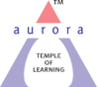
Aurora’s Degree & PG College
Chikkadpally,Hyderabad -500020
Short Report
On
Outreach Program
On the occasion of “Sir CV Raman Birthday”

NAME OF THE EVENT | Outreach Program  On the occasion of “Sir CV Raman Birthday Day”
TYPE OF EVENT | College level
FACULTY INCHARGE | C.Aruna & B.Udaya Sree
DEPARTMENT | Physics & Electronics
DATE | 7th November, 2022
VENUE | Andhra Mahila Sabha Junior College,OU Campus
TARGET AUDIENCE | MPC Intermediate Students

OBJECTIVE:
To make students to understand the basic components of physics and to make students to know the contribution of Sir C V Raman in the field of Physics.

BRIEF ABOUT THE EVENT :
Department of Physics, Aurora’s Degree and PG College conducts this event with great enthusiasm every year.
Faculty members C.Aruna & B.Udaya Sree along with final year B.Sc students conducted an outreach program in Andhra Mahila Sabha Junior College. They interacted with Intermediate MPC students and explained about Invention of Raman effect and its applications. Few apparatus like Prism, Battery, Vernier Callipers,Screw gauge,Tuning Fork,Resistors,Convex and Concave lens etc were demonstrated practically and also few concepts like Dispersion of light through Prism, Measuring diameter & thickness of wire by using Vernier calipers, screw gauge etc were explained to the students.
Students participated very enthusiastically and actively in the session.

OUTCOME:
Students gained practical knowledge on basic apparatus in physics and on latest inventions in physics. Students got motivated to take up their career in the field of physics.

Photographs:

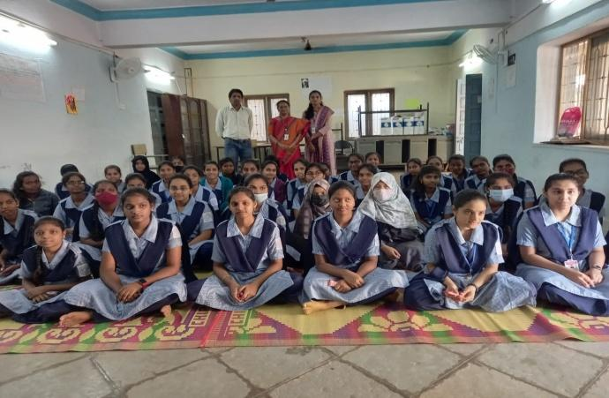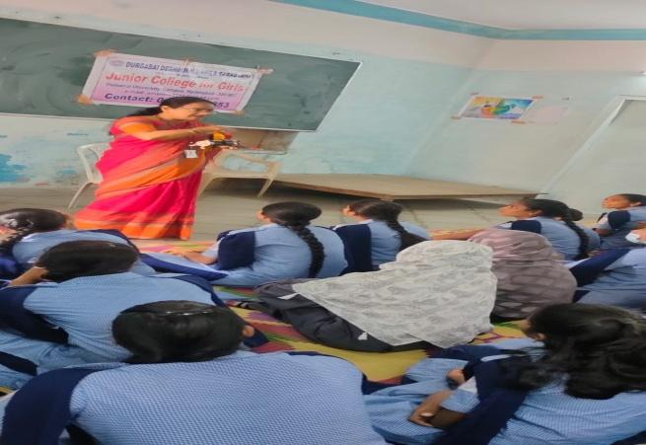

Aurora’s Degree & PG College
Chikkadpally,Hyderabad -500020
A Detailed Report
On
Outreach Program
On the occasion of “Sir CV Raman Birthday”

EVENT / ACTIVITY DETAILED REPORT

NAME OF THE EVENT | Outreach Program  On the occasion of “Sir CV Raman Birthday ”
TYPE OR TITLE OF EVENT | College level
FACULTY INCHARGE | C.Aruna & B.Udaya Sree
DEPARTMENT | Physics & Electronics
DATE | 7th November, 2022
VENUE | Andhra Mahila Sabha Junior College,OU Campus
TARGET AUDIENCE | MPC Intermediate Students

PROGRAM SCHEDULE: 7th November, 2022 from 10:00 am to 12:00 pm.
VENUE: Andhra Mahila Sabha Junior College,OU Campus
LIST OF FACULTY COORDINATORS :
C.Aruna - Department of Electronics.
B.Udaya Sree -Department of Physics.
LIST OF THE STUDENT COORDINATORS :
Pooja,1051-20-468-002,MPCS 3A
Sri laxmi,1051-20-468-001,MPCS 3A

LIST OF THE PARTICIPANTS:
s.no | Name of the student | Grade
1 | Preethi Kumari | MPCI
2 | G.Manasa | MPCI
3 | G.Siri | MPCI
4 | B.Dixitha | MPCI
5 | V.Rupa Laxmi | MPCI
6 | V.Vaishnavi Goud | MPCI
7 | Sana Begum | MPCI
8 | B.Chandana | MPCI
9 | B.Samyuktha | MPCI
10 | N.Keerthi | MPCI
11 | K.Harshitha | MPCI
12 | G.Sowmya | MPCI
13 | J.V.Siri chandana | MPCI
14 | G.Manisha | MPCI
15 | Rayana Sai Saranya | MPCI
16 | K.Malavika | MPCI
17 | P.Bhargavi | MPCI
18 | S.Mounika | MPCI
19 | Muskan Rani Muktha | MPCI
20 | Samlet Swetha | MPCI
21 | N.Akshaya | MPCI
22 | Zuha Maryana | MPCI
23 | K.Rakshitha | MPCI
24 | U.Poojitha | MPCI
25 | A.Hemalatha | MPCI
26 | Katapaga Vaishnavi | MPCII
27 | K.Vaishnavi | MPCII
28 | A.Prathibha | MPCII
29 | N.Bhagyalaxmi | MPCII
30 | Samrun Fathima | MPCII
31 | Summaiya Sultana | MPCII
32 | M.Meghana | MPCII
33 | M.Jayashree | MPCII
34 | R.Sahasra Sharma | MPCII
35 | S.Nara | MPCII
36 | Keerthana | MPCII
37 | Poojitha sai | MPCII
38 | M.Sreenidhi | MPCII
39 | C.Niharika | MPCII
40 | K.Chaitanya | MPCII
41 | D.Jayasiri | MPCII
42 | M.Lokeshwari | MPCII
43 | K.Poojitha | MPCII
44 | C.Jhansi Yadav | MPCII
45 | B.Soujanya | MPCII
46 | G.Divya | MPCII
47 | C.Bhargavi | MPCII
48 | C.Niharika | MPCII
49 | M.Nikitha | MPCII
50 | S.Sruthi | MPCII
51 | G.Laxmi Prasanna | MPCII
52 | Irfana Parveen | MPCII
53 | A.Pujitha | MPCII
54 | B.Swathi | MPCII
55 | N.Gangothri | MPCII
56 | Akshaya | MPCII
57 | Shravani.TV.Keerthana | MPCII
58 | Soumya | MPCII
59 | Ooha | MPCII
60 | Siri | MPCII
61 | Ashwini | MPCII
62 | Pravalika | MPCII

Paragraph about the Proceedings
The Raman Effect was probably the most important invention of the 20th century. The great scientist Sir CV Raman who is responsible for the invention of the Raman effect.
Today Raman Spectroscopy is commonly used in chemistry to provide structural fingerprint by which molecules can be identified.. Hence every year 7th November his birthday is celebrated all over the world and his discoveries and inventions are remembered on this occasion.
Department of Physics, Aurora’s Degree and PG College conducts this event with great enthusiasm every year.
Faculty members C.Aruna & B.Udaya Sree with final year B.Sc students conducted an outreach program in Andhra Mahila Sabha Junior College,OU Campus. They interacted with Intermediate MPC students and explained about Invention of Raman effect and its applications .
Following apparatus were demonstrated practically
- Prism
- Battery
- Vernier calipers
- Tuning Fork
- Screw gauge
- Resistors, Capacitors and LEDs
- Convex and Concave Lenses
- Galvanometer
Following concepts were explained to the students:
- Dispersion of light through Prism
- Measuring diameter & thickness of wire by using Vernier calipers, screw gauge
- Image formation by convex lens and concave lens
- Basic difference between lens were explained.
Students participated very enthusiastically and actively in the session.

INCOME AND EXPENDITURE : N/A

Event Photos:

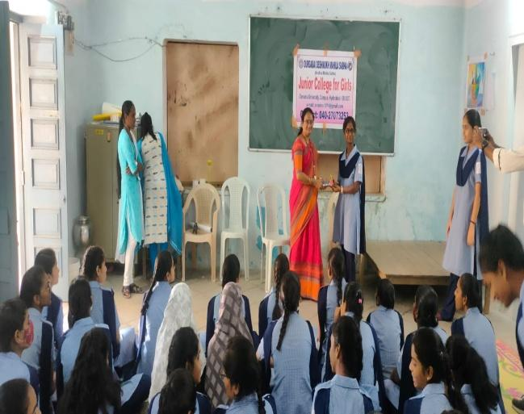
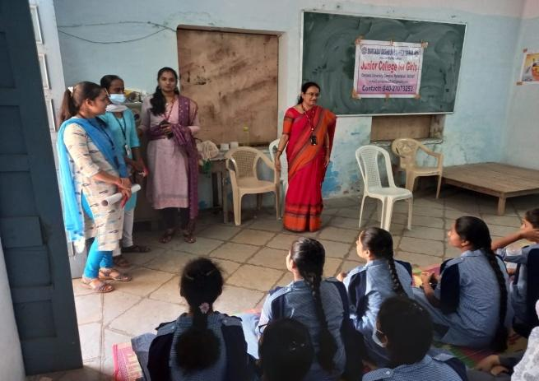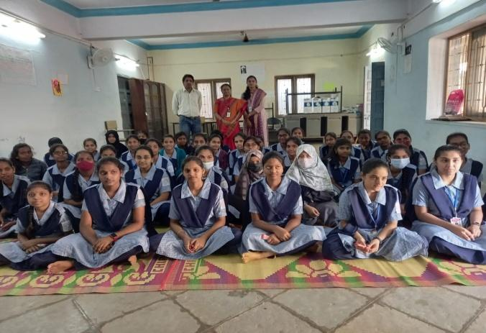

GUEST PROFILE: N/A

FEED BACK : Students gave positive feedback and they felt happy for conducting this event.

Aurora’s Degree and PG College
(ACCREDITED BY NAAC WITH ‘B++’ GRADE)
Chikkadpally, Hyderabad 500020
Department of Physics

EVENT PROPOSAL
for
Dr. C V Raman Birthday celebrations
Event Name: Dr. C V Raman Birthday celebrations
Event Title: Dr. C V Raman Birthday celebrations
Department Event: Physics Department
Faculty coordinator: C. Aruna, B. Udaya Sree
Date & Venue: 7/11/2022 & Andhra Mahila Sabha Junior College for college
Target audience: Intermediate Students
Platform: Offline
Level: Department level
Student Volunteer’s: Harini, Lavanya, Pooja
Budget: N/A
Objective: To pay tribute to an eminent scientist “Sir C V Raman” on occasion of his birthday.
Proposed activities:
- Visiting to Intermediate College
- Demonstrating Experiments in Optics
- Awareness about Career in Physics
.

Event Coordinator IQAC Coordinator Principal
C. Aruna (Dr. Meera Joshi) (Dr. Viswanadham Bulusu) B. Udaya Sree

EVENT / ACTIVITY NOTICE : N/A
RECEIPTS : N/A
CERTIFICATES : N/A
LETTERS OF COMMUNICATION :

