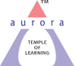
Aurora’s Degree & PG College
(Accreditedby NAAC with 'B++' grade)
Chikkadpally, Hyderabad- 500020
Department of Chemistry

EVENT REPORT

EVENT TITLE | Career Opportunities & Sustainable in Plastic & Waste Management In association with CIPT and AURORA Degree and PG College
TYPE OF EVENT | Departmental Event
FACULTY INCHARGE | VIRITHA BEZAWADA
DEPARTMENT | Chemistry
DATE | 16th October 2022
VENUE | CIPET,CHARLAPALLY,HYDERABAD
TARGET AUDIENCE | UG (Life science) and PG(Organic chemistry) students

OBJECTIVE:
To understand the basic of polymers & Plastic materialsTechnical Awareness on plastic processing, Plastic Moulds, Testing & Quality control etc Plastic Recycling, waste Management & Alternatives.
BRIEF ABOUT THE EVENT:
Workshop was conducted in two sessions.In the first session technical event has been conducted. PPT has been given by Mr.B.SRIKAR(SrTechnicalofficer)CIPET and Mr.D.Anjaneya Sharma( Manager)CIPET regarding processing of Polymers and Recycling of Polymers.In the afternoon session work shop was conducted by the technical team CIPET Regarding the processing and testing of the purity of polymers.
OUTCOME:
The event was successful. Nearly 40 students were participated in this workshop. The event discloses the carrier opportunities in Polymeric Engineering Technologies in national wide. Entreprenurship opportunities for UG and PG students in processing of Polymer industry.

PHOTOGRAPHS

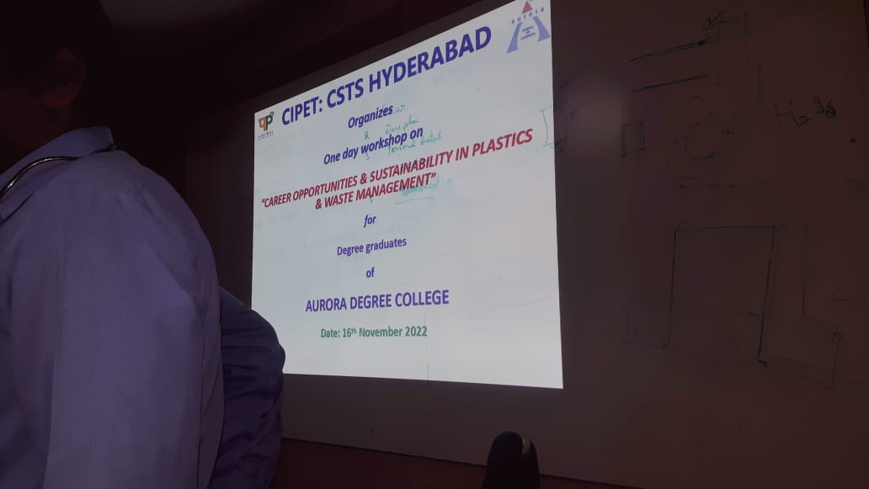

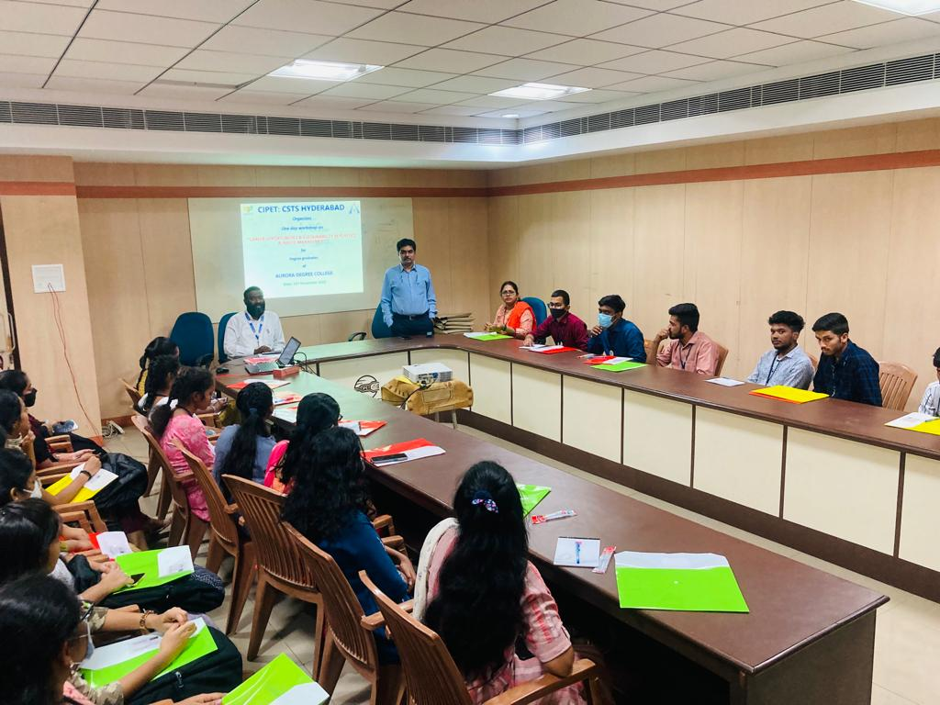

Detailed report:

The event was began at 10.0 clock at CIPET,CHARLAPALLY.. Event is started with an inauguration by CIPET technical team. Workshop was conducted in two sessions.In the first session technical event has been conducted. PPT has been given by Mr.B.SRIKAR(SrTechnicalofficer)CIPET and Mr.D.Anjaneya Sharma( Manager)CIPET regarding processing of Polymers and Recycling of Polymers.In the afternoon session work shop was conducted by the technical team CIPET Regarding the processing and testing of the purity of polymers.
In the workshop session the technical team practically shown how the polymers are processed by different moulding techniques like injection moulding,blow moulding etc and how the purity of polymers tested by different instruments like density meter,viscometer etc
After the workshop session has been completed interaction session was conducted by CIPET Technical team.Students were very excited at the processing techniques of polymers visuvalised by them.They clarified their doubts and shared their thoughts.
Total 40 Students are participated at B.Sc level and M.Sc level. Certificates were distributed to all the participants at end of the workshop.

DETAILS OF THE STUDENTS PARTICIPATED
S.NO | NAME OF THE STUDENT | REGISTERED NO | SECTION
1 | U.PADMA TEJA | 105121503066 | M.Sc. FINAL YEAR
2 | G.NAVITHA | 105121503061 | M.Sc. FINAL YEAR
3 | P.KRISHNA REDDY | 105121503012 | M.Sc. FINAL YEAR
4 | K.SUSMITHA | 105121503055 | M.Sc. FINAL YEAR
5 | MOHAMMAD SAFIUDDIN | 105121503006 | M.Sc. FINAL YEAR
6 | MYASA RAVALIKA | 105121503051 | M.Sc. FINAL YEAR
7 | MOHAMMAD ASIF | 105121503004 | M.Sc. FINAL YEAR
8 | D. KRISHNA SAGAR REDDY | 105121503069 | M.Sc. FINAL YEAR
9 | RUDRARAJU BHARGAV SAI VARMA | 105121503013 | M.Sc. FINAL YEAR
10 | PALLA VAMSHI | 105121503056 | M.Sc. FINAL YEAR
11 | HANUMANTHU DINESH KUMAR | 105121503011 | M.Sc. FINAL YEAR
12 | UPPALA NAGASAI | 105121503007 | M.Sc. FINAL YEAR
13 | CHITTIPROLU UMESH CHANDRA | 105121503068 | M.Sc. FINAL YEAR
14 | D. SUPRIYA | 105121503054 | M.Sc. FINAL YEAR
15 | JARANG SNEHA | 105121503060 | M.Sc. FINAL YEAR
16 | K. ARCHANA | 105121503064 | M.Sc. FINAL YEAR
17 | K. SHARANAYA | 105120488002 | BtBiC FINAL YEAR
18 | K. SAI RAGAVENDRA | 105120488008 | BtBiC FINAL YEAR
19 | M. KRIPALI | 105120488018 | BtBiC FINAL YEAR
20 | D. AKSHITH REDDY | 105120488025 | BtBiC FINAL YEAR
21 | V. JHANSI | 105120488042 | BtBiC FINAL YEAR
22 | P. KRISHANA BHARATHI | 105120488043 | BtBiC FINAL YEAR
23 | S. SAI BHARDWAJ | 105120488044 | BtBiC FINAL YEAR
24 | M. LOKESH | 105120459015 | MiGC FINAL YEAR
25 | RISCHI CHANDAN | 105120471006 | MiBiC FINAL YEAR
26 | V. RAGUVAMSH | 105121471013 | MiBiC II YEAR
27 | Y. AKANKSHA | 105121459006 | MiGC II YEAR
28 | S. VANJA CHOWDARY | 105121459019 | MiGC II YEAR
29 | S. SHIVANI | 105121459028 | MiGC II YEAR
S.NO | NAME OF THE STUDENT | REGISTERED NO | SECTION
30 | RAMYA MAHA LAXMI | 105121459031 | MiGC II YEAR
31 | M. BHARGAVI | 105121459032 | MiGC II YEAR
32 | R. DHRAMIKA | 105121459033 | MiGC II YEAR
33 | S. SWAMINADAN | 105121459009 | MiGC II YEAR
34 | B. RAJKIMAR REDDY | 105121459014 | MiGC II YEAR
35 | Ch. JAHANAVI | 105121459020 | MiGC II YEAR
36 | V. SRAVAN | 105120488017 | BtBiC FINAL YEAR
37 | N. NAGA SUNDER | 105120488048 | BtBiC FINAL YEAR

PHOTOGRAPHS
