Aurora’s Degree & PG College 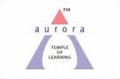
(ACCREDITED BY NAAC WITH 'B++' GRADE)
Chikkadpally, Hyderabad 500020

EVENT / ACTIVITY DETAILED REPORT

NAME OF THE EVENT | NUTRI WEEK
TYPE OF EVENT | College event
FACULTY INCHARGE | Dr. V.Nagavani
DEPARTMENT | Biochemistry
DATE | 01-09-2022 to 07-09-2022
VENUE | Aurora’s Degree and PG College Main Block and RTC Block
TARGET AUDIENCE | Students of all streams

Nutrition is the study of various types of food and their vital role in maintaining good health and welfare. Nutrition significantly promotes human growth and development. But many of us are unaware about the healthy food habits and because of that we suffer from various health issues. So nutri club in our campus gives us flair knowledge about various types of food included in our diet, good healthy food habits and create awareness among people about the value of nutrition. It also helps us to lead a healthy active life style. The main aim of the club is to enlighten the students and faculty in our campus about the importance of nutrition to achieve good health by providing excellent resources available.
Objective:
- To impart knowledge about nutrition and its role in maintaining good health.
- To create awareness about right nutrition and its importance in daily life.
- Importance of physical activity and exercise for long term health benefits.
Brief About the Event:
We the Department of Biochemistry celebrated Nutri-week as a part of Nutri club from 1st to 7th September 2022. In this connection various competitions were conducted like ppt presentation; Nutri Quiz, Milky frappe, Healthy munch, Debate and Discussion, Collage Making, Yoga & aerobic. The aim of all these competitions was to share the knowledge of nutrition and its vital role in our day today life and also bring awareness about the importance of physical activity for maintaining a healthy life.

Day 1- 3.9.2019
Competition 1: Nutri Quiz
It was a spot event. Quiz questions were asked. this event are conducted as 3 rounds in which 1st round is questions and answers round, and 2nd round comprises of pictures in which they need to determine which low calorie and healthy food and in 3rd round photos of diseased person are displayed and students need to identify deficiency of which elements.
Winners:
First Prize CH. Jerome MIGC 3
K. Manjunath MIGC 3
Arjun MIGC 3
M. Lokesh MIGC 3
Second Prize K. Ramji BTBIC 3
B. Abhishek BTBIC 3
G. Surya BTBIC 3
Kushal vishwakarma BTBIC 3

List of participants
Roll number | Name | Class | Section
105120459001 | CH. Jerome | MIGC 3
105120459014 | K. Manjunath | MIGC 3
105120459027 | Arjun | MIGC 3
105120459015 | M. Lokesh | MIGC 3
105120488010 | G. Madhu mohan | BTBIC 3
105120488030 | M. Krisostam | BTBIC 3
105120488027 | N. Akhila | BTBIC 3
105120488041 | V. Niharika Rao | BTBIC 3
105120488039 | S. Sridhya | BTBIC 3
105120488015 | Kripali Maheshbai | BTBIC 3
105120488005 | I. Prathyusha | BTBIC 3
105120488021 | Saavi Jaiswal | BTBIC 3
105120488016 | B. Renusree | BTBIC 3
105120488019 | Shreya P Joshi | BTBIC 3
105120488004 | V. B. Sneha | BTBIC 3
105120488006 | G. Bhavika | BTBIC 3
105120488024 | Kushal Vishwakarma | BTBIC 3
105120488009 | G. Prem kumar | BTBIC 3
105120471009 | - Poojitha Reddy | MIBIC 3
105120471015 | G. Akanksha | MIBIC 3
105120471012 | - Varsha | MIBIC 3
105120488013 | P. Sakruthi | BTBIC 3
105120459038 | S. Prerana | MIGC 3
105120459019 | S. Charitha | MIGC 3
105120459034 | L. Utkarsha | MIGC 3
105120459005 | Nitisha | MIGC 3
105120459004 | Vagdevi | MIGC 3
105120471004 | S. Sheryas | MIBIC 3
105120471005 | - Anish | MIBIC 3
105120459009 | KK. Sundareshan | MIGC 3
105120459010 | K. Ganesh | MIGC 3
105121471013 | V. Raghuvamsh | MIBIC 2
105121471006 | G. Saikrishna | MIBIC 2
105121459009 | Swaminathan | MIGC 2
105121459020 | - Jahnavi | MIGC 2
105120488012 | K. Ramji | BTBIC 3
105120488035 | B.Abhishek | BTBIC 3
105120488031 | G. Surya | BTBIC 3

Day 1- 3.9.2019
Competition: 2 Make a Protein Diet
Students prepared Protein diet .They prepared it with nuts, fruits and vegetables.
Winners:
First Prize I. Prathyusha BTBIC 3
Second Prize E. Jahnavi MIGC 2
List of participants
Roll number | Name | Class | Section
105120471015 | G. Akanksha | MIBIC 3
105120471012 | Varsha | MIBIC 3
105120459034 | L. Utkarsha | MIGC 3
105120459005 | Nitisha | MIGC 3
105120488015 | Kripali Maheshbai | BTBIC 3
105120488005 | I. Prathyusha | BTBIC 3
105120488021 | Saavi Jaiswal | BTBIC 3
105120488016 | B. Renusree | BTBIC 3
105120488015 | Kripali Maheshbai | BTBIC 3
105121459020 | - Jahnavi | MIGC 2

Day 2- 1.9.2022
Competition: 1 Milky Frappe
Students prepared healthy food items made of pulses and explained about their nutritive values. They prepared different types of salads, idli,stuffed sprouts parathas with pulses.
Winners:
First Prize Priyanka and Mahathi B.Com (Comp Applications) 3B
Second Prize S. Srividhya and M. Niharika BTBIC 3
List of participants
Roll number | Name | Class | Section
105120488039 | S. Srividhya | BTBIC 3
105120488040 | M. Niharika | BTBIC 3
105120488004 | V. Sneha | BTBIC 3
105120488006 | Bhavika | BTBIC 3
105120405088 | Jeevan Sai | B.Com (Comp Applications | 3B
105120405117 | Vallabh | B.Com (Comp Applications | 3B
105120405129 | Priyanka | B.Com (Comp Applications | 3B
105120405130 | Mahathi | B.Com (Comp Applications | 3B
105120405036 | Rohan | B.Com (Comp Applications | 3A
105120405099 | Mohit | B.Com (Comp Applications | 3A
105120488012 | K. Ramji | BTBIC 3
105120488035 | B. Abhishek kumar | BTBIC 3
105120488021 | Saavi Jaiswal | BTBIC 3
105120488005 | Prathyusha | BTBIC 3

Day 2- 2.9.2022
Competition: 2 PPT Presentation (Impact of carb diet on health)
The debate was on advantages and disadvantages of fortified foods.
Winners:
First prize Rohan and Mohit B.Com (Comp Applications) 3A
List of participants
Roll number | Name | Class | Section
105120405088 | Jeevan Sai | B.Com (Comp Applications | 3B
105120405117 | Vallabh | B.Com (Comp Applications | 3B
105120405036 | Rohan | B.Com (Comp Applications | 3A
105120405099 | Mohit | B.Com (Comp Applications | 3A
1051-20-459-002 | Mettu Pratyusha | MIGC 3
1051-20-459-004 | Machiraju Vagdevi | MIGC 3
1051-20-471-012 | Bandari Varsha | MIBIC 2
1051-20-471-004 | Sadineni Shreyas | MIBIC 2
1051-20-488-009 | Gundu Prem Kumar | BTBIC3
1051-20-488-010 | Gottam Madhumohan | BTBIC 3

Day 3- 3.9.2022
Competition: Healthy Appetizer
Students prepared various types of traditional foods followed in our country and explained their nutritive values.
Winners:
First Prize P. Meghana BTBIC 3

List of participants
Roll number | Name | Class | Section
105121471006 | G. Saikrishna | MIBIC 2
105121459009 | Swaminathan | MIGC 2
105120488020 | P. Meghana | BTBIC 3
105120488021 | Saavi Jaiswal | BTBIC 3
105120488016 | B. Renusree | BTBIC 3
105120488019 | Shreya P Joshi | BTBIC 3
105120488004 | V. B. Sneha | BTBIC 3
105120488006 | G. Bhavika | BTBIC 3
105120488021 | Saavi Jaiswal | BTBIC 3

Day 4-5.9.2022
Debate and Discussion (Theme: Is Processed food is good to health)
Students are actively participated in this event and expressed their views and thoughts regarding processed foods.
Winners: G. Shravya and Kripali Maheshbhai BTBIC 3
List of Participants
Roll number | Name | Class | Section
105120488036 | Y. Sahith Srivathsava | BTBIC 3
105120488031 | G. Surya | BTBIC 3
105120488050 | G. Shravya | BTBIC 3
105120488045 | T. Vinayak | BTBIC 3
105120488018 | Kripali Maheshbhai | BTBIC 3
105121488037 | S. Pavan | BTBIC 2
105121488035 | B. Abhishek kumar | BTBIC 2

Day 5-7.9.2019
College Making (Theme: Health Coach)
Winners: G. Shravya BTBIC 3
List of Participants
Roll number | Name | Class | Section
105120488019 | Sherya P Joshi | BTBIC 3
105121488005 | Neha | BTBIC 2
105121488007 | M. Pallavi | BTBIC 2
105120488050 | G. Shravya | BTBIC 3
105121459021 | Palthya Yamini Sindhu | MIGC 2
105121459033 | R Dharmika | MIGC 2
105121471014 | Guduri Shivani | MIBIC 2
105121471001 | Sapna Ghosh | MIBIC 2

Day 6-7.9.2022
Physical activity – For cheerful and lively life.
The event was conducted to train the students for simple aerobics by was supervised by Veeresh and Vijaya kumar yoga instructor of Yoga Shala, Uppal, Hyderabad.
List of Participants
Roll number | Name | Class | Section
1051-21-488-001 | Kachchhi Rahil | BTBIC 2
1051-21-488-002 | Sirigiri Aishwarya | BTBIC 2
1051-21-488-003 | Kusshika Hemanth | BTBIC 2
1051-21-488-006 | Kanani Muskan Dilesh | BTBIC 2
1051-21-488-007 | M Pallavi | BTBIC 2
1051-21-488-008 | Abdul Waheed Khan | BTBIC 2
1051-21-488-009 | Dalugari Sathyanarayana Reddy | BTBIC 2
1051-21-488-012 | Alicia Mary Frantz | BTBIC 2
1051-21-488-013 | P Keerthi Chandana | BTBIC 2
1051-21-488-017 | G Sankeerthana | BTBIC 2
1051-21-488-020 | B Om Maheshwar Singh | BTBIC 2
1051-21-488-021 | Baddam Srileka | BTBIC 2
1051-21-488-022 | Nareddy Usha Reddy | BTBIC 2
1051-21-488-023 | Gullepelli Akshay Kumar | BTBIC 2
1051-21-488-025 | N Gnaneshwar Rao | BTBIC 2
1051-20-468-050 | Aritra Dey | MPCS 3B | 3B
1051-20-468-056 | Raparty Harivatsa | MPCS 3B | 3B
1051-20-468-058 | Mohammed Adnan | MPCS 3B | 3B
1051-20-468-059 | Mohammed Aman | MPCS 3B | 3B
1051-20-468-060 | Mohd Abdul Mutaleeb | MPCS 3B | 3B
1051-20-684-044 | Omar Mohammed Ibrahim | BBA 3A | 3A
1051-20-684-119 | Veerabomma Sai Prakash | BBA 3C | 3C
1051-20-684-122 | Yedama Tharun Reddy | BBA 3C | 3C
1051-20-684-146 | Sunalkar Sreedhar Rohit | BBA 3C | 3C
1051-20-684-157 | Solleti Rajeev | BBA 3C | 3C
1051-20-488-002 | Kappagantula Sri Sai Kamala Saranya | BTBIC 3
1051-20-488-003 | G Keerthipriya | BTBIC 3
1051-20-488-004 | Veera Boyina Sneha | BTBIC 3
1051-20-488-005 | Itikyala Prathyusha | BTBIC 3
1051-20-488-006 | Ganathi Bhavika | BTBIC 3
1051-20-488-008 | Kotla Sairaghavendra Reddy | BTBIC 3
1051-20-488-009 | Gundu Prem Kumar | BTBIC 3
1051-20-488-010 | Gottam Madhumohan | BTBIC 3
1051-20-488-013 | Poladi Sakruthi | BTBIC 3
1051-20-488-015 | Thotapalli Varun | BTBIC 3
1051-20-488-016 | Bujunuri Renusree | BTBIC 3
1051-20-488-017 | Valluri Shravan | BTBIC 3
1051-20-488-018 | Makhecha Kripali Maheshbhai | BTBIC 3
1051-20-488-019 | Shreya P Joshi | BTBIC 3
1051-20-488-020 | Pudi Anjani Meghana | BTBIC 3
1051-20-488-021 | Saavi Jaiswal | BTBIC 3
1051-20-488-024 | Kushal Vishwakarma | BTBIC 3
1051-20-488-026 | Abdul Owais | BTBIC 3
1051-20-488-027 | Nenavath Akhila | BTBIC 3
1051-20-488-029 | Mandula Sharath | BTBIC 3
1051-20-488-030 | Muthakani Krisostom | BTBIC 3
1051-20-488-031 | Giduturi Surya Venkata Rama Rao | BTBIC 3
1051-20-488-032 | Abdul Wahed | BTBIC 3
1051-20-488-033 | Burra Jeevan | BTBIC 3
1051-20-488-035 | Benni Abhishek Kumar | BTBIC 3
1051-20-488-036 | Yeturi N G N M Sahith Srivathsa | BTBIC 3
1051-20-488-040 | Manchalakatta Niharika | BTBIC 3
1051-20-488-041 | Vujjini Nikhitha | BTBIC 3
1051-20-488-042 | Vyakaranapu Jhansi | BTBIC 3
1051-20-488-043 | Pittala Krishna Bharathi | BTBIC 3
1051-20-488-045 | Tandle Vinayak | BTBIC 3
1051-20-488-046 | Ningollu Geethanjali | BTBIC 3
1051-20-488-048 | Peddoji Rohit | BTBIC 3
1051-20-488-049 | Narlapati Naga Sundar | BTBIC 3
1051-20-488-050 | Gaade Shravya | BTBIC 3
1051-20-471-002 | Nimma Harshitha | MIBIC 3
1051-20-471-008 | Kaitha Anusha | MIBIC 3
1051-20-471-009 | Aleti Poojitha | MIBIC 3
1051-20-684-044 | Omar Mohammed Ibrahim | BBA 3A | 3A
1051-20-684-119 | Veerabomma Sai Prakash | BBA 3C | 3C
1051-20-684-122 | Yedama Tharun Reddy | BBA 3C | 3C
1051-20-684-146 | Sunalkar Sreedhar Rohit | BBA 3C | 3C
1051-20-684-157 | Solleti Rajeev | BBA 3C | 3C

OUTCOME :
- The main aim of the events conducted by nutriweeek was to enlighten the students about the knowledge about right nutrition.
- To impart awareness among students about healthy eating habits.
- To make them understand healthy foods and their nutritive values.
- To provide information about physical activity in their daily life.
LIST OF THE STUDENT COORDINATORS
Roll number | Name | Class | Section
1051-20-488-041 | Vujjini Nikhitha | BtBiC | 3
1051-20-488-016 | Bujunuri Renusree | BtBiC | 3
1051-20-488-014 | N Sindhuja | BtBiC | 3
1051-20-488-027 | Nenavath Akhila | BtBiC | 3
1051-20-488-040 | Manchalakatta Niharika | BtBiC | 3
1051-20-488-013 | Poladi Sakruthi | BtBiC | 3
1051-20-488-003 | G Keerthipriya | BtBiC | 3
1051-20-471-010 | Vadla Gnaneshwari Devi | MiBiC | 3
1051-20-471-003 | Saleveer Vaishnavi | MiBiC | 3
1051-20-471-009 | Aleti Poojitha | MiBiC | 3

Photos:
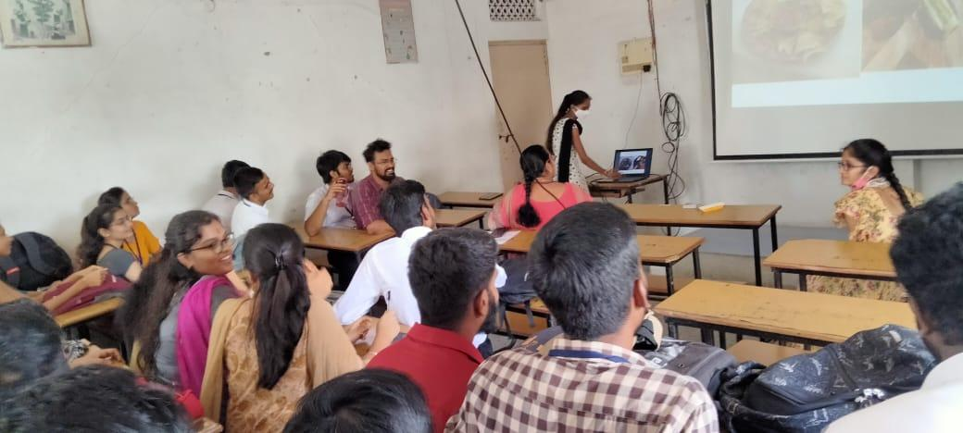
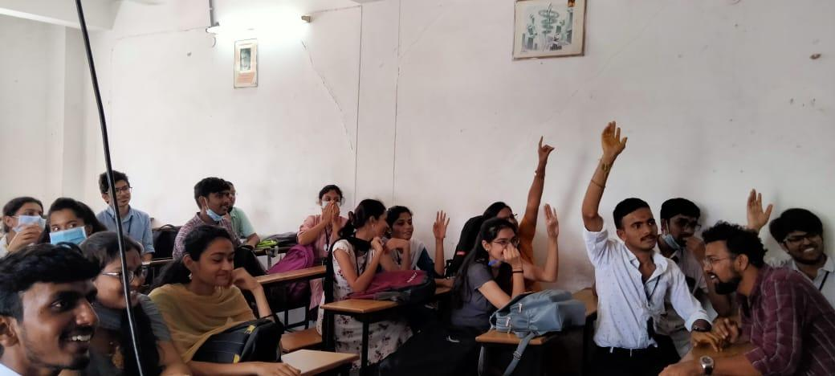
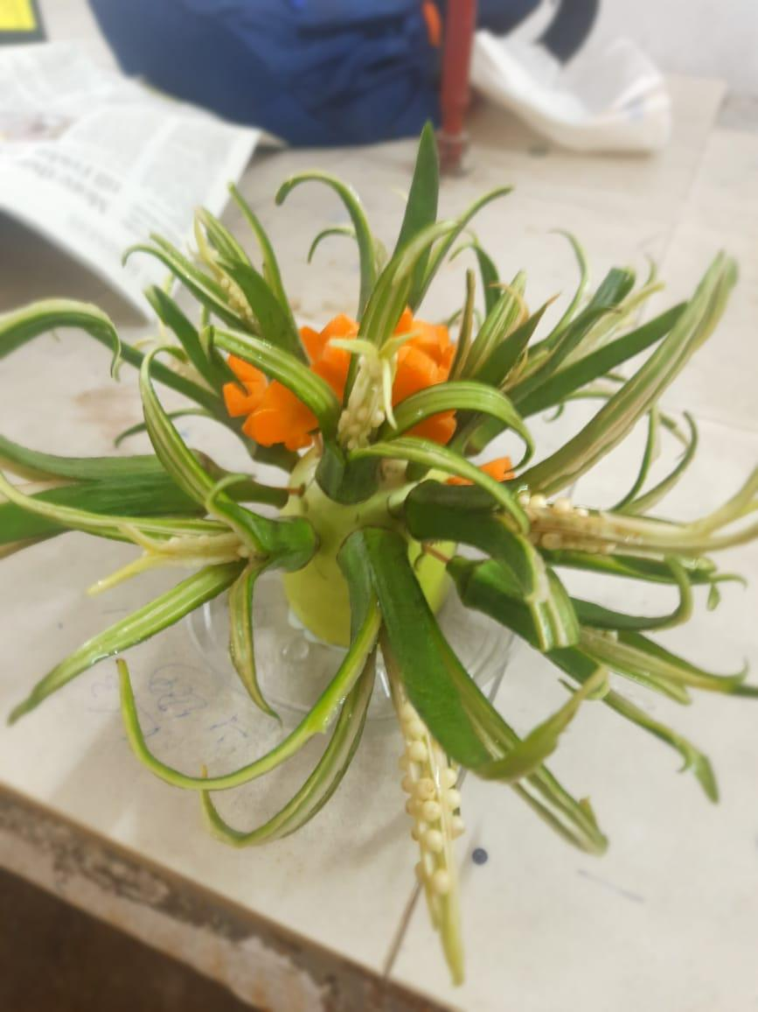
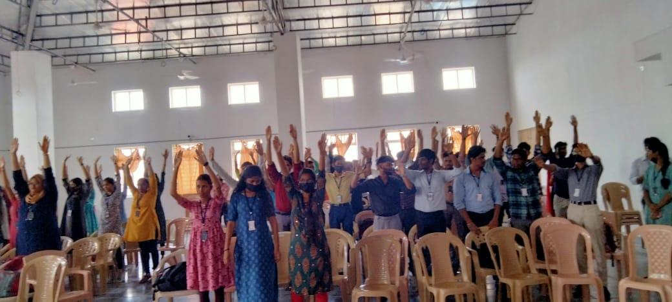

GUEST PROFILE (IF ANY): Nil

FEED BACK IF ANY: Nil

ATTACHMENTS:
EVENT/ACTIVITY PROPOSAL:
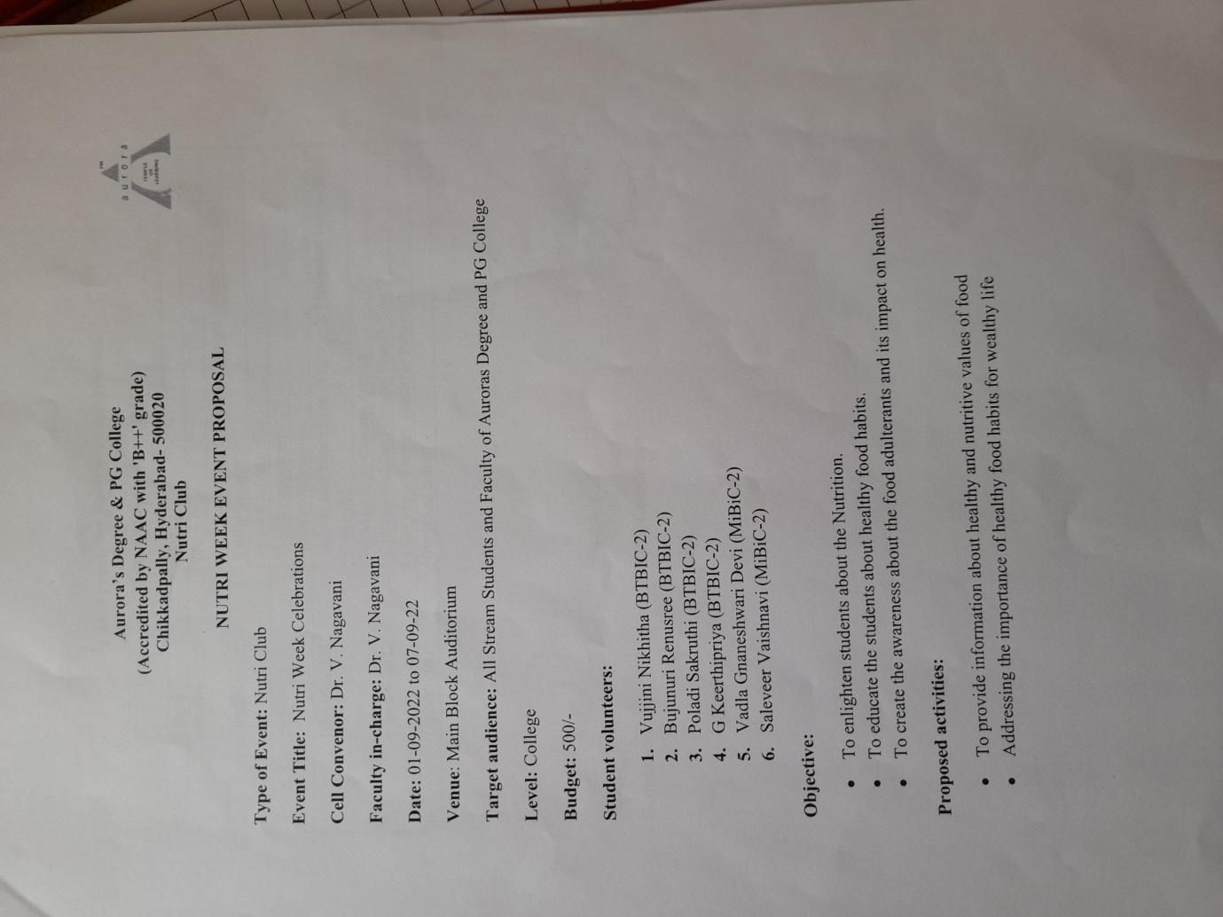

RECEIPTS (IF ANY):
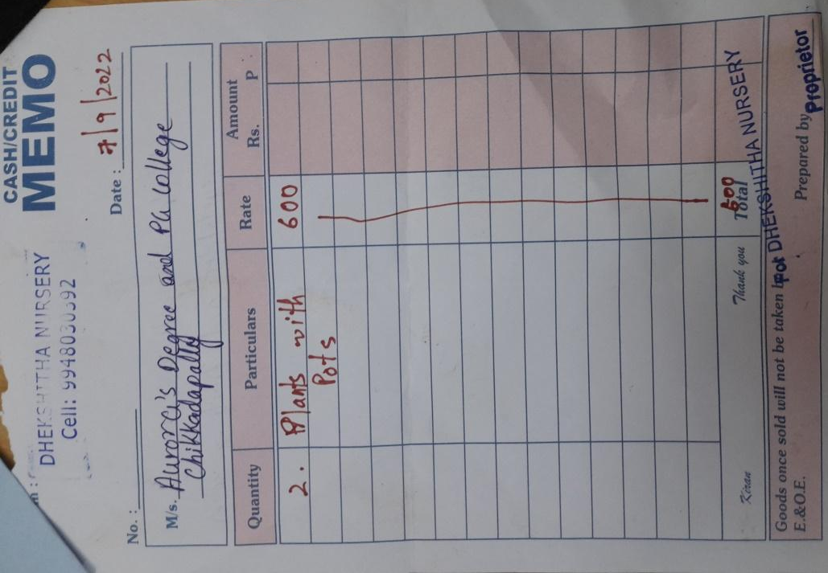

CERTIFICATES (IF ANY):
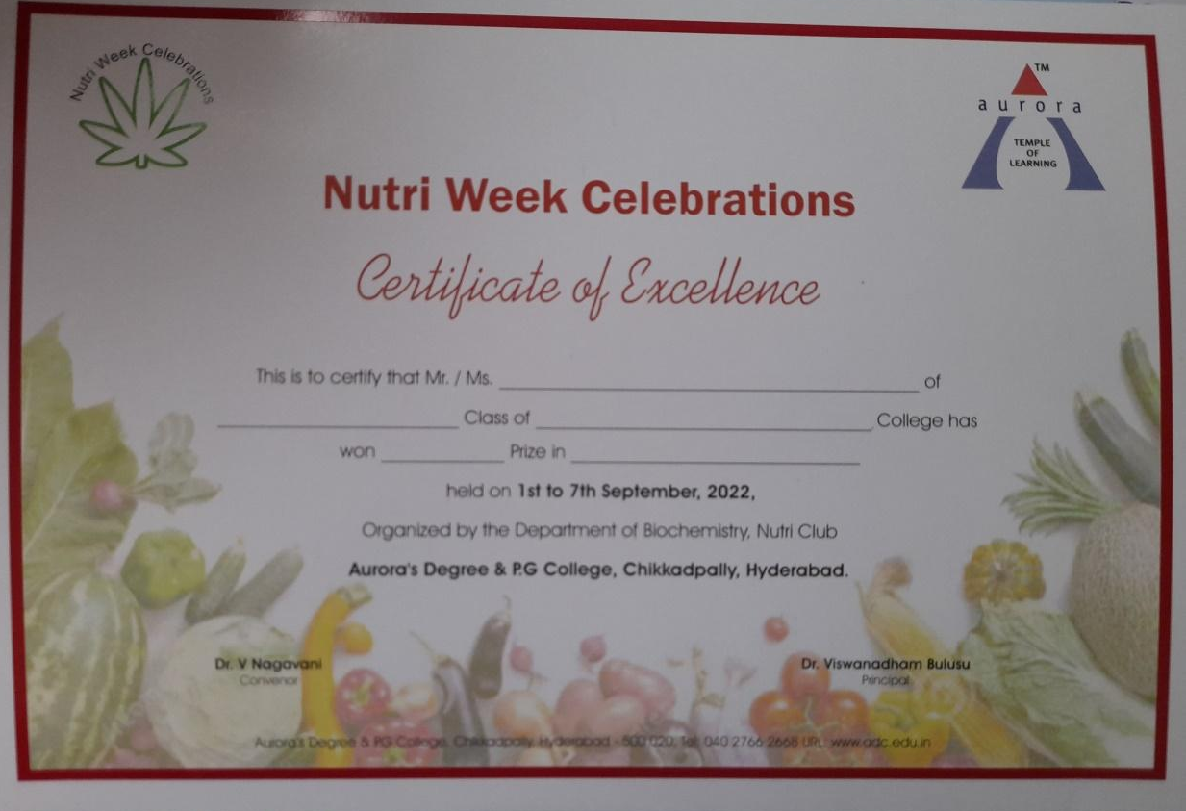

LETTERS OF COMMUNICATION (IF ANY): NIL

