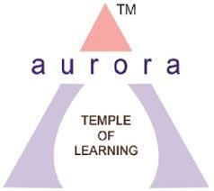
Aurora’s Degree and PG College
(Accredited by NAAC with B++ grade)
Genome Club
EVENT DETAILED REPORT

EVENT TITLE | Science Expo
TYPE OF EVENT | College Event
CONVENER | Mrs. Padma M
DATE | 29th & 30th August 2022
VENUE | Main Block
TARGET AUDIENCE | Intermediate Students

PROGRAM SCHEDULE
Date of the event: 29-08-2022 & 30-08-2022
Time of the event: 09:30 am to 03:30 pm

LIST OF FACULTY COORDINATORS
S.No | Name of the faculty | Department
1 | Mrs M. Padma (HOD) | Microbiology
2 | Vasudevan R | Microbiology
3 | Mary Manjusha Rani | Microbiology
4 | Dr. Laxminarayan | Microbiology
5 | Rahul G (HOD) | Biotechnology
6 | Dr. Leelamani | Biotechnology
7 | Sunitha G (HOD) | Biochemistry
8 | Veeranki Nagavani | Biochemistry
9 | G.Bindu | Biochemistry
10 | Lavanya | Biochemistry
11 | Romana Begum | Genetics
12 | B. Arthika | Genetics
13 | Srikonda Saikrishna | Chemistry
14 | Dr. Latha | Chemistry
15 | Rani Kethavath | Chemistry
16 | Viritha | Chemistry

LIST OF FACULTY ATTENDED
S.No | Name of the faculty | Department
1 | Dr.Vishwanadham Bulusu | Principal
2 | Mrs M. Padma (HOD) | Microbiology
3 | Vasudevan R | Microbiology
4 | Mary Manjusha Rani | Microbiology
5 | Dr. Laxminarayan | Microbiology
6 | Rahul G (HOD) | Biotechnology
7 | Dr. Leelamani | Biotechnology
8 | Sunitha G (HOD) | Biochemistry
9 | Veeranki Nagavani | Biochemistry
10 | G.Bindu | Biochemistry
11 | KNK Lakshmi Lavanya | Biochemistry
12 | Romana Begum | Genetics
13 | B. Arthika | Genetics
14 | Srikonda Saikrishna | Chemistry
15 | Dr. Latha | Chemistry
16 | Rani Kethavath | Chemistry
17 | Viritha Bezwada | Chemistry

LIST OF STUDENT VOLUNTEERS
S.No. | Name of the student | Roll No | Class & Section
1 | Namita Yadav | 105120459032 | MiGC III
2 | Prerna S Shankpal | 105120459038 | MiGC III
3 | Vagdevi Machiraju | 105120459004 | MiGC III
4 | Charitha Sheri | 105120459019 | MiGC III
5 | Bandari Vaishnavi | 105120459037 | MiGC III
6 | Utkarsha Lonare | 105120459034 | MiGC III
7 | V. Jhansi | 105120488042 | BtBiC III
8 | V. Nikhitha | 105120488041 | BtBiC III
9 | B. Renusree | 105120488016 | BtBiC III
10 | P. Sakruthi | 105120488013 | BtBiC III
11 | M.Niharika | 105120488040 | BtBiC III
12 | S. Srividhya | 105120488039 | BtBiC III
13 | V. Sneha | 105120488004 | BtBiC III
14 | N. Akhila | 105120488027 | BtBiC III
15 | G. Bhavika | 105120488006 | BtBiC III | No. of Girls | 26
16 | Shreya Joshi | 105120488019 | BtBiC III
17 | C. Jahnavi | 105121459020 | MiGC II
18 | Y. Akanksha | 105121459006 | MiGC II
19 | P. Kavya | 105121459026 | MiGC II
20 | S. Deekshitha | 105121459025 | MiGC II
21 | T. Keerthi | 105121471011 | MiBiC II
22 | M. Sanjana | 105121459030 | MiGC II
23 | KSN Renu Vaishnavi | 105121459018 | MiGC II
24 | E. Namaami | 105121459010 | MiGC II
25 | M. Roopa Sri | 105121459004 | MiGC II
26 | CH. Deekshitha | 105121459016 | MiGC II
27 | Arun Kumar | 105120459011 | MiGC III
28 | Vadla Kaushal | 105120459012 | MiGC III
29 | Umakanth Reddy | 105120459025 | MiGC III
30 | G.Arjun | 105120459027 | MiGC III | No. of Boys | 10
31 | Manjunath | 105120459014 | MiGC III
32 | S.Shreyas | 105120471004 | MiBiC III
33 | Vinayak | 105120488045 | BtBiC III
34 | M.Sharath | 105120488029 | BtBiC III
35 | Abhishek | 105120488035 | BtBiC III
36 | Surya | 105120488031 | BtBiC III

LIST OF THE PARTICIPANTS
S.No. | Name of the student | Name of the college | Course
1 | B.Lakshmi Sai Deepika | Little flower junior college | BiPC
2 | Allu Keerthana | Little flower junior college | BiPC
3 | Daphne Theresa Reddy | Little flower junior college | BiPC
4 | Sanjana Reddy | Little flower junior college | BiPC
5 | Usha Sri | Little flower junior college | BiPC
6 | K. Supriya | Little flower junior college | BiPC
7 | B.Pallavi | Railway junior college | BiPC
8 | C.Jahnavi | Railway junior college | BiPC
9 | P. Srinidhi | Railway junior college | BiPC
10 | K.Manisha | Raghava Laxmi Devi Gov. junior college | BiPC
11 | K.Sravani | Raghava Laxmi Devi Gov. junior college | BiPC
12 | Lydia | Raghava Laxmi Devi Gov. junior college | BiPC
13 | Muskan | Raghava Laxmi Devi Gov. junior college | BiPC | No. of Girls | 38
14 | Rama Devi | Sri Chaitanya junior college | BiPC
15 | Crissy Sharon | Little flower junior college | BiPC
16 | Vennela Joshi | Little flower junior college | BiPC
17 | Bellam Lahari | SR. Sri Gayatri junior college | BiPC
18 | Snikitha | Little flower junior college | BiPC
19 | Anupriya | New Era junior college | BiPC
20 | Laxmipriya | New Era junior college | BiPC
21 | P.Ramya | New Era junior college | BiPC
22 | Tabassum | New Era junior college | BiPC
23 | Sneha | New Era junior college | BiPC
24 | Geethika | New Era junior college | BiPC
25 | Aanam | New Era junior college | BiPC
26 | G.Akshitha | Raghava Laxmi Devi Gov. junior college | BiPC
27 | B.Lahari | Raghava Laxmi Devi Gov. junior college | BiPC
28 | G.Pranitha | Sri Aakash junior college | BiPC
29 | V.Bhavani | Sri Aakash junior college | BiPC
30 | Himmat Kami | Sri Aakash junior college | BiPC
31 | U.Rameshwari | Sri Aakash junior college | BiPC
32 | K.Roshini | Sri Aakash junior college | BiPC
33 | B.Shivani | Sri Aakash junior college | BiPC
34 | Wajiha Fathima | Sri Aakash junior college | BiPC
35 | Sana Sultana | Sri Aakash junior college | BiPC
36 | Sravani | Sri Aakash junior college | BiPC
37 | R.Shivani | Sri Aakash junior college | BiPC
38 | V.Nandini | Sri Aakash junior college | BiPC
39 | Sai Tarun | Sri Aakash junior college | BiPC
40 | S.Anil Kumar | Sri Aakash junior college | BiPC
41 | S.Naresh | Sri Aakash junior college | BiPC
42 | P.Venkat Sai Trivedh | Raghava Laxmi Devi Gov. junior college | BiPC
43 | N.Shankar | Raghava Laxmi Devi Gov. junior college | BiPC
44 | B.Pavan Kumar | Raghava Laxmi Devi Gov. junior college | BiPC
45 | Vikky | Navya junior college | BiPC
46 | Anas | Navya junior college | BiPC
47 | Bharat | Navya junior college | BiPC
48 | Arun | Navya junior college | BiPC
49 | Ali Hussain | Navya junior college | BiPC
50 | Vishal | Railway junior college | BiPC
51 | D.Tarun | Railway junior college | BiPC
52 | R.Rakesh | Railway junior college | BiPC
53 | P.Siddharth | Railway junior college | BiPC
54 | C.Pranav | Omega junior college | BiPC
55 | P.Prasad | Omega junior college | BiPC
56 | A.Yashwanth | Omega junior college | BiPC
57 | Nikhil | Little flower junior college | BiPC
58 | P.Rethish | Little flower junior college | BiPC | No. of Boys | 40
59 | S.Naresh | Sri Aakash junior college | BiPC
60 | S.Anil Kumar | Sri Aakash junior college | BiPC
61 | M.Sai Tarun | Sri Aakash junior college | BiPC
62 | Harshithchopra | New Era junior college | BiPC
63 | G.Srikar | New Era junior college | BiPC
64 | A.Manish | New Era junior college | BiPC
65 | S.Amaan | New Era junior college | BiPC
66 | Aziz | New Era junior college | BiPC
67 | T.Aditya | New Era junior college | BiPC
68 | Chaithanya | New Era junior college | BiPC
69 | Veera Narasimha | New Era junior college | BiPC
70 | N.Tejas | Little flower junior college | BiPC
71 | Jaychandra | Little flower junior college | BiPC
72 | Saitanay | Little flower junior college | BiPC
73 | Kevin | Little flower junior college | BiPC
74 | Noel | Little flower junior college | BiPC
75 | Sathvik | Little flower junior college | BiPC
76 | Pruthvi Raj | Little flower junior college | BiPC
77 | Jerripothula Srikar | Omega junior college | BiPC
78 | Midthapalli Mahesh | Omega junior college | BiPC

OBJECTIVE:
To create interest in students and to make Science learning joyful. To provide good media for the Science students for trying out theory into practice and to understand the practical application and utility of Science.
BRIEF ABOUT THE EVENT:
The event was scheduled on 29th & 30th August 2022 to develop Scientific attitude and critical thinking among students and facilitate the students to update their knowledge in Science.
OUTCOME:
Helped students to develop the knowledge on:
- Bacterial Identification 11. Catalase Test
- Culturing of Microorganisms 12. Screening for Bacterial Enzymes
- Blood Typing 13. Karyotyping
- Cell Division 14. Dosage Compensation
- DNA Isolation 15. Fermenter Model.
- Wine Production 16. Estimation of Hemoglobin
- Osmosis 17. Ninhydrin Test
- Molisch Test 18. Detecting Food Adulteration
- Titrations 19. Osazone Test
- Brown Ring Test 20. Flame Test
INCOME & EXPENDITURE: Nil

EVENT PHOTOS:
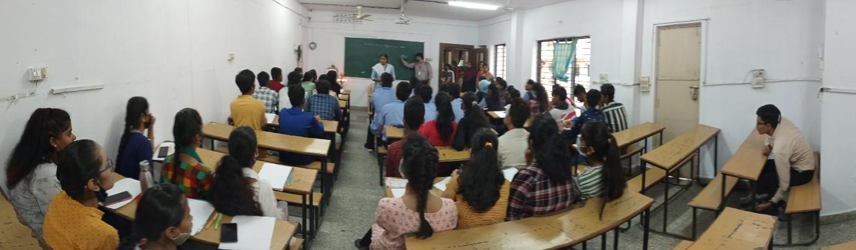

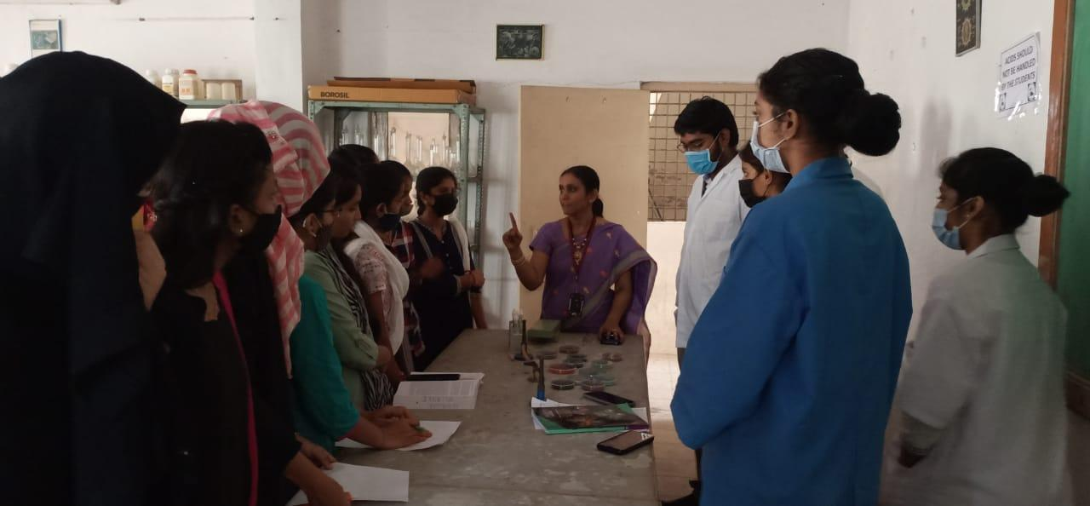

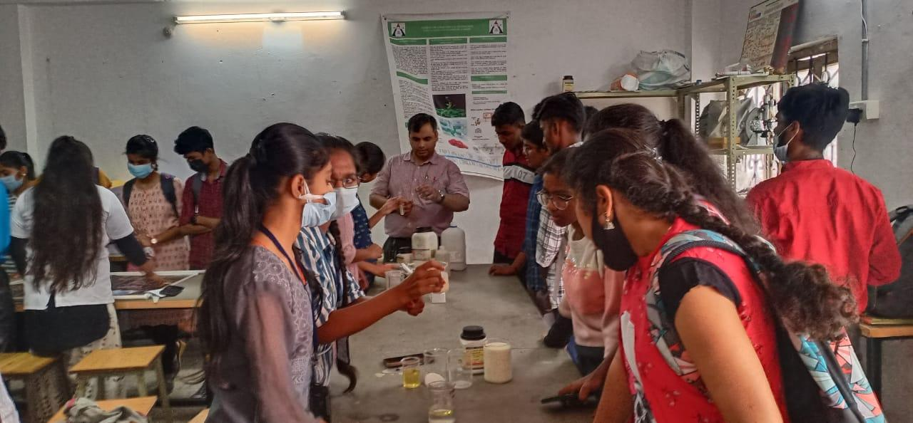

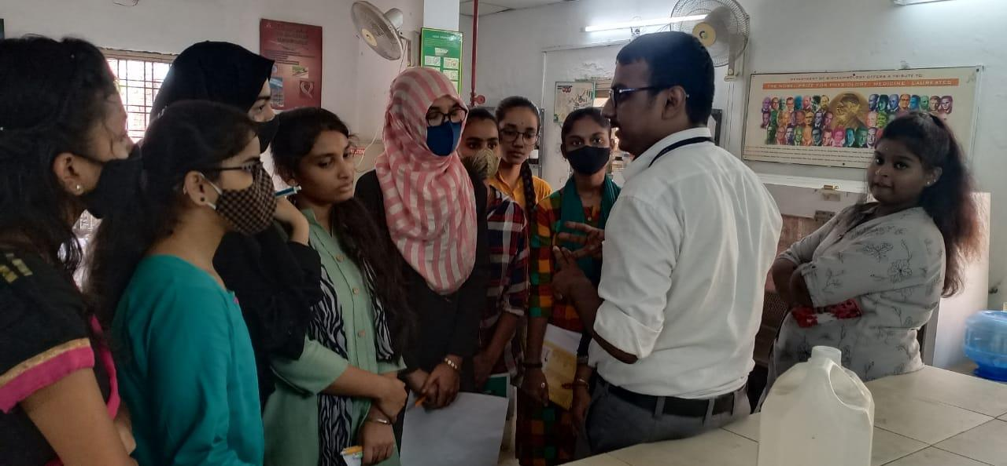
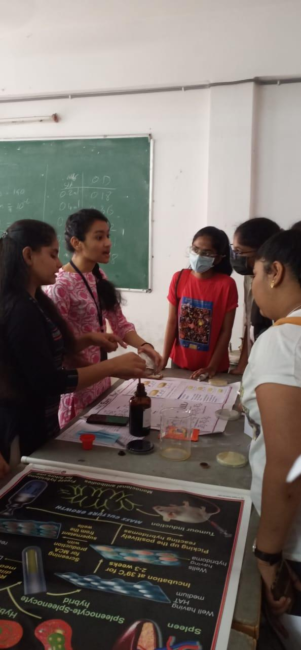

EVENT SCROLL:
