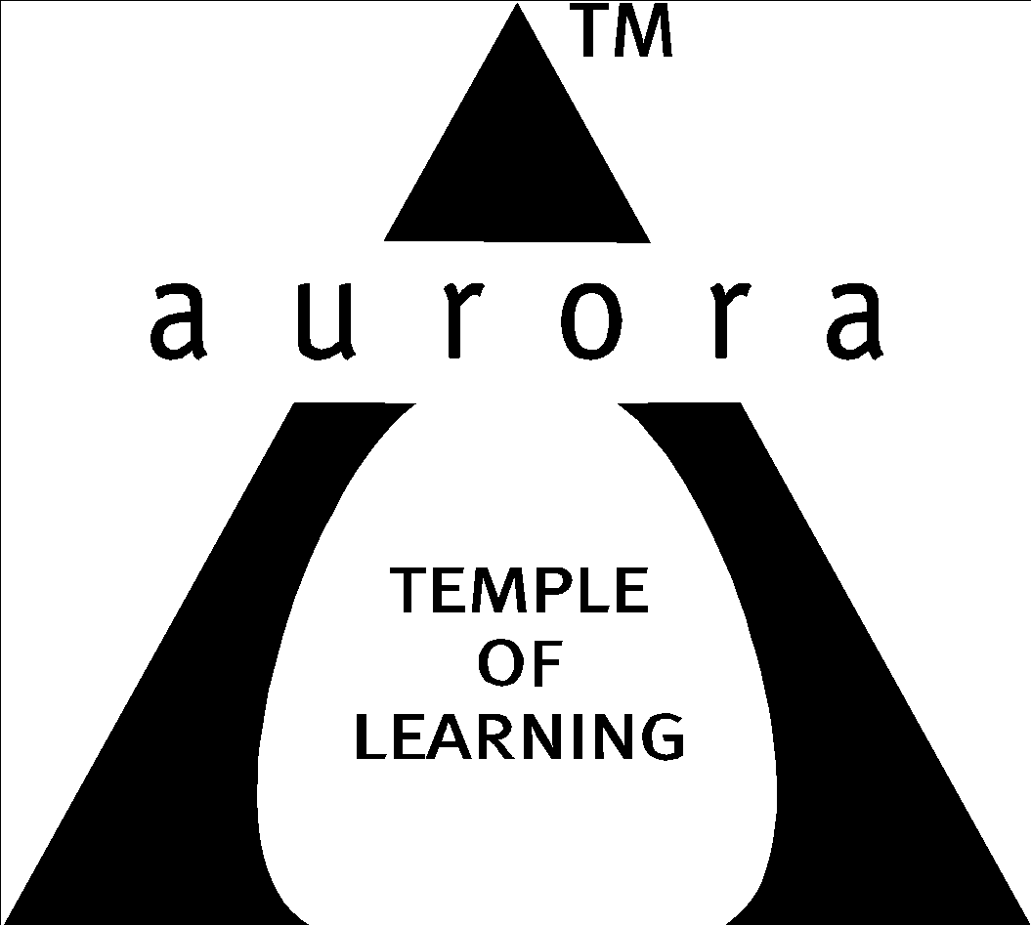

Aurora’s Degree & PG College
(ACCREDITED BY NAAC WITH 'B++' GRADE)
Chikkadpally, Hyderabad 500020

EVENT / ACTIVITY DETAILED REPORT

NAME OF THE EVENT / ACTIVITY | National Statistics Day
TYPE OR TITLE OF EVENT / ACTIVITY | Applications of Statistics
FACULTY INCHARGE | Y Aruna Rekha
DEPARTMENT/CELL/COMMITTEE/CLUB | Statistics
DATE | 29-6-2022
VENUE | Aurora’s Degree and PG College
TARGET AUDIENCE | PG (Statistics & Applied Statistics ) Students

- PROGRAM SCHEDULE:
The event scheduled on 29th June 2022, Wednesday at 1:00 p.m .
The following is the schedule.
- Inaugural address by Y Aruna Rekha.
- PowerPoint Presentation by the students.
- Quiz Competition on Applications of Statistics.
- Image Recognition.

- LIST OF FACULTY COORDINATORS (DEPARTMENT): Y Aruna Rekha (Statistics)

- LIST OF THE STUDENT COORDINATORS (NAME , ROLL NO, CLASS & SECTION)
Name: Ruchitha (PG Statistics)
Roll No: 1051-20-507-008
Class: MSc Statistics second year

- LIST OF THE PARTICIPANTS
The participant students:
- MSC(Statistics & Applied Statistics 1st years)
- MSC(Statistics & Applied Statistics 2nd years)
Msc(statistics)-1st year

S.No | Roll No. | Name
1 | 1051-21-507-001 | Gundumala Meghana
2 | 1051-21-507-002 | Rompicharla Sai Vandana
3 | 1051-21-507-005 | Burra Mounika
4 | 1051-21-507-006 | Pasula Harika
5 | 1051-21-507-007 | Gannapuram Rajini
6 | 1051-21-507-008 | Putta Sai Priya
7 | 1051-21-507-010 | Goure Sravya
8 | 1051-21-507-011 | A Aruna
9 | 1051-21-507-012 | Manpoor Sai Priya
10 | 1051-21-507-013 | Kommula Sushanthika
11 | 1051-21-507-014 | Myakala Srilaxmi
12 | 1051-21-507-015 | Gopishetty Shripadh
13 | 1051-21-507-016 | Bhoompag Victor Jayanth
14 | 1051-21-507-017 | Arruri Vamshi Prasad
15 | 1051-21-507-019 | Devi Kavya
16 | 1051-21-507-020 | Ailaboina Srikanya
17 | 1051-21-507-021 | Pasaladi Vinay Kumar
18 | 1051-21-507-027 | Ramanakolu Sushmitha
19 | 1051-21-507-028 | Batkala Shaila Sri

MSc (Applied Statistics) -1st year

S.No | Roll No. | Name
1 | 1051-21-508-001 | Shaista Fatima
2 | 1051-21-508-002 | J Lakshmi Sai Gayathri
3 | 1051-21-508-003 | Arra Keerthana
4 | 1051-21-508-005 | Ayesha Siddiqua
5 | 1051-21-508-006 | Marella Niharika
6 | 1051-21-508-009 | B Bhargavi
7 | 1051-21-508-011 | Kyama Likitha
8 | 1051-21-508-013 | M Vijay Bhaskar
9 | 1051-21-508-014 | Dhanturi Shirisha
10 | 1051-21-508-017 | V Naveena
11 | 1051-21-508-018 | N Vandana
12 | 1051-21-508-019 | Annavajjala Sarali
13 | 1051-21-508-021 | Govindu Sushmitha
14 | 1051-21-508-027 | Simran Kumari
15 | 1051-21-508-028 | Indukuri Laxmi Mounika
16 | 1051-21-508-029 | Kodiganti Suresh
17 | 1051-21-508-030 | Banuri Shirisha
18 | 1051-21-508-034 | Afreen Sulthana
19 | 1051-21-508-035 | S Sampath Kumar
20 | 1051-21-508-039 | Vempati Anusha
21 | 1051-21-508-040 | Panchamurthi Pravalika
22 | 1051-21-508-041 | D Karthik Kumar Reddy

M.Sc(Statistics)-2nd year
S.No | Roll No. | Name
1 | 1051-20-507-001 | Mankala Vaishnavi
2 | 1051-20-507-004 | Musunuri Naga Phani
3 | 1051-20-507-006 | R Sindhu
4 | 1051-20-507-007 | Madella Anusha
5 | 1051-20-507-008 | Vollala Ruchitha
6 | 1051-20-507-014 | Ramadugu Sai Bhavani
7 | 1051-20-507-015 | Mohammad Nelofar
8 | 1051-20-507-016 | J. Vijayalaxmi
9 | 1051-20-507-017 | Mudigiri Akshaya
10 | 1051-20-507-022 | Y Saileela
11 | 1051-20-507-023 | Madagani Maheswari
12 | 1051-20-507-024 | Patlolla Laxmi Nikhitha
13 | 1051-20-507-027 | Pusa Hemanth
14 | 1051-20-507-028 | Gundelli Sravanthi
15 | 1051-20-507-036 | Gone Sharanya
16 | 1051-20-507-038 | Yellannagari Akshitha
17 | 1051-20-507-039 | Arkatala Srinidhi
18 | 1051-20-507-040 | Sattenapalli Sai Kiran

MSc (Applied Statistics) -2nd year

S.No | Roll No. | Name
1 | 1051-20-508-001 | Dupakuntla Sri Laxmi
2 | 1051-20-508-004 | Salveru Manasa
3 | 1051-20-508-005 | Tammanaboina Navya
4 | 1051-20-508-006 | K Chandrika Bai
5 | 1051-20-508-007 | Reddigari Shriha
6 | 1051-20-508-008 | R Pavithra
7 | 1051-20-508-013 | Indukuri Lavanya Lahari
8 | 1051-20-508-014 | Kukatla Ajay Kumar
9 | 1051-20-508-017 | Nallapati Anitha
10 | 1051-20-508-022 | Edla Prathyusha
11 | 1051-20-508-023 | Adupa Veena
12 | 1051-20-508-030 | Byagari Akhila
13 | 1051-20-508-032 | Sadhu Priyanka
14 | 1051-20-508-034 | Kethavath Sai Kumar
15 | 1051-20-508-037 | Kayithi Chandana

- PARAGRAPH ABOUT THE PROCEEDINGS (TILL THE END OF THE EVENT):
The event was organized on 29-06-2022 for Students. This session was started with the introductory speech by J. Vinita, Senior Assistant Professor (HOD), Department of Statistics. She gave a brief applications on the importance of statistics in the MNC companies. Post that, PG Statistics second year student Ruchitha briefed students and faculty about the achievements and importance of Prof. P.C. Mahalanobis.
A.Srinidhi of M.Sc Statistics 2 nd yr gave a PowerPoint Presentation on applications of statistics in various domains. K.Sai Kumar of M.Sc Applied Statistics 2nd yr gave a PowerPoint Presentation on the theme of National Statistics Day i.e., “Data for Sustainable Development.” He gave a brief idea about the 17 sustainable development goals like NO POVERTY, ZERO HUNGER, QUALITY EDUCATION, GENDER EQUALITY etc.,
Mr.Sanjay UG External Examiner shared his ideas on applications of statistics in industry. K.Parimala Diana Sudhir Associate Professor shared her thoughts on alumni involvement in projects. After the talk Quiz Competition was conducted to the students. Questions were displayed on the screen. Students answered the questions on papers individually. Student Coordinator collected the answer scripts and N. Sai Kishore Assistant Professor evaluated the papers and given marks to the students. Later Image Recognition on Statisticians was conducted. Students participated with very enthusiastically and identified the images of statisticians. Student coordinator Ruchitha gave vote of thanks. With this we completed the Prof.P.C.Mahalanobis Celebrations.

- INCOME AND EXPENDITURE: NIL
- EVENT PHOTOS ( MIN 2 MAX 4):
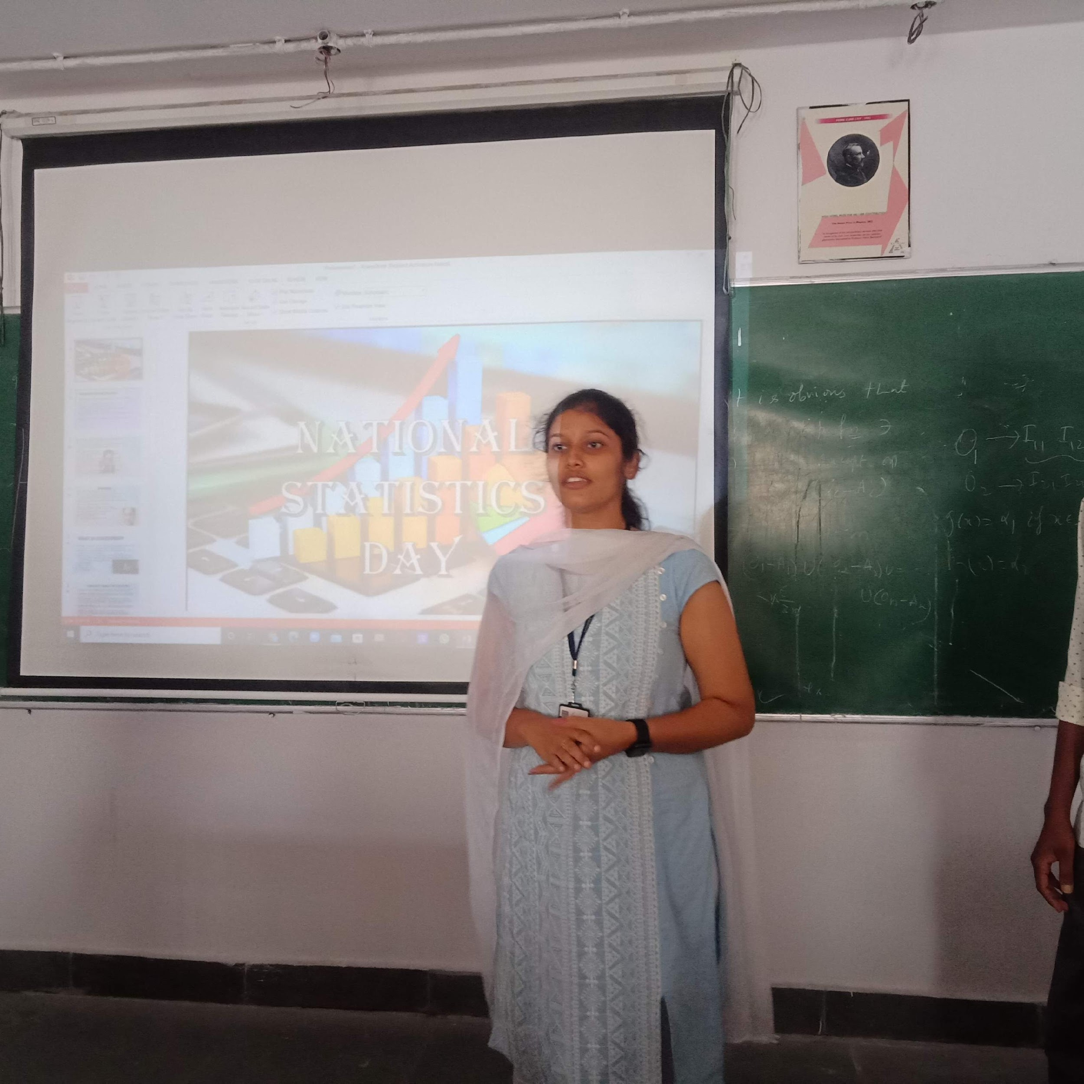

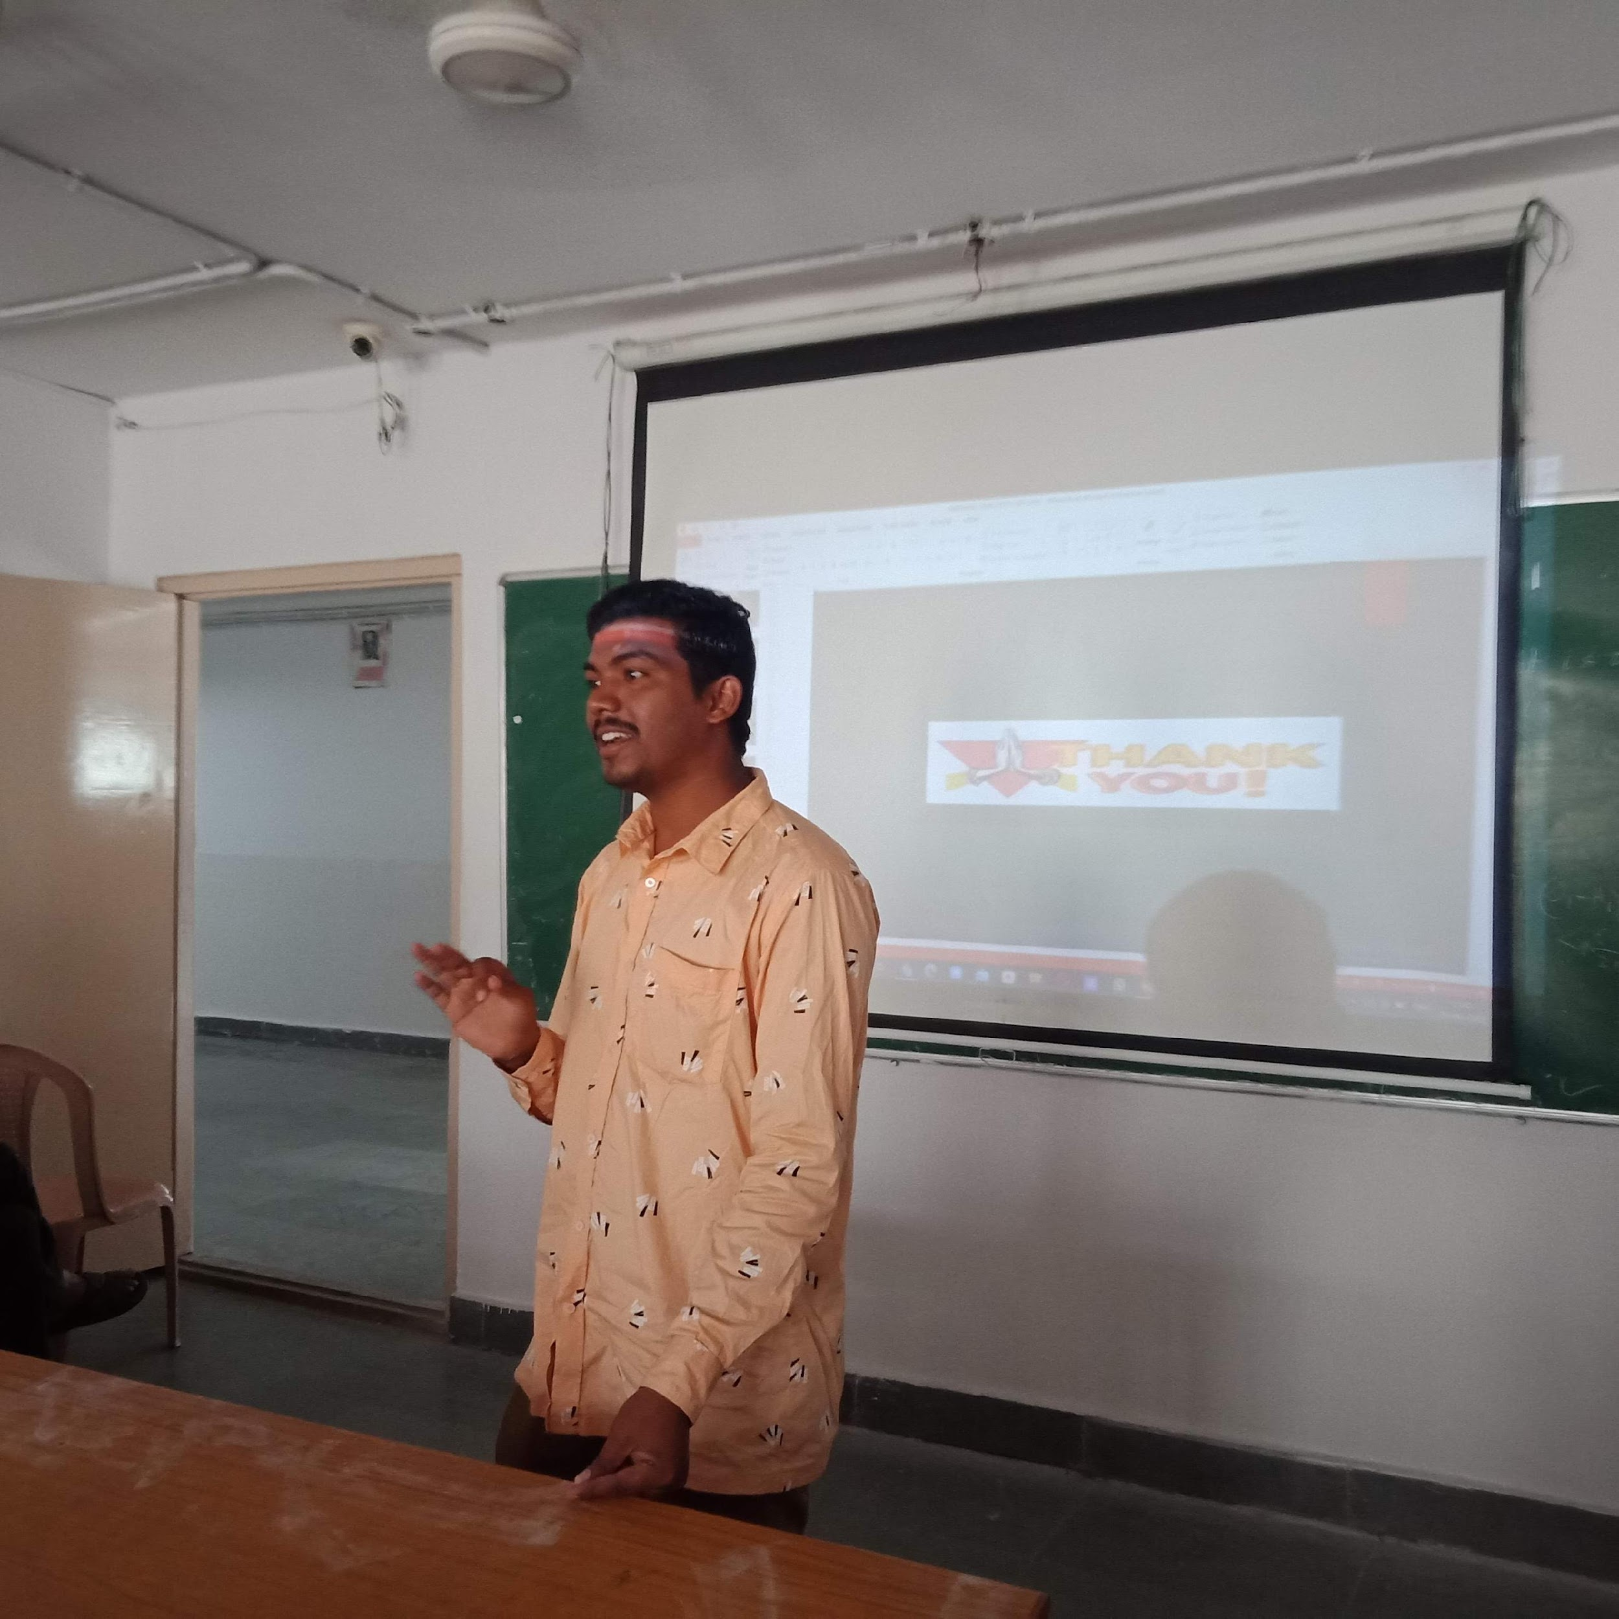

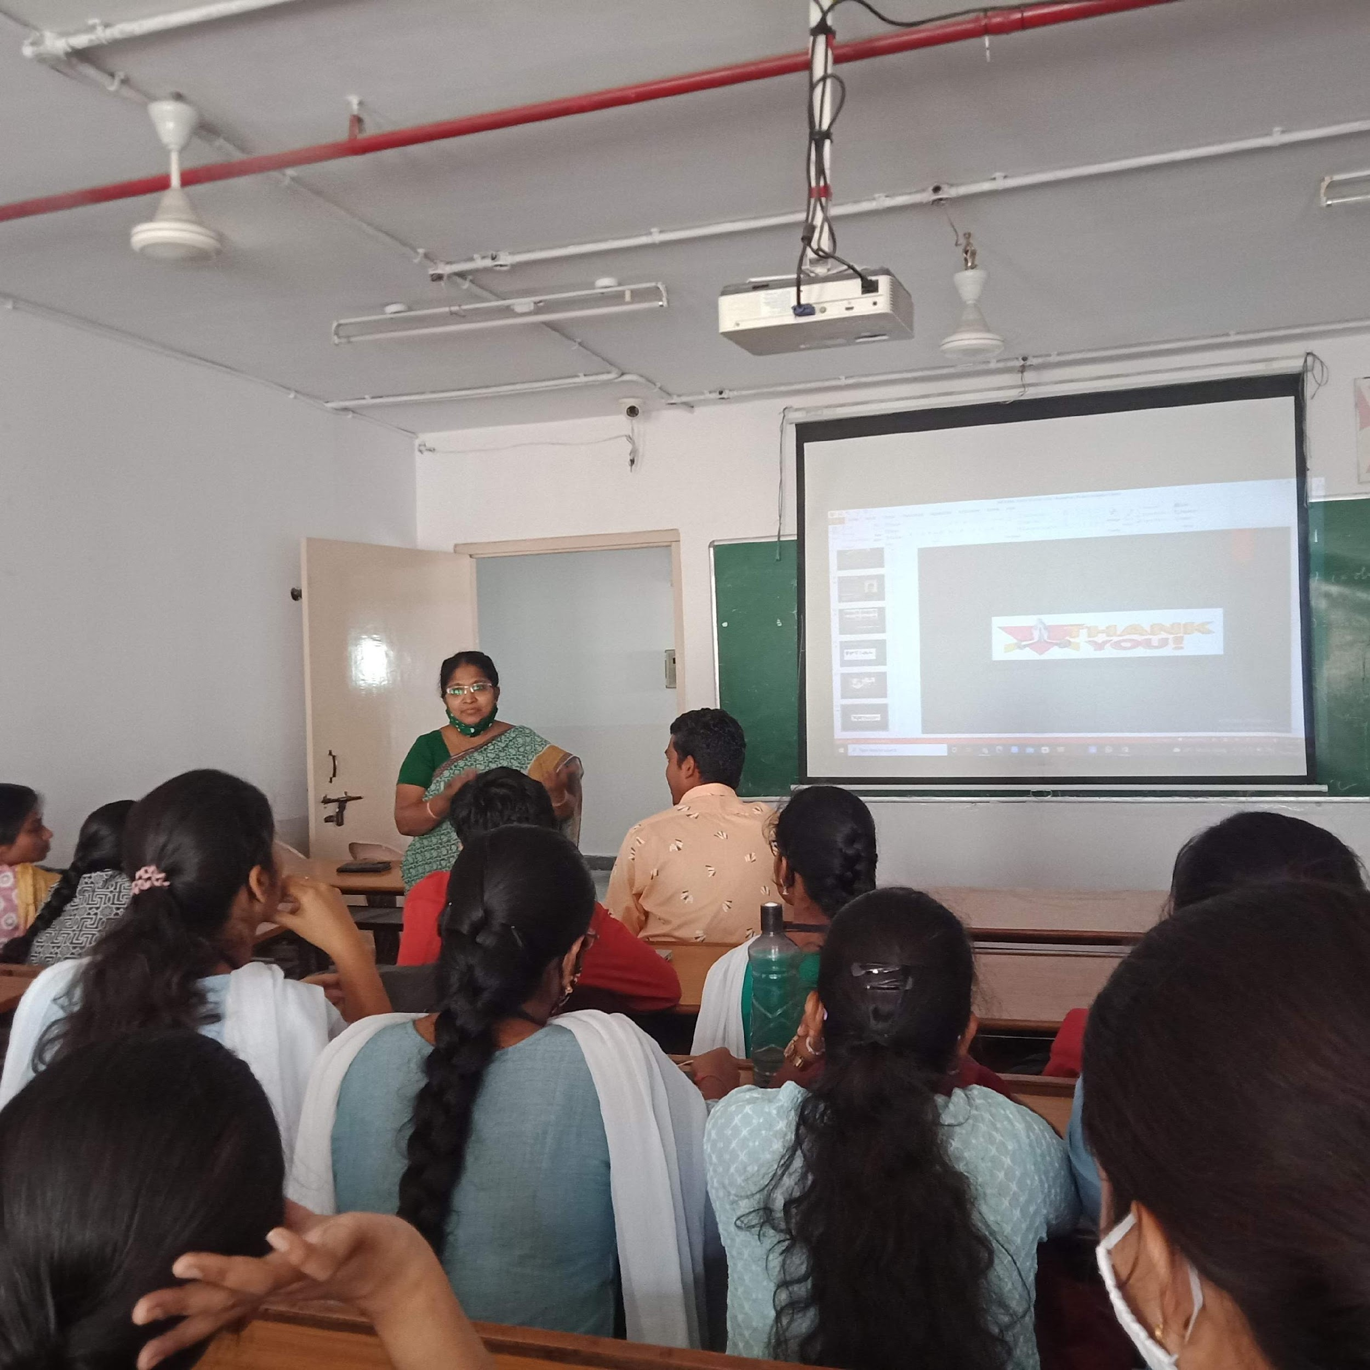

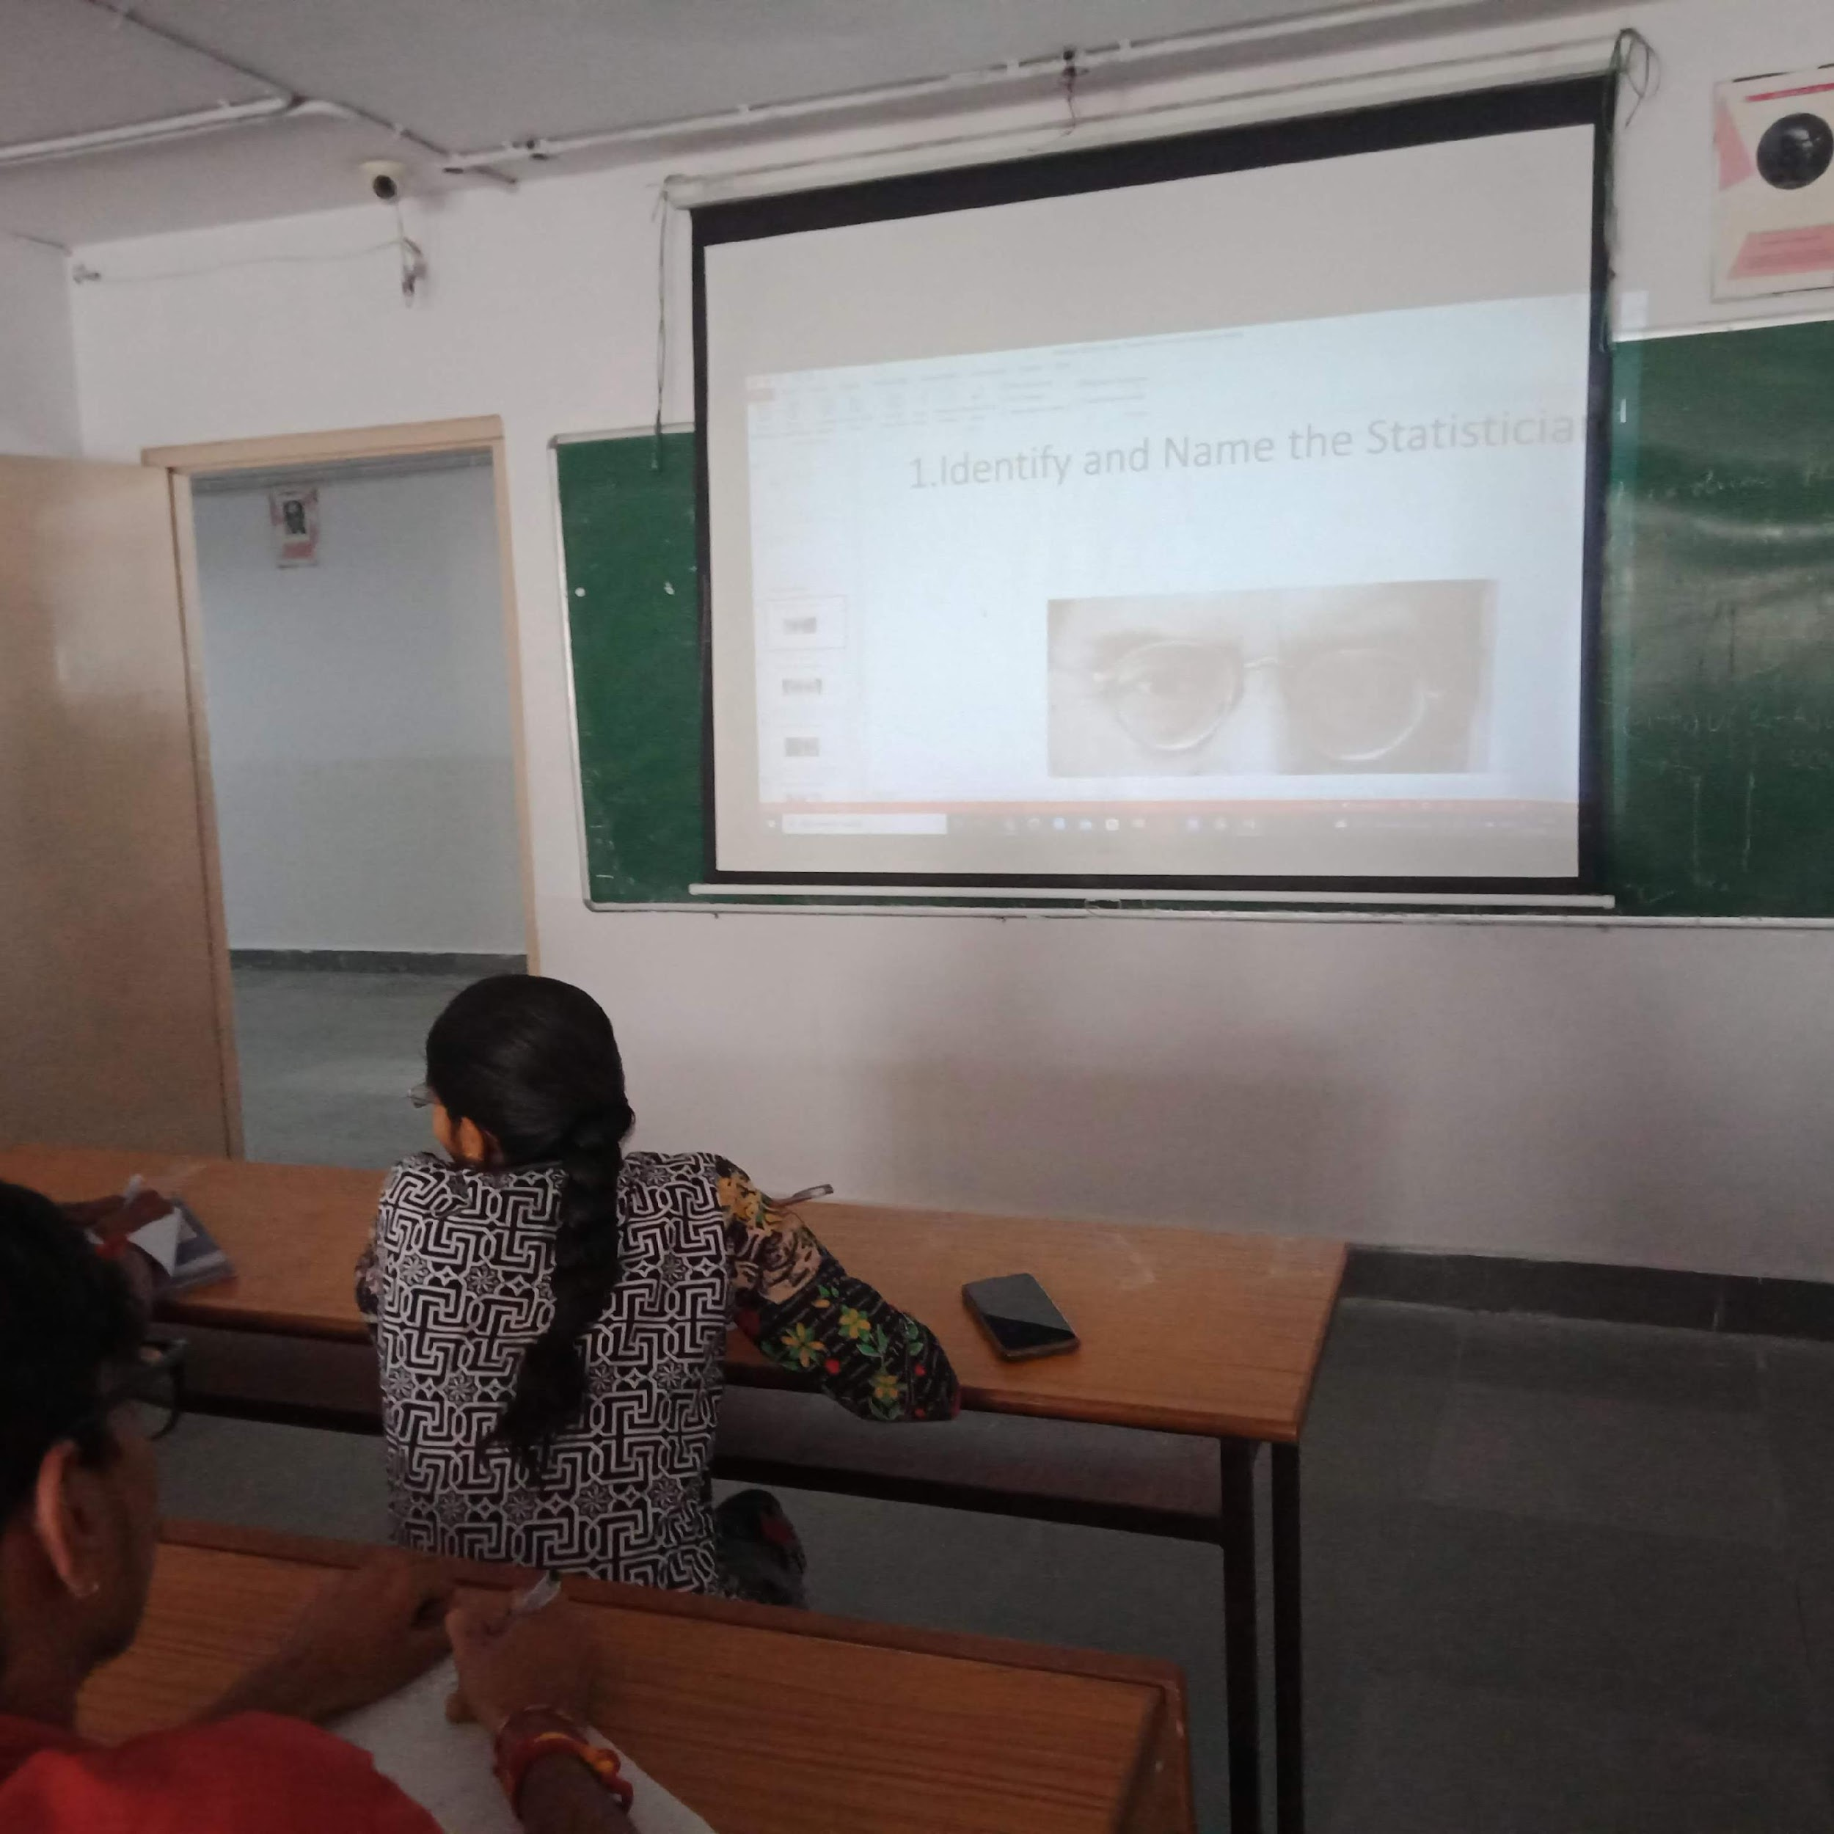
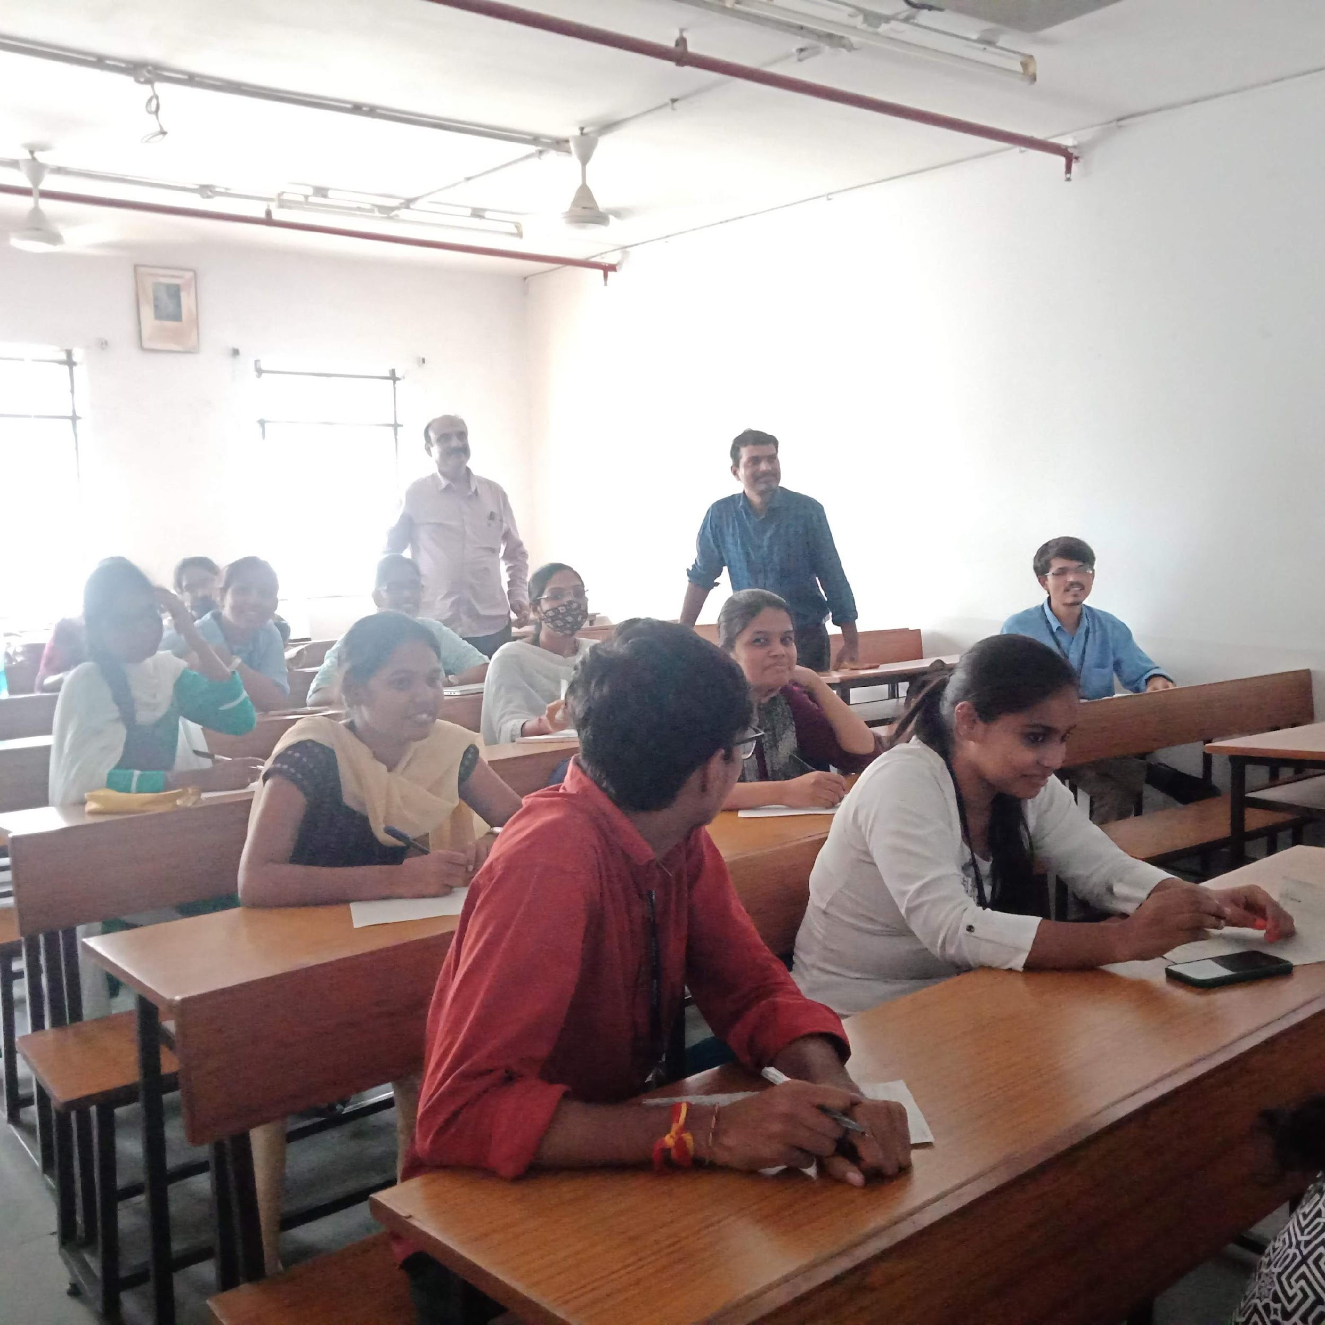
- GUEST PROFILE (IF ANY): NIL
- FEED BACK IF ANY: NIL
- ATTACHMENTS:
EVENT/ACTIVITY PROPOSAL
EVENT PROPOSAL
for

National Statistics day Celebrations

Event/Activity Name: National Statistics Day
Event/Activity Title: Prof. P C Mahalanobis Birthday
Cell / Committee/Club Convener/facilitator: Nil
Faculty coordinator: Y. Aruna Rekha
Date: 29-06-2022
Venue: Aurora’s Degree and PG College
Target audience: PG(Applied Statistics & Statistics) Sem-II & Sem-IV Students
Platform: Offline
Level: College
Student Volunteer’s: Ruchitha and O.Priyanka
Proposed activities: 1.Quiz on Applications of Statistics
2.Image Recogization
Budget: Nil

Coordinator Principal
(Y.Aruna Rekha) Dr. Viswanadham Bulusu

EVENT / ACTIVITY NOTICE

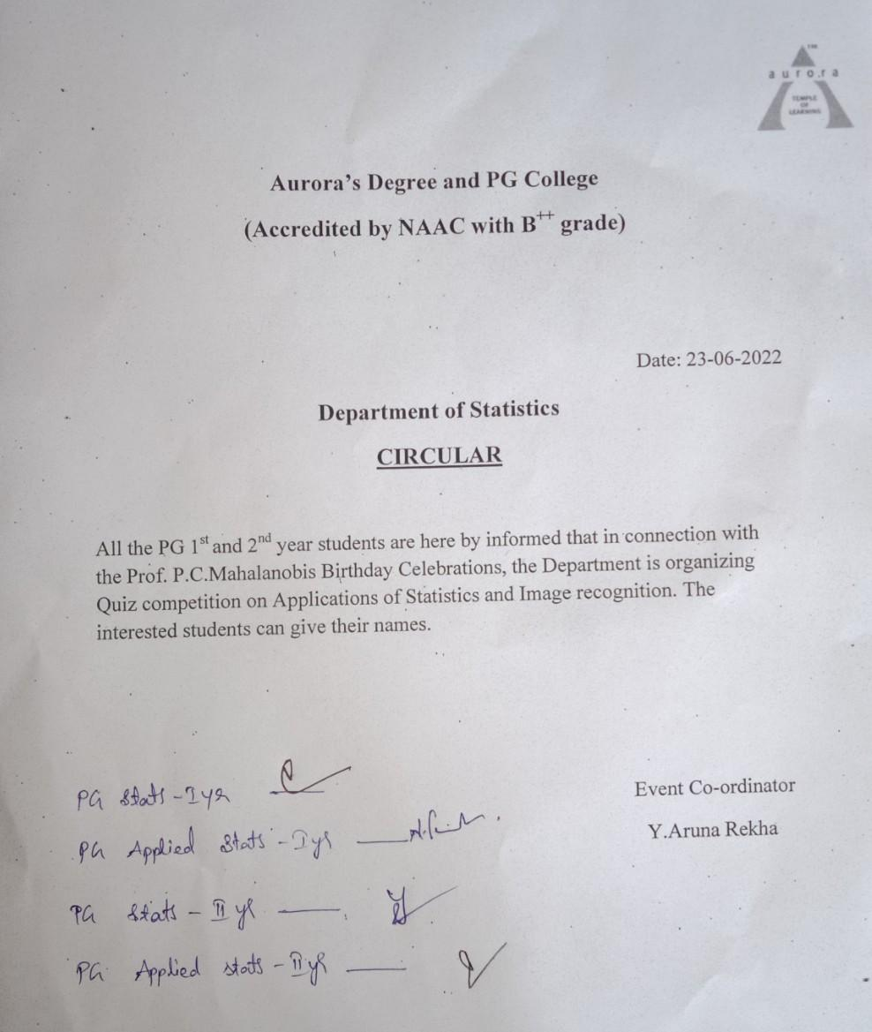

RECEIPTS (IF ANY): NIL
CERTIFICATES (IF ANY): NIL
LETTERS OF COMMUNICATION (IF ANY): NIL

