Aurora’s Degree and PG College 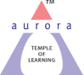
(ACCREDITED BY NAAC WITH ‘B++’ GRADE)
Chikkadpally, Hyderabad 500020
CLASS EVENT PROPOSAL
For

Premchand Jayanthi
Event/Activity Name: Premchand Jayanthi
Faculty coordinators: , R.Heena Dr. Shivhar Biradar,
Date 31 st July 2021.
Venue: Aurora’s Degree PG College
Target audience: UG Students
Platform: Online- Microsoft TEAMS
Level: Class Room Level
Student Volunteer’s: 1. Pankaj Sahani - 1051-20-401-019 (B. Com Generals 1‘A’)
Objective: The main aim of the event is to create awareness among the students about the Hindi Language.
Budget: Nil

Co - ordinator Dr.Padmaja
R.Heena H O D

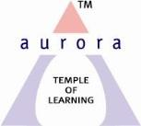

Aurora’s Degree & P.G College
(Accredited by NAAC with ‘B++’ grade)
Chikkadpally, Hyderabad 500020

NAME OF THE EVENT | Premchand Jayanthi
FACULTY INCHARGE | Dr. Shivhar Biradar  R.Heena
DEPARTMENT | Languages
DATE | 31 July 2021
VENUE | Aurora’s Degree & PG College
TARGET AUDIENCE | Hindi Students

Objective: The main aim of the event is to create awareness among the Students about the Hindi
Language
Brief about the event Premchand Jayanthi was celebrated on 31 July 2021 Aurora’s Degree & PG College. The event commenced with the introduction of the participants in the Online Microsoft Teams with the convener of the event Dr.Shivhar Biradar from Department of Languages .He has given an introduction speech about Premchand Jayanthi . Students have participated and have shared their views on Premchand Jayanthi. Student coordinators are Aayush Chabra B.Com 2C,Pankaj Kumar Sahani – B.Com Gen- 1A.
Outcome: Students got to know about Hindi Language importance through this event. According to Students view, conducting such events will give them awareness about the opportunities to showcase their talent which motivates.Depending upon the topics the situations and importance with respect to the writer premchand is known, understood and learnt.

PHOTOGRAPH:
EVENT PHOTOS ( MIN 2 MAX 4)

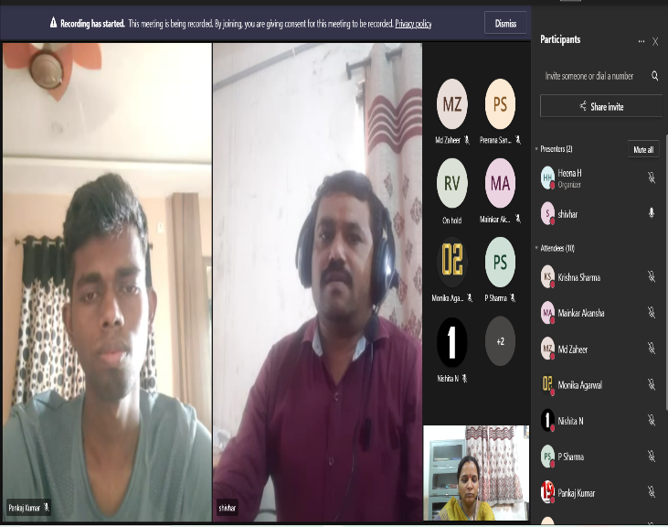
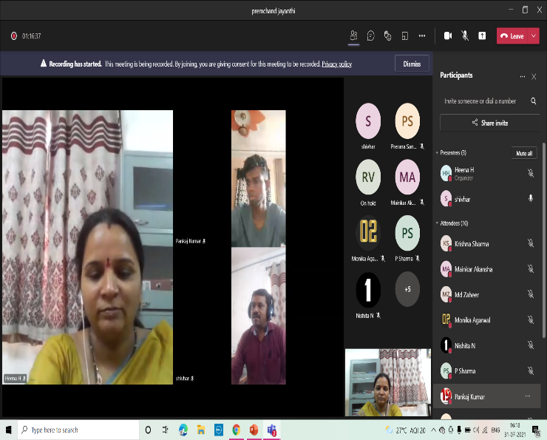

Aurora’s Degree & PG College
(ACCREDITED BY NAAC ‘B++’ GRADE)
Chikkadpally, Hyderabad 500020
EVENT / ACTIVITY DETAILED REPORT
NAME OF THE EVENT | Premchand Jayanthi
TYPE OF EVENT | Class Event
FACULTY INCHARGE | Dr. Shivhar Biradar  R.Heena
DEPARTMENT | Languages
DATE | 31st July 2021
VENUE | Online Through Microsoft Teams
TARGET AUDIENCE | B.COM -1 A & BBA -1 A

- PROGRAM SCHEDULE
31st July 2021
- The program has started at 3.00 p.m
At 3.10 p.m R.Heena has started the event
- At ’ 4.15 p.m the program has ended.
- At 4.20 p.m photo session has started
- At 4.25p.m vote of thanks by Dr. Shivhar Biradar

LIST OF FACULTY COORDINATORS (DEPARTMENT)
Dr. Shivhar Biradar , (Associate Professor – Department of Languages)
R.Heena (Assistant Professor – Department of Languages)

- LIST OF THE STUDENT COORDINATORS (NAME , ROLL NO, CLASS & SECTION)

Pankaj Kumar Sahani B. Com General 1st year Roll no. 1051-20-401-019

- LIST OF THE PARTICIPANTS (NAME , ROLL NO, CLASS & SECTION, NO OF GIRLS, BOYS, CASTE )
STUDENTS ATTENDED
BOYS:
1.1051-20-401-019 | Pankaj Kumar sahani | Bcom(general) 1,A
2. 1051-19-468-150 | P bhaskar sharma | Mpcs2c
3. 1051-19-488-065 | Adnan Karani | Btbic 2b
- 4. 1051-20-684-021 | Shaik Amaanahmed | BBA 1A
5. 1051-20-684-027 | Krishna Sharma | BBA1A
- 6. 1051-20-684-029 | Prateek Saini | BBA 1 A
- 7. 1051-20-684-028 | Vansh agarwal | BBA1A
8. 1051-20-684-047 | Prashant N Ghanshyani | BBA1A
9. 1051-20-684-081 | VIJAY BHOLENATHGUPTHA | BBA1B
GIRLS
10. 1051-19-459-055 | K Priyanjali | Migc 2b
11. 1051-19-459-058 | Sanyukta Singh Rawat | MIGC 2B
12. 1051-19-459-059 | KAINAAT KHOJA | Migc 2B
13. 1051-19-459-063 | Dinky patel | Migc 2b
14. 1051-19-467-153 | Swathi kumari | Mscs-2D
15. 1051-19-467-155 | K. Raga Srinidhi | MSCS - 2D
16. 1051-19-488-056 | B.Hruthvika | Btbic2b
17. 1051-20-459-038 | Prerana Sanjay Shankpal | MiGC-1A
18. 1051-20-467-112 | Salve pragnya | Mscs1B
19. 1051-20-488-018 | Kripali Makhecha | Btbic
20. 1051-20-684-005 | Pooja Goyal | BBA 1A
21. 1051-20-684-006 | Anu jain | BBA 1A
22. 1051-20-684-008 | D. Sree nija | BBA 1 A
23. 1051-20-684-010 | SHIVANI KHONDE | BBA 1A
24. 1051-20-684-058 | A. S. Tejaswini | BBA1B
25. 1051-20-684-059 | Radhari Varshitha Yadav | BBA 1 B
26. 1051-20-684-075 | Hemanth badukali | BBA 1B
27. 1051-20-684-124 | AYESHA BIBI | BBA1C
PARAGRAPH ABOUT THE PROCEEDINGS (TILL THE END OF THE EVENT)

DETAILED REPORT: Event started at 3.15 p.m, students from our college joined through Microsoft Teams. The program started with introduction. Introduction was given by Dr. Shivhar Biradar. After introduction. R.Heena explain about Premchand Jayanthi with the PPT Presentation on the screen. After that one of the first year Student Pankaj explain the story of premchand KAFAN very effectively. Some students put forth their views about Premchand More than 20 participants participated in this online event. Students actively participated in this program conducted by Language department. The event was successful. At the end of the informative session vote of thanks was given by
Dr. Shivhar Biradar and this was followed by a photo session. The event ended around 4.15 p.m.

EVENT LINK- https://drive.google.com/file/d/1BA_5Q9nPqmyJ1sR3ccF2CJFN9YiGcoSi/view?usp=sharing

5.INCOME AND EXPENDITURE
No

6.EVENT PHOTOS ( MIN 2 MAX 4)

Photographs
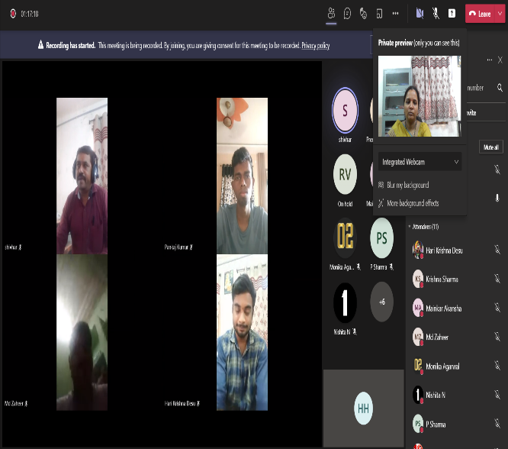 | 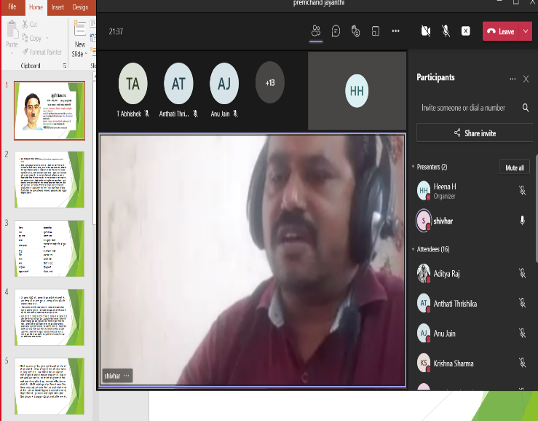

7.GUEST PROFILE (IF ANY)
NO

8.FEED BACK IF ANY
NO

9.ATTACHMENTS:
NO
EVENT/ACTIVITY PROPOSAL
(CLASS -EVENT)

