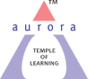
Aurora’s Degree & PG College
(ACCREDITED BY NAAC WITH 'B++' GRADE)
Chikkadpally, Hyderabad 500020

EVENT / ACTIVITY DETAILED REPORT

NAME OF THE EVENT / ACTIVITY | Save Earth Save Yourself
TYPE OR TITLE OF EVENT / ACTIVITY | City Level Event
FACULTY INCHARGE | Dr. Shivhar Biradar
DEPARTMENT/CELL/COMMITTEE/CLUB | Languages
DATE | 22nd April 2022
VENUE | RTC Cross Road, Block 6 ,Room No :- 310
TARGET AUDIENCE | Intermediate Students

- PROGRAM SCHEDULE : The programme was scheduled on 22nd April 2022 from 2 – 3.30pm, at RTC cross road, Block 6
- The programme began at 2 pm
- Dr. Dr.Padmaja, Head of the Department welcomed the Students and explained about the competitions and schedule.
- The Event programme began at 2.05 pm
- The programme ended with Photo Session & vote of thanks given by Dr. Shivhar Biradar.

2. LIST OF FACULTY COORDINATORS (DEPARTMENT)
S.no | Faculty Name | Role | Department
1 | Dr. Shivhar Biradar | Convener | Associate Professor – Department of languages

- LIST OF THE STUDENT COORDINATORS (NAME , ROLL NO, CLASS & SECTION)
S.No | Name | Roll No. | Class & Section
1 | Shweta Rai | 1051-19-467-001 | Mscs–3A
2 | Ayush Chhabra | 1051-19-401-151 | B.com Gen 3C
3 | T. Srinath Singh | 1051-21-467-046 | Mscs-1A

LIST OF THE PARTICIPANTS (NAME, ROLL NO, CLASS & SECTION, NO OF GIRLS, BOYS, CASTE)

The participants were Intermediate students having come from various colleges across Hyderabad.

No. of Participants in the event = 40
No. Of Participants in Essay Competition = 25
No. of Participants in Drawing Competition = 15

Name of the Student | Name of the College | E mail Address
Bandi Manoj | St Fransis college | bandimanoj19@gmail.com
Gnaneshwari | Badruka junior college | vadlagnaneshwaridevi20@gmail.com
Mansi B Khurdale | St Fransis college | mansibkhurdale21@gmail.com
Chavi shah | Badruka junior college | chavishah21@gmail.com
S Arya gupta | Badruka junior college | singavarapuaryagupta@gmail.com
Sunil kumar | Little flower junior college | tudumusunilkumar13@gmail.com
Hari Shankar.G | Little flower junior college | harishankargogula@gmail.com
Vadthyavath Anand | Little flower junior college | anandmbbs0044@gmail.com
Kamandalam harpitha | St.marys centenary degree college | kamandalamharpitha@gmail.com
M.Akshitha | Badruka junior college | makshitha413@gmail.com
Sahil karnani | Little flower junior college | karnanisahil0@gmail.com
Monisha sarai | Little flower junior college | monisha25.sar@gmail.com
Devansh Agarwal | St Fransis college | devanshagarwal21@gmail.com
D.Soni | St.Fransis Junior College for girls | danturisoni@gmail.com
D Akshitha | St Fransis college | danturiakshitha@gmail.com
Niharika | St.Fransis Junior College for girls | manchalakattaniharika@gmail.com
S Srividhya | St.Fransis Junior College for girls | vidhyasri9885@gmail.com
Sripoorna Mohanty | St Ann's degree and pg College for women's | sripoorna2430@gmail.com
Anirudh Singh | St.Marys centenary degree college | singhanirudh649@gmail.com
Mahankali yamini | St.Mary's centenary degree college | yaminimahankali@gmail.com
Gulapali Gauthami | St.Marys centenary degree college | gauthamimudhiraj29@gmail.com
D Anurag | St Mary's centenary degree college | dyagalaanurag@gmail.com
Namaratha Mehta | Badruka junior college for girls | namarathamehta@gmail.com
M.Sushrutha | Badruka girls college | metharisushrutha@gmail.com
Aritra Dey | Kmics | aritradey20@gmail.com
Raparty Harivatsa | Kmics | rapartyharivatsa20@gmail.com
CH Ujwal Sai Santhosh Naidu | St Mary's centenary degree college | chujwal13053@gmail.com
M.L Bhavana gamya | Vasundhara women's college | manchineellabharadwaj@gmail.com
Kannuri sathvik | New Era Junior College | kannurisathvik@gmail.com
Praneeth Bandari | Alphores junior collage | praneethbandari4438@gmail.com
Sukhbir | Narayana college | sardarsukhbirsing@gmail.com
Shravan Kumar | Sri Chaitanya college | ones48928@gmail.com
Rishi | Rishi Junior College | rishinabde@gmail.com
Jangam Akirosh | Govt polytechnic College | jangamaki3@gmail.com
Abdul Rahman | Narayana junior college | abdulrahman.ashs3@gmail.com
Mohammed Ayazali | Mohammed Ayazali | mohammedayazali83@gmail.com
Maru Ankitha | New Era Junior College | maruankitha19@gmail.com
G Yashwanth | Siddhartha junior college | charanakvip1@gmail.com
N Jashwanth | SR junior college | jashwanthbablu18@gmail.com
M Akshith | Govt ITI mallepally | mudhamakshith2004@gmail.com
Pavan | Chaitanya junior college | pavanladdu58@gmail.com
M.Arunasri | Indhira Priya darshini women's degree clg Nampally | arunasri828@gmail.com
A Akhil | Govt Jr College Saroornagar | akhildimpu3@gmail.com
M Srinivas | Sri Venkateshwara Jr College | charanakvip2@gmail.com
Prearna Bhailikar | New Era Junior College | prearnabhailikar20@gmail.com
N Sri Vaishnavi | Sarojini Naidu Vanita Maha Vidyalaya | nv692753@gmail.com
Aelluru neha sri | Tapasya junior college | nehaasri001@gmail.com
Asuri Sri Kriti | Sri Chaitanya Junior college | asurisrikriti@gmail.com
K V Pallavi | Sri Chaitanya Junior college | chowdarypallavi452@gmail.com
Vemula Lalenthika | Tapasya Junior college | bllr.v4@gmail.com
Aadhya pp | Tapasya Junior college | aadhyasai23@gmail.com
Karlapudi Niravadya | Narayana Junior college | karlapudiniru@gmail.com
Arya Shreshta Bandari | Tapasya Junior college | shreshtaarya96@gmail.com
Nenavath.Akhila | Tapasya Junior college | nenavathakhila20@gmail.com
J. Shruthi Chandra | Avinash College of Commerce | j.chandra1027@gmail.com
Bhagyashree Khatri | Avinash College of Commerce | bhagyashreekhatri956@gmail.com
Amreen Begum | Avinash college of commerce | amreen.begum2503@gmail.com
N Vishnu | Govt ITI college shanthinagar | charanakvip3@gmail.com
Anurag Prasad | Kmics | Sardargabbarsingh59@gmail.com
Barla Apoorva | Avinash College of Commerce | sjsa1133@gmail.com
Deepthi devarajula | Keshav memorial institute of commerce and science | devarajuladeepthi@gmail.com
Devarakadra Ashwitha | Keshav memorial institute of commerce and science | ashwithamanikanta@gmail.com
Shahista tehreen | Keshav memorial institute of commerce and science | shahistatehreen068@gmail.com
B Aishwarya | Badruka jr. college | Ishwaryagoud003@gmail.com
Dhotre Geeta | Keshav memorial institute of commerce and sciences | geetadhotre29@gmail.com
Mugala Shravanthi | New Era Junior College | shravanthimugala2305@gmail.com
Dhaiphule Priyanka | Kmics | dhaiphulepriyanka@gmail.com
Pranathi Purohit | Badruka junior college for girls | pranathipurohit@gmail.com

PARAGRAPH ABOUT THE PROCEEDINGS (TILL THE END OF THE EVENT)
Event started at 2.30 pm, intermediate students who registered themselves for the event, from all Colleges across Hyderabad came to the venue. The program started with introduction by Dr. Shivhar Biradar where he briefed about the competitions and event schedule. After introduction, the student coordinators have anchored very effectively guiding the participants and conducting the competitions – Essay Writing and Drawing.
Around 40 Intermediate students actively participated in this event, conducted by Department of Languages. At the end of the competitions, prizes to the winners (1st and 2nd prizes I both Essay Writing and Drawing competitions) were given away by Dr. Padmaja, HOD, Department of Languages. After the successful completion of the event, vote of thanks was given by the student volunteers and this was followed by a photo session. The event ended around 4pm.

6. INCOME AND EXPENDITURE
1. Mementos 750/-
2. Certificates 70/-
Total:- 810/-

7. EVENT PHOTOS (MIN 2 MAX 4)

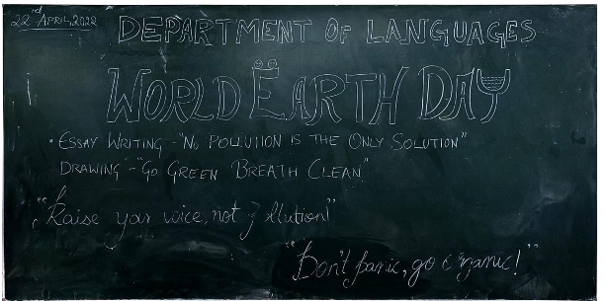
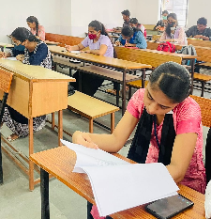 | 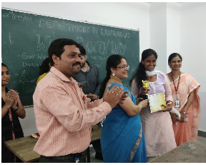
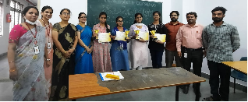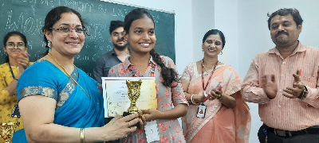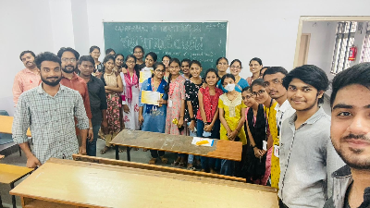
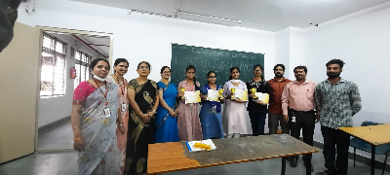

EVENT/ACTIVITY PROPOSAL
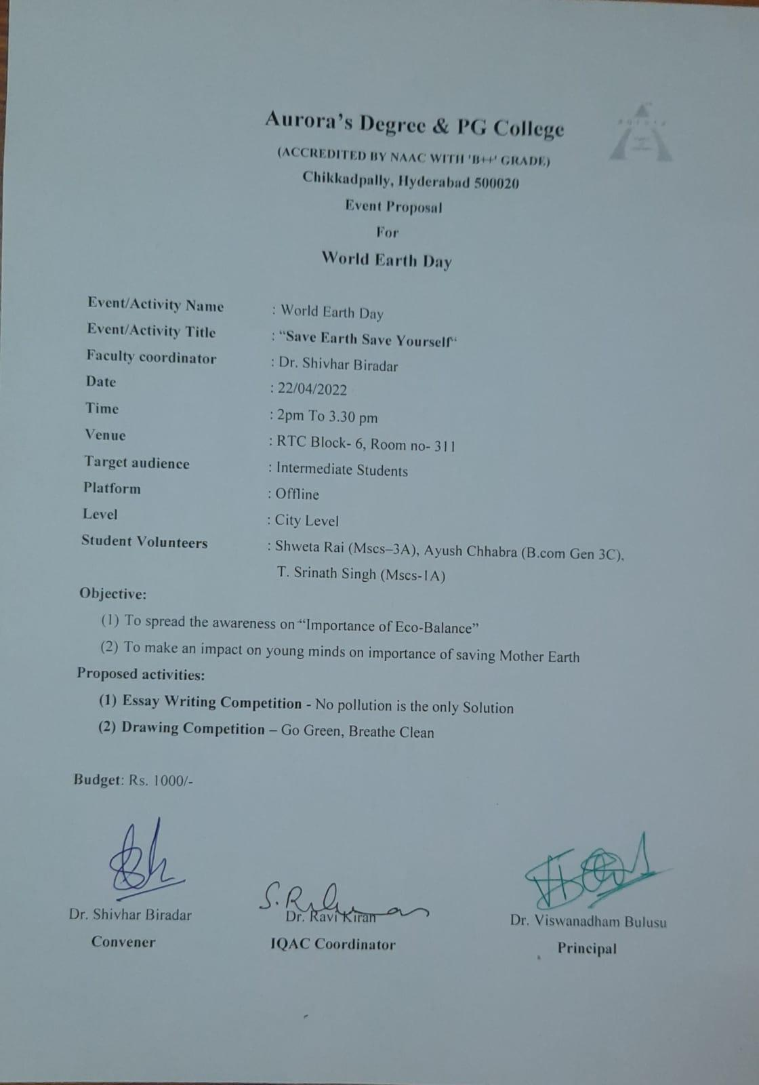

EVENT / ACTIVITY NOTICE

GUEST PROFILE (IF ANY)
No
FEED BACK IF ANY
No
RECEIPTS (IF ANY)
No
CERTIFICATES (IF ANY)
No
LETTERS OF COMMUNICATION (IF ANY)
No

