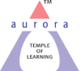
Aurora’s Degree & PG College
(ACCREDITED BY NAAC WITH 'B++' GRADE)
Chikkadpally, Hyderabad 500020

EVENT / ACTIVITY SHORT REPORT

NAME OF THE EVENT / ACTIVITY | WORLD FOREST DAY
TYPE OR TITLE OF EVENT / ACTIVITY | CLASS EVENT
FACULTY INCHARGE | Dr.Padmini S
DEPARTMENT/CELL/COMMITTEE/CLUB | COMPUTER APPLICATIONS
DATE | 21/03/2022
VENUE | AURORA’S DEGREE & PG COLLEGE
TARGET AUDIENCE | B.COM COMPUTER APPLICATIONS

OBJECTIVE:
To Create awareness among the students about the importance of forest, adverse climate change, droughts, pollution, floods, and ecological system.
BRIEF ABOUT THE EVENT:
The event was conducted on 21st March 2022 by the Dept. of Commerce – Computer Applications. On the day of the event Students have given presentation on what is the importance of Forest, Why government is insisting on plantation of trees.

On this occasion, students were made in to groups one set of students have come with Posters and another set of students have presented PPT. The students actively participated in the event.

OUT COME:
Students have understood the importance of Forest .This Day is an opportunity to learn more about issues, that we have to face if forests are not taken proper care.

PHOTOGRAPH:

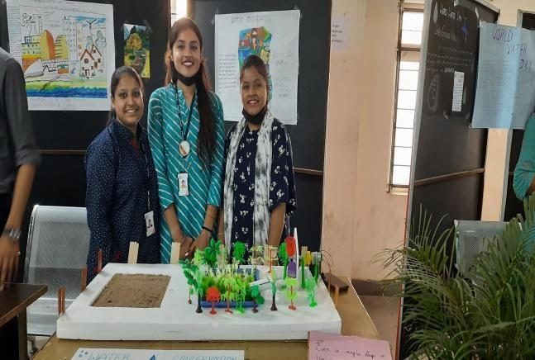

Aurora’s Degree & PG College
(ACCREDITED BY NAAC WITH 'B++' GRADE)
Chikkadpally, Hyderabad 500020

EVENT / ACTIVITY DETAILED REPORT

NAME OF THE EVENT / ACTIVITY | WORLD FOREST DAY
TYPE OR TITLE OF EVENT / ACTIVITY | CLASS EVENT
FACULTY INCHARGE | Dr.PADMINI S
DEPARTMENT/CELL/COMMITTEE/CLUB | COMPUTER APPLICATIONS
DATE | 21/03/2022
VENUE | AURORA’S DEGREE & PG COLLEGE
TARGET AUDIENCE | B.COM COMPUTER APPLICATIONS

- PROGRAM SCHEDULE:
The event scheduled on 21st March 2022 .
The following is the following schedule
- PowerPoint Presentation by the students

- LIST OF FACULTY COORDINATORS (DEPARTMENT)
Dr.Padmini S (Commerce - Computer Applications)
- LIST OF THE STUDENT COORDINATORS (NAME , ROLL NO, CLASS & SECTION)
- Shivaratri Akanksha 1051-21-405-127 B.Com Computer Applications 1C
- A.Bhuvana 1051-21-538-019 Business Analytics
- LIST OF THE PARTICIPANTS (NAME , ROLL NO, CLASS & SECTION, NO OF GIRLS, BOYS )
Roll Number | Name | Class & Section
1051-20-408-004 | G.Ganesh | MCOM
1051-20-408-010 | Kavya | MCOM
1051-20-408-011 | Mallika | MCOM
1051-20-408-014 | S.Vyshnavi | MCOM
1051-20-408-026 | Akshay | MCOM
1051-20-408-031 | Omkar | MCOM

- PARAGRAPH ABOUT THE PROCEEDINGS (TILL THE END OF THE EVENT)
Objective: To Create awareness among the students about the importance of forest, adverse climate change, droughts, pollution, floods, and ecological system.

On the day of the event, the session started in Room No.201, at 11:00 am with the introduction by Dr.Padmini S (Associate Professor in Department of Computer Application). Later Akanksha and Bhuvana of B.Com I year have made a ppt presentation on Importance of Forest , Afforestation etc .

After the powerpoint presentation, students have actively participated by presenting the posters , and charts . M.Com students have prepared different charts and posters and explained others about the forest resources .

- INCOME AND EXPENDITURE : NIL
- EVENT PHOTOS ( MIN 2 MAX 4):

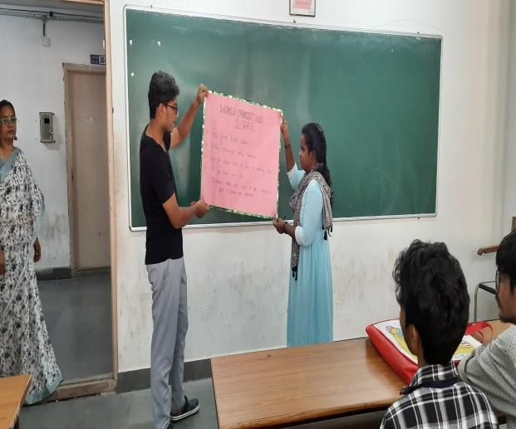

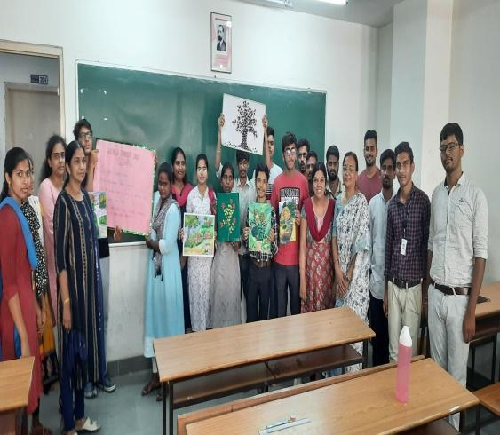
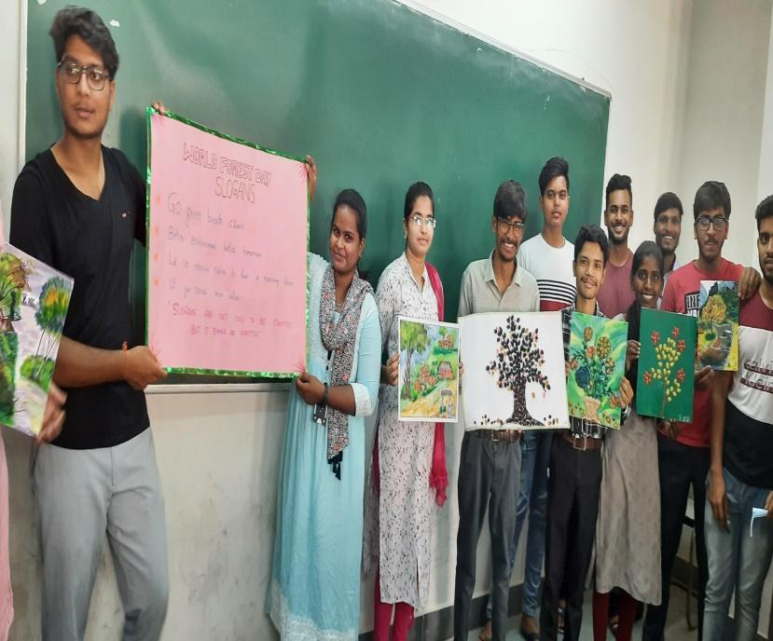
- GUEST PROFILE (IF ANY): NIL
- FEED BACK IF ANY: NIL
- ATTACHMENTS:
EVENT/ACTIVITY PROPOSAL:
Aurora’s Degree and PG College
(ACCREDITED BY NAAC WITH ‘B++’ GRADE)
Chikkadpally, Hyderabad 500020
EVENT PROPOSAL
For
WORLD FOREST DAY

Event Name: WORLD FORES DAY
Event Convenor: K.Sujatha
Department: COMMERCE
Faculty coordinator:Dr. Padmini S
Date: 21-03-2022
Venue: Aurora’s Degree and PG College
Target audience: BCOM COMPUTER APPLICATIONS
Platform: ON LINE
Level: College
Student Volunteer’s: Akanksha , A.Bhuvana
Objective: To Create awareness among the students about the importance of forest and making them to understand the various problems that we need to face.
Proposed activities:
- PPT PRESENTATION

Guest/Speaker details: - Nil
Budget: Nil
Convener IQAC Coordinator Principal
Dr.Padmini Dr. Ravi kiran Dr. Viswanadham Bulusu

EVENT / ACTIVITY NOTICE - NIL
RECEIPTS (IF ANY) - NIL
CERTIFICATES (IF ANY) - NIL
LETTERS OF COMMUNICATION (IF ANY) -NIL

