Aurora’s Degree and PG College 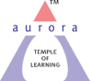
(ACCREDITED BY NAAC WITH ‘B++’ GRADE)
Chikkadpally, Hyderabad 500020
Department of Electronics
EVENT PROPOSAL
for
Workshop – Design and Development of Clap Switch using LED Light

Event/Activity Name: Transistor Invention Day
Event/Activity Title: Workshop – Design and Development of Clap Switch using LED Light
Event Conducted Department: Department of Electronics
Faculty coordinators: 1. Poornachander P
2. Dr. L Radhika Rani
Date: 16-12-2021
Venue: Aurora’s Degree & PG College – Block –III - ElectronicsLab
Target audience: B.Sc (MECs) First Years& MSCs Final Years
Platform: Offline @ Aurora’s Degree & PG College –Electronics Lab
Level: College
Student Volunteer’s: N/A

Objective:The main objective of the Workshop is to create awareness among students on development of clap switch by using LED lights.
Proposed activities:
- Hands on experience on Design and Development of Clap Switch using LED
Guest/Speaker details: MrHamedRaza In collaboration with Innovative technologies
Budget: Rs 500 per Participant /-

Coordinators IQAC Coordinator Principal
Poornachander P & Dr. Radhika Rani Dr. Ravi kiran Dr. ViswanadhamBulusu
Aurora’s Degree & PG College
Chikkadpally,Hyderabad -500020
Brief Report
On
Workshop
On the occasion of “Transistor Invention Day”

NAME OF THE EVENT | Workshop  On the occasion of “Transistor Invention Day”
TYPE OF EVENT | Department level
FACULTY INCHARGE | Dr. L Radhika Rani, P Poornachander
DEPARTMENT | Electronics
DATE | 16th December, 2021
VENUE | Aurora’s Degree and PG College, Chikkadpally
TARGET AUDIENCE | I B.Sc., M.E.Cs

OBJECTIVE:
- To motivate the students towards Electronics subject.
- Create awareness among the students about basic electronics components.
- Transform theoretical knowledge into practical applications
BRIEF ABOUT THE EVENT:
Department of Electronics organized a One day Workshop on “Design and Development of Clap Switch using LED Light” for B.Sc., 1st Year M.E.Cs Students.
In this workshop students designed “Clap Switch using LED Light”, is an electronic circuit thatswitches ON and OFF when some person claps near the circuit.
Totally 20 Students from 1st year M.E.Cs participated and feedback from the participants was also highly positive. The students expected the same type of workshop in future as well.
OUTCOME:
- Confidence in designing a circuit and testing it
- Improves the subject knowledge and boost confidence.
- Students received certificate along with Kit.

PHOTOGRAPHS:
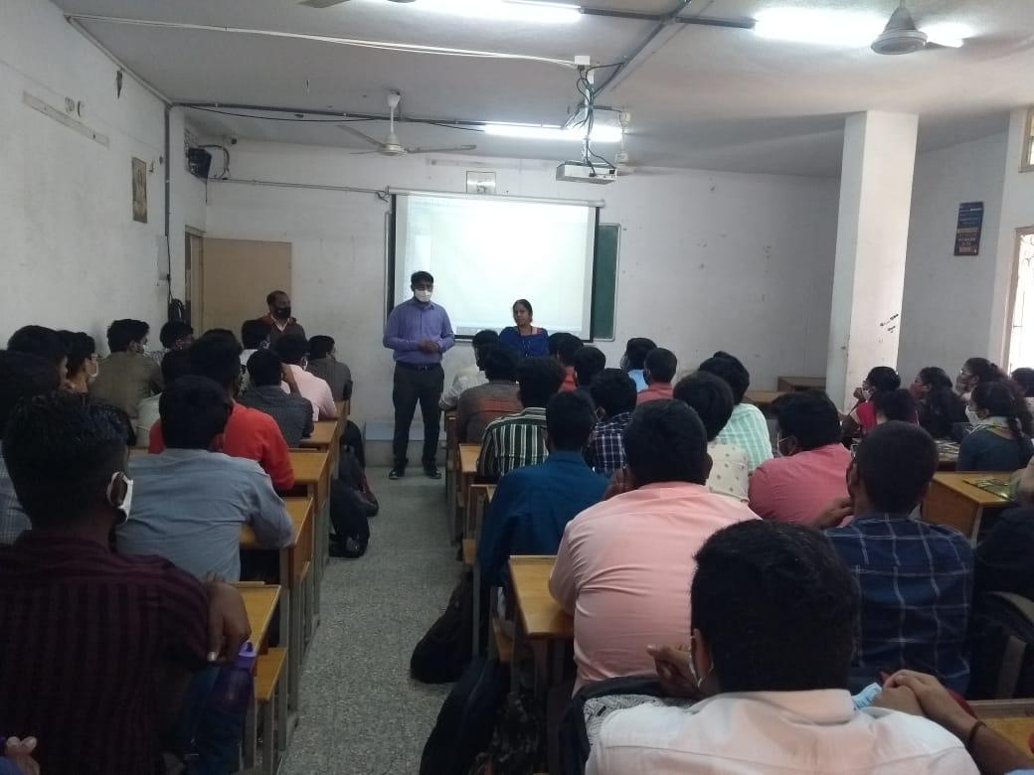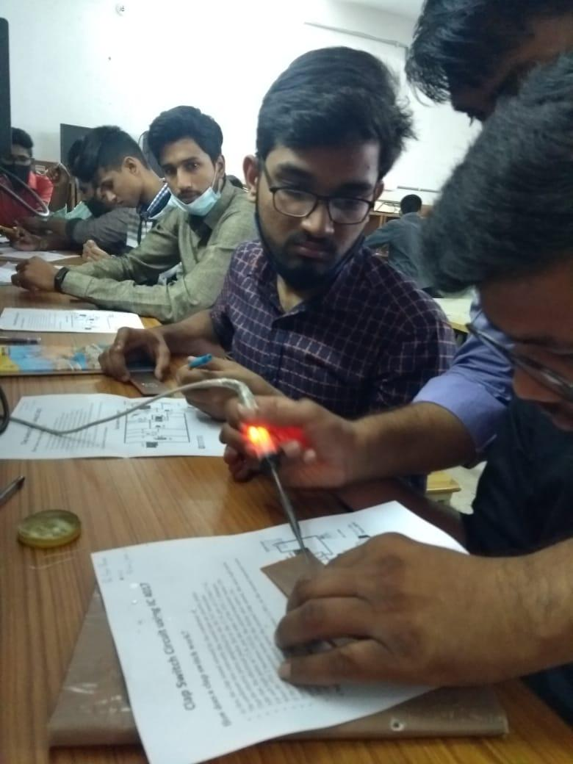

Aurora’s Degree & PG College
Chikkadpally, Hyderabad -500020
A Detailed Report
On
Workshop
On the occasion of “Transistor Invention Day”

NAME OF THE EVENT | Workshop  On the occasion of “Transistor Invention Day”
TYPE OF EVENT | Department level
FACULTY INCHARGE | Dr. L Radhika Rani, P Poornachander
DEPARTMENT | Electronics
DATE | 16th December, 2021
VENUE | Aurora’s Degree and PG College, Chikkadpally
TARGET AUDIENCE | I B.Sc., M.E.Cs

PROGRAM SCHEDULE: 16thDecember, 2021 from 9:30 am to 4 pm.
Session 1: Theory session on “Basic components “
Session 2 : Designing a Circuit
Session 3 : Assembling the components on General PCB board
Session 4 : Soldering of components
Session 5 : Testing the Circuit

VENUE: Aurora’s Degree and PG College, Chikkadpally

LIST OF FACULTY COORDINATORS:Dr. L Radhika Rani, P Poornachanderdepartment of Electronics.

LIST OF THE STUDENT COORDINATORS: ----

LIST OF THE PARTICIPANTS:
S.No | Roll No | Name of the Student
1 | 1051-21-474-002 | Mohammed Ghouse Pasha
2 | 1051-21-474-003 | Siddula Satish Netha
3 | 1051-21-474-004 | Syed Adnan Hussain
4 | 1051-21-474-005 | Gandhi Raj Basumatary
5 | 1051-21-474-006 | Mohammed Parvez
6 | 1051-21-474-008 | Pagunta Vishnuvardhan Reddy
7 | 1051-21-474-009 | Pershettiwar Sai Bharath
8 | 1051-21-474-010 | CH Naga Srija
9 | 1051-21-474-011 | Vadla Vishnu Vardhan Chary
10 | 1051-21-474-014 | Naini Ashish Kumar
11 | 1051-21-474-015 | Deepak Urade
12 | 1051-21-474-016 | Shaik Abdul Rajak
13 | 1051-21-474-017 | Madyanam Karthik Reddy
14 | 1051-21-474-018 | Sharvirala Krishna Priya
15 | 1051-21-474-023 | Bende Sriram
16 | 1051-21-474-025 | Uyyala Sowmya
17 | 1051-21-474-029 | Katakam Nithin
18 | 1051-21-474-032 | Bidar Pranith Raj
19 | 1051-21-474-033 | A Pavan Datta
20 | 1051-21-474-034 | Sai Datta Manish

PARAGRAPH ABOUT THE PROCEEDINGS

Introduction of the Event:
Department of Electronics organized a One day Workshop on “Design and Development of Clap Switch using LED Light” for B.Sc., 1st Year M.E.Cs Students
The Workshop is designed such that students learn subject in detail apartfrom their regular curriculum. The workshop provides more practical knowledge to the studentsin designing electrical circuits.
In this workshop students designed “Clap Switch using LED Light”, is an electronic circuit that switches ON and OFF when some person claps near the circuit.
Methodology:
Department of Electronics, Aurora’s Degree and PG College conducts this event with great enthusiasm every year. This year workshop was conducted on Design and Development of Clap Switch using LED Light” for B.Sc., 1st Year M.E.Cs Studentsby Mr. Hamed Raza Director, Innovative technologies, Hyderabad.
The program was conducted in Electronics lab from 09:30 to 04:00pm. Mr. Hamed Razaexplained about basic components in electronics and importance of transistor in session -I.
He also explained Designing of simple electronic circuits and designing of clap switch. In practical session he explained how to assemble components on PCB and how to soldering the components. After completion of design and soldering he tested the circuit.
Totally 20 Students from 1st year M.E.Cs participated and feedback from the participants was also highly positive. The students expected the same type of workshop in future as well.

INCOME AND EXPENDITURE :
Income collected from students: 500X20=Rs10000/-
Kit and certificate : 485X20= Rs9700/-
Lunch for the guest: Rs 300/-
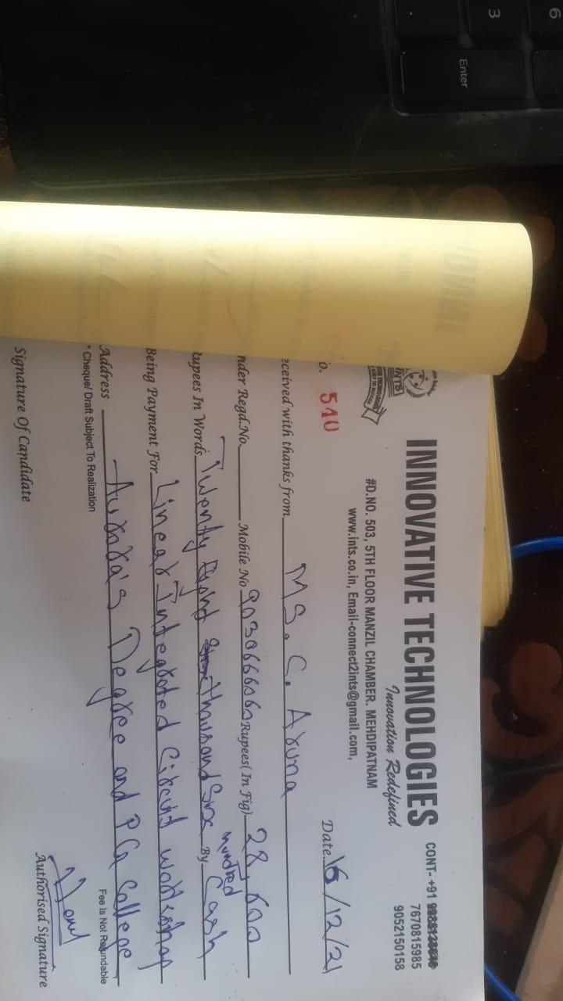

EVENT PHOTGRAPHS:

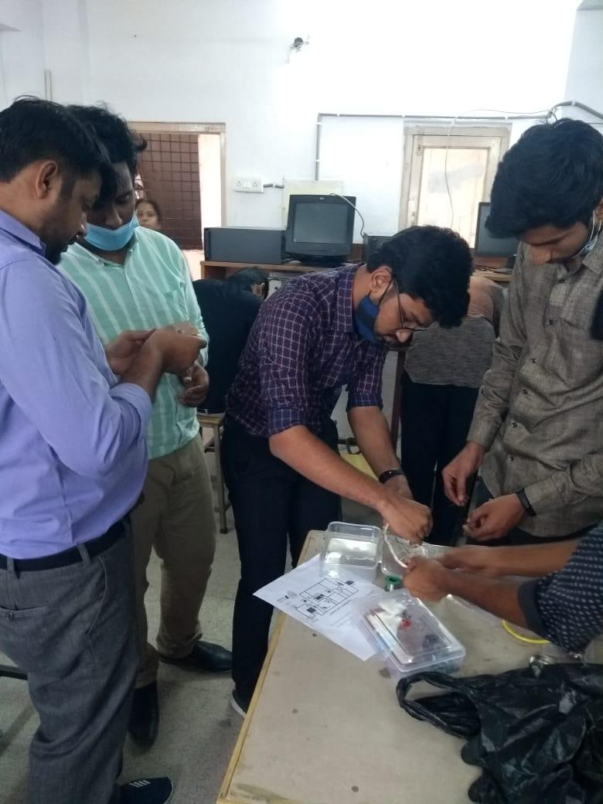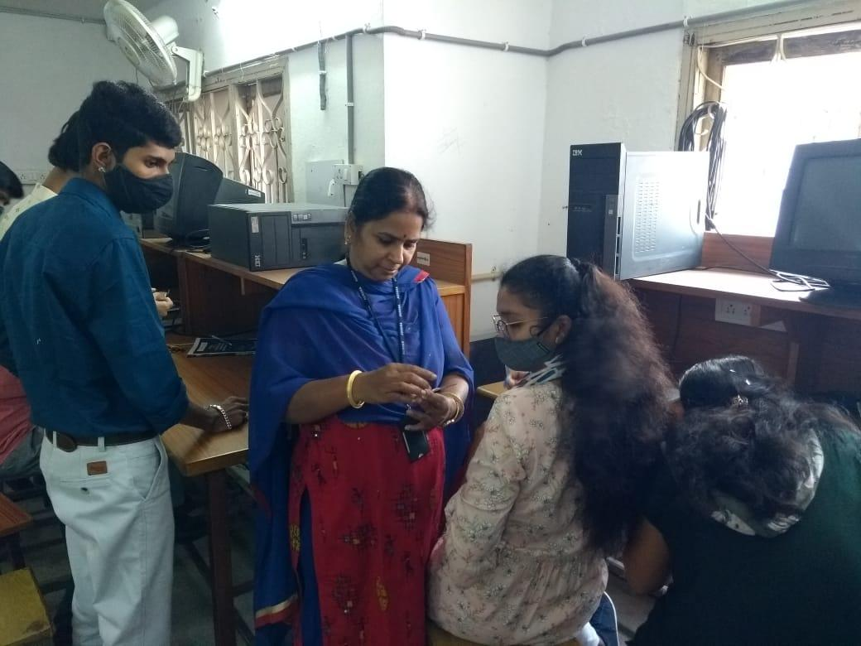

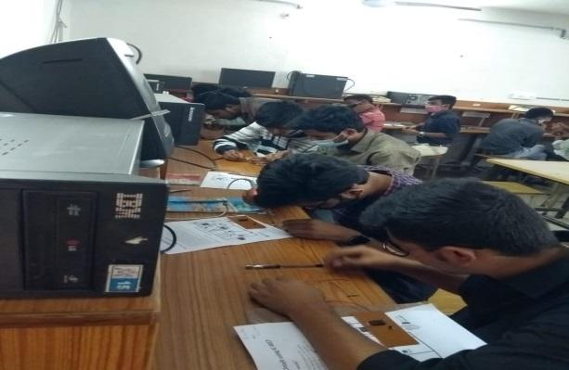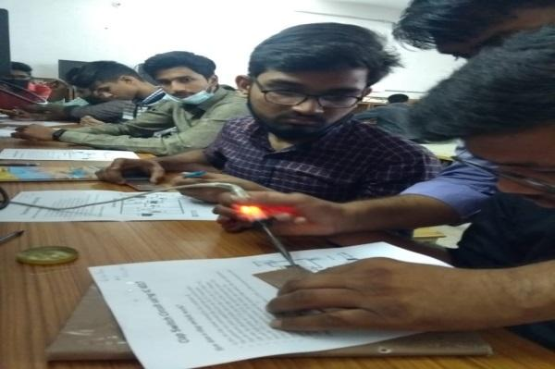
GUEST PROFILE: MrHamedRazaDirector, Innovative technologies
FEED BACK : Students gave positive feedback and they felt happy for conducting this event.
CERTIFICATe and PROJECT KIT
