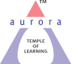
Aurora’s Degree & PG College
(ACCREDITED BY NAAC WITH 'B++' GRADE)
Chikkadpally, Hyderabad 500020

EVENT / ACTIVITY DETAILED REPORT

NAME OF THE EVENT / ACTIVITY | ANTI CORRUPTION DAY
TYPE OR TITLE OF EVENT / ACTIVITY | ANTI CORRUPTION DAY
FACULTY INCHARGE | K.SATHISH KUMAR
DEPARTMENT/CELL/COMMITTEE/CLUB | COMMERCE
DATE | 09-12-2021
VENUE | AURORA’DEGREE AND PG COLLEGE
TARGET AUDIENCE | B.COM(COMPUTER APPLICATIONS)STUDENT

- PROGRAM SCHEDULE:
- LIST OF FACULTY COORDINATORS (DEPARTMENT) : K.SATHISH KUMAR(Commerce)
- LIST OF THE STUDENT COORDINATORS (NAME , ROLL NO, CLASS & SECTION)
NAME | ROLL NO | CLASS | SECTION
Jetangi Lokesh | 1051-19-405-023 | B.Com | 3D(Computer.Applications)
M.K.Sunny Paul | 1051-19-405-023 | B.Com | 3D(Computer.Applications)
Ganji Kalyan ChakravarthY | 1051-19-405-023 | B.Com | 3D(Computer.Applications)
Bijala Shravan | 1051-19-405-023 | B.Com | 3D(Computer.Applications)
Kotha Naga Shashank | 1051-19-405-023 | B.Com | 3D(Computer.Applications)
T.Madhan | 1051-19-405-023 | B.Com | 3D(Computer.Applications)
I.Sanjana | 1051-19-405-023 | B.Com | 3D(Computer.Applications)
P.Aiswaria | 1051-19-405-023 | B.Com | 3D(Computer.Applications)
G.Gayathri Devi | 1051-19-405-023 | B.Com

- LIST OF THE PARTICIPANTS (NAME , ROLL NO, CLASS & SECTION, NO OF GIRLS, BOYS, CASTE )
NAME | ROLL NO | CLASS | SECTION | GIRL/BOY
Harsh Sharma | 1051-20-405-134 | B.Com(Computer Applications) | 2A | BOY | OC-B
Mohammed Furqan Ali | 1051-20-405-135 | B.Com(Computer Applications) | 2A | BOY | OC-B
Amar Chand Rohit Jain | 1051-20-405-136 | B.Com(Computer Applications) | 2A | BOY | OC-B
Kirti Sharma | 1051-20-405-137 | B.Com(Computer Applications) | 2A | BOY | OC-G
Ritika Devi Biradar | 1051-20-405-138 | B.Com(Computer Applications) | 2A | GIRL | BC-B-G
D Tanuja Aparna | 1051-20-405-139 | B.Com(Computer Applications) | 2A | GIRL | BC-D-G
Neeha Roy | 1051-20-405-140 | B.Com(Computer Applications) | 2A | GIRL | OC-G
Gatla Manikya Vaishnavi | 1051-20-405-141 | B.Com(Computer Applications) | 2A | GIRL | BC-D-G
Nandagowli Pornima | 1051-20-405-142 | B.Com(Computer Applications) | 2A | GIRL | BC-B-G
K Nikitha | 1051-20-405-143 | B.Com(Computer Applications) | 2A | GIRL | BC-A-G
Ruchi Dugar | 1051-20-405-144 | B.Com(Computer Applications) | 2A | GIRL | OC-G
Sanika Manilal Patil | 1051-20-405-145 | B.Com(Computer Applications) | 2A | GIRL | OC-G
Kanduri Someswari Sindhu | 1051-20-405-146 | B.Com(Computer Applications) | 2A | GIRL | OC-G
Ajay Singh | 1051-20-405-147 | B.Com(Computer Applications) | 2A | BOY | BC-A-B
Md Asim Saif | 1051-20-405-148 | B.Com(Computer Applications) | 2A | BOY | OC-B
Gourav Upadhyay | 1051-20-405-149 | B.Com(Computer Applications) | 2A | BOY | OC-B
S Manav Raj | 1051-20-405-150 | B.Com(Computer Applications) | 2A | BOY | BC-B-B
Thakur Rajesh Singh | 1051-20-405-151 | B.Com(Computer Applications) | 2A | BOY | BC-B-B
Pandre Kiran | 1051-20-405-152 | B.Com(Computer Applications) | 2A | BOY | BC-D-B
Suryavanshi Vishnuraj | 1051-20-405-153 | B.Com(Computer Applications) | 2A | BOY | BC-B-B
Ghanshyam Barabde | 1051-20-405-154 | B.Com(Computer Applications) | 2A | BOY | BC-B-B
Mahesh Tekale | 1051-20-405-155 | B.Com(Computer Applications) | 2A | BOY | BC-B-B
Sudhansu Ranjan | 1051-20-405-156 | B.Com(Computer Applications) | 2A | BOY | OC-B
Mihir Keshwani | 1051-20-405-157 | B.Com(Computer Applications) | 2A | GIRL | OC-B
Anish S Mane | 1051-20-405-158 | B.Com(Computer Applications) | 2A | BOY | BC-B-B
Aman Singh | 1051-20-405-159 | B.Com(Computer Applications) | 2A | BOY | BC-A-B
Mohammed Abdul Lateef | 1051-20-405-160 | B.Com(Computer Applications) | 2A | BOY | BC-E-B
Tarun Nirwan | 1051-20-405-161 | B.Com(Computer Applications) | 2A | BOY | SC-B
Yash Dhilod | 1051-20-405-162 | B.Com(Computer Applications) | 2A | BOY | SC-B
Kunal Babde | 1051-20-405-163 | B.Com(Computer Applications) | 2A | BOY | BC-B-B
Mohammed Anas Amer Hassan | 1051-20-405-164 | B.Com(Computer Applications) | 2A | BOY | OC-B
Sai Dheeraj | 1051-20-405-165 | B.Com(Computer Applications) | 2A | BOY | OC-B
N Raja Vigneshwaran | 1051-20-405-166 | B.Com(Computer Applications) | 2A | BOY | OC-B
Shaik Kareem Nawaz | 1051-20-405-167 | B.Com(Computer Applications) | 2A | BOY | OC-B
Keshav Goel | 1051-20-405-168 | B.Com(Computer Applications) | 2A | BOY | OC-B
Bala Prasad Shankarendra Landge | 1051-20-405-169 | B.Com(Computer Applications) | 2A | BOY | BC-B-B
Maruge Aman | 1051-20-405-170 | B.Com(Computer Applications) | 2A | BOY | BC-A-B
Poosa Varun Raj | 1051-20-405-171 | B.Com(Computer Applications) | 2A | BOY | BC-A-B
Deepak Kumar | 1051-20-405-172 | B.Com(Computer Applications) | 2A | BOY | BC-A-B
Mohammed Musharaff | 1051-20-405-173 | B.Com(Computer Applications) | 2A | BOY | OC-B
Mupparam Sai Giridhar Mudhiraj | 1051-20-405-174 | B.Com(Computer Applications) | 2A | BOY | BC-D-B
Saggam Abhinav | 1051-20-405-175 | B.Com(Computer Applications) | 2A | BOY | BC-B-B
G Karthikeya | 1051-20-405-176 | B.Com(Computer Applications) | 2A | BOY | SC-B
Kopalle Giridhar Sai | 1051-20-405-177 | B.Com(Computer Applications) | 2A | BOY | OC-B
Yashlal Singh | 1051-20-405-178 | B.Com(Computer Applications) | 2A | BOY | BC-B-B
Dhanraj Sharma | 1051-20-405-179 | B.Com(Computer Applications) | 2A | BOY | OC-B
Ayush Pipriyea | 1051-20-405-180 | B.Com B.Com(Computer Applications) (Computer Applications) | 2A | BOY | BC-B-B
Balram Tarun Singh | 1051-20-405-181 | B.Com(Computer Applications) | 2A | BOY | BC-A-B
Chintha Prudhvi Raj | 1051-20-405-182 | B.Com(Computer Applications) | 2A | BOY | BC-A-B
Anupatla Shravan Karthik | 1051-20-405-183 | B.Com(Computer Applications) | 2A | BOY | SC-B
Syed Shafi Ahmed | 1051-20-405-184 | B.Com(Computer Applications) | 2A | BOY | OC-B
Datrik Shashank | 1051-20-405-185 | B.Com(Computer Applications) | 2A | BOY | BC-D-B
Singh Yogender | 1051-20-405-186 | B.Com(Computer Applications) | 2A | BOY | BC-A-B
Modala Rakesh | 1051-20-405-187 | B.Com(Computer Applications) | 2A | BOY | BC-D-B
Maheshwaram Bhoomika | 1051-20-405-188 | B.Com(Computer Applications) | 2A | BOY | BC-B-G
Guduru Bharat Bushan | 1051-20-405-189 | B.Com(Computer Applications) | 2A | BOY | BC-B-B
Pulimamidi Bharath Simha Reddy | 1051-20-405-190 | B.Com(Computer Applications) | 2A | BOY | OC-B
Bhavish Bhosle | 1051-20-405-191 | B.Com(Computer Applications) | 2A | BOY | BC-B-B
Gaddi Girish Yadav | 1051-20-405-193 | B.Com(Computer Applications) | 2A | BOY | BC-D-B
Chadal Venu Gopal Rao | 1051-20-405-194 | B.Com(Computer Applications) | 2A | BOY | BC-A-B
Prasadam Manasa | 1051-20-405-195 | B.Com(Computer Applications) | 2A | BOY | BC-A-G
Aellala Pavan Kumar | 1051-20-405-196 | B.Com(Computer Applications) | 2A | BOY | BC-A-B
Kishore Patil | 1051-20-405-197 | B.Com(Computer Applications) | 2A | BOY | OC-B
Budidha Pranay Goud | 1051-20-405-198 | B.Com(Computer Applications) | 2A | BOY | BC-B-B
M Harsha Vardhan | 1051-20-405-201 | B.Com(Computer Applications) | 2A | BOY | BC-A-B
- PARAGRAPH ABOUT THE PROCEEDINGS (TILL THE END OF THE EVENT):Brief Introduction by the student Voultenteers about the Importance of Anti Corruption Day.
- INCOME AND EXPENDITURE:NIL
- EVENT PHOTOS ( MIN 2 MAX 4)
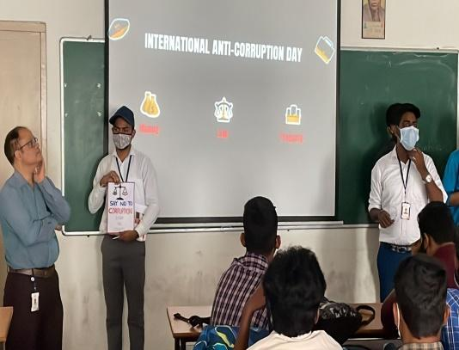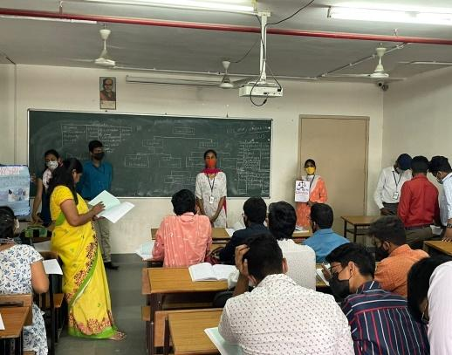
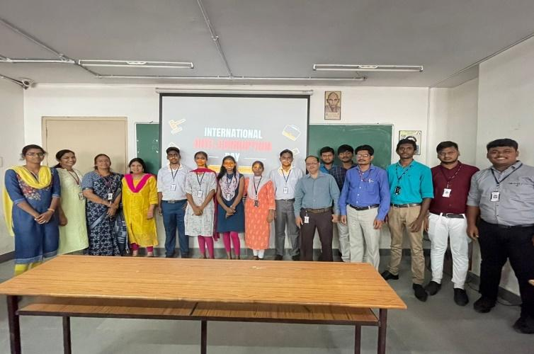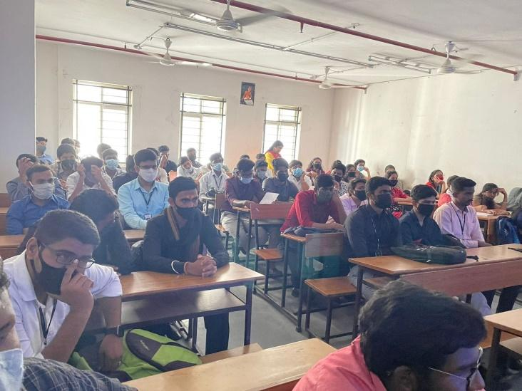
- GUEST PROFILE (IF ANY):NOT APPLICABLE
- FEED BACK IF ANY:
- ATTACHMENTS:
EVENT/ACTIVITY PROPOSAL:
EVENT / ACTIVITY NOTICE:No
RECEIPTS (IF ANY):
CERTIFICATES (IF ANY):NO
LETTERS OF COMMUNICATION (IF ANY):NO

