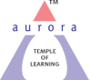
Aurora’s Degree & PG College
(ACCREDITED BY NAAC WITH 'B++' GRADE)
Chikkadpally, Hyderabad 500020

EVENT / ACTIVITY SHORT REPORT

NAME OF THE EVENT / ACTIVITY | Dr APJ Abdul Kalam Birthday Celebrations
TYPE OR TITLE OF EVENT / ACTIVITY | Dr APJ Abdul Kalam Birthday Celebrations
FACULTY INCHARGE | Sunanda G  Aslam Shareef
DEPARTMENT/CELL/COMMITTEE/CLUB | Physics
DATE | 13-10-2021  14-10-2021  15-10-2021
VENUE | Aurora Degree & College
TARGET AUDIENCE | Intermediate, Undergraduate Students

OBJECTIVE: Igniting the minds of the students and to create leadership qualities among the students and experienced to become enlightened citizens and to work for sustainable development.
BRIEF ABOUT THE EVENT;
On account of Dr. APJ. Abdul Kalam Birthday Celebrations Department of Physics has organized Live Quiz, Crossword Puzzle, Guess the Quote, and Memory Game for Intermediate & Undergraduate students. A total of 206 participants from various colleges of city have actively participated in the games organized on 13th and 14th October. A tribute remembering the eminent personality was paid by a video & PPT presentation on valedictory session on 15th October. Announcement of Prize winners was done.
OUTCOME: Students get motivated by his simple living and inspirational thinking. And his quotes
Ignited the minds of students and faculty also.
PHOTOGRAPH:
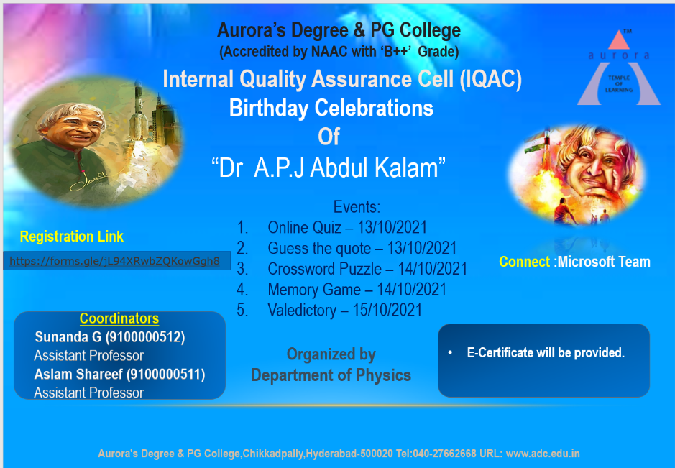
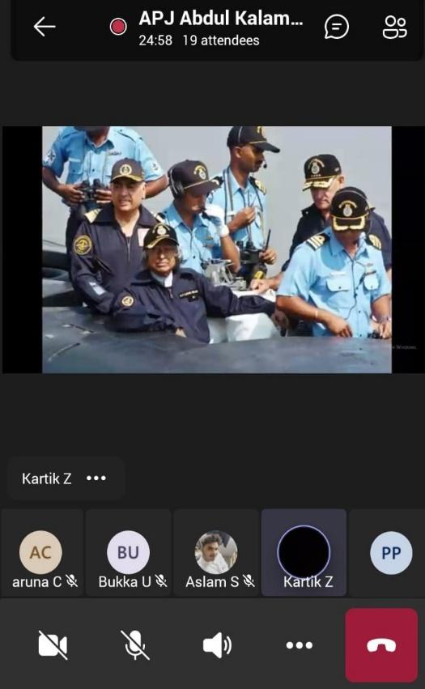
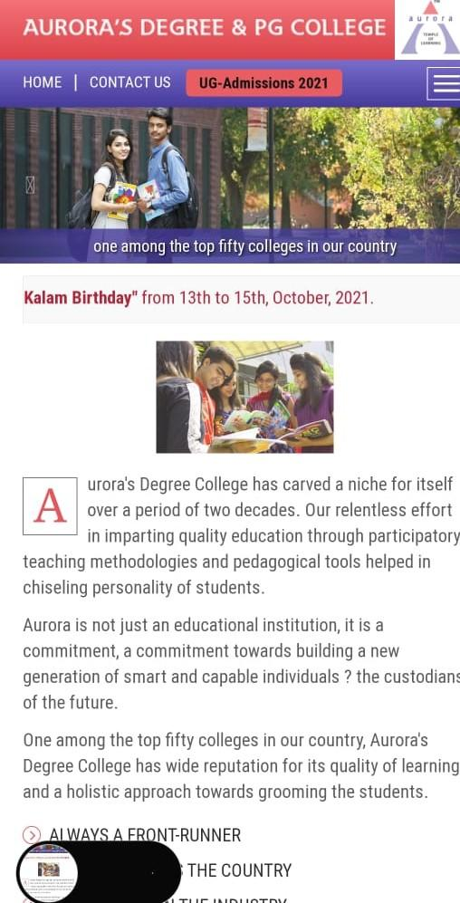
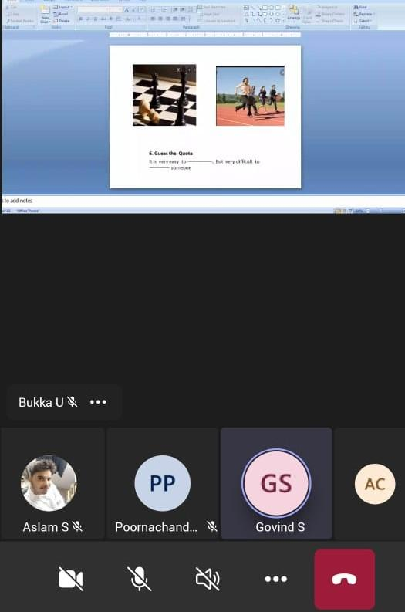

Aurora’s Degree & PG College
(ACCREDITED BY NAAC WITH 'B++' GRADE)
Chikkadpally, Hyderabad 500020

EVENT / ACTIVITY DETAILED REPORT

NAME OF THE EVENT / ACTIVITY | Dr. APJ Abdul Kalam Birthday Celebration
TYPE OR TITLE OF EVENT / ACTIVITY | Dr. APJ Abdul Kalam Birthday Celebration
FACULTY INCHARGE | Sunanda G  Aslam Shareef
DEPARTMENT/CELL/COMMITTEE/CLUB | Physics
DATE | 13/10/2021,14/10/2021,15/10/2021
VENUE | Aurora Degree & PG College
TARGET AUDIENCE | Intermediate and Undergraduate students

PROGRAM SCHEDULE
- Online Quiz:
Date: 13/10/2021
Timings: 11:00 Am -12:00 Noon
Platform: Microsoft teams
- Guess the quote:
Date: 13/10/2021
Timings: 2:00 Pm -3:00 Pm
Platform: Microsoft teams

- Memory Game:
Date: 14/10/2021
Timings: 11:00 Pm -12:00 Noon
Platform: Microsoft teams

- Crossword Puzzle:
Date: 14/10/2021
Timings: 2:00 PM - 3:00 PM
Platform: Microsoft teams

LIST OF FACULTY COORDINATORS:
1.Sunanda G
Asst.Professor
Dept. of Physics
2.Aslam Shareef
Asst.Professor
Dept. of Physics
LIST OF THE STUDENT COORDINATORS
Name | Roll. No | Section
Karthik Zingade | 105119468003 | MPCs 3A
Ashish | 105119468049 | MPCs 3A

LIST OF THE PARTICIPANTS
S.No | Name | Course | College
1 | Kartik s z | Bsc | Aurora's degree and pg college
2 | L.N.Udaya Sree | B.Sc MPCs | St.Ann's College for Women
3 | Dola Amulya | Mpcs | St Ann's college for women
4 | Veeramalla Chandrika | B.SC(MPC's) | St.Ann's college for women
5 | Adukula srilaxmi | B.sc | Aurora degree and PG college
6 | Vishnu | Diploma (mechanical engineering) | Tkr engineering college
7 | G.Soumya Sree | BSC.MPCs | St.Ann's college for women
8 | Raniya Aleem | BSc MPCs | St Ann's college for women
9 | Dommata Bhavya shree | Mecs | St Francis college for women's
10 | R. Bridget Felicia | B.Sc | St. Francis College
11 | ZAINA SIDDIQUA | Bsc.Mathematics /Electronics/Computer science | St.Francis College for Women
12 | Gracy Sowmya Jami | BSc. MECs | St. Francis College for Women, Begumpet
13 | J.Kavya shree | Mpc | Bhavans Sri Aurobindo Junior College
14 | E. Swetha | MEC-B.Sc | St. Francis college for women
15 | JAKKAM CHANDANA NAIDU | BSC MECs | St.Francis College For Women
16 | S.D.N.V.Nikhila | MECs | St Francis Degree College for Women
17 | Saniya Roobi | B.Sc | St. Francis college for women
18 | Anam Begum | B.Com Computers | St.Ann's Degree College
19 | K.Sai nikitha | MECS | st.francis College for women
20 | Medaboina Sowmya | BSC | St.Francis College For Women
21 | Akanksha Ponaganti | B.Sc | St. Francis College For Women
22 | M Niharika | B.sc | St.Francis college for women
23 | B. Shrisha | B. Sc | St. Francis women college
24 | Ridha hakeem | B.sc MECs | St.francis degree college for women
25 | SHAIK HABEEB AHMED | B.Sc | Aurora's Degree & PG College
26 | Bongu komal | Bsc ( Maths, electronics,computer science) | St Francis degree begumpet
27 | Bendi Vivek | Bsc electronics and technology | Loyola Academy
28 | BADDAM SREEJA | Bsc mecs | St.Anns College for women
29 | Koneti.Nagamani | B.com computers | St.Ann's college for women, Mehdipatnam
30 | Thota Ganesh Uma Arjun | B.sc | St.marys college yousufguda
31 | M.Vamshi Krishna | Bsc.mecs | St.Marys college
32 | pavan kumar | mecs | st Mary's College
33 | Bindu | BBA | St.Ann's degree college for women
34 | R. Varalika | MECs | St. Ann's college for women, Mehdipatnam.
35 | K.Sesha Sai Sreya | MPCS | St.Anns COllege For Women
36 | M. Pooja Devi | Bsc | St Ann's college for women
37 | Bandreddy Sai Sindhura | Bsc mecs | St Ann's women's degree College
38 | S.Navya Reddy | BSC (MPC'S) | st.anns college for women's
39 | U.chaitanya | Bsc Mpcs | St.Ann's college for women
40 | Sadaf Fatima | BBA | St anns degree college for women
41 | B.Navya | Bsc mpcs | Rbvrr women's College
42 | B.Madhavi | Mpc | Rbvrr women's clg
43 | J. Madhavi | B. Sc(mpcs) | Rbvrr women's clg
44 | Jenige Akhila | MPCs | Rbvvr women's college, Narayanaguda
45 | Simranjeet kaur | BSC(mecs) | Aurora's Degree and PG College
46 | Rushikaa Edulakanti | Bcom computers | St Joseph degree college
47 | Kunduru Rishitha | Bsc(MPCS) | RBVRR women's college
48 | Syeda Basra Sultana | B. Com computers | St. Ann's College For Women
49 | B Ganesh chary | Mecs | Aurora degree and pg college
50 | MohammedZaheer | Bsc | Aurora Degree and pg college
51 | Vignasri | Bsc msds | St Ann's college for women mehdipatnam
52 | vennavaram anusha | mec | st francis degree college for womens
53 | Likhitha Manikonda | MEC | St.Francis collage for women
54 | CHALLA.KEERTHANA | BSC MECS | ST.FRANCIS COLLEGE FOR WOMEN
55 | Ravuluri.Bhavya | B.sc | St.francis college for women
56 | V.LIKITHA DEVI | mec | st.francis college for women
57 | G Arjun | bsc | Aurora degree college
58 | Khusi Lama | BSc Mpcs | St. Ann's degree and PG college for women
59 | Sidhika Sharma | MECs | St.Francis women's degree college
60 | S VARSHA | Bsc Life sciences | Aurora's Degree and PG College
61 | Haritha Chilkuri | MEC | St.francis
62 | BIDAR Akshitha | Mecs | St.francis
63 | Kollipara Naga Sai Mounika | B pharmacy | Pulla Reddy Institute Of Pharmacy
64 | Areeba Ahmad | B.Sc | St Ann's College for women
65 | Navaneeth v | MPC | narayana
66 | Balusupati Anjali Venkata Lakshmi | Pharm. D | Malla Reddy Institute of Pharmaceutical Sciences
67 | Rounak Singh | B. Sc ( Btbic ) | Aurora's degree and PG college
68 | Dumpalagattu Jesintha | B pharmacy | Pulla reddy institute of pharmacy
69 | K CHARAN KUMAR REDDY | MPC | EAKALAVYA JUNIOR COLLEGE, KOTHAPET
70 | kethavath raja nayak | mpc | narayana jr college
71 | Zahabiyah | Bsc | St Ann's College for women
72 | A.Mounika | B sc | St.Ann's college for women,hyd.
73 | E.SAIKUMAR | MPC | AKALAVYA JUNIOR COLLEGE
74 | Kavitha Devasi | Bsc | St. Ann's college for women
75 | Chenna Manasa Yadav | BSc MECs | St.Ann’s College for Women
76 | Chippala.Swetha | B pharmacy | Pulla reddy institute of pharmacy
77 | MA affan | Cec | Badruka jr college
78 | Tammanaboina Navya | Bsc(MSCS) | Kavitha Memorial Degree and Pg college
79 | S.ShruthiReddy | B.sc | St Ann's
80 | Usha Rani | B.sc-MECs | St Anns College For Women
81 | Alampally Vrushank | Bcom hons | Badruka college of commerce and arts
82 | Sakshi Rai | B.com honors | BCCA
83 | Anuradha biradar | b.com honours | Badruka college of commerce and arts
84 | Trupthi Jhawar | Bcom honors | Badruka college of arts and commerce
85 | Simran vyas | B.com (hons) | Badruka college of commerce and arts
86 | Manasa G | Bsc MECs | St Ann's
87 | P.Divya Sri | B.com (honours) | Badruka college of commerce and arts
88 | Anjali Gurung | B.Com | Badruka college of commerce and Arts
89 | Shubham Kumar | B.com (business analyst) | Badruka College of commerce and arts
90 | Bishakha Agrawal | B.com honours | Badruka Degree college for commerce and arts
91 | Devunoori Rachana | Bsc. Electronics and communication technology | Loyola academy
92 | A. Jinesh Jain | B. Com (Honours) | Badruka College of Commerce and Arts
93 | DORNALA SAI KIRAN | BCOM | BADRUKA COLLEGE OF COMMERCE AND ARTS
94 | Ms.Aasritha Gudipati | B.com | Badruka college of commerce and arts
95 | Nirna.sanjana | MECs | St Ann's women's degree college
96 | Syed Faiz Hussain | Bcom honours | Badruka college
97 | Sheefa Tabassum | B.Sc | St. Francis degree college for women
98 | SHEEFA TABASSUM | B.Sc | St. Francis degree college for women
99 | P.sowgandhya | B.com | Bhadruka college of commerce and arts
100 | Ch.Sai Kavya | BSc.MECs | St.Francis degree college for women
101 | Jyothsla beena | Mec | St Francis college for women
102 | Meher shree | B.Sc | St. Francis college for women
103 | Arti Kumari | MECs | St.frances college for women
104 | P YAMINI | MECs | St Francis college for women, Begumpet
105 | T. Mounika | Mec, bsc | St. Francis college for women
106 | E.Preethi | B.Sc (MECs) | St.Francis college for women
107 | Raja Satvika | B.Sc | St Francis college
108 | N.Pavani | MECs | St.Francis college for women
109 | K.Sree Varshitha | MECs | St.Francis College For Women
110 | fatima unissa | MEC | st francis
111 | SALMA SUHEERA | B. Sc | St. Francis College for Women, Begumpet.
112 | RAHILA NAZNEEN | Bsc | St Francis women's collage
113 | S varsha | Bsc Mecs | St francis degree college
114 | Kranthi reddy | B.Sc(mecs) | St. Francis College for Women
115 | D. S. Rishitha | Mecs | St Francis college for women
116 | Revelli Sreshtaa | MECs | St.Francis College for Women
117 | Vaishnavi | BSc (MECs) | St.Francis college for women
118 | Rampur kaveri | MECs | ST FRANCIS COLLEGE FOR WOMEN
119 | G.Aapeksha | MECs | St.francis college for women
120 | I.shruti yadav | Bsc | St. Francis college for women
121 | ODELA VAISHNAVI | BScMECs | St.Francis college for women
122 | B.Laharika | Bsc MECS | St Francis college for women
123 | Elitam Sony | B.SC | St.Francis college for women
124 | B.Lalitha | BSC-MECs | st.francis college for women
125 | Supraja Ambari | MECS | St.Francis College for Women
126 | MD.FIZA begum | MEC | St.francis college for women
127 | B SANKEERTHANA | B.Sc | St Francis College for women
128 | K. Mythri priya | Mecs | St.francis college for women
129 | Makthala Vasundhara | BSC-MEC'S | St Francis College for Women
130 | K.divya | Bsc MECS | St Francis college for women
131 | A.varnitha lakshmi | MECS | St.francis college for women
132 | A. Varshitha Lakshmi | B.Sc | St. Francis College for Women
133 | M. Paavani | M. E. C | St. Francis college for women
134 | Mantripragada Sarada Prasanna | B.Sc | St .Francis college for women
135 | P.RAMYA | MECS | BSC-MECS
136 | Mandha Vaishnavi | MECs | St Francis College for womens
137 | J.sai mounika | B.sc | St Francis college for women
138 | Renuka | MEC | St.francis
139 | Nimika Aelias | BSC -MECS | St Francis college for women
140 | Nikhitha E | BSC-MECS | St. Francis college for women
141 | M . Navya | BSc MECs | St Francis college
142 | Jyothi Sahani | BSc. [MECs] | Saint Francis College for women
143 | Mubashera Arif | B.Sc | St.ann's College
144 | P. Aishwarya | Bsc. Mecs | St. Ann's
145 | Vaishnavi | MEC | St Ann's college for women's
146 | Katta jhansi | Mpcs BSC | Government degree college for womens
147 | B.Harika | B.Sc | Government degree college for womens ,begumpet
148 | K Anusha | B. Sc.Mpcs | Government degree college for women in Begumpet
149 | Ganjipalli srilaxmi | BSC.MPCS | Government degree college for women (Autonomous) Begumpet
150 | Ganga Shinde | BSc MPCs | Government Degree college for women
151 | Gayatri Ashok Mokashi | MPC | Government Degree College for Women
152 | BALANOLLA PRASANNA | BSC(MPCS) | GOVERNMENT DEGREE COLLEGE FOR WOMEN (BEGUMPET)
153 | Devaguptapu Varalakshmi | MECs | Saint Francis college for women
154 | Armur meghana | Mpcs | Gdcw, begumpet
155 | M.Manasa | B.sc (mpcs) | Government degree college for women's begumpet
156 | Taneha Begum | Mpcs | Government Womens Degree college Begumpet
157 | Donthi pravalika | Bsc mpcs | Government degree college for women's Begumpet
158 | Rakshitha Nandula | BSc | St Francis College for Women
159 | A Diksha Goud | Bsc Mecs | St Francis College For Women
160 | GM Shivani | BSc MECs | St Francis College For Women
161 | Angara Naga Gayathri | MECs | St.francis college for women
162 | B. Mounika | Bsc(mpcs) | Government degree collage for womens
163 | M Shilpa | B.sc (MPCs) | GDCW Begumpet Autonomous
164 | Adeli Ashwitha | MPCS | Government women's degree college Begumpet
165 | KONETY GAYATHRI RAJ | B.com Hons | IIMC
166 | Lahari y | B.com(hons) | Badruka college of commerce and ARTS
167 | A.Varsha sharoon | B.Sc(MECs) | St.anns college
168 | B. Nandhini | MEC | St. Ann's college for women
169 | P.ritvika | B.sc | St.anns college
170 | Sravya | B.Sc(MECS) | St.Ann's
171 | G.Divya Sree | MECs | St.Ann's College for Women
172 | Pagide Reethu Joyce Priyanka | MECS | St.Francis college
173 | G navya sree | Bsc mecs | St Francis
174 | Arpita Janel Kothapalli | Bsc.MECs | St. Francis College for Women
175 | Aparna | Mecs | st.francis
176 | R.saieshwari | MEC | St.francis college for women
177 | Alekhya | Bsc Mecs | St. Francis
178 | KANDADAI DIVYA LAKSHMI | B.Sc(MECS) | St.francis college for women
179 | Niteesha | B.sc MECS | St.francis college for women
180 | Lakshmi kiranmai Nagulakonda | B.sc MECs | St francis degree college
181 | Gokulyadav | B.sc | Loyola academy
182 | Biradar Sneha | MEC | St.Ann's College for Women
183 | A.Lahari | Mecs | St Francis degree college for women
184 | SHRAAVANI | B.Sc. | St. Francis College for women
185 | Tannazul | Bsc | Govt degree college for women begumpet
186 | Sushmita .R.Mahtani | Ceml | St George junior college
187 | Mahankali Rekha | Bsc | St Ann's women's college
188 | Srishti Kulkarni | MECs | St.anns college for women
189 | Lukkani Nagamani | MECs | St Ann's women's college
190 | Ch Anusha | MECS | St.anns womens College
191 | V.Sneha | BSc (MECs) | St Ann's degree college
192 | Aishwarya | MEC | St Ann's clg for women
193 | Megha Manoj | MEC | St Ann's college
194 | Sara shaiesta | BSC COMPUTERS | SIVA SIVANI JUNIOR COLLEGE
195 | V.Likitha | MEC | St Ann's college
196 | Pulumamidi Mounika | MECS | St.Ann's college for women
197 | PALLENI SRUTHI | Bsc life sciences | AURORA'S DEGREE AND PG COLLEGE
198 | Prachi Goyal | MEC | Badruka junior college
199 | Vadla Sriya chary | MEC | ST Anne's women's collage
200 | Khushi kumari | B.sc | St.anne
201 | E. Bhuvaneshwari | B. Sc. Physics | Cauvery college for women
202 | Simran Kaur | Bcom honours | Badruka College of Commerce and Arts
203 | Deekshitha | Bsc (Mecs) | St Ann's college
204 | Abhishek Kumar Singh | B.sc | Loyola degree college
205 | Nidhi Vyas | B.com | St.Anns college for women

PARAGRAPH ABOUT THE PROCEEDINGS
On account of Dr. APJ. Abdul Kalam Birthday Celebrations Department of Physics has organized Live Quiz, Crossword Puzzle, Guess the Quote, and Memory Game for Intermediate & Undergraduate students. A total of 205 participants from various colleges of city have actively participated in the different games organized on 13th and 14th October 2021. A tribute remembering an eminent personality Dr. APJ Abdul Kalam was paid through a video & PPT presentation by our Student Karthik Zingade from MPCs 3A on valedictory session on 15th October2021 . Announcement of Prize winners was also done.
INCOME AND EXPENDITURE: N/A

EVENT PHOTOS:
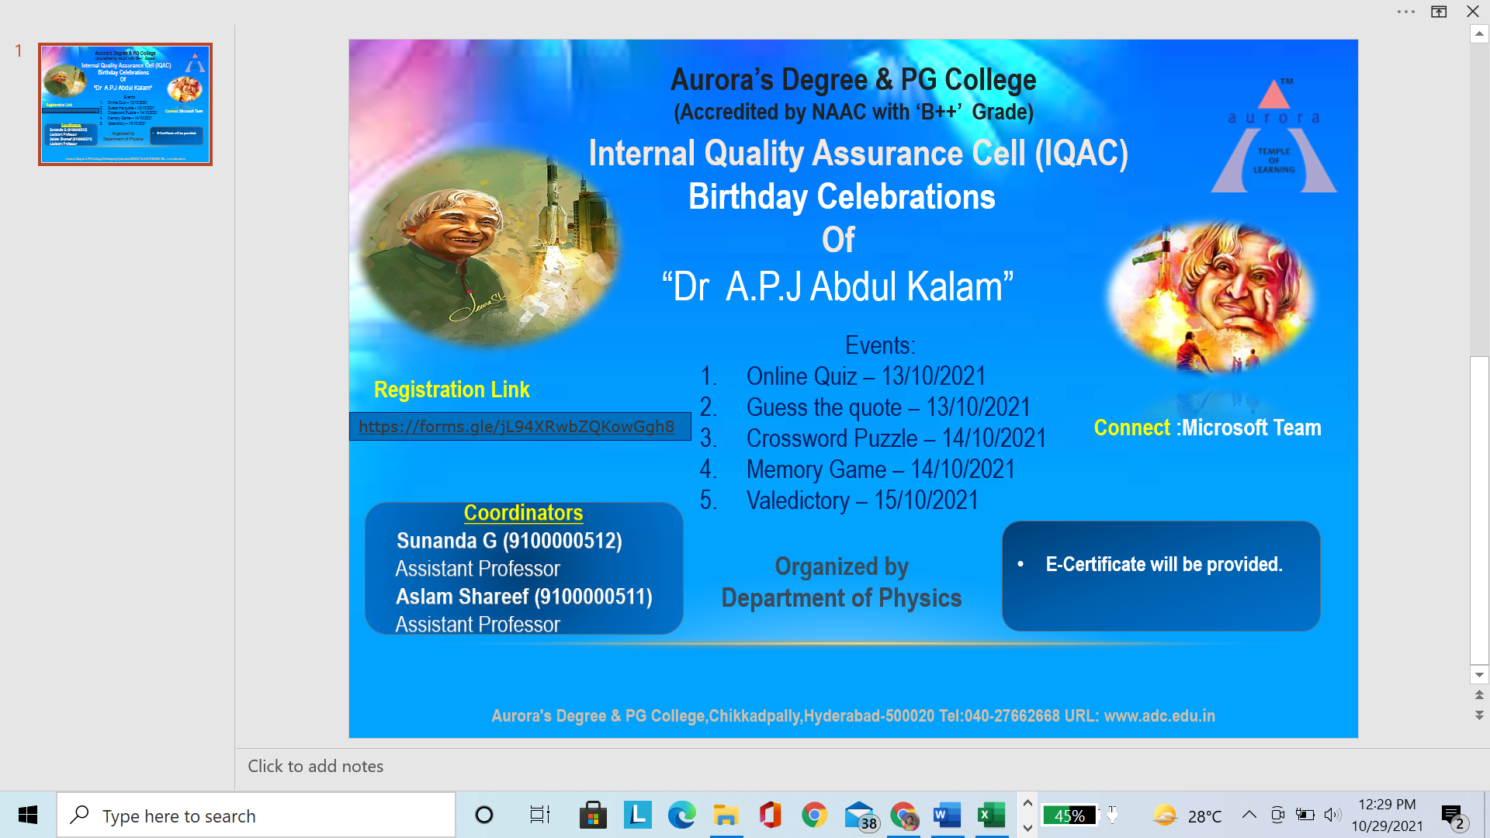

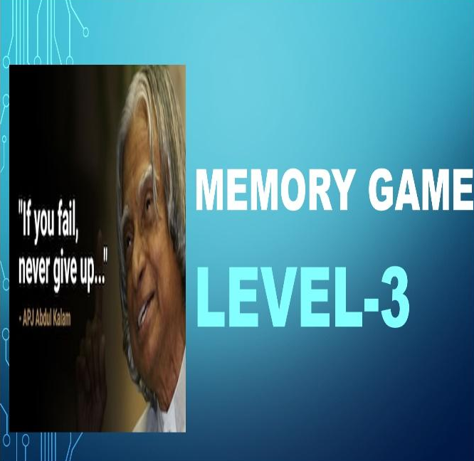

GUEST PROFILE: N/A
FEED BACK : Participants were very much interested and actively participated from various colleges of the city and gave a positive feedback for the events conducted.
Attachments:
EVENT PROPOSAL :

Aurora’s Degree and PG College
(ACCREDITED BY NAAC WITH ‘B++’ GRADE)
Chikkadpally, Hyderabad 500020
Department of Physics

EVENT PROPOSAL
for

Dr. A.P.J Abdul Kalam Birthday celebrations

Event Name: Dr. A.P.J Abdul Kalam celebrations

Event Title: Dr. A.P.J Abdul Kalam celebrations

Department Event: Physics Department
Faculty coordinator: Sunanda G
Date& Venue: 13th, 14th, 15th October 2021, Aurora Degree & PG College
Target audience: Intermediate & UG students.
Platform: Online
Level: City level
Student Volunteer’s: Karthik Sanjay, Harshini & Ravi Verma
Objective: To pay tribute to an eminent scientist “Dr. A.P.J Abdul Kalam” on the occasion of his birthday.
Proposed activities/ Schedule
S.No | Activity | Day | Time | Coordinator
1 | Online quiz | 13/10/2021 | 11:00am -12:00pm | Sunanda G & Udaysree B
2 | Guess the quote | 13/10/2021 | 2:00pm-3:00pm | Sunanda G &  Archana p
3 | Crossword Puzzle | 14/10/2021 | 11:00am -12:00pm | Sunanda G & Aslam Shareef
4 | Memory Game | 14/10/2021 | 2:00pm-3:00pm | Sunanda G &  Archana p
5 | Valedictory | 15/10/2021 | 3:00pm-4:00pm | Sunanda G
Convener IQAC Coordinator Principal
EVENT / ACTIVITY NOTICE:
RECEIPTS: N/A
CERTIFICATE: 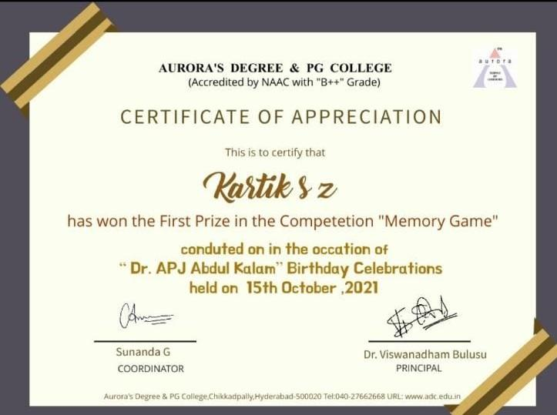

LETTERS OF COMMUNICATION:
Greetings!!!
Aurora's Degree & PG College invites Students of Intermediate and undergraduation to participate in
E- Competition on Birthday Celebrations of “Dr A.P.J Abdul Kalam”
Date: 13/10/2021 to 15/10/2021
Events Details:
1. Online Quiz - 13/10/2021 @ 11:00Am - 12:00 Noon
2. Guess the Quote - 13/10/2021 @ 02:00 Pm - 03:00 Pm
3. Crossword Puzzle - 14/10/2021 @ 11:00 Am - 12:00 Noon
4. Memory Game - 14/10/2021 @ 02:00 Pm - 03:00 Pm
5. Valedictory - 15/10/2021 @ 03:00 Pm - 04:00 Pm
Link will be disabled @ 12.00 Noon and 03:00 Pm for Each competition respectively.
Registration Link:
https://forms.gle/jL94XRwbZQKowGgh8
E- Certificate will be issued.
Coordinators
1. Sunanda G - 9100000512
Assistant Professor in Physics dept
2. Aslam Shareef - 9100000511
Assistant Professor in Physics dept
Warm Regards,
Department of Physics
Aurora’s Degree and PG College

-------------------------------------------------------------------------------------------------------------------------------

