Aurora’s Degree & PG College
(ACCREDITED BY NAAC WITH 'B++' GRADE)
Chikkadpally, Hyderabad 500020

EVENT / ACTIVITY DETAILED REPORT

NAME OF THE EVENT / ACTIVITY | A Two Day National Level FDP On “Recent Trends In Optimization Theory”
TYPE OR TITLE OF EVENT / ACTIVITY | National level FDP
FACULTY INCHARGE | B. Madhavi & A Sandhya Rani
DEPARTMENT/CELL/COMMITTEE/CLUB | Mathematics
DATE | 17th & 18th September 2021
VENUE | ______
TARGET AUDIENCE | Faculty & Research Scholars from Various States

- PROGRAM SCHEDULE
Day 1:
10:45 am – B. Madhavi convener and Associate professor from Department of Mathematics started the event allowing the participants to join.
11:00 am - Welcome address and Introduction by Ms. G. Prathibha, head, Department of mathematics
11:10 am - Introduction of the speaker by Ms. A. Sandhya Rani
11:15 am – Lecture by Dr. Ashish Kumar Prasad is Assistant Professor in Department of Mathematics, School of Advanced Sciences, VIT, Vellore on the topic “ Basic Framework of Nonlinear and Variational Analysis”.
12:45 pm – Doubts clarification
1.00pm - Vote of thanks by Ms. B.Madhavi
Day 2:
10:45 am – B. Madhavi convener and Associate professor from Department of Mathematics started the event allowing the participants to join.
11:10 am - Introduction of the speaker by Ms. A. Sandhya Rani
11:15 am – Lecture by Dr. Amrit Das, Assistant Professor, Department of Mathematics, School of Advanced Sciences, VIT,Vellore, on the topic “Fuzzy sets and its applications in optimal decision making problem”.
12:30 pm – Doubts clarification
12.45pm - Vote of thanks by Ms. B.Madhavi
- LIST OF FACULTY COORDINATORS (DEPARTMENT) : Ms. B.Madhavi & Ms. A. Sandhya Rani
- LIST OF THE STUDENT COORDINATORS (NAME , ROLL NO, CLASS & SECTION) : Nil
- LIST OF THE PARTICIPANTS

S.No | Name | College Name |  |  | Email Id
 | Aleti Rekha | Chaitanya Deemed to be University |  |  | aletirekha8179@gmail.com
 | ASHA ALICE S | St. Xavier's Catholic College of Engineering |  |  | alice@sxcce.edu.in
 | B MANASA | Aurora's Degree and PG College |  |  | Manasab@adc.edu.in
 | B Sravanthi | Bbcit |  |  | bandarisravanthi1989@gmail.com
 | Devarasetty Rajeswari | RGUKT, APIIIT |  |  | raji5msc@gmail.com
 | Dhwani N | Little Flower Degree College, Uppal |  |  | dhwani@lfdc.edu.in
 | Dr .P.KALAISELVI | Government Arts and Science College(Women) Orathanadu |  |  | gkalaimaths@gmail.com
 | Dr SOMESHWAR SIDDI | St. Martin's Engineering College |  |  | someshsiddi@gmail.com
 | Dr. D. Mary Mettalin | St. Xavier's catholic college of engineering chunkankadai nagercoil |  |  | mettalin@sxcce.edu.in
 | Dr. Meerajoshi | Aurora's Degree & PG College |  |  | meerajoshi@adc.edu.in
 | Dr.M.Felix Nes Mabel | St. Xavier's Catholic College of Engineering |  |  | felix@sxcce.edu.in
 | Dr.P.Balaji | SCSVMV DEEMED TO BE UNIVERSITY,KANCHIPURAM |  |  | pbalaji@kanchiuniv.ac.in
 | Dr.P.KALAISELVI | Government Arts and Science College (Women) Orathanadu |  |  |  | gkalaimaths@gmail.com
 | Dr.p.pranay | Chaitanya Deemed to be university warangal urban Telangana state |  |  |  | Pettempranay@gmail.com
 | DR.PRAROOPA YENUBARI | Andhra Loyola college Vijayawada |  |  |  | praroopaphd@gmail.com
 | Dr.S.Amutha | RCHM, Alagappa University, Karaikai-3. |  |  |  | amutharchm2020@gmail.com
 | Dr.V.Vijimon Moni | St. Xavier's Catholic College of Engineering, Chunkankadai |  |  |  | vijimonmoni@sxcce.edu
 | G Pavani | G.Pulla Reddy Degree and PG College |  |  |  | pavaniganduri78@gmail.com
 | Gattu Uday | Chaitanya Deemed to be University |  |  |  | gattuuday123@gmail.com
 | GOPINATH D | Chaitanya (Deemed to be University) |  |  |  | drgopinathduggi@gmail.com
 | Gurram. Srinivas | Sree chaitanya institute of technological sciences,lmd,karimnagar |  |  |  | srinivas.gurram2010@gmsil.com
 | K. Srujana | BBCIT |  |  |  | srujanakundaram@gmail.com
 | K. V. L. N. Mallika | Andhra Loyola College |  |  |  | mallikalakshmi51@gmail.com
 | Kasarla Shravani | Chaitanya Deemed to be university |  |  |  | kasarlashravani1995@gmail.com
 | KEERTHI SPANDANA | CHAITANYA DEEMED TO BE UNIVERSITY |  |  |  | spandana.keerthi7@gmail.com
 | KORRAPATI RAJYALAKSHMI | Vignan Degree&Pg College, Guntur |  |  |  | korrapatirajyalakshmi5@gmail.com
 | Korrapati Rajyalakshmi | Vignan degree&pg college, Guntur. |  |  |  | korrapatirajyalakshmi5@gmail.com
 | L.Mary Florida | St.Xaviers Catholic College of Engineering |  |  |  | floridanxn@gmail.com
 | M. Alexlin Sahaya Ithal | St. Xavier's Catholic College of Engineering |  |  |  | ithal@sxcce.edu.in
 | M. Padmavathi | Kamaraj college, Tiruchendure road, Thoothukudi |  |  |  | padmavathimariappan@gmail.com
 | M.Devika | ADC |  |  |  | devikam@adc.edu.in
 | Mary Florida.L | St.Xaviers Catholic College of Engineering |  |  |  | florida@sxcce.edu.in
 | Math Muragesh Mantayya | Blde du medical college vijayapur |  |  |  | murageshmathapati5@gmail.com
 | Mrs.ANUPAMA PANDEY | BBCIT |  |  |  | anupamaanjesh@gmail.com
 | Ms Shafeen Komalam Mohan | University of Technology and Applied Sciences - IBRA |  |  |  | shafeen@ict.edu.om
 | P SWARAJYA LAKSHMI | APIIIT |  |  |  | swarajyalakshmipitta@gmail.com
 | P. Chandrakala | Aurora's Degree & PG College |  |  |  | chandrakalap@adc.edu.in
 | PARITALA SUNEETHA | Vignan Degree And P. G College |  |  |  | Jclawtelugu@gmail.com
 | Pavani Ganduri | G.Pulla Reddy Degree and PG College |  |  |  | pavaniganduri78@gmail.com
 | Prathibha G | Aurora's Degree and Pg College |  |  |  | prathibag@adc.edu.in
 | R.CHANDRASHEKAR | Aurora's degree and pg college |  |  |  | chandrashekarr@adc.edu.in
 | S. Pratap | Chaitanya Deemed to be University |  |  |  | sangapratap@gmail.com
 | S.Sophia | St.Xavier's Catholic College of Engineering, Chunkankadai |  |  |  | sophia@sxcce.edu.in
 | Shafeen Komalam Mohan | University of Technology and Applied Sciences- Ibra |  |  |  | shafeen@ict.edu.om
 | Smt.S.Saritha | Indian Institute of Management and Commerce |  |  |  | sarithasambu@gmail.com
 | Sunitha polu | CDU |  |  |  | Suneetha911polu@gmail.com
 | T VANI MADHAVI | Chaitanya Deemed to be University |  |  |  | vanimadhavialloju@gmail.com
 | T. Berjin Magizha | St. Xavier's Catholic College of Engineering Nagercoil |  |  |  | berjin@sxcce.edu.in
 | Y Sri Krishna Mohan | Aurora's Degree and PG College |  |  |  | srikrishnamohany@adc.edu.in
 | Yenubari Pradeeptha | DS Govt. Degree college, Ongole |  |  |  | pradeepthayenubari@gmail.com
39 | Pavani Ganduri | G.Pulla Reddy Degree and PG College |  |  |  | pavaniganduri78@gmail.com
40. | Prathibha G |  | Aurora's Degree and Pg College | prathibag@adc.edu.in
41 | R.CHANDRASHEKAR |  | Aurora's degree and pg college | chandrashekarr@adc.edu.in
42 | S. Pratap |  | Chaitanya Deemed to be University | sangapratap@gmail.com
43 | S.Sophia |  | St.Xavier's Catholic College of Engineering, Chunkankadai | sophia@sxcce.edu.in
44 | Shafeen Komalam Mohan |  | University of Technology and Applied Sciences- Ibra | shafeen@ict.edu.om
45 | Smt.S.Saritha |  | Indian Institute of Management and Commerce | sarithasambu@gmail.com
46 | Sunitha polu |  | CDU | Suneetha911polu@gmail.com
47 | T VANI MADHAVI |  | Chaitanya Deemed to be University | vanimadhavialloju@gmail.com
48 | T. Berjin Magizha |  | St. Xavier's Catholic College of Engineering Nagercoil | berjin@sxcce.edu.in
49 | Y Sri Krishna Mohan |  | Aurora's Degree and PG College | srikrishnamohany@adc.edu.in
50 | Yenubari Pradeeptha |  | DS Govt. Degree college, Ongole | pradeepthayenubari@gmail.com

- PARAGRAPH ABOUT THE PROCEEDINGS (TILL THE END OF THE EVENT)
On account of birthday celebrations of Georg Friedrich Bernhard Riemann on 17th & 18th September 2021 the Department of Mathematics organised a two day National Level Faculty Development Program on “Recent Trends in Optimization Theory” through online mode (Microsoft Teams).
The Program started on 17-09-2021 at 11.00 AM .The first day of the program started with an introductory speech by G. Prathibha head of the department of mathematics, Aurora’s Degree & PG College, and A Sandhya Rani introduced the speaker Dr. Ashish Kumar Prasad is Assistant Professor in Department of Mathematics, School of Advanced Sciences, VIT, Vellore. The session is handover to the Speaker. The lecture started at 11:15 AM. by Prof. Ashish Kumar Prasad. He delivered the lecture on “Basic Framework of Nonlinear and Variational Analysis”. In the lecture, sir explained Convexity & Duality, which includes the role of convexity in optimization theory and multi-objective programming problems. The lecture was very interesting. He spoke about how the faculty members need to keep them updated with all skills from time to time.
On the next day 18-09-2021 the Program started at 11.00 AM with Dr. Amrit Das lecture on “Fuzzy Set and Its Applications in Optimal Decision Making Problem”. In the lecture, the speaker explained about definition & properties of fuzzy sets, the representation of fuzzy numbers, and different forms of fuzzy sets. He also explained the applications of fuzzy sets to optimal decision-making problems.
The main objective is to understand the concepts from Nonlinear Analysis & Variational Analysis from the perspective of Optimization Theory and also to educate and motivate the faculty members for research in the area of Optimization Techniques.
The Faculty in Mathematics got knowledge in new techniques in teaching mathematics and different ideas in Optimization Techniques. On each day around 50 members were participated.

- INCOME AND EXPENDITURE: Nil
- EVENT PHOTOS ( MIN 2 MAX 4)
- 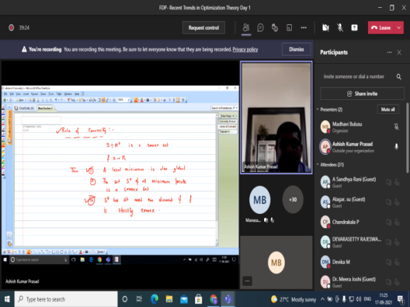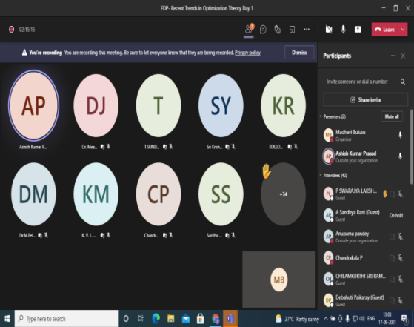
- 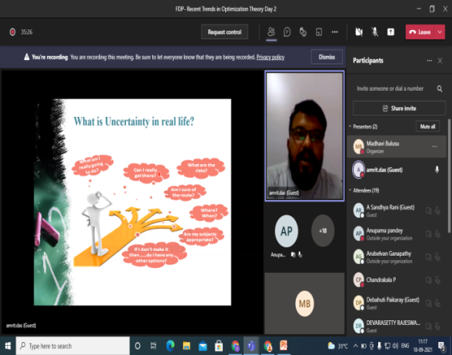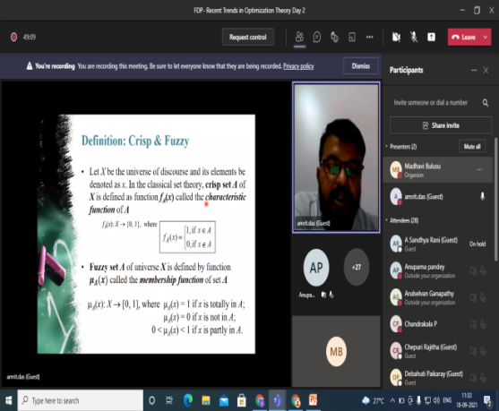

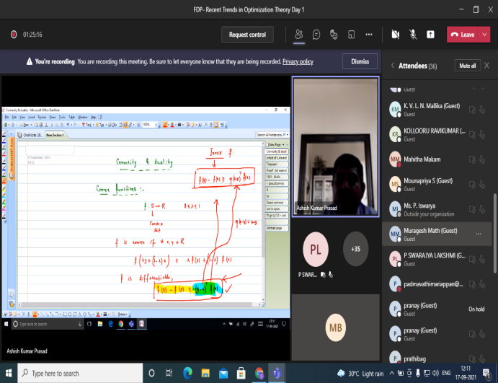

- GUEST PROFILE (IF ANY)

- FEED BACK IF ANY

- ATTACHMENTS:
EVENT/ACTIVITY PROPOSAL
Aurora’s Degree & PG College
(ACCREDITED BY NAAC WITH 'B++' GRADE)
Chikkadpally, Hyderabad 500020
Department of Mathematics

EVENT PROPOSAL

Event Name : A Two Day Faculty Development Programme on account of

Riemann’s Birthday Celebrations.
Faculty Coordinator : Ms. B. Madhavi & Ms. A. Sandhya Rani
Date : 17/09/2021 & 18/09/2021
Venue : Aurora’s Degree & PG College, Chikkadpally, Hyderabad.
Target Audience : Faculty of various degree and PG colleges
Level : National level
Budget : Nil
Theme : Recent Trends in Optimization Theory
Objective : To understand the concepts from Nonlinear Analysis & Variational Analysis from the perspective of Optimization Theory.

Proposed Activities : A two day national level FDP
On account of birthday celebrations of Georg Friedrich Bernhard Riemann on 17 September 2021 the department of Mathematics is organizing a Faculty Development Programme. He was a German mathematician who made contributions to analysis, number theory, and differential geometry. In the field of real analysis, he is mostly known for the first rigorous formulation of the integral, the Riemann integral, and his work on Fourier series.

Day 1 :
Resource person: Dr. Ashish Kumar Prasad, Assistant Professor, Department of Mathematics
School of Advanced Sciences, VIT,Vellore
Topic: Basic Framework of Nonlinear and Variational Analysis
Day 2:
Resource person: Dr Amrit Das, Assistant Professor, Department of Mathematics
School of Advanced Sciences, VIT,Vellore
Topic: Fuzzy set and its applications in optimal decision making problem

B.Mdhavi & A.Sandhya Dr. Ravi Kiran Dr.Viswandhm Bulusu
EVENT COORDINATOR IQAC COORDINATOR PRINCIPAL

EVENT / ACTIVITY NOTICE: Nil
RECEIPTS (IF ANY): Nil
CERTIFICATES (IF ANY)
Guest certificates:
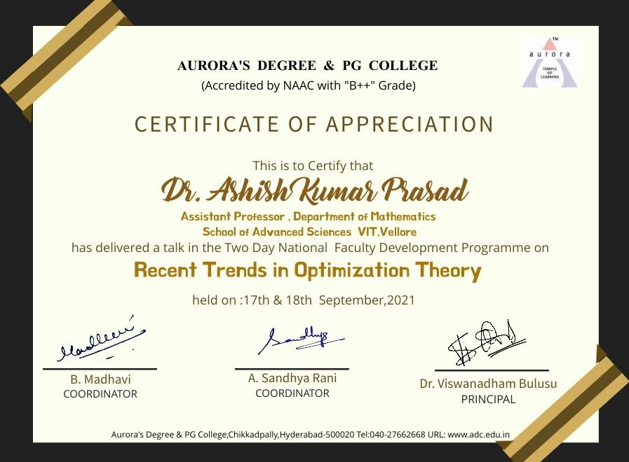
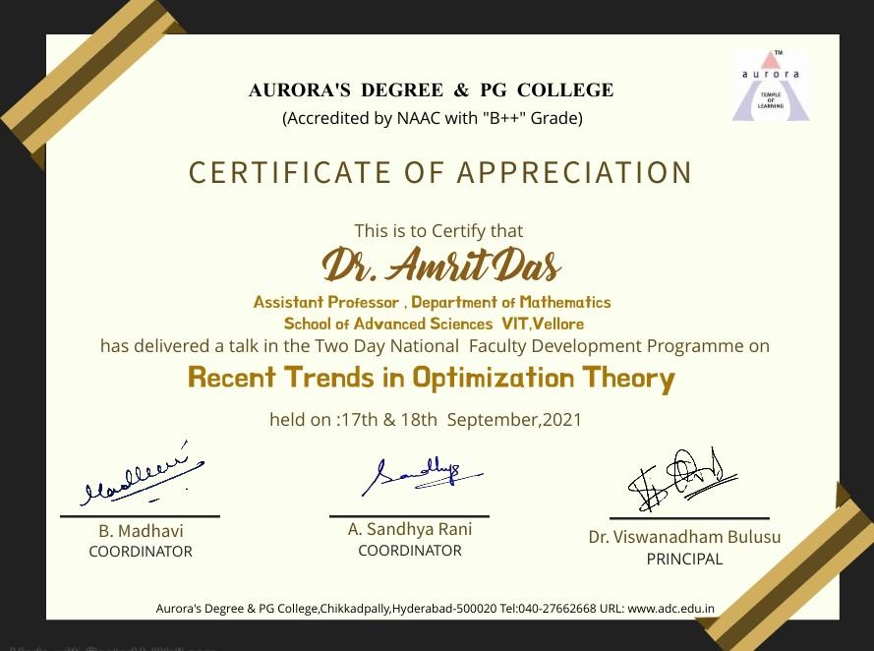
Certificate given to participants:

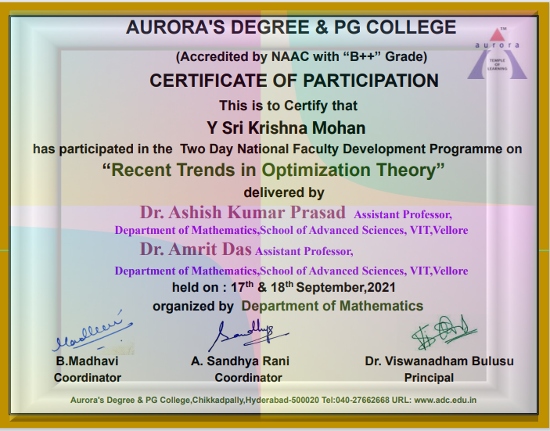

LETTERS OF COMMUNICATION (IF ANY):

Invitation regarding as a resource person for FDP
External
Madhavi Bulusu <madhavibulusu@adc.edu.in> | Thu, Aug 26, 11:15 AM
to ashish.kumar

Good Morning Sir,
I am B.Madhavi, working as an associate professor in the Department of Mathematics at Aurora's Degree and PG College Hyderabad, Telangana.

The Department organises lecture series, workshops, conferences, FDPs etc; for the benefit of students and teachers at the graduate and under graduate levels.
We would like to organize a two day FDP on ‘Fuzzy Optimization' on 17th & 18th of September. I hereby request you to be a resource person for one day.
So, I request you to kindly accept my invitation to be a speaker so that the teacher community will be benefited.
In case you feel the title needs a change, you can change it the way you want.
We have the capacity of organizing the programme on Microsoft Teams. In the present scenario, we are making the registration free for the participants.
Thanking you
With regards
B.Madhavi,
Department of Mathematics,
Chikkadapally,
Hyderabad.
Ashish Kumar Prasad <ashish.kumar@vit.ac.in> | Fri, Aug 27, 12:15 AM
to me

Dear Madam,
I am very glad to know that you are organising FDP on Fuzzy Optimization. My area of research is Convex Optimization/ Variational Analysis. If you are comfortable I would like to give lectures on " Variational Analysis and it's Applications to Optimization". Hope this topic may be interesting and useful. I will be waiting for your reply.
Thanks
Ashish

From: Madhavi Bulusu <madhavibulusu@adc.edu.in>
Sent: Thursday, August 26, 2021 11:15:16 AM
To: ashish.kumar@vit.ac.in <ashish.kumar@vit.ac.in>
Subject: Invitation regarding as a resource person for FDP

...
[Message clipped] View entire message
Madhavi Bulusu <madhavibulusu@adc.edu.in> | Fri, Aug 27, 3:44 PM
to Ashish

Dear Professor,
Thank you so much for your acceptance. I will let you know the details very soon. May I know your phone number so that I can contact .
Ashish Kumar Prasad <ashish.kumar@vit.ac.in> | Fri, Aug 27, 4:10 PM
to me

Dear Madam,
My contact no is +91-9931283062
Thanks
Get Outlook for Android

From: Madhavi Bulusu <madhavibulusu@adc.edu.in>
Sent: Friday, August 27, 2021 3:44:20 PM
To: Ashish Kumar Prasad <ashish.kumar@vit.ac.in>
Subject: Re: Invitation regarding as a resource person for FDP

...
[Message clipped] View entire message
Ashish Kumar Prasad <ashish.kumar@vit.ac.in> | Wed, Sep 8, 1:13 PM
to me

Respected Madam,
Please find attached here my CV.

Topic of Talk: Basic Framework of Nonlinear and Variational Analysis

Best Regards
Ashish Kumar Prasad
------------------------------------------------
Dr. Ashish Kumar Prasad
Assistant Professor | Department of Mathematics
School of Advanced Sciences | VIT
Vellore-632014 | India
Email: ashishprasa@gmail.com
Mobile: +91-9931283062
-----------------------------------------------
VIT – Recognised as Institution of Eminence (IoE) by Government of India

From: Ashish Kumar Prasad
Sent: Friday, August 27, 2021 4:12:52 PM
To: Madhavi Bulusu

...
[Message clipped] View entire message
Attachments area
Madhavi Bulusu <madhavibulusu@adc.edu.in> | Wed, Sep 8, 4:08 PM
to Ashish

Thank you very much. sir
ReplyForward

Invitation regarding as a resource person for FDP
External
Inbox
Madhavi Bulusu <madhavibulusu@adc.edu.in> | Mon, Aug 16, 3:13 PM
to amrit.das

Good Morning Sir,

I am B.Madhavi, working as an associate professor in the Department of Mathematics at Aurora's Degree and PG College Hyderabad, Telangana. The Department organises lecture series, workshops, conferences, FDPs etc; for the benefit of students and teachers at the graduate and under graduate levels.We would like to organize a two day FDP on ‘Fuzzy Optimization' on 17th & 18th of September. I hereby request you to be a resource person for one day.So, I request you to kindly accept my invitation to be a speaker so that the teacher community will be benefited. In case you feel the title needs a change, you can change it the way you want.
We have the capacity of organizing the programme on Microsoft Teams. Please let us know your expectations with regard to support required from ourside.
In the present scenario, we are making the registration free for the participants.
Thanking you
With regards
B.Madhavi,
Department of Mathematics,
Chikkadapally,
Hyderabad.
Amrit Das <amrit.das@vit.ac.in> | Tue, Aug 17, 11:13 AM
to me

Respected Madam,
I am honored by your invitation and will be happy to deliver a talk on this FDP. Meanwhile please let me know what facilities you are providing for an online speaker from your side. It would be highly appreciable for me to have this information from you.
With thanks,
Amrit

Dr. Amrit Das
Assistant Professor, Department of Mathematics,
VIT University, Vellore, India.
https://scholar.google.co.in/citations?user=iMXGlyEAAAAJ&hl=en
VIT – Recognised as Institution of Eminence (IoE) by Government of India

From: Madhavi Bulusu <madhavibulusu@adc.edu.in>
Sent: Monday, August 16, 2021 3:13:00 PM
To: Amrit Das
Subject: Invitation regarding as a resource person for FDP

...
[Message clipped] View entire message
Madhavi Bulusu <madhavibulusu@adc.edu.in> | Wed, Aug 18, 2:33 PM
to Amrit

Thank you very much sir for accepting our invitation.
We are planning to organize the FDP through microsoft teams. In this pandemic situation, for the benefit of the faculty we are making registrations free.
Microsoft teams app should be download in your laptop. As soon as you join, we will make you as a presenter so that you can share your screen,
Amrit Das <amrit.das@vit.ac.in> | Wed, Aug 18, 3:51 PM
to me

Respected Prof.
Thanks for your last email, just one clarification requires to sort out here and it is about the honorarium for a speaker, please let me about it.
Thanks and regards
Amrit.

Dr. Amrit Das
Assistant Professor, Department of Mathematics,
VIT University, Vellore, India.
https://scholar.google.co.in/citations?user=iMXGlyEAAAAJ&hl=en
VIT – Recognised as Institution of Eminence (IoE) by Government of India

From: Madhavi Bulusu <madhavibulusu@adc.edu.in>
Sent: Wednesday, August 18, 2021 2:33:45 PM
To: Amrit Das
Subject: Re: Invitation regarding as a resource person for FDP

...
[Message clipped] View entire message
Madhavi Bulusu <madhavibulusu@adc.edu.in> | Sat, Aug 21, 4:05 PM
to Amrit

Good evening professor,
In this pandemic situation, as we are not collecting any registration fee from the participants, we cannot afford any honorarium.
Thank you so much sir if you accept otherwise, we miss your lecture.

Regards,
B. Madhavi,
Department of Mathematics,
Chikkadapally,
Hyderabad.
Amrit Das <amrit.das@vit.ac.in> | Sat, Aug 21, 4:16 PM
to me

Respected Prof.
Thanks to you for sharing the information, Madam, I have no issue at all and will be very happy to participate in your program. Please share all the relevant supplements related to my talk and your FDP.
Best regards
Dr. Amrit Das
Assistant Professor, Department of Mathematics,
VIT University, Vellore, India.
https://scholar.google.co.in/citations?user=iMXGlyEAAAAJ&hl=en
VIT – Recognised as Institution of Eminence (IoE) by Government of India

From: Madhavi Bulusu <madhavibulusu@adc.edu.in>
Sent: Saturday, August 21, 2021 4:05:49 PM

...
[Message clipped] View entire message
Madhavi Bulusu <madhavibulusu@adc.edu.in> | Mon, Aug 23, 4:30 PM
to Amrit

Dear Professor,
Thank you so much for your kind heart. I will let you know about the details very soon.
Madhavi Bulusu <madhavibulusu@adc.edu.in> | Sat, Sep 4, 11:13 AM
to Amrit

Good morning Professor,

May I know your contact number?
Amrit Das <amrit.das@vit.ac.in> | Sat, Sep 4, 3:21 PM
to me

Hello Maam,
My contact number is 9774227053.
Best regards
Amrit

Dr. Amrit Das
Assistant Professor, Department of Mathematics,
VIT University, Vellore, India.
https://scholar.google.co.in/citations?user=iMXGlyEAAAAJ&hl=en
VIT – Recognised as Institution of Eminence (IoE) by Government of India

From: Madhavi Bulusu <madhavibulusu@adc.edu.in>
Sent: Saturday, September 4, 2021 11:13:30 AM

...
[Message clipped] View entire message
Amrit Das <amrit.das@vit.ac.in> | Tue, Sep 7, 11:16 AM
to me

Good morning ma'am,
In the webinar, the title of my talk is "Fuzzy set and its applications in optimal decision making problem".
I like to give my talk on 18th Sepetember and any time after 10 AM will be okay for me.
And ma'am one request if you are preparing any poster for your FDP please share it with me.
Best regards
Amrit.

Dr. Amrit Das
Assistant Professor, Department of Mathematics,
VIT University, Vellore, India.
https://scholar.google.co.in/citations?user=iMXGlyEAAAAJ&hl=en
VIT – Recognised as Institution of Eminence (IoE) by Government of India

From: Amrit Das
Sent: Saturday, September 4, 2021 3:23:00 PM
To: Madhavi Bulusu

...
[Message clipped] View entire message
Madhavi Bulusu <madhavibulusu@adc.edu.in> | Tue, Sep 7, 11:53 AM
to Amrit

Good moring Professor,
Sure I will share the posture after preparing it. Could you please send your profile sir?
Amrit Das <amrit.das@vit.ac.in> | Wed, Sep 8, 2:31 PM
to me

Respected Maam
PFA.
Best regards.
Amrit

Dr. Amrit Das
Assistant Professor, Department of Mathematics,
VIT University, Vellore, India.
https://scholar.google.co.in/citations?user=iMXGlyEAAAAJ&hl=en
VIT – Recognised as Institution of Eminence (IoE) by Government of India

From: Madhavi Bulusu <madhavibulusu@adc.edu.in>
Sent: Tuesday, September 7, 2021 11:53:18 AM

...
[Message clipped] View entire message
Attachments area

