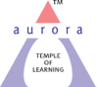
Aurora’s Degree & PG College
(ACCREDITED BY NAAC WITH 'B++' GRADE)
Chikkadpally, Hyderabad 500020

NAME OF THE EVENT | World Senior Citizen Day
TYPE OF EVENT | College Event
FACULTY INCHARGE | K.Sujatha
DEPARTMENT | Commerce
DATE | 21/8/2020
VENUE | Musheerabad- Little Sisters Home for the aged
TARGET AUDIENCE | Nil

OBJECTIVE:
- This event is preferred to enlighten the students on the significance of elderly people in up bringing their family and society.
- The World Senior Citizen’s Day is selected to help our students to overcome from that tendency and meet those abandoned elderly people and help them in possible ways

BRIEF ABOUT THE EVENT:
The students of Present B.com 3A, 3B, 3C, 3D & 3E captains have taken part in this event. As mentioned in the proposal we have visited an old age home at Musheerabad- Little Sisters Home for the aged.There were around 50 old people staying in the home. Most of them were abandoned by their children. This is the most unfortunate thing happening in the society.
OUTCOME:
Our students interacted with the elderly people even the situation is Corona- pandemic. They felt sorry for them and contributed the requirements mentioned by the home. The students are happy to do some social service and they are so delighted to participate in more events.

Photographs:
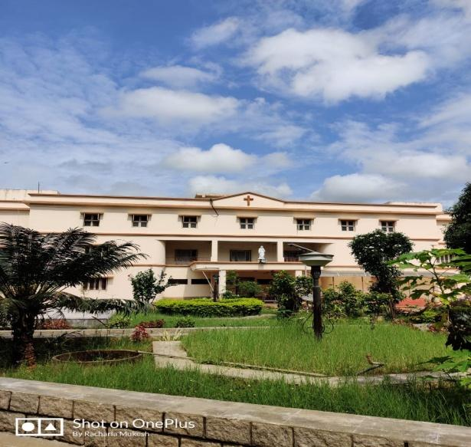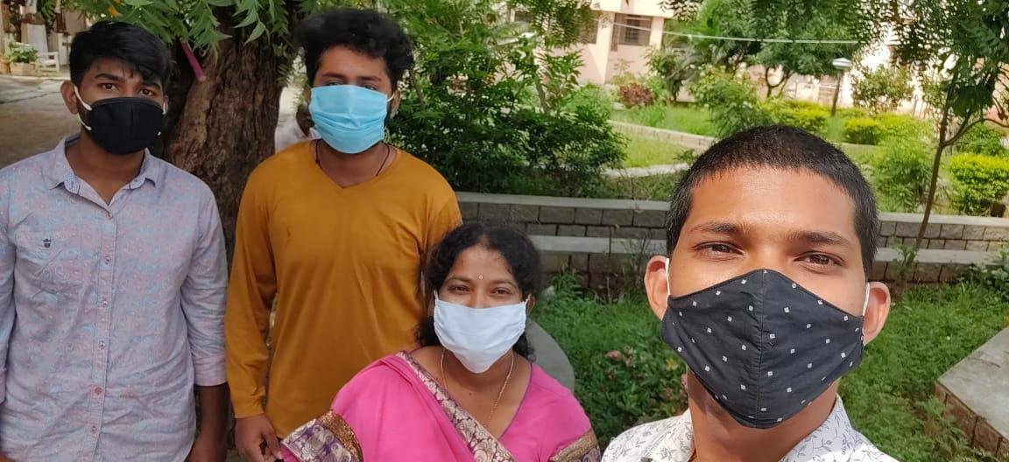

DETAILED REPORT:
The main aim of conducting this event is to create some genuine awareness in the present world. Now a day’s the children are not interested to live with parents or continue with them may be before or after their settlement, the old parents are kept in old age homes or left on the roads etc..
So to bring some special experience, give some societal knowledge as what’s exactly happening in the world, how they are suffering children and how are they cheated. This event was taken by sujatha.k from commerce department has organized with the help of our class captains of present B.com 3A,B,C,E and two more students of B.com 3A & 3C been a part of the event.
The World Senior Citizens Day is acknowledged for the welfare of elder persons to enroll and appreciate their achievements. As mentioned in the proposal we have visited an old age home Musheerabad - Little sisters home for the aged Secunderabad. Most of them were abandoned by their children. This is the most unfortunate thing in the society.
Budget: Total Amount Collected was 1900rs.
Groceries : 500/-
Detergents : 700/-
Underpads: 700
- LIST OF THE STUDENT COORDINATORS (NAME , ROLL NO, CLASS & SECTION)
Name | Class & Section
Pravalika | 2A
Bharath | 2A
B.Prranav | 2B
Sony | 2C
Mukesh | 2E
G.Rohit | 2C

PHOTOGRAPH:

