Aurora’s Degree & PG College
(ACCREDITED BY NAAC WITH 'B++' GRADE)
Chikkadpally, Hyderabad 500020
Department of Mathematics

EVENT PROPOSAL

Event Name : Cauchy’s Birthday
Faculty Coordinator : B. Madhavi
Event Date & Venue : 21/08/2020, Aurora’s Degree & PG College, Chikkadpally, Hyderabad.

Target Audience : UG students

Level : Class level
Budget : Nil
Objective : To make students aware about contributions of Cauchy in mathematics field as to inspire and motivate students.

Proposed Activities : Conducting quiz and webinar and PPT presentation

Event Details : Baron Augustin-Louis Cauchy (21 August 1789 – 23 May 1857) was a French mathematician, engineer, and physicist who made pioneering contributions to several branches of mathematics, including mathematical analysis and continuum mechanics. He was one of the first to state and rigorously prove theorems of calculus, rejecting the heuristic principle of the generality of algebra of earlier authors. He almost singlehandedly founded complex analysis and the study of permutation groups in abstract algebra.
A profound mathematician, Cauchy had a great influence over his contemporaries and successors; Hans Freudenthal stated: "More concepts and theorems have been named for Cauchy than for any other mathematician (in elasticity alone there are sixteen concepts and theorems named for Cauchy)." Cauchy was a prolific writer; he wrote approximately eight hundred research articles and five complete textbooks on a variety of topics in the fields of mathematics and mathematical physics.

OUTCOME:
- The participants will learn the true value of analytics.
- The Participants will learn about the role of statistics in Analytics.

Aurora’s Degree & PG College
(ACCREDITED BY NAAC WITH 'B++' GRADE)
Chikkadpally, Hyderabad 500020

NAME OF THE EVENT | Cauchy Birthday
TYPE OF EVENT | Department event
FACULTY INCHARGE | B. Madhavi
DEPARTMENT | Mathematics
DATE | 21st August 2020
VENUE | Aurora’s Degree and PG College
TARGET AUDIENCE | Faculty from various colleges from various states

OBJECTIVE:
- To enlighten the participants about the primary role of statistics in analytics.
Event Details : Baron Augustin-Louis Cauchy (21 August 1789 – 23 May 1857) was a French mathematician, engineer, and physicist who made pioneering contributions to several branches of mathematics, including mathematical analysis and continuum mechanics. He was one of the first to state and rigorously prove theorems of calculus, rejecting the heuristic principle of the generality of algebra of earlier authors. He almost single handedly founded complex analysis and the study of permutation groups in abstract algebra.
A profound mathematician, Cauchy had a great influence over his contemporaries and successors; Hans Freudenthal stated: "More concepts and theorems have been named for Cauchy than for any other mathematician (in elasticity alone there are sixteen concepts and theorems named for Cauchy)." Cauchy was a prolific writer; he wrote approximately eight hundred research articles and five complete textbooks on a variety of topics in the fields of mathematics and mathematical physics

Proposed Activities : Conducting quiz, webinar and PPT presentation
OUTCOME:
- The participants will learn the true value of analytics.
- The Participants will learn about the role of statistics in Analytics.

Photographs:

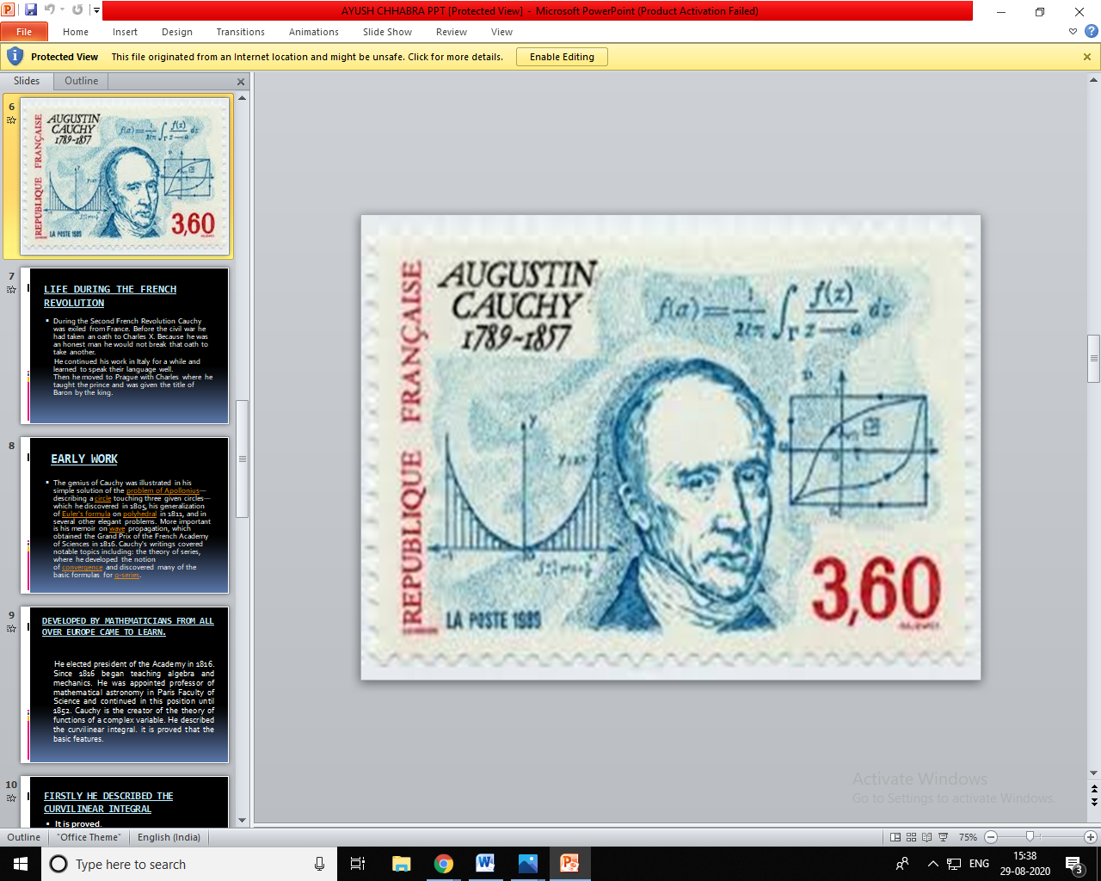
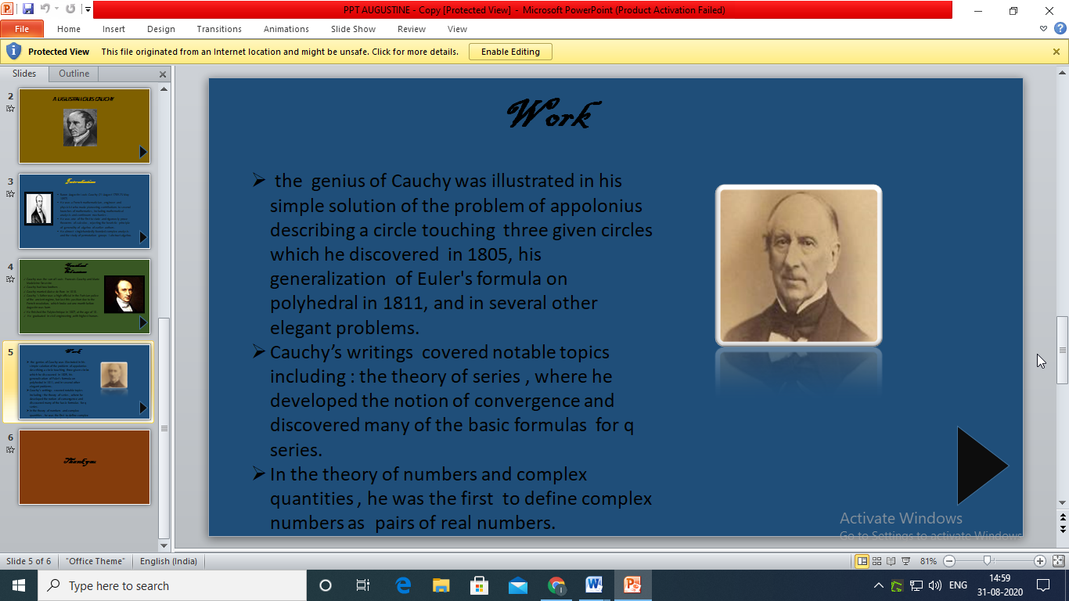
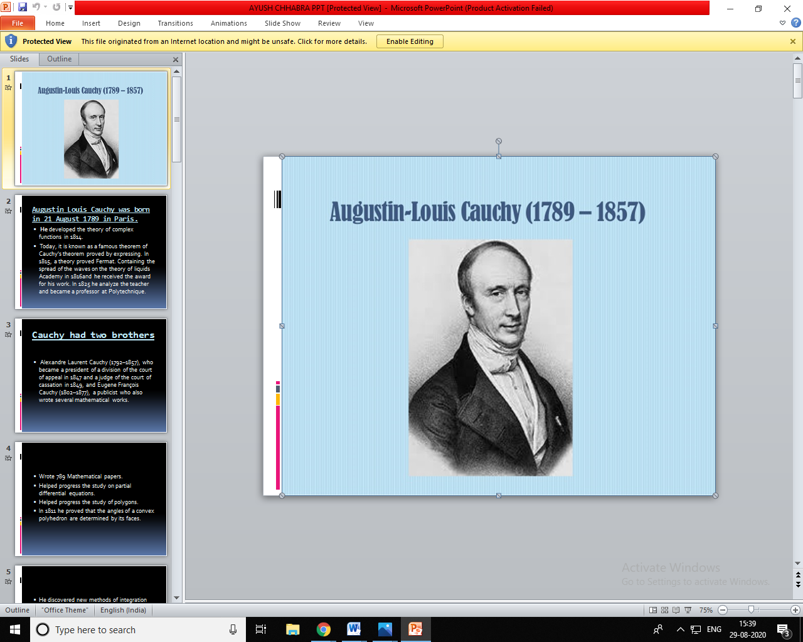
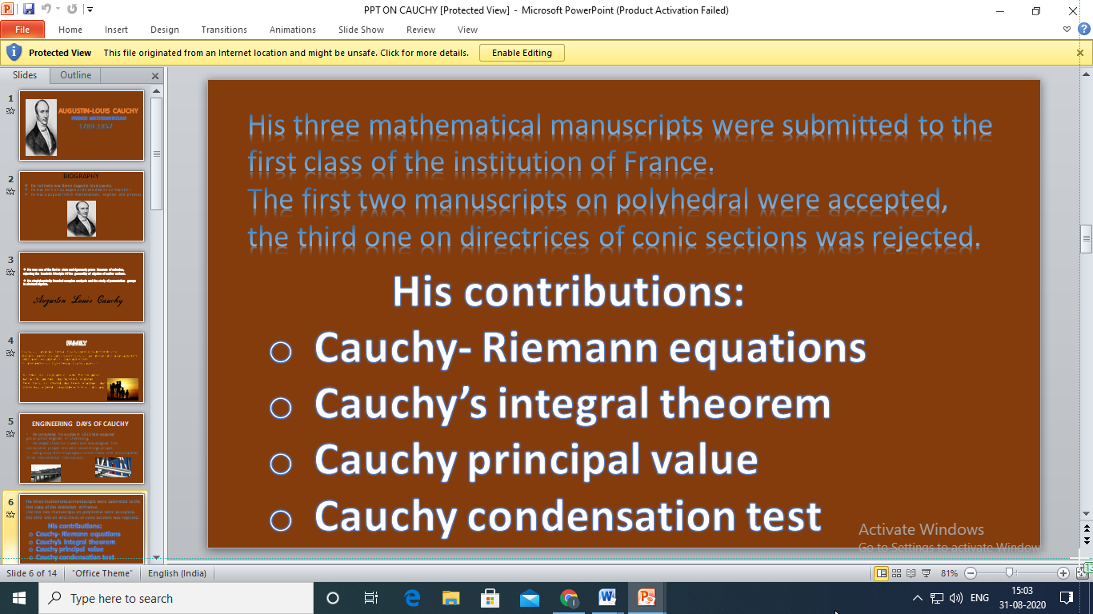
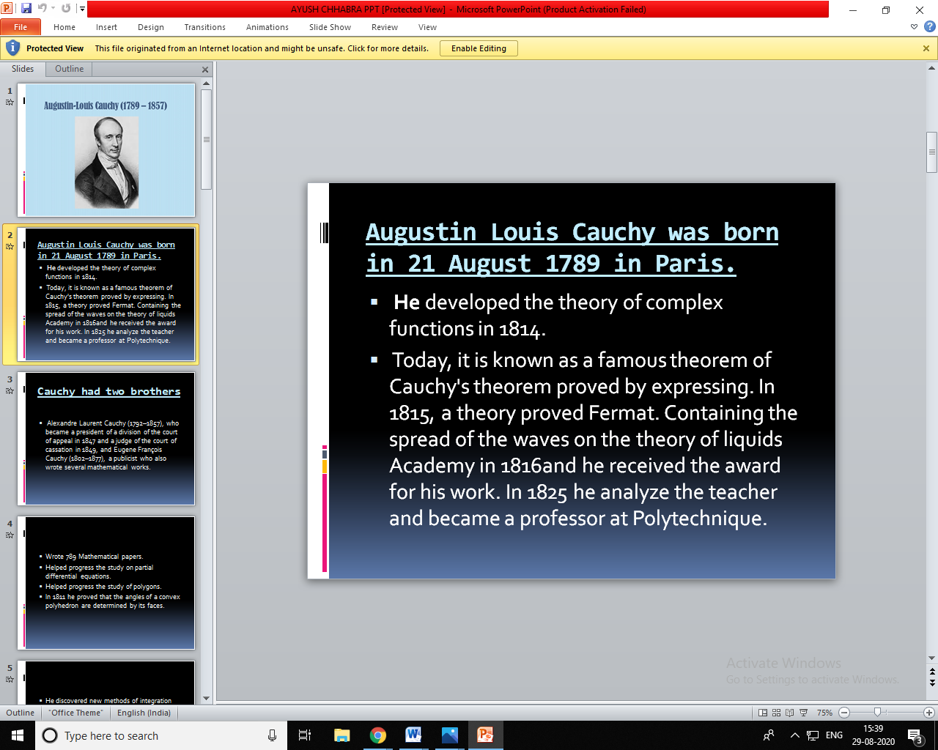

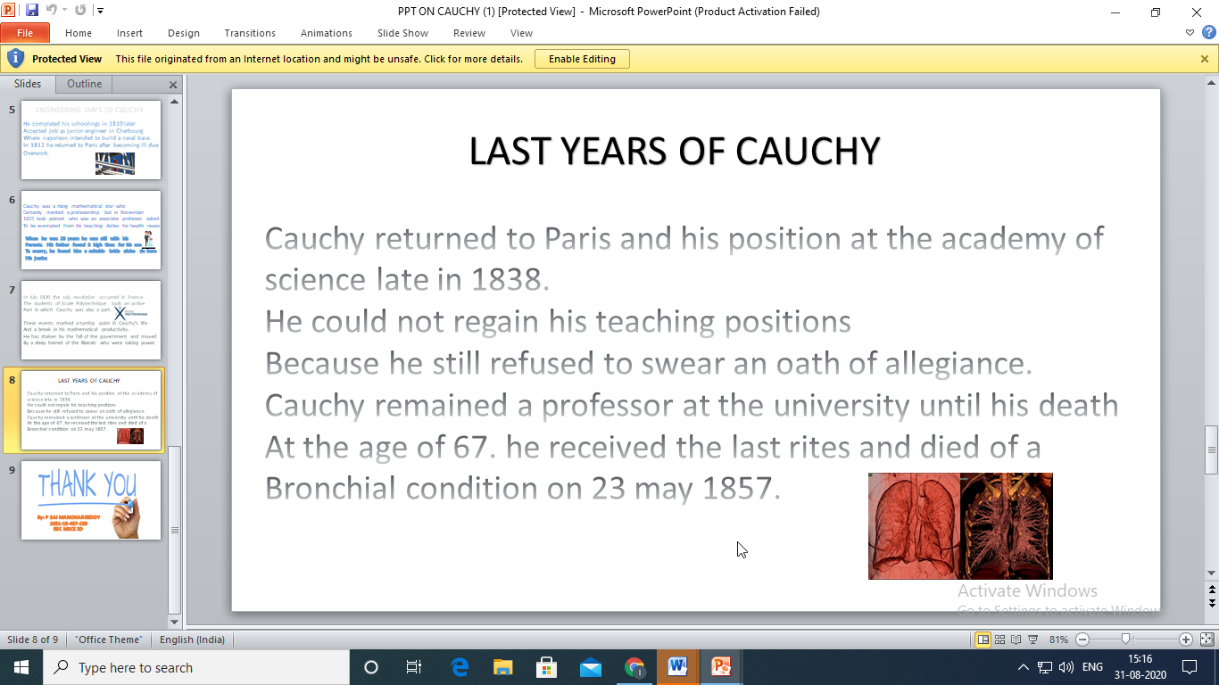
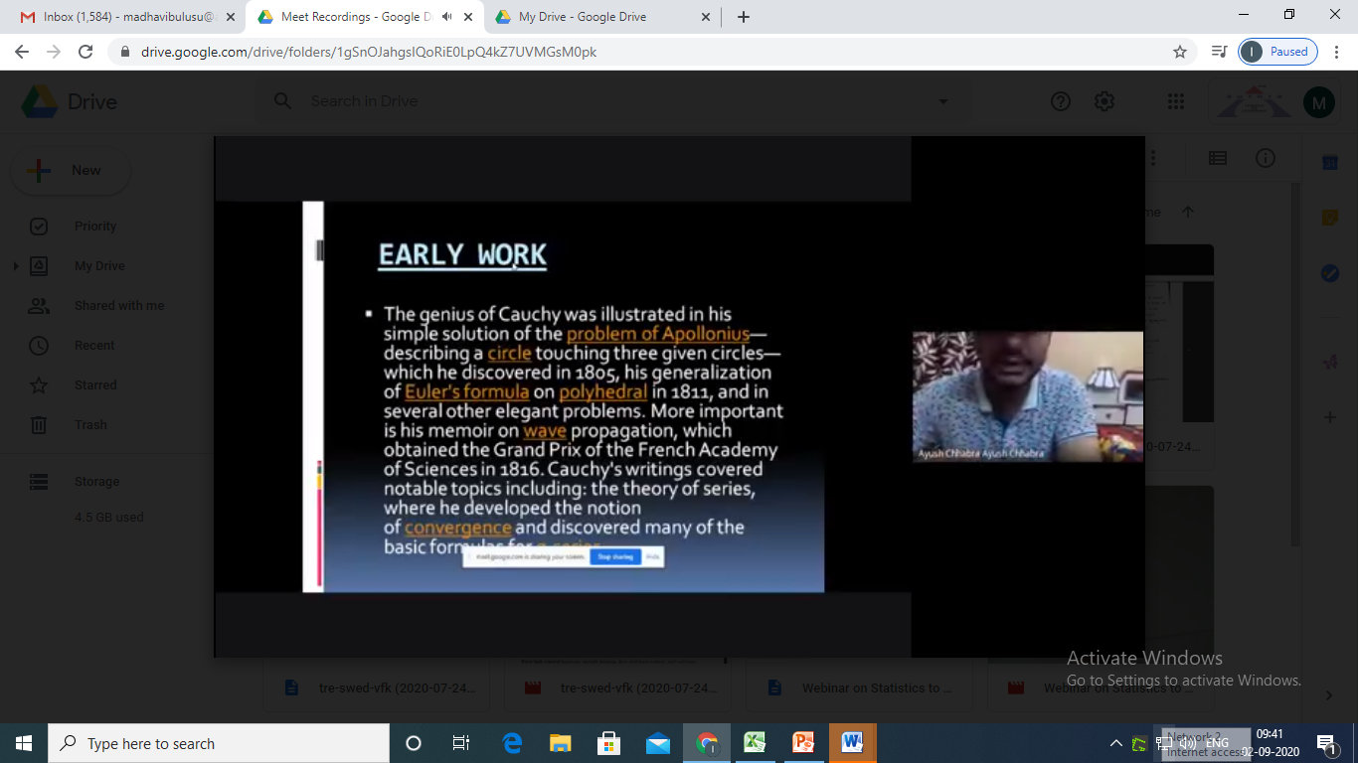
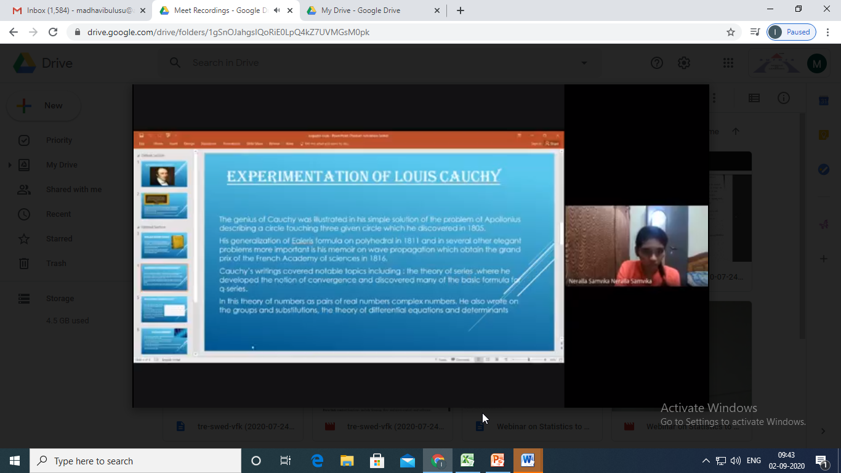

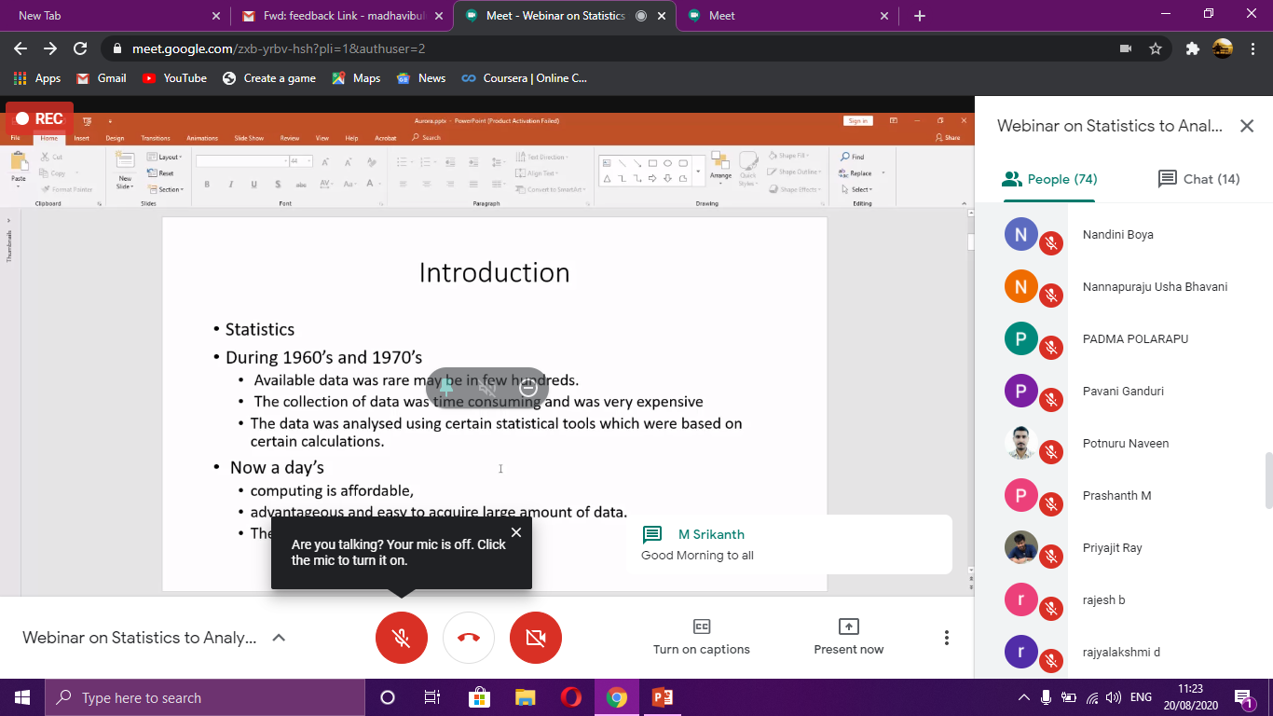

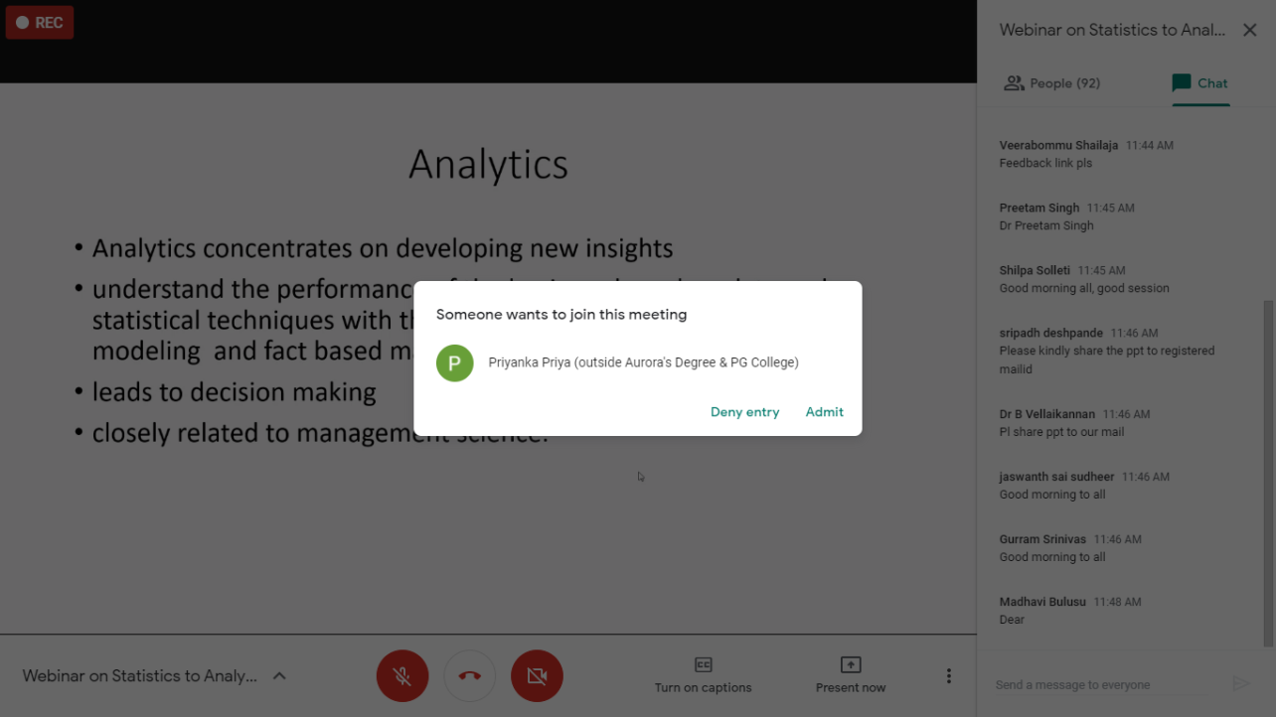

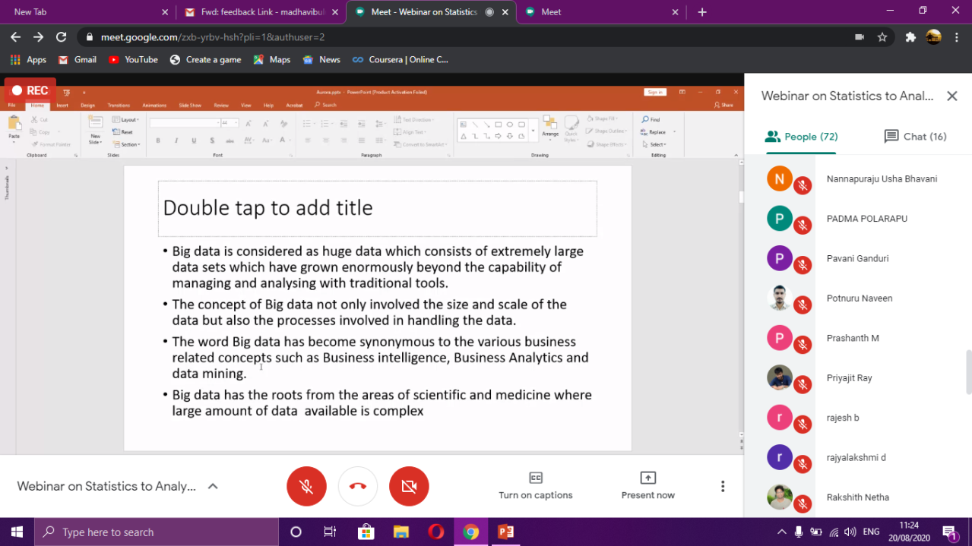
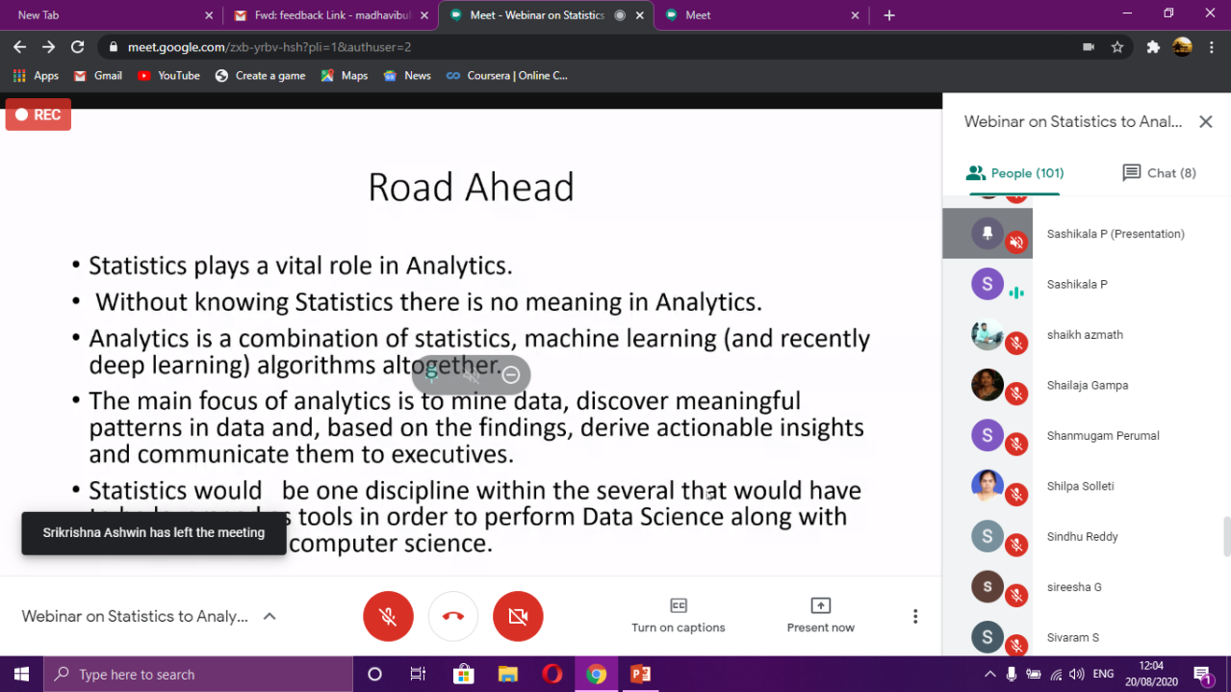

Aurora’s Degree & PG College
(ACCREDITED BY NAAC WITH 'B++' GRADE)
Chikkadpally, Hyderabad 500020

NAME OF THE EVENT | Cauchy Birthday
TYPE OF EVENT | Department event
FACULTY INCHARGE | B.Madhavi
DEPARTMENT | Mathematics
DATE | 21st August 2020
VENUE | Aurora’s Degree and PG College
TARGET AUDIENCE | Faculty from various colleges from various states

OBJECTIVE:
- To enlighten the participants about the primary role of statistics in analytics.
Event Details : Baron Augustin-Louis Cauchy (21 August 1789 – 23 May 1857) was a French mathematician, engineer, and physicist who made pioneering contributions to several branches of mathematics, including mathematical analysis and continuum mechanics. He was one of the first to state and rigorously prove theorems of calculus, rejecting the heuristic principle of the generality of algebra of earlier authors. He almost singlehandedly founded complex analysis and the study of permutation groups in abstract algebra.
A profound mathematician, Cauchy had a great influence over his contemporaries and successors; Hans Freudenthal stated: "More concepts and theorems have been named for Cauchy than for any other mathematician (in elasticity alone there are sixteen concepts and theorems named for Cauchy)." Cauchy was a prolific writer; he wrote approximately eight hundred research articles and five complete textbooks on a variety of topics in the fields of mathematics and mathematical physics

Proposed Activities : Conducting quiz, webinar and PPT presentation

OUTCOME:
- The participants will learn the true value of analytics.
- The Participants will learn about the role of statistics in Analytics

About PPT competition: PPT competition was conducted on 19th August. Students were participated enthusiastically and all of them were presented their PPTs in Google Meet.

Brief about the webinar:

The webinar was organised by Department of Mathematics, Aurora’s Degree and P.G. College on 20-08-2020 from 11:00 a.m. to 12:15 p.m. Ms. G. Prathibha, Head, Department of Mathematics, started the session by introducing the college, giving brief introduction about the mathematician Augustine Louis Cauchy and invited the speaker and the participants of the event.
Session: The speaker discussed about how the statistics is useful in businessworld.
The Webinar was organised through Google Meet.
Topic: Statistics to Analytics – The road ahead
Time: August 20, 2020 11.00 AM India
Report of Webinar
DEPARTMENT OF MATHEMATICS
DETAILED REPORT : WEBINAR : “Statistics to Analytics – The road ahead”
In connection with the College Development activities, with the encouragement of Management and with the constant support of the dynamic principal Dr. Viswanatham Bulusu , The Department of Mathematics organised a webinar on the occasion of birthday on Statistics to’ Analytics – The road ahead’ for the benefit of the Students, Research scholars, Faculty and other Participants from various places of the country 20th August 2020.
Ms. G. Prathibha, Head, Department of Mathematics, started the session by introducing the college , giving introduction of the mathematician Augustine Louis Cauchy and invited the speaker and the participants of the event.
Then Ms. B.Madhavi, faculty, department of Mathematics introduced the speaker, Dr. P.Sashikala, Professor in Statistics from ICFAI, Hyderabad and invited her to take over the proceedings.
The speaker discussed about how the statistics is useful in business world with real life examples , the techniques and tools used to handle a huge data and patiently cleared all the queries of the participants on this concept.
Later the session was closed by the vote of thanks by the coordinator, Ms. B.Madhavi, Associate Professor, Department of Mathematics.
The Webinar was organised through Google Meet.
Topic: Statistics to Analytics – The road ahead
Time: August 20, 2020 11.00 AM India

Posture of webinar:
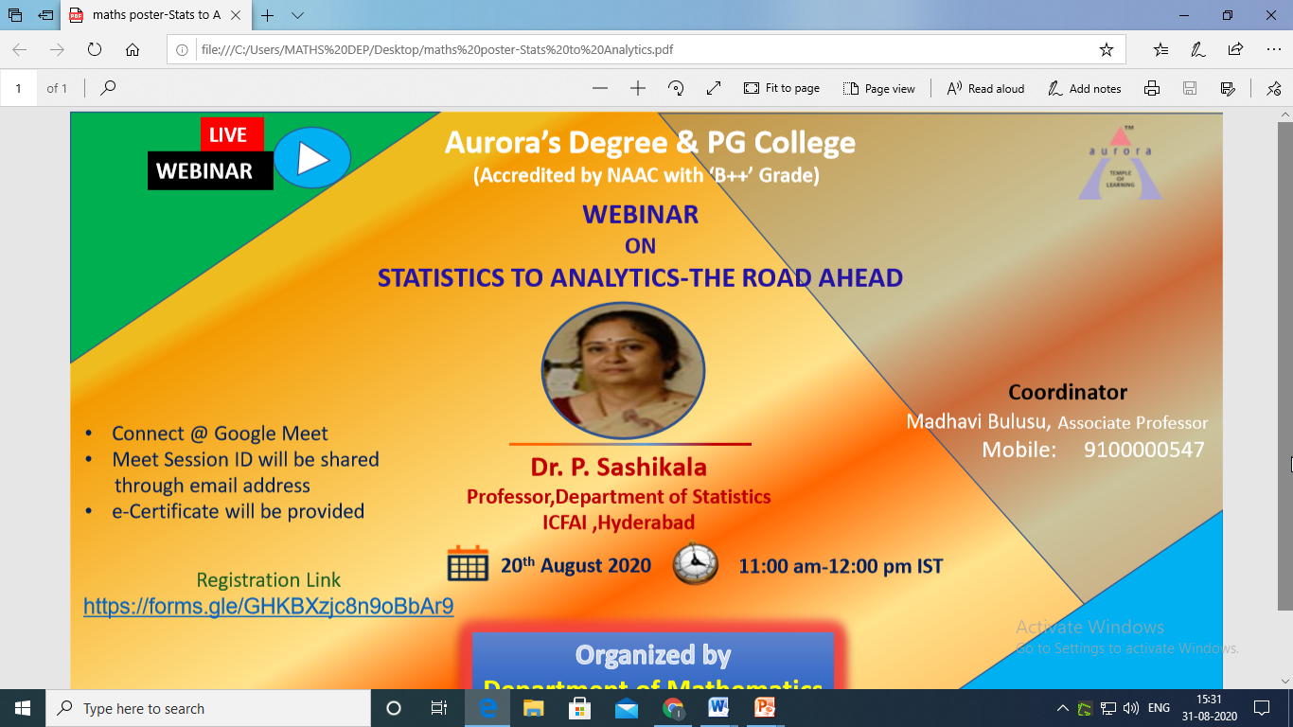

LIST OF PARTICIPANTS
S.NO | Name | Name of the College | Mailid
1 | TARANNUM JAHAN | Indira priyadarshini Govt Degree College for Women | tarannumjahan.tj@gmail.com
2 | Dr.S.Kailasavalli | PSNA College of Engineering and Technology,Dindigul | skvalli2k5@gmail.com
3 | S.Iswarya | Nadar Saraswathi College Of Arts And Science Theni | ishuishu1421@gmail.com
4 | TARANNUM JAHAN | Indira priyadarshini Govt Degree College for Women | tarannumjahan.tj@gmail.com
5 | Dr Gajendra Ujjainkar | Maharaja Bhoj Govt P G college Dhar MP | gajendra_ujjainkar@yahoo.co.in
6 | Dr S S NIRMALA | B S Abdur Rahman Crescent Institute of Science and Technology Vandalur | ssnirmala1971@gmail.com
7 | S. PERUMAL | RMK COLLEGE OF ENGINEERING AND TECHNOLOGY | perumalmaths@gmail.com
8 | Y Sri Krishna Mohan | Aurora's Degree and PG College | srikrishnamohany@adc.edu.in
9 | D ASHOK REDDY | RGUKT-IIIT-SKLM | ashokrjl@gmail.com
10 | K. Sangeetha | Kasturba Gandhi Degree & PG College for Women | lksangeetha1903@gmail.com
11 | K Srikrishna | Sardar Patel College | sreekrish48@gmail.com
12 | Shaik Azmath | Mumtaz Degree college | mail2atik@gmail.com
13 | Dr.P.JEYA PUVANESWARI | VIVEKANANDA COLLEGE , AGASTEESWARAM | jeyapuvaneswari@gmail.com
14 | Priyajit Ray | University of Calcutta | raypriyajit11@gmail.com
15 | Mrs. Varalakshmi | Marudhar kesari Jain college for women Vaniyambadi | varalakshmijanaki93@gmail.com
16 | SANGHADEEP SUKHADEO GAJBHIYE | VIVA INSTITUTE OF PHARMACY | sangh26bcp@gmail.com
17 | M.N.L.ANURADHA | Vidya Jyothi Institute of Technology, Hyderabad | anuradha.chennuru@gmail.com
18 | Shaik Azmath | Mumtaz Degree college | mail2atik@gmail.com
19 | R. VANITHA | Marudhar kesari Jain College for women Vaniyambadi | vanivanitha2280@gmail.com
20 | Naveen Reddy | AURORA'S DEGREE &P.G COLLEGE | naveenreddy0831@gmail.com
21 | ANITHA.N | CAHCET | anithanithi1111@gmail.com
22 | Katheeja Mary G | Marudhar Kesari Jain College for Women | katheejamary15@gmail.com
23 | SRIPADH DESHPANDE | KESHAV MEMORIAL INSTITUTE OF COMMERCE AND SCIENCES | sripadhdeshpande@gmail.com
24 | Dr. M . A. S .Srinivas | J N T U Hyderabad | massrinivas@jntuh.ac.in
25 | Dr. M.Renuka | Besant Theosophical College Madanapalli | malyamrenuka@gmail.com
26 | K.VIJAY KUMAR | RAILWAY DEGREE COLLEGE | k.vijaykumargoud@gmail.com
27 | B MANASA | Aurora's Degree and PG College | manasab@adc.edu.in
28 | MADHURI AVADHANULA | VISHNU SCHOOL-BHIMAVARAM | madhuriavadhanula4@gmail.com
29 | Dr. P. L. N. VARMA | VFSTR | plnvarma@gmail.com
30 | Pheiroijam Suranjoy Singh | Bodoland University | surphei@yahoo.com
31 | Dr Balakrishnan Vellaikannan | Thiagarajar college of engineering MADURAI 15 TN | bvkmat@tce.edu
32 | SURAPURAJU SIVARAM | Gudlavalleru Engineering College | sivaram9@gmail.com
33 | Mapu. Soni | Dewan bahadur padmarao mudaliar degree for women | rocksoni2000@gmail.com
34 | G. DHARANIDHARAN | INDIRA GANDHI NATIONAL OPEN UNIVERSITY | dharanidharandaan.dd@gmail.com
35 | M Abhishek | A v College | muthyalanagalaxmi@gmail.com
36 | Dr. L. LEO FRANKLIN | JJ COLLEGE OF ARTS AND SCIENCE (AUTONOMOUS), PUDUKKOTTAI | franklincomjj@gmail.com
37 | Gurralla Chathurya | St Ann's degree college for women,mallapur | chathuryamudhiraj22@gmail.com
38 | GURRAM SRINIVAS | Sreechaitanya institute of technological sciences lmd,karimnagar | srinivas.gurram2010@gmail.com
39 | Afreen Begum | K. V Ranga Reddy Degree College for Women | afreenkhan3005@gmail.com
40 | Dr.K.L.Vasundhara | Stanley college of engineering and technology for women | drvasundhara@stanley.edu.in
41 | Prashanth Manthramurthy | Little Flower Degree College | prashanthmathsdept@gmail.com
42 | Thumma manjula | Aurora degree and pg college | manjuthumma95@gmail.com
43 | NARSINI SRINIVAS | SAP COLLEGE VIKARABAD | narsini_sri@yahoo.com
44 | V. JYOTHIMANI | M.M.E.S WOMEN'S ARTS AND SCIENCE COLLEGE | jyothimanumsc@gmail.com
45 | Ms. D vaishnavi | K V RANGA REDDY DEGREE COLLEGE FOR WOMEN | vishnuchandrika17@gmail.com
46 | Dr.V.MANJULATHA | The Hindu College, Machilipatnam | drvmanjulatha@gmail.com
47 | S.Iswarya | Nadar Saraswathi College Of Arts And Science Theni | ishuishu1421@gmail.com
48 | Mr PRIYAJIT RAY | University of Calcutta | raypriyajit11@gmail.com
49 | Dr.P.JEYA PUVANESWARI | VIVEKANANDA COLLEGE,AGASTEESWARAM | jeyapuvaneswri@gmail.com
50 | Katheeja Mary G | Marudhar Kesari Jain College for Women | katheejamary15@gmail.com
51 | Gampa Shailaja | Malla Reddy College of Engineering & Technology | shailajagampa@gmail.com
52 | Kontham anusha | St. Anns degree college for women malapur | anumudhirajanu@gmail.com
53 | Pavani.Ganduri | G.Pulla Reddy Degree and PG college , lecturer , department Mathematics. | pavaniganduri78@gmail.com
54 | Malyala Sowmya | St.Anns degree college | sowmyamudiraj31@gmail.com
55 | KESARI KOTESWARA RAO | Swarnandhra College of Engineering and Technology Narasapur | k.koteswararao6@gmail.com
56 | RIZWANA BEGUM | ANWARUL ULOOM PG COLLEGE | syedsubhanhussaini@gmail.com
57 | R. VANITHA | Marudhar kesari Jain College for women Vaniyambadi | vanivanitha2280@gmail.com
58 | AKI SRINIVASARAO | Government degree college YELLANDU | srinivasaki963@gmail.com
59 | NARSINI NAVEEN KRISHNA | Osmania university post graduate college | narsini.naveen@yahoo.com
60 | Dr. N. KANDARAJ. Associate Professor | Saiva Bhanu Kshatriya College, Aruppukottai | n.kandarajsbkc1998@gmail.com
61 | S. Lakshmi | Aurora's Degree &PG College | lakshmis@adc.edu.in
62 | DR. SABEENA KAZI | College of Computer and Information Sciences, Majmaah University, Al-Majmaah, KSA | s.badesaheb@mu.edu.sa
63 | MADHURI AVADHANULA | VISHNU SCHOOL-BHIMAVARAM | madhuriavadhanula4@gmail.com
64 | Dr. K.ARUNA KUMARI | ICDS, Tekulapally, Bhadradri Kothagudem District | drkolisettiaruna@gmail.com
65 | Anjani Swetha Ananthapalli | OUCCBM | askonduri@gmail.com
66 | Dr.Bhumika Panigrahi | Gopal Krishna college of engineering and technology | bhumika.phd@gmail.com
67 | Dr.Tirumala Haripriya | Sreyas Institute of Engineering and Technology | Haripriya.t@sreyas.ac.in
68 | SHYLAJA KOMISHETTI | SRI CHAKRA COLLEGE OF EDUCATION | Shailaja0765@gmail.com
69 | Potnuru Naveen | AP-IIIT SRIKAKULAM | potnuru123@gmail.com
70 | NARSINI NAVEEN KRISHNA | Osmania university post graduate college | narsini.naveen@yahoo.com
71 | Mr. K Raghuram Bhattar | ACE ENGINEERING COLLEGE | KRaghuram@ace-ec.in
72 | JELLA BHARGAVI | ST.ANN'S DEGREE COLLEGE FOR WOMEN | bhargavij2301@gmail.com
73 | Mapu. Soni | Dewan bahadur padmarao mudaliar degree for women | rocksoni2000@gmail.com
74 | V.Jayanthi | Aurora's degree and pg college | vjayanthi188@gmail.com
75 | B.Mahesh | A.V. College of Arts, Science and Commerce | bejjankimahesh94@gmail.com
76 | S.Dhanalakshmi, Research Scholar | Sri parasakthi college for women, Courtallam | prithira456@gmail.com
77 | Gampa Shailaja | Malla Reddy College of Engineering & Technology | shailajagampa@gmail.com
78 | MOHAMMED ALEEMUDDIN | GHS (JRC) BHONGIR | aleemuddinm44@gmail.com
79 | Adam shafi shaik | Jkc college, Guntur, Andhrapradesh | adamshafi27@gmail.com
80 | R. VANITHA | Marudhar kesari Jain College for women Vaniyambadi | vanivanitha2280@gmail.com
81 | Dr.P.K.Singh,Professor | S.G.S.Govt.P.G.(Auto.)College,Sidhi(M.P.) | pksingh.sidhi@gmail.com
82 | Dr Preetam Singh | Jaipur National University Jaipur | singhpreetamsingh@gmail.com
83 | Boina Srilaxmi | K. G. B. V Amadalavala | potnuru124@gmail.com
84 | Dr. B.D. Shrivastava | Govt PG College Dhar | bdshrivastava@gmail.com
85 | Dr. Yasmeen Banu | Anwarul Uloom College | yahmed_banu2000@yahoo.com
86 | Ms. D Vaishnavi Lecturer in STATISTICS | K V RANGA REDDY DEGREE COLLEGE FOR WOMEN | vishnuchandrika17@gmail.com
87 | Mr. MANTHA SRIKANTH | MALLA REDDY ENGINEERING COLLEGE(AUTONOMOUS) | srikanth.2027@gmail.com
88 | Ayush Chhabra | Aurora Degree & PG College | ayushchhabra19@adc.edu.in
89 | Mrs.S.Shilpa | BV Raju Institute of Technology, Narsapur | shilpa.s@bvrit.ac.in
90 | Dr. N. KANDARAJ, Associate Professor | PG and Research Department of Mathematics, Saiva Bhanu Kshatriya College, Aruppukottai | n.kandarajsbkc1998@gmail.com
91 | Dr.K.ARUNA KUMARI | ICDS, Tekulapally, Bhadradri Kothagudem District, Telangana State | drkolisettiaruna@gmail.com
92 | B.LALITHA | KV RANGA REDDY DEGREE COLLEGE FOR WOMEN | lalithab67@gmail.com
93 | Divya Patil | Aurora's Degree And PG College | divyapatil19@adc.edu.in
94 | Purmasowjanya | St.Anns degree college for women mallpur | Purmasoujanya2@gmail.com
95 | DR.P.BALAJI | SCSVMV UNIVERSITY, KANCHIPURAM | pbr1002017@gmail.com
96 | Mrs.P.V.Himabindu | DBPM Degree and PG College for women | himabindu.prayaga@gmail.com
97 | P. Laxmi Prasanna | RBVRR Women's college | laxmi.prasanna877@gmail.com
98 | Avuti Sumanjali | Aurora's Degree &P.G college | avutisuma99@gmail.com
99 | SAKALA KAVITHA JOSYULA | VISHNUSCHOOL BHIMAVARAM | sakalakavitha@gmail.com
100 | DR | P.BALAJI | pbr1002017@gmail.com
101 | Manasa katraju | St.ann's degree College mallapur | katrajumanasa@gmail.com
102 | Rakshith | aurora | rakshithgundeti135@gmal.com
103 | Pragati Oza | Aurora Degree & PG College | pragatioza19@adc.edu.in
104 | DEVI.P.,M.SC.,M.Phil.,B.Ed., | Malar Matric Higher Secondary School | ammuresam@gmail.com
105 | Dr.Tirumala Haripriya | Sreyas Institute of Engineering and Technology | Haripriya.t@sreyas.ac.in
106 | Kodamarthi Lakshmi Haripriya | Aurora's Degree & PG College | haripriya.kodam@gmail.com
107 | Malyala Sowmya | St.Anns Degree and Pg college | sowmyamudiraj31@gmail.com
108 | Gurralla Chathurya | St Ann's degree college for women,mallapur | chathuryamudhiraj22@gmail.com
109 | padma.polarapu@gmail.com | Govt Degree College | padma.polarapu@gmail.com
110 | Cripati Radhika | ZPHS FORT GOOTY | praisy74@gmail.com
111 | Thodeti Raju | GDC, Yellandu | thodetiraj@gmail.com
112 | Purmasowjanya | St.Anns degree college for women ,mallapur | Purmasoujanya2@gmail.com
113 | Dr Syed Salahuddin | Anwarul Uloom College Hyderabad | sayeed87@yahoo.com
114 | NANDHAKUMAR C | MERIT HAJI ISMAIL SAHIB ARTS AND SCIENCE COLLEGE, PERNAMBUT | nandhakumarnew5@gmail.com
115 | Dr.G.Sireesha | VNRVJIET | sireesha_g@vnrvjiet.in
116 | Rajya Lakshmi | Aurora's Degree & PG College | rajyalakshmid@adc.edu.in
117 | Y Padmavathi | Vishnu School | yesudason.antony1@gmail.com
118 | Dr.P.Aparna | VNRVJIET, HYDERABAD | aparnapodila@gmail.com
119 | Lagma Naga Saraswathi Mudunuri | Vishnu School, Bhimavaram | lagmamudunuri@gmail.com
120 | Dr.N.Pothanna | VNRVJIET | pothanna_n@vnrvjiet.in
121 | Ravitejafeb1@gmail.com | Universitat, Kassel | Ravitejafeb1@gmail.com
122 | Dr.P.Padmaja | Prasad V. Potluri Siddhartha Institute of Technology | admajapdila@gmail.com
123 | Prateek Singh | Sunrise Valley school ,Mauganj ,Rewa (M.P) | prateek.sidhi@gmail.com
124 | Pukkalla. Saiprakash | AKITS | saiprakash2805@gmail.com
125 | Prateek Singh | Sunrise Valley School ,Mauganj,Rewa(M.P.) | prateek.sidh@gmail.com
126 | M. DEEPTHI | V. S. R. Government Degree and P. G. College, Movva | deepthi.m999@gmail.com
127 | G.MAMATHA | St Ann's degree college for women mallapur | godumakuntamamatha@gmail.com
128 | Dr.Sharath Babu Khandayrao | Matrusri Engineering College Saidabad | sharathsiddipet@gmail.com
129 | Kupireddy Rupa | Gurunaanak institutions technical campus | krr1186@gmail.com
130 | Sreelatha sankuru | Singareni collieries women's degree and pg college | ssreelathamsc@gmail.com
131 | Kupireddy Rupa | Gurunaanak institutions technical campus | krr1186@gmail.com
132 | Boddu Elizabeth Rani | S. K. N. R. Govt Arts and Science College | srikrutha007@gmail.com
133 | S KARTHIKEYAN | J J College of Arts and Science (Autonomous) | keya.placement@gmail.com
134 | Prathibha G | Aurora's Degree and Pg College | prathibg@adc.edu.in
135 | S Seeta Rani Dandu | Vishnu school | seetaranidandu1984@gmail.com
136 | Dr. K. ARUNA KUMARI | ICDS, Tekulapally, Bhadradri Kothagudem District | drkolisettiaruna@gmail.com
137 | P. Chandrakala | Aurora's Degree & Pg College | chandrakalap@adc.edu.in
138 | M.Devika | Aurora's Degree and PG College | devikam@adc.edu.in
139 | R. CHANDRASHEKAR | Aurora’s Degree and PG College | chandrashekarr@adc.edu.in
140 | A Sandhya Rani | Auroras degree and Pg College | sandhyarania@adc.edu.in
141 | V GANESH KUMAR | VNRVJIET | ganeshkumar68@gmail.com
142 | KOTTU DHANA NARASIMHA MURTHY | Swarnandhra college of engineering and technology | narasimhakottu@gmail.com
143 | T.Rajani Devi | University College for Women | trdevi11@yahoo.com
144 | Gandham Shekhar | Government Degree College Yellandu | ushagoudg2014@gmail.com

MATHEMATICS-ICT in Teaching-Learning Mathematics FEEDBACK

S.NO | Name | Mailid | Satisfaction | Presentation | Informative | Suggestions for topic
1 | TARANNUM JAHAN | tarannumjahan.tj@gmail.com | 5 | 5 | 5 | Tips and tricks to crack net/set Commerce
2 | Dr.S.Kailasavalli | skvalli2k5@gmail.com | 5 | 5 | 5 | Nil
3 | S.Iswarya | ishuishu1421@gmail.com | 5 | 5 | 5 | Good
4 | TARANNUM JAHAN | tarannumjahan.tj@gmail.com | 5 | 5 | 5 | Tips and tricks to crack net/set Commerce
5 | Dr Gajendra Ujjainkar | gajendra_ujjainkar@yahoo.co.in | 4 | 5 | 5 | Expand duration next time
6 | Dr S S NIRMALA | ssnirmala1971@gmail.com | 5 | 5 | 5 | No comments
7 | S. PERUMAL | perumalmaths@gmail.com | 4 | 4 | 5 | Graph Theory
8 | Y Sri Krishna Mohan | srikrishnamohany@adc.edu.in | 4 | 5 | 5
9 | D ASHOK REDDY | ashokrjl@gmail.com | 5 | 5 | 5 | Good
10 | K. Sangeetha | lksangeetha1903@gmail.com | 5 | 5 | 5
11 | K Srikrishna | sreekrish48@gmail.com | 5 | 5 | 5 | Human Resource Management Policies Post Covid-19
12 | Shaik Azmath | mail2atik@gmail.com | 4 | 5 | 5
13 | Dr.P.JEYA PUVANESWARI | jeyapuvaneswari@gmail.com | 5 | 5 | 5 | Excellent
14 | Priyajit Ray | raypriyajit11@gmail.com | 5 | 5 | 5
15 | Mrs. Varalakshmi | varalakshmijanaki93@gmail.com | 4 | 4 | 4 | No
16 | SANGHADEEP SUKHADEO GAJBHIYE | sangh26bcp@gmail.com | 4 | 5 | 4 | Very nice and informative session
17 | M.N.L.ANURADHA | anuradha.chennuru@gmail.com | 5 | 5 | 5 | Reaserch paper publication process
18 | Shaik Azmath | mail2atik@gmail.com | 4 | 5 | 5
19 | R. VANITHA | vanivanitha2280@gmail.com | 5 | 5 | 5 | Very nice presentation and wonderful useful session
20 | Naveen Reddy | naveenreddy0831@gmail.com | 5 | 5 | 5
21 | ANITHA.N | anithanithi1111@gmail.com | 4 | 4 | 4
22 | Katheeja Mary G | katheejamary15@gmail.com | 5 | 5 | 5 | No
23 | SRIPADH DESHPANDE | sripadhdeshpande@gmail.com | 4 | 4 | 4 | STATISTICS
24 | Dr. M . A. S .Srinivas | massrinivas@jntuh.ac.in | 5 | 5 | 5
25 | Dr. M.Renuka | malyamrenuka@gmail.com | 5 | 5 | 5 | Good
26 | K.VIJAY KUMAR | k.vijaykumargoud@gmail.com | 5 | 5 | 5 | Required a session on Data analysis
27 | B MANASA | manasab@adc.edu.in | 5 | 5 | 5
28 | MADHURI AVADHANULA | madhuriavadhanula4@gmail.com | 5 | 5 | 5 | English related
29 | Dr. P. L. N. VARMA | plnvarma@gmail.com | 4 | 5 | 4 | nothing in particular
30 | Pheiroijam Suranjoy Singh | surphei@yahoo.com | 4 | 4 | 4 | Relativity and cosmology
31 | Dr Balakrishnan Vellaikannan | bvkmat@tce.edu | 4 | 4 | 3 | Statistical modelling
32 | SURAPURAJU SIVARAM | sivaram9@gmail.com | 4 | 4 | 4 | Optimization Techniques
33 | Mapu. Soni | rocksoni2000@gmail.com | 5 | 5 | 5 | Informative session madam we want some more webinar... Thankful🙏
34 | G. DHARANIDHARAN | dharanidharandaan.dd@gmail.com | 5 | 5 | 5
35 | M Abhishek | muthyalanagalaxmi@gmail.com | 4 | 4 | 4
36 | Dr. L. LEO FRANKLIN | franklincomjj@gmail.com | 5 | 5 | 5 | nice and more informative
37 | Gurralla Chathurya | chathuryamudhiraj22@gmail.com | 5 | 5 | 5 | We want more events like this
38 | GURRAM SRINIVAS | srinivas.gurram2010@gmail.com | 5 | 5 | 5 | Iam very happy to participate in this webinar
39 | Afreen Begum | afreenkhan3005@gmail.com | 5 | 5 | 5
40 | Dr.K.L.Vasundhara | drvasundhara@stanley.edu.in | 5 | 5 | 5 | Good
41 | Prashanth Manthramurthy | prashanthmathsdept@gmail.com | 4 | 5 | 5
42 | Thumma manjula | manjuthumma95@gmail.com | 5 | 5 | 5 | Computer skills
43 | NARSINI SRINIVAS | narsini_sri@yahoo.com | 5 | 5 | 5 | Report writing method webinar
44 | V. JYOTHIMANI | jyothimanumsc@gmail.com | 5 | 5 | 5
45 | Ms. D vaishnavi | vishnuchandrika17@gmail.com | 5 | 5 | 5 | Based R programming
46 | Dr.V.MANJULATHA | drvmanjulatha@gmail.com | 5 | 5 | 5 | Good
47 | S.Iswarya | ishuishu1421@gmail.com | 5 | 5 | 5 | Good
48 | Mr PRIYAJIT RAY | raypriyajit11@gmail.com | 5 | 5 | 5
49 | Dr.P.JEYA PUVANESWARI | jeyapuvaneswri@gmail.com | 5 | 5 | 5 | Excellent
50 | Katheeja Mary G | katheejamary15@gmail.com | 5 | 5 | 5 | No
51 | Gampa Shailaja | shailajagampa@gmail.com | 4 | 4 | 4 | Markov models
52 | Kontham anusha | anumudhirajanu@gmail.com | 5 | 5 | 5
53 | Pavani.Ganduri | pavaniganduri78@gmail.com | 4 | 4 | 3 | Topics on Big Data
54 | Malyala Sowmya | sowmyamudiraj31@gmail.com | 5 | 5 | 5 | I suggest more topics about regression anaysis
55 | KESARI KOTESWARA RAO | k.koteswararao6@gmail.com | 5 | 5 | 5 | Sciences
56 | RIZWANA BEGUM | syedsubhanhussaini@gmail.com | 5 | 5 | 5 | statistical role in astro physics
57 | R. VANITHA | vanivanitha2280@gmail.com | 5 | 5 | 5 | Very nice presentation and wonderful useful session
58 | AKI SRINIVASARAO | srinivasaki963@gmail.com | 5 | 5 | 5
59 | NARSINI NAVEEN KRISHNA | narsini.naveen@yahoo.com | 5 | 5 | 5 | -
60 | Dr. N. KANDARAJ. Associate Professor | n.kandarajsbkc1998@gmail.com | 5 | 5 | 5 | Good
61 | S. Lakshmi | lakshmis@adc.edu.in | 5 | 5 | 5
62 | DR. SABEENA KAZI | s.badesaheb@mu.edu.sa | 4 | 4 | 4 | Applying tehniques
63 | MADHURI AVADHANULA | madhuriavadhanula4@gmail.com | 5 | 5 | 5 | english related
64 | Dr. K.ARUNA KUMARI | drkolisettiaruna@gmail.com | 5 | 5 | 5 | Good session
65 | Anjani Swetha Ananthapalli | askonduri@gmail.com | 5 | 5 | 5
66 | Dr.Bhumika Panigrahi | bhumika.phd@gmail.com | 5 | 5 | 5 | Group discussions
67 | Dr.Tirumala Haripriya | Haripriya.t@sreyas.ac.in | 5 | 5 | 5 | Nothing
68 | SHYLAJA KOMISHETTI | Shailaja0765@gmail.com | 5 | 5 | 5 | Excellent session
69 | Potnuru Naveen | potnuru123@gmail.com | 5 | 5 | 5 | Nice session
70 | NARSINI NAVEEN KRISHNA | narsini.naveen@yahoo.com | 4 | 5 | 5 | -
71 | Mr. K Raghuram Bhattar | KRaghuram@ace-ec.in | 5 | 5 | 5 | Statistics related to AI&ML
72 | JELLA BHARGAVI | bhargavij2301@gmail.com | 5 | 5 | 5
73 | Mapu. Soni | rocksoni2000@gmail.com | 5 | 5 | 5 | Good
74 | V.Jayanthi | vjayanthi188@gmail.com | 5 | 4 | 4 | Statistics for planning and development
75 | B.Mahesh | bejjankimahesh94@gmail.com | 4 | 4 | 4 | No
76 | S.Dhanalakshmi, Research Scholar | prithira456@gmail.com | 5 | 5 | 5 | presentation is very useful, Thank you
77 | Gampa Shailaja | shailajagampa@gmail.com | 4 | 5 | 4 | Markov models
78 | MOHAMMED ALEEMUDDIN | aleemuddinm44@gmail.com | 5 | 4 | 5
79 | Adam shafi shaik | adamshafi27@gmail.com | 5 | 5 | 5 | Most valuable session
80 | R. VANITHA | vanivanitha2280@gmail.com | 5 | 5 | 5 | Very nice presentation and wonderful session
81 | Dr.P.K.Singh,Professor | pksingh.sidhi@gmail.com | 5 | 5 | 5 | Nice webinar
82 | Dr Preetam Singh | singhpreetamsingh@gmail.com | 4 | 5 | 5 | How to develop a model for research
83 | Boina Srilaxmi | potnuru124@gmail.com | 5 | 5 | 5 | Nice madam
84 | Dr. B.D. Shrivastava | bdshrivastava@gmail.com | 4 | 5 | 5 | Data mining
85 | Dr. Yasmeen Banu | yahmed_banu2000@yahoo.com | 5 | 5 | 5 | Research methodology
86 | Ms. D Vaishnavi Lecturer in STATISTICS | vishnuchandrika17@gmail.com | 5 | 5 | 5 | Big data analytics
87 | Mr. MANTHA SRIKANTH | srikanth.2027@gmail.com | 5 | 5 | 5 | Nothing
88 | Ayush Chhabra | ayushchhabra19@adc.edu.in | 5 | 5 | 5
89 | Mrs.S.Shilpa | shilpa.s@bvrit.ac.in | 5 | 5 | 5 | Statistical tools
90 | Dr. N. KANDARAJ, Associate Professor | n.kandarajsbkc1998@gmail.com | 5 | 5 | 5 | Good
91 | Dr.K.ARUNA KUMARI | drkolisettiaruna@gmail.com | 5 | 5 | 5 | Informative session
92 | B.LALITHA | lalithab67@gmail.com | 5 | 5 | 5 | MATHEMATICS
93 | Divya Patil | divyapatil19@adc.edu.in | 5 | 5 | 5
94 | Purmasowjanya | Purmasoujanya2@gmail.com | 5 | 5 | 5 | Mor informativte of stastics
95 | DR.P.BALAJI | pbr1002017@gmail.com | 5 | 5 | 5 | Connection between Automata,Graph theory and Petri nets.
96 | Mrs.P.V.Himabindu | himabindu.prayaga@gmail.com | 5 | 5 | 5
97 | P. Laxmi Prasanna | laxmi.prasanna877@gmail.com | 3 | 3 | 4
98 | Avuti Sumanjali | avutisuma99@gmail.com | 4 | 4 | 4
99 | SAKALA KAVITHA JOSYULA | sakalakavitha@gmail.com | 5 | 5 | 5 | Excellent 👍
100 | DR | pbr1002017@gmail.com | 5 | 5 | 5 | Relation between Graphs,Automata and Petrinets
101 | Manasa katraju | katrajumanasa@gmail.com | 5 | 5 | 5 | S
102 | Rakshith | rakshithgundeti135@gmal.com | 4 | 4 | 3
103 | Pragati Oza | pragatioza19@adc.edu.in | 5 | 5 | 5
104 | DEVI.P.,M.SC.,M.Phil.,B.Ed., | ammuresam@gmail.com | 3 | 3 | 3 | History of Mathematicians and his troubles
105 | Dr.Tirumala Haripriya | Haripriya.t@sreyas.ac.in | 5 | 5 | 5 | Nothing
106 | Kodamarthi Lakshmi Haripriya | haripriya.kodam@gmail.com | 5 | 5 | 5
107 | Malyala Sowmya | sowmyamudiraj31@gmail.com | 5 | 5 | 5
108 | Gurralla Chathurya | chathuryamudhiraj22@gmail.com | 5 | 5 | 5 | We want more events like this
109 | padma.polarapu@gmail.com | padma.polarapu@gmail.com | 5 | 5 | 5 | try to organize more programs thanks
110 | Cripati Radhika | praisy74@gmail.com | 4 | 4 | 5 | Good I felt so happy
111 | Thodeti Raju | thodetiraj@gmail.com | 5 | 5 | 5
112 | Purmasowjanya | Purmasoujanya2@gmail.com | 5 | 5 | 5 | Statistics
113 | Dr Syed Salahuddin | sayeed87@yahoo.com | 5 | 4 | 4 | Software for this
114 | NANDHAKUMAR C | nandhakumarnew5@gmail.com | 5 | 5 | 5 | Statistics
115 | Dr.G.Sireesha | sireesha_g@vnrvjiet.in | 4 | 4 | 4 | nice
116 | Rajya Lakshmi | rajyalakshmid@adc.edu.in | 4 | 4 | 5
117 | Y Padmavathi | yesudason.antony1@gmail.com | 5 | 5 | 5 | Classroom Engagement
118 | Dr.P.Aparna | aparnapodila@gmail.com | 5 | 5 | 5 | no
119 | Lagma Naga Saraswathi Mudunuri | lagmamudunuri@gmail.com | 5 | 5 | 5 | No suggestions
120 | Dr.N.Pothanna | pothanna_n@vnrvjiet.in | 5 | 5 | 5 | Statistics using R
121 | Ravitejafeb1@gmail.com | Ravitejafeb1@gmail.com | 5 | 5 | 4 | Thanks
122 | Dr.P.Padmaja | admajapdila@gmail.com | 5 | 5 | 5 | no
123 | Prateek Singh | prateek.sidhi@gmail.com | 5 | 5 | 5 | Nice
124 | Pukkalla. Saiprakash | saiprakash2805@gmail.com | 5 | 4 | 4 | Thanks
125 | Prateek Singh | prateek.sidh@gmail.com | 5 | 5 | 5 | Nice
126 | M. DEEPTHI | deepthi.m999@gmail.com | 4 | 5 | 5 | Abstract Algebra
127 | G.MAMATHA | godumakuntamamatha@gmail.com | 5 | 5 | 5
128 | Dr.Sharath Babu Khandayrao | sharathsiddipet@gmail.com | 5 | 5 | 5 | I WILL PRESENT ONE Topic as a resource person.
129 | Kupireddy Rupa | krr1186@gmail.com | 5 | 5 | 5
130 | Sreelatha sankuru | ssreelathamsc@gmail.com | 5 | 5 | 5 | Significance
131 | Kupireddy Rupa | krr1186@gmail.com | 5 | 5 | 5 | Operations research
132 | Boddu Elizabeth Rani | srikrutha007@gmail.com | 4 | 5 | 5 | Good
133 | S KARTHIKEYAN | keya.placement@gmail.com | 5 | 5 | 5
134 | Prathibha G | prathibg@adc.edu.in | 5 | 5 | 5 | Informative Lecture
135 | S Seeta Rani Dandu | seetaranidandu1984@gmail.com | 1 | 4 | 5 | Yes
136 | Dr. K. ARUNA KUMARI | drkolisettiaruna@gmail.com | 5 | 5 | 5 | Good
137 | P. Chandrakala | chandrakalap@adc.edu.in | 5 | 5 | 5 | Matlab
138 | M.Devika | devikam@adc.edu.in | 5 | 5 | 5
139 | R. CHANDRASHEKAR | chandrashekarr@adc.edu.in | 4 | 5 | 5 | Nice
140 | A Sandhya Rani | sandhyarania@adc.edu.in | 5 | 5 | 5
141 | V GANESH KUMAR | ganeshkumar68@gmail.com | 5 | 5 | 5 | nothing
142 | KOTTU DHANA NARASIMHA MURTHY | narasimhakottu@gmail.com | 5 | 5 | 5 | Excellent program
143 | T.Rajani Devi | trdevi11@yahoo.com | 4 | 4 | 5 | Any topic related to Data Anylitics
144 | Gandham Shekhar | ushagoudg2014@gmail.com | 5 | 5 | 5 | .

Brief about e-quiz:
E- Quiz was conducted on 21st August 2020 i.e. on Cauchy Birthday. 101 members were participated and e-certificates were given for the candidates who scored more than 60%.
S.NO | Name | Mailid | Total score | Percentage
1 | Fuck u asshole | emmaeri@188.com | 5 | 25.0%
2 | Pranay | pranaychidre@gmail.com | 5 | 25.0%
3 | Prathibha G | prathibag@adc.edu.in | 2 | 10.0%
4 | Sirisha | soutarajitha6@gmail.com | 5 | 25.0%
5 | Malthar vaishnavi | vaishnavimalthar09@gmail.com | 7 | 35.0%
6 | MOHAMMED AMER | mohammedamer19@adc.edu.in | 20 | 100.0%
7 | Souta Sirisha goud | sirishagoud2000@gmail.com | 17 | 85.0%
8 | Raparthi spoorthi | spoorthiraparthi119@gmail.com | 7 | 35.0%
9 | G. Vaishnavi Devi Reddy | vaishnavigondesi2002@gmail.com | 4 | 20.0%
10 | Shalini | Shalu247.shalini@gmail.com | 5 | 25.0%
11 | Malkapuram Kavya | kavyamalkapuram487@gmail.com | 5 | 25.0%
12 | Rishi sharma | srishi2250@gmail.com | 4 | 20.0%
13 | PASUNURI SATHYAVATHI | sathya.pasunuri@gmail.com | 8 | 40.0%
14 | Sravani chittaboina | sravanichittaboina99@gmail.com | 19 | 95.0%
15 | Devarakonda bhargavi | bhargavidvk2000@gmail.com | 19 | 95.0%
16 | Eshitha | eshitharaj11@gmail.com | 16 | 80.0%
17 | Prathmesh baheti | prathmeshbaheti18@adc.edu.in | 19 | 95.0%
18 | Nikhilparashar | nikhilparashar18@adc.edu.in | 19 | 95.0%
19 | Sharma Durvakshi | sharmadurvakshi18@adc.edu.in | 19 | 95.0%
20 | Ch.Laxman | chakalilaxman19@adc.edu.in | 4 | 20.0%
21 | PASUNURI SATHYAVATHI | sathya.chinni28@gmail.com | 20 | 100.0%
22 | G. Vaishnavi Devi Reddy | varalakshmireddy2416@gmail.com | 8 | 40.0%
23 | V. supriya | vorugantisupriya1999@gmail.com | 19 | 95.0%
24 | Sheelam Bhanu sree | bhanusree.sheelam@gmail.com | 18 | 90.0%
25 | RITHIK JAISWAL | rithikjaiswal555@gmail.com | 19 | 95.0%
26 | sudireddykavya | sudireddykavya2000@gmail.com | 3 | 15.0%
27 | V.Shirisha | vorugantisirisha@16gmail.com | 20 | 100.0%
28 | Marati vishala | marativishala2001@gmail.com | 20 | 100.0%
29 | Megha navander | meghanavander18@gmail.com | 17 | 85.0%
30 | sarthaksureka | sarthaksureka2@gmail.com | 19 | 95.0%
31 | GOSAR KEVAL KUMAR | kevalgosar38@gmail.com | 19 | 95.0%
32 | Shivek | shivekagarwal37@gmail.com | 2 | 10.0%
33 | Devanshi jadhav | devanshijadhav85@gmail.com | 19 | 95.0%
34 | Kotha shivani | kothashivani1237@gmail.com | 6 | 30.0%
35 | M Jamshed | jamshedkhan24@gmail.com | 4 | 20.0%
36 | C.J.kamalika | cjkamalika18@adc.edu.in | 17 | 85.0%
37 | Ayush Chhabra | ayushchhabra19@adc.edu.in | 17 | 85.0%
38 | Sonowane Aishwarya | sonowaneaishwarya@gmail.com | 2 | 10.0%
39 | Padigela Ruchitha | padigelaruchitha@adc.edu.in | 20 | 100.0%
40 | Aakansha | inform2suji@gmail.com | 5 | 25.0%
41 | Kushal sharma | kushalsharma2212@gmail.com | 6 | 30.0%
42 | Mohammad Azhar Ali | mohammadazharali18@adc.edu.in | 13 | 65.0%
43 | Sadia begum | sadiatazmeen67@gmail.com | 14 | 70.0%
44 | E. Shivani | eshivani60@gmail.com | 12 | 60.0%
45 | Sharma muskan | sharmamuskan18@adc.edu.in | 17 | 85.0%
46 | BANDI MANOJ | bandimanoj19@adc.edu.in | 16 | 80.0%
47 | A Sai kiran | ritoosair@gmail.com | 4 | 20.0%
48 | Manisha khileri | manishakhileri7@gmail.com | 19 | 95.0%
49 | Kandhadie vijayaraghavan | kvijayaragha1@gmail.com | 10 | 50.0%
50 | D. Ganga Bhavani | gangabhavanideshvena84@gmail.com | 19 | 95.0%
51 | M.Gayathri | gayathrimanga16@gmail.com | 20 | 100.0%
52 | Nandigama saikiran | saikiran0500@gmail.com | 7 | 35.0%
53 | Manasa | Saimanasa885@gmail.com | 18 | 90.0%
54 | Gujjula Sripriya | sripriyagujjula25@gmail.com | 9 | 45.0%
55 | K. Saicharan | ksaicharan18@adc.edu.in | 16 | 80.0%
56 | Thurpu Srija | srijathurpu55@gmail.com | 18 | 90.0%
57 | KOMAL SHARMA | sharmakomal@adc.edu.in | 16 | 80.0%
58 | A.Sai Kiran | alladurgamsaikiran@gmail.com | 19 | 95.0%
59 | Nazeema | nazeema25@yahoo.com | 3 | 15.0%
60 | Augustin Louis Cauchy | auglou.1789@gmail.com | 15 | 75.0%
61 | B Naga Sai Deepak | beetukurinagasaideepak18@adc.edu.in | 13 | 65.0%
62 | Shabana | shaikruksanashasha777@gmail.com | 7 | 35.0%
63 | Shweta | raishweta1208@gmail.com | 3 | 15.0%
64 | G.V.Manjushree | gurramvijayamanjushree18@adc.edu.in | 18 | 90.0%
65 | D. Sushma | domalasushma593@gmail.com | 19 | 95.0%
66 | Pokala sravani | sravanipokala80@gmail.com | 19 | 95.0%
67 | Pokala pratyusha | pokalapratyusha@gmail.com | 19 | 95.0%
68 | MARUPAKULA YAMINI GOUD | ashwinigoudmaripakula@gmail.com | 17 | 85.0%
69 | SHAIK RUKSANA | shaikruksana54671@gmail.com | 20 | 100.0%
70 | K. Ramya sri | ramyasri121218468044@gmail.com | 19 | 95.0%
71 | Shweta Rai | shwetarai19@adc.edu.in | 18 | 90.0%
72 | Sravanthi Jalamana | govindjalamana@gmail.com | 13 | 65.0%
73 | Timmaraju Jahnavi | timmarajujahnavi19@adc.edu.in | 9 | 45.0%
74 | SuryaReddy Jambula | sjambula6@gmail.com | 17 | 85.0%
75 | Peddigari Divya | divyagdp321@gmail.com | 6 | 30.0%
76 | Komatineni Lakshmitirumala | tejasrinukomatineni@gmail.com | 15 | 75.0%
77 | Makhan Amisha | makhanamisha@gmail.com | 7 | 35.0%
78 | Thorramamidi saikiran | saikiran2832@gmail.com | 18 | 90.0%
79 | SHAIK RIYAZ AHMED | shaikriyazahmed54671@gmail.com | 20 | 100.0%
80 | Nazeema | nazeema25@yahoo.com | 17 | 85.0%
81 | Dr.Sharath Babu Khandayrao | sharathsiddipet@gmail.com | 13 | 65.0%
82 | Mukkera Nandini | nandinimukkera54@gmail.com | 5 | 25.0%
83 | Y.S.V.S.N.VAISHNAVI | ylakshmi78@gmail.com | 16 | 80.0%
84 | M.Gopalgoud | gopalgoudm1005@gmail.com | 6 | 30.0%
85 | Kunchala dilip kumar | kunchaladilipkumar19@adc.edu.in | 13 | 65.0%
86 | Harshini | gunturiharshini@gmail.com | 10 | 50.0%
87 | N.akhila | nakhila18@adc.edu.in | 4 | 20.0%
88 | ANNIMALLA SRIVIDHYA | asrividhya99@gmail.com | 19 | 95.0%
89 | SHAIK SHAFEE | shafeemech@cvsr.ac.in | 20 | 100.0%
90 | Sai Sridhar | Nenavathsai121@gmail.com | 18 | 90.0%
91 | vijendar lahari | vijendarlahari@gmail.com | 15 | 75.0%
92 | N Sai Rupesh | nsr.student@gmail.com | 9 | 45.0%
93 | Potlachervu Srilatha | srilathapotlacheruvu0011@gmail.com | 17 | 85.0%
94 | Kaleru Korusha | kalerukorusha@gmail.com | 16 | 80.0%
95 | Advala Annapurna | annapurna.advala910@gmail.com | 16 | 80.0%
96 | Bingi Jayanth | bingijayanth@adc.edu.in | 5 | 25.0%
97 | Sirnam Manisha | sirnammanisha@gmail.com | 10 | 50.0%
98 | Ram Prasad | akuthotaramprasad@adc.edu.in | 6 | 30.0%
99 | G.sahithi | sahithigubbala1111@gmail.com | 19 | 95.0%
100 | Are Sharada Devi | sharadaare08@gmail.com | 14 | 70.0%
101 | Pagadala Manasa | manasapagadala26@gmail.com | 17 | 85.0%

