Aurora’s Degree and PG College 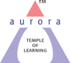
(ACCREDITED BY NAAC WITH ‘B++’ GRADE)
Chikkadpally, Hyderabad 500020

EVENT PROPOSAL

Event/Activity Name: Photography Workshop

Event/Activity Title: Online Workshop on Basics of Photography
Cell / Committee/Club Convener/facilitator: Mr. K. Anurag Reddy
Faculty coordinators: Mr. K. Anurag Reddy
Date: 19-08-2020
Venue: Block VI, RTC ‘X’ Roads, Aurora’s Degree & PG College,
Target audience: Faculty & Students of Aurora’s Degree & PG College
Platform: Online- Google Meet
Level: College Level
Student Volunteer’s: NA
Objective: To teach students to become proficient at the technical aspect of photographing with a digital camera.
Proposed activities:
- Session on introduction and basic of Photography
- Showing basic digital camera operation and features
- Teaching basic composition rules and framing
- Interaction with the students
Guest/Speaker details: Mr. Anand Maddula (Professional Photographer)
Budget: NA
Club Convener IQAC Coordinator Principal
K. Anurag Reddy Dr. Ravi kiran Dr. Viswanadham Bulusu

Aurora’s Degree & PG College
(ACCREDITED BY NAAC WITH 'B++' GRADE)
Chikkadpally, Hyderabad 500020

EVENT / ACTIVITY SHORT REPORT

NAME OF THE EVENT | Online Workshop on Basics in Photography
TYPE OF EVENT | Photography Workshop
FACULTY INCHARGE | K. Anurag Reddy
DEPARTMENT | Mass Communication Club – Dept. of Humanities
DATE | 19th August, 2020
VENUE | Aurora’s Degree & PG College, Block VI, RTC ‘X’ Roads
TARGET AUDIENCE | Students and faculty of Aurora’s Degree & PG College

OBJECTIVE:
To teach participants to:
- have a mental image of the photo first, and then to create a photo that matched their thoughts
- become proficient at the technical aspect of photographing with a digital camera
- learn to shoot with digital cameras maximizing the quality of the output from them
- develop and practice skills using digital photography tools and posting to a website
- learn the basics of photography
- develop the habit of looking closely at the visible world around you in order to represent it in terms of aesthetics, beauty and truth
- express and exchange ideas and respond to the ideas of others
- make participants learn from an expert while developing their own style

BRIEF ABOUT THE EVENT:
The Mass Communication Club of Aurora's Degree and PG College celebrated the ‘World Photography Day’ on 19th August 2020. To mark tribute to a wonderful day, club conducted Online Workshop on Basics in Photography for students and faculty of the college. The online workshop aimed at making participants learn from an expert while developing their own style.
Total number of registrations for the workshop was 126, out of which 111 students and 15 faculty attended the workshop.

OUTCOME:
- Response to the event was good.
- Participants have learnt about the basics in photography
- They’ve learnt operating digital camera and its features, along with composition rules and framing

PHOTOGRAPHS:
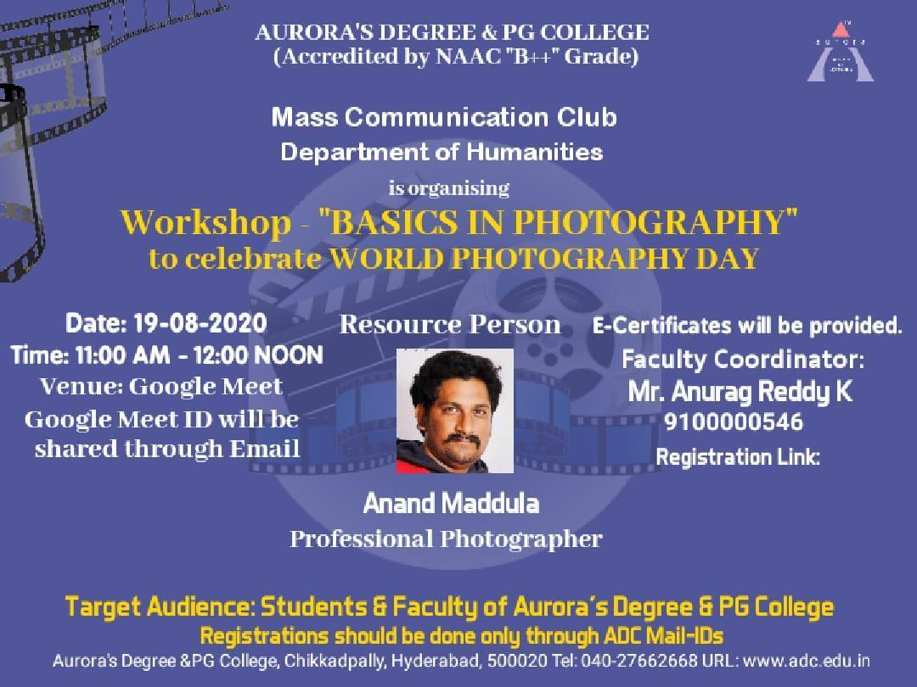

Aurora’s Degree & PG College
(ACCREDITED BY NAAC WITH 'B++' GRADE)
Chikkadpally, Hyderabad 500020
Mass Communication Club

EVENT / ACTIVITY DETAILED REPORT
NAME OF THE EVENT | Online Workshop on Basics in Photography
TYPE OF EVENT | Photography Workshop
FACULTY INCHARGE | K. Anurag Reddy
DEPARTMENT | Mass Communication Club ; Dept. of Humanities
DATE | 19th August, 2020
VENUE | Aurora’s Degree & PG College, Block VI, RTC ‘X’ Roads
TARGET AUDIENCE | Students and faculty of Aurora’s Degree & PG College

Program Schedule-
S. No. | Schedule | Timings
1. | Introduction/Welcoming | 11:00 AM - 11:05 AM
2. | Guest Profile | 11:06 AM - 11:08 AM
3. | Commencement of Workshop by our Resource person - Mr. Anand Maddula | 11:09 AM - 12:00 PM
4. | Q&A | 12:01 PM - 12:10 PM
5. | Vote of Thanks | 12:11 PM - 12:15 PM

List of Faculty Coordinator/Coordinators-
Mr. K. Anurag Reddy, Dept. of Humanities

List of Student Coordinators- NA

List of Participants-
Name | Student/ Faculty | Stream/ Department | Class & Section | Contact Number
B Naga Sai Deepak | Student | BA | BA 2 (MC. PS. Li) | 6301266230
Utsav Tripathi | Student | B.com | 1B | 9652034003
Pusala Pavan Kumar | Student | Mpcs | 2c | 9100712046
Joga Jagadeesh | Student | Bsc | Mibic | 9912392109
MOHURLE. BHAVANI | Student | Bsc. | MIGC 3B | 9398468139
Anupreethi Mehendikar | Student | B. Com | B. Com (Comp.) 3D | 8143262055
PALLENI SRUTHI | Student | B.sc | Mibic 1 | 9000508422
Raqshan Aleem | Student | Mi. Bi. C | Mi. Bi. C 3 | 8008698012
Ch Ramu | Student | Bcom | bcom computer application 1b | 9949142930
L. Kaushik | Student | BSC(MECs) | 2A | 8686860116
Nidhi Nagula | Student | Bcom | Bcom (comp. app.)3 | 9121653650
S. Lakshmi | Faculty | CS |  | 9705323078
Satvika | Student | BA: MCPSML | BA 2 | 9704844527
Pavan v | Student | B.com | B.com (G)1- c | 8520988458
E.Hemanth kumar | Student | B.COM | (Comp.) 3A | 8801015055
G.keerthana | Student | Bsc | Bt.bi.c - 1b | 7993687311
sravanKumar | Student | B.com | B.com (Comp.) 2b | 6300370426
PADIGELA RUCHITHA | Student | BSC:MSCS | Mscs 3c | 7036918033
A.Manisha | Student | B.com((Comp.)) | Second year and A section | 8309010627
Sarthak Sureka | Student | Bcom General | 2 year 2c | 8919541178
BANDARI BHANU PRAKASH | Student | BSC : MEC'S | MEC'S 3C | 6302868345
Mohammed Ateef Ali | Student | B.B.A | B.B.A-1B | 7989978808
BALUSANI SAVYA | Student | Bsc mscs | 2A | 9676125486
M Govinda Raju | Student | BSC | MSCs 2 A | 7286973082
Madhagoni 6 | Student | B.com | Honors 1A | 7207530680
Patel Sampath Kumar | Student | Bsc | Mecs 2c | 7729002581
Laxman | Student | B. Com(Gen) | 1B | 7680804863
Divya Patil | Student | BSC | MSCs 2B | 9703753155
Bheema lalshman | Student | Bsc | Mec's 1A | 09948146101
MOHAMMED AMER | Student | BBA | BBA1B | 9398849993
Pola Neha | Student | B. Com | Computer C | 9030988481
Apeksha bhati | Student | B.com (general) | 2C | 7995399674
BANDI MANOJ | Student | B.com | B.com (Comp. App.) 1D | 9381207996
Sony Biradar | Student | B.Com | B.Com generals -2'C' | 6303973264
SIDDALA AKSHITHA | Student | B.COM Honors | Honors 1B | 7993616227
Syeda amreen fatima | Student | Bsc | Migc | 9700140704
Bingi Jayanth | Student | BBA | BBA 1C | 7095316014
G.Ruchika | Student | B.com (Comp. App.) | B.com (Comp. App.) 1c | 9849842361
C A Akhilesh Yadav | Student | B.Com (Comp. App.) | B.Com(1st year) 1B | 9959967839
Deepalika Reddy Anugu | Student | BBA | BBA-1B | 7569811239
Naveen Reddy | Student | Mscs | M.s.cs 3A | 7032065175
Prathyush Nallella | Student | BA | BA II Mc.Ps.Li | 9000702702
Ayush chhabra | Student | B.COM | B.Com gen 1 'C' | 9939911199
Sudhanshu Vyas | Student | B.COM | B.COM ((COMP.)) 3C | 7416367060
Keyura | Student | Bba | 2b | 9000256468
Survi Sairam | Student | B.com (Comp.) | 3 (D) | 9515594098
R.Mamatha | Faculty | Commerce |  | 9100000583
Simran Gehlot | Student | B.com | Bcom 3D | 9704305137
K.Manasa | Student | BBA |  | 7995734946
S.Sai Kiran | Student | Bsc | Mpcs 3B | 7330973507
SANDHYA RANI G | Faculty | B.COM |  | 916004566
Rishika Agarwal | Student | B.com Comp. App. |  | 9110562793
P.Sai Sumanth Reddy | Student | BSC | Btbic 2A | 9502631099
B. Shashank | Student | B.COM (Comp.) | 3C | 9963623098
Soumya Mohan Akhilesh | Faculty | BBA |  | 8142678528
Tarun shah | Student | BBA | 2nd year 2B | 7702268851
Akshara Chunduri | Student | BBA | BBA-2A | 8143230400
Saikiran pottigari | Student | B.COM COMPUTER | B. COM(COMP) 2C | 8500823216
M.keerthi | Student | Bs.c | Bt.bi.c-1A | 9640074015
Rahul Boine | Student | B.com (Comp.) | Bcom (Comp.) 3B | 9502596554
Gosar Keval kumar | Student | B.com.computer | 2c | 8074152637
P.Bhavani Prasad | Student | B.COM | computer application | 9298950084
Shubham singh | Student | B.com (Gen) | 3c | 8555055355
Rani | Student | Bcom | Computer 3c | 9381631091
Kaushik | Student | B.Com | B.com comp. 3b | 9030559123
T.Bindu | Student | B.com General | 2E | 9182667285
MakkalaSrikanth | Student | Bcom | 3d general | 9573670979
shalini | Faculty | CS |  | 8885199726
K.Haneesha | Faculty | CS |  | 9100000516
Syeda Nausheen | Faculty | CS |  | 9100000620
M.ARUN | Student | B.COM | B.COM (COMP.) 3C | 8179374252
Chandra Praveen N | Faculty | CS |  | 9100000549
Shifa khan | Student | B.com | BCA 1C | 8297814086
Keerthika GV | Student | BBA | 2A | 9515353354
Vishwanath Sai Kiran | Student | BSc | MECs-1B | 9502795804
Maddela Sushmitha | Student | B.COM | B.COM GENERAL 3B | 7702909996
Hruthvika Babburi | Student | Bsc life sciences | BtBiC 1b | 7396978005
Kasthuri chetana | Student | Bsc;mscs | Mscs3A | 79979297777
Sirra Sukanya | Student | B.Com ( Honours) | 2nd Year & B Section | 8179953605
SHYAM MONANI | Student | B.Com (Comp.) | BCA- IC | 8317615931
Singam Nitish | Student | BSc | mecs3C | 7036643195
Sharma muskan | Student | B com | B com generals 2c | 7995817619
Kashish | Student | Bsc | Migc 2b | 9182476908
Dr.B.Leelamani | Faculty | B.Sc |  | 9441313556
UDAY KUMAR NIMMALA | Faculty | Chemistry |  | 9100000557
Shivarag.S | Student | B.COM | 1ç | 9666710729
Nimmagadda Akshitha | Student | B.com (Comp. App.) | 1c | 9866222869
Varun kumar | Student | B.COM (Comp. App.) | 1C | 9492043478
Abdur rehman khan | Student | B.COM | BCA 1C | 7987367066
Meghraj Preksha | Student | B.Sc | MiGC 1B | 9290848731
Raga sudha Jonnada | Faculty | Maths |  | 9100001626
Raghavendra | Student | Bsc; MiGC | MiGC | 09491438753
MEGHA KIRTHI RELEKAR | Student | MiGC | 1A | 7799093069
Varindani N Bhupesh | Student | B.COM-(COMP.APP.) | BCA 1C | 8247717308
Ayushi Jhawar | Student | BCOM | Bcom computer 3B | 8247250861
Harshini | Student | B. Com (honours) | A | 9121824889
S Vamshi | Student | B.S.c | mscs 2c | 9182683191
Ajith Kumar Singh | Student | BA | A | 8686161676
p keerthan sai | Student | Mecs | mecs 2c | 8317515398
yashwanth erra | Student | Mecs | mecs 2c | 7981861369
KUSHAL SHARMA | Student | B.com | B.com Generals 3B | 7702086364
varun | Student | bsc mecs | 2b | 9248058111
Kota Nagalaxmi | Student | Bcom | A | 9347024976
Hemanth kumar | Student | BA |  | 8522947807
Vimala Devi Choudhary | Student | B.COM | 1A | 7702315540
P S L Vishwitha | Student | BBA | 3A | 9515904942
Dharanidhar | Student | B com (Comp. app.) | 1year,1B | 9492144356
Jagdish agarwal | Student | B.com | 3B | 9515030214
Sandeep | Student | Bsc | Migc | 9154108809
Ramadas Dronamraju | Student | B.Sc | MECs 1C | 7095909495
Chandu | Student | Bsc.Mpcs | 1c | 9346949905
Bharath Yadav | Student | B.COM | Bcom generals 3A | 9100144274
MANNEM RAHUL REDDY | Student | Bsc | MIGC 2A | 7093532741
Mannem Rahul reddy | Student | BSC | MIGC 2A | 7093532741
Ch pooja | Student | MSCS | 3A | 6309355602
Ragam preethi | Student | Bcom | (Comp.)3c | 9573599002
Satvika | Student | BA; MCPSML | BA-2 | 9704844527
Bhavana Parthireddy | Faculty | English |  | 7981494046
Ch. Sai Naveena | Student | B.com | 2c compuers | 703679587
SANDHYA RANI G | Faculty | COMMERCE |  | 9160040566

Program Proceedings-
Mr. Anand Maddula, a professional photographer has shared his experiences to the students.
The workshop has taught participants about exposure triangle, Aperture, Shutter Speed, Focus, Image capture on film, White balance, Camera accessories, Exposure control, Metering and many more camera attributes.

Income & Expenditure- NA

Event Photographs-
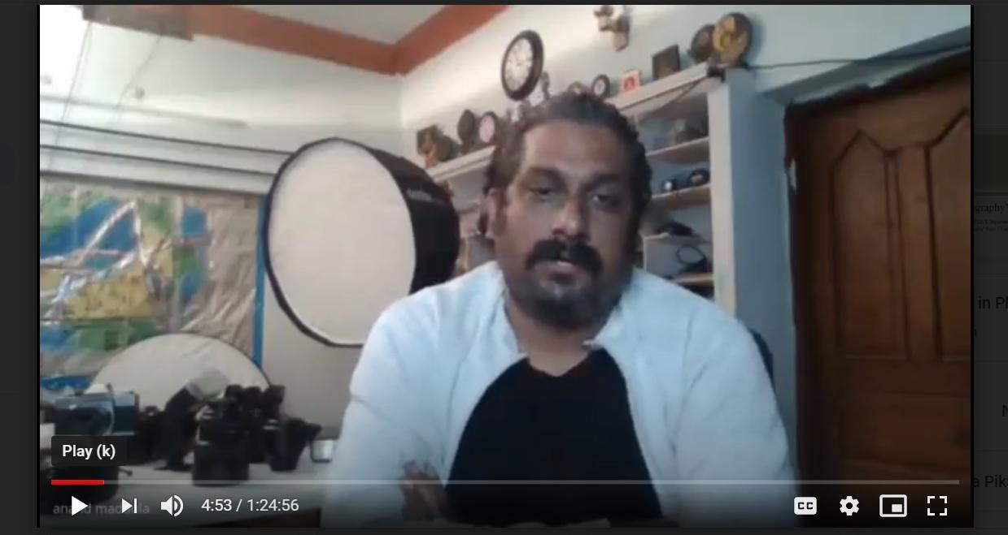

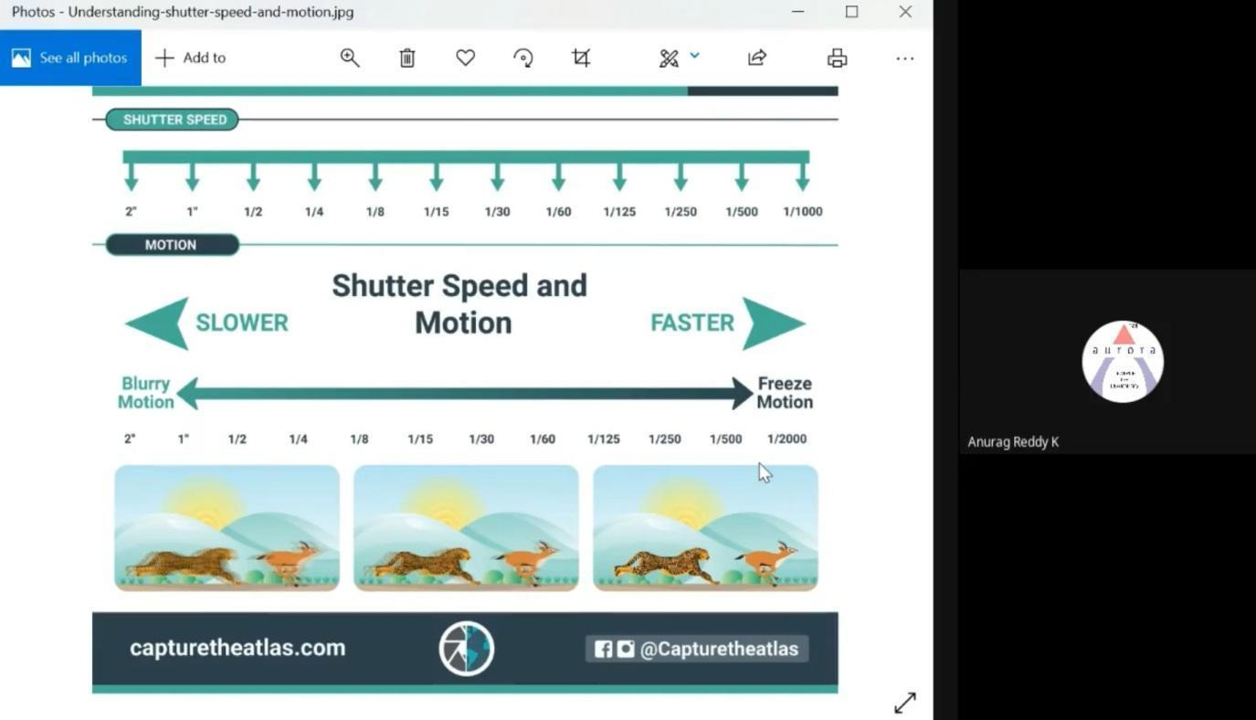
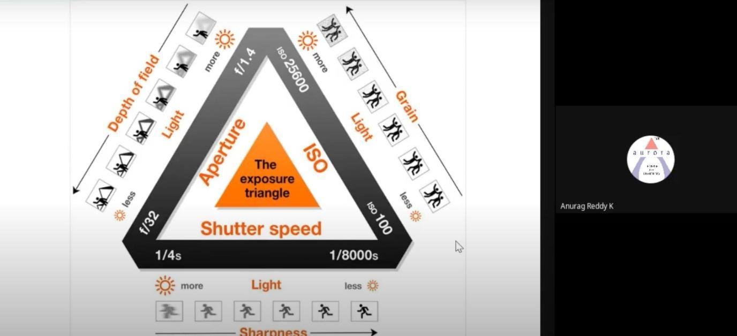

Guest Profile-
Mr. Anand Maddula is a Professional Photographer. He has been in photography for many years & has covered a lot of shoots for various models and weddings across the nation. He is well known for his naturalistic-looking imagery in the field.

Feedback-

