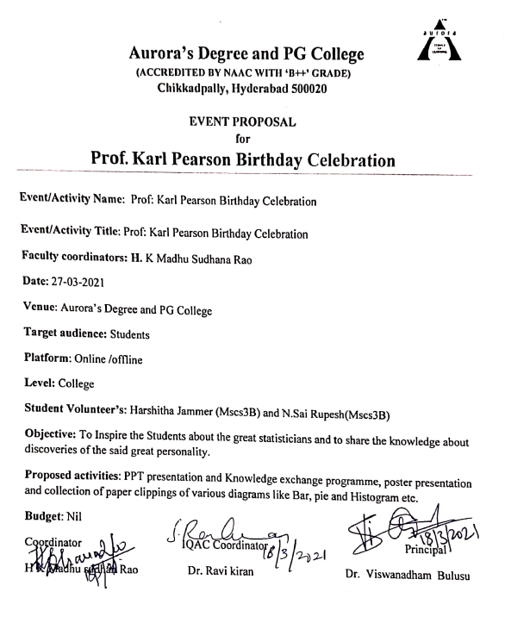

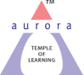
Aurora’s Degree & PG College
(ACCREDITED BY NAAC WITH 'B++' GRADE)
Chikkadpally, Hyderabad 500020

EVENT / ACTIVITY SHORT REPORT

NAME OF THE EVENT / ACTIVITY | Prof: Karl Pearson Birthday
TYPE OR TITLE OF EVENT / ACTIVITY | Prof: Karl Pearson Birthday
FACULTY INCHARGE | H K Madhu Sudhan Rao
DEPARTMENT/CELL/COMMITTEE/CLUB | Department
DATE | 27-03-2021
VENUE | Aurora’s Degree and PG College
TARGET AUDIENCE | Students

OBJECTIVE: To Inspire the Students about the great statisticians and to share the knowledge about discoveries of the said great personality
BRIEF ABOUT THE EVENT: On Occasion of Karl Pearson 164th Birthday celebrations the department conducted the event on google flat form due to pandemic. Further the activities are conducted like preparation of Power point presentation, collection of paper clippings of various diagrams and tables regarding the data collection on the contribution of Late Prof. Karl Pearson’s in the field of Statistics and his achievements in recognition of the notable contributions made by Late Prof Karl Pearson in the field of Statistics. He was an influential mathematician and Biostatistician.
OUTCOME: Students came to know about the various contributions and works done by Prof. Karl Pearson’s in the field of Statistics and his achievements
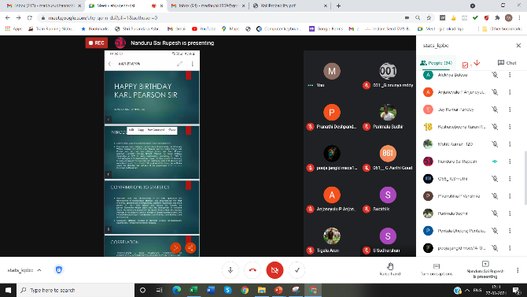
PHOTOGRAPH:
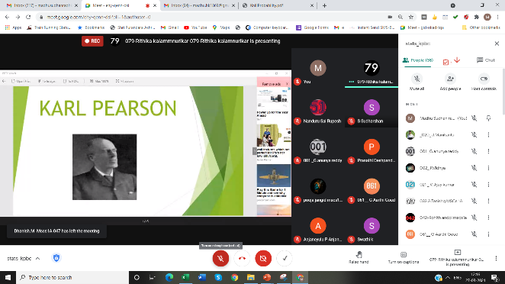

Aurora’s Degree & PG College
(ACCREDITED BY NAAC WITH 'B++' GRADE)
Chikkadpally, Hyderabad 500020

EVENT / ACTIVITY DETAILED REPORT

NAME OF THE EVENT / ACTIVITY | Prof: Karl Pearson Birthday
TYPE OR TITLE OF EVENT / ACTIVITY | Prof. Karl Pearson Birthday
FACULTY INCHARGE | H. K Madhu Sudhana Rao
DEPARTMENT/CELL/COMMITTEE/CLUB | Statistics
DATE | 27/03/2021
VENUE | Aurora’s Degree & PG College
TARGET AUDIENCE | B.Sc (MSCs I Year Students)

- PROGRAM SCHEDULE:
The event scheduled on27th march 2021, Saturday at 12:00 p.m. .
The following is the schedule.
- Inaugural address by H K Madhu Sudhana Rao
- PowerPoint and poster Presentation by the students

- LIST OF FACULTY COORDINATORS (DEPARTMENT)
H K Madhu Sudhana Rao (Statistics)
- LIST OF THE STUDENT COORDINATORS (NAME , ROLL NO, CLASS & SECTION)
- Harshitha Jammer 1051-18-467-078 MSCs 3B
- N.Sai Rupesh 1051-18-467-051 MSCs 3B

- LIST OF THE STUDENTS WHO PRESENTED THE PPT’S POSTERS (NAME, ROLL NO, CLASS &SECTION,)
S.NO | ROLL NO | NAME | SECTION | KIND OF ACTIVITY
1 | 1051-20-467-087 | KASHYAP BHARD | MSCS 1B | PPT
2 | 1051-20-467-097 | TIGALA TARUN | MSCS1B | TABLE SHOWING LITERACY RATE
3 | 1051-20-467-076 | K SHARATH CHANDRA | MSCS1B | PICTURES REGARDING COVID-19
4 | 1051-20-467-107 | S SUDHARSHAN | MSCS1B | TABLE SHOWING CENSUS
5 | 1051-20-467-008 | M.KEYURI | MSCS1A | PPT
6 | 1051-20-467-001 | G ANUNYA REDDY | MSCS1A | PPT
7 | 1051-20-467-059 &009 | DEEKSHITHA & SRAVANI | MSCS1A | PPT
8 | 1051-20-467-082 | CH BHASKAR | MSCS1B | PPT
9 | 1051-20-467-006,33 &42 | POOJA AND TEAM | MSCS1A | PDF
10 | 1051-20-467-021 &27 | Ajay kumar &laxmi narasimha | MSCS1A | PPT
11 | 1051-20-467-030 | G .NAGARAJ YADAV | MSCS1A | PPT
12 | 1051-20-467-087 | P.PRAVEEN | MSCS1B | TABLE SHOWING VOTERS LIST
13 | 1051-20-467-065 | Mohammed Althaf Qureshi | MSCS1B | POSTER PRESENTATION
14 | 1051-20-467-105 | Mella Naveen Kumar | MSCS1B | POSTER PRESENTATION
15 | 1051-20-467-114 | Tula Bhavani | MSCS1B | PPT
16 | 1051-20-467-115 | Paras Rupani | MSCS1B | PPT
17 | 1051-20-467-116 | Jay Kumar Pandey | MSCS1B | POSTER PRESENTATION
18 | 1051-20-539-007 | Pranathi Deshpande | MSDS | POSTER PRESENTATION
19 | 1051-20-467-038 040 | A SHIVANANDA &JALA SANJAY | MSCS1A | PPT
5. | LIST OF PARTICIPANTS

Participants | Joined | Left | Duration
Madhu Sudhan rao HK | 3-27-2021 12:26:39 | 3-27-2021 12:51:15 | 00:24:36
_020_ J.Manikanta | 3-27-2021 12:26:39 | 3-27-2021 12:51:15 | 00:24:36
001 _G.anunya reddy | 3-27-2021 12:26:39 | 3-27-2021 12:51:15 | 00:24:36
002_ P.Vidhya | 3-27-2021 12:26:39 | 3-27-2021 12:51:15 | 00:24:36
021 _ V. Ajay kumar | 3-27-2021 12:26:39 | 3-27-2021 12:51:15 | 00:24:36
033 A.Tanishq MSCs 1A | 3-27-2021 12:26:39 | 3-27-2021 12:51:15 | 00:24:36
042-Rohith andol mscs1a | 3-27-2021 12:26:39 | 3-27-2021 12:51:15 | 00:24:36
061__ G Aarthi Goud | 3-27-2021 12:26:39 | 3-27-2021 12:51:15 | 00:24:36
064_ P Navaneetha | 3-27-2021 12:26:39 | 3-27-2021 12:51:15 | 00:24:36
069- Sawant Sai Neetesh | 3-27-2021 12:26:39 | 3-27-2021 12:51:15 | 00:24:36
072 A.Trinath | 3-27-2021 12:26:39 | 3-27-2021 12:51:15 | 00:24:36
076 - K.Sharath | 3-27-2021 12:26:39 | 3-27-2021 12:51:15 | 00:24:36
079-Rithika | 3-27-2021 12:26:39 | 3-27-2021 12:51:15 | 00:24:36
087- kashyap bharadwaj | 3-27-2021 12:26:39 | 3-27-2021 12:51:15 | 00:24:36
Aditya Raj Singh | 3-27-2021 12:26:39 | 3-27-2021 12:51:15 | 00:24:36
Alekhya Bulusu | 3-27-2021 12:26:39 | 3-27-2021 12:51:15 | 00:24:36
Amar Das | 3-27-2021 12:26:39 | 3-27-2021 12:51:15 | 00:24:36
Anapuram Sanjay | 3-27-2021 12:26:39 | 3-27-2021 12:51:15 | 00:24:36
Anjaneyulu P Anjaneyulu P | 3-27-2021 12:26:39 | 3-27-2021 12:51:15 | 00:24:36
CH. Rajashekar | 3-27-2021 12:26:39 | 3-27-2021 12:51:15 | 00:24:36
Jay Kumar Pandey | 3-27-2021 12:26:39 | 3-27-2021 12:51:15 | 00:24:36
Karuna Tata | 3-27-2021 12:26:39 | 3-27-2021 12:51:15 | 00:24:36
Mahankali Vishal | 3-27-2021 12:26:39 | 3-27-2021 12:51:15 | 00:24:36
Mangali Ganesh | 3-27-2021 12:26:39 | 3-27-2021 12:51:15 | 00:24:36
Mohit Kumar -120 | 3-27-2021 12:26:39 | 3-27-2021 12:51:15 | 00:24:36
Namal Lingraj | 3-27-2021 12:26:39 | 3-27-2021 12:51:15 | 00:24:36
O58_ K.Shruthi | 3-27-2021 12:26:39 | 3-27-2021 12:51:15 | 00:24:36
P Vanshika P Vanshika | 3-27-2021 12:26:39 | 3-27-2021 12:51:15 | 00:24:36
Pentala Dheeraj | 3-27-2021 12:26:39 | 3-27-2021 12:51:15 | 00:24:36
pooja jangid mscs1A-006 | 3-27-2021 12:26:39 | 3-27-2021 12:51:15 | 00:24:36
Pranathi Deshpande | 3-27-2021 12:26:39 | 3-27-2021 12:51:15 | 00:24:36
Praveen Panchaguda | 3-27-2021 12:26:39 | 3-27-2021 12:51:15 | 00:24:36
Purmishetty Srujan | 3-27-2021 12:26:39 | 3-27-2021 12:51:15 | 00:24:36
rajyalakshmi d | 3-27-2021 12:26:39 | 3-27-2021 12:51:15 | 00:24:36
Rangam Parthiv | 3-27-2021 12:26:39 | 3-27-2021 12:51:15 | 00:24:36
S Sudharshan | 3-27-2021 12:26:39 | 3-27-2021 12:51:15 | 00:24:36
S Vinay Raj | 3-27-2021 12:26:39 | 3-27-2021 12:51:15 | 00:24:36
Sudhir Sharma | 3-27-2021 12:26:39 | 3-27-2021 12:51:15 | 00:24:36
Swathi k | 3-27-2021 12:26:39 | 3-27-2021 12:51:15 | 00:24:36
Tigala Arun | 3-27-2021 12:26:39 | 3-27-2021 12:51:15 | 00:24:36
Tula Bhavani Tula | 3-27-2021 12:26:39 | 3-27-2021 12:51:15 | 00:24:36
Tumma Alekhya Anand | 3-27-2021 12:26:39 | 3-27-2021 12:51:15 | 00:24:36
Vinita J | 3-27-2021 12:26:39 | 3-27-2021 12:51:15 | 00:24:36

- PARAGRAPH ABOUT THE PROCEEDINGS (TILL THE END OF THE EVENT)

Objective: To Inspire the Students about the great statisticians and to share the knowledge about discoveries of the said great personality.

Date: 27-03-2021
Brief about the event: On Occasion of Karl Pearson 164th Birthday celebrations the department conducted the event on google flat form due to pandemic. Further the activities are conducted like preparation of Power point presentation, collection of paper clippings of various diagrams and tables regarding the data collection on the contribution of Late Prof. Karl Pearson’s in the field of Statistics and his achievements in recognition of the notable contributions made by Late Prof Karl Pearson in the field of Statistics. He was an influential mathematician and Biostatistician.

The event was conducted on occasion of the 164th birthday of Prof: Karl Pearson The event was conducted to inspire the students about the life and achievements of prof: Karl Pearson
On this occasion, The Department of Statistics conducted online PowerPoint presentations, poster presentations and knowledge exchange program to the MSCS/MSDS Degree first year students. The students actively participated in the event.
Shard Chandra, Kashyap Bhardwaj, of MSCS 1B section and Pooja and team of MSCS1A stood Ist , 2nd and 3rd places respectively. The prizes are also announced
The session began with an introduction of Prof Karl Pearson by H K Madhu Sudhana Rao working as
Associate Professor, Department of Statistic, followed by Power Point presentation, given by Harshitha Jammer & N. Sai Rupesh of MSCs III-year students, on contributions & achievements Prof: Karl Pearson in the field of statistics like Skewness, Correlation and Chi-Square test to the first-year students of MSCS/MSDS students. The students interacted with the participants and explained the importance of statistics in various fields, job opportunities by doing the course. Further the students of Ist year also presented the PPT’S and Posters regarding the contributions of Prof: Karl Pearson in the field of modern Statistics. Finally the program was ended by proposing vote of thanks by J Vinita senior Asst: professor Dept: of Statistics
OUTCOME: The students were enlightened on the contributions & achievements of Prof Karl Pearson and the importance of statistics in various fields.

- INCOME AND EXPENDITURE: NIL
- EVENT PHOTOS (MIN 2 MAX 4):

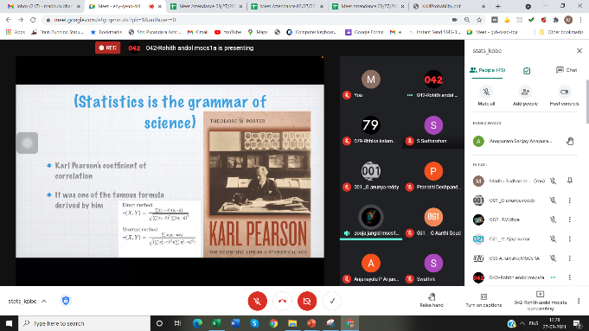
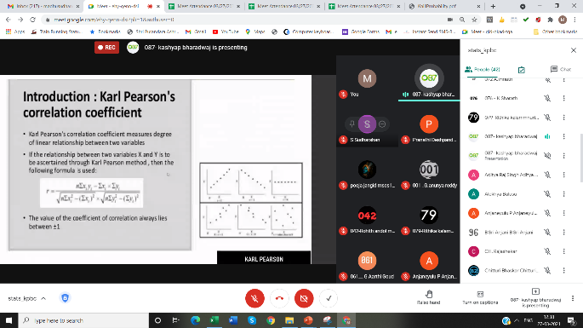

- GUEST PROFILE (IF ANY): NIL
- FEED BACK IF ANY: NIL
- ATTACHMENTS: NIL
- MEET RECORDING LINK: https://tinyurl.com/y2bybtdx

12.EVENT/ACTIVITY PROPOSAL

EVENT PROPOSAL
for

Prof. Karl Pearson Birthday Celebration

Event/Activity Name: Prof. Karl Pearson Birthday Celebration

Event/Activity Title: Prof. Karl Pearson Birthday Celebration

Faculty coordinators: H K Madhu Sudhana Rao
Date: 27-03-2021
Venue: Aurora’s Degree and PG College
Target audience: Students
Platform: Online
Level: College
Student Volunteer’s: Harshitha Jammer (Mscs3B) and N. Sai Rupesh (Mscs3B)
Objective: To enlighten the students in statistics and Remembering the Legendary Statisticians
Proposed activities: PPT presentation and Knowledge exchange programme, poster presentation and collection of paper clippings of various diagrams (like Bar, Pie etc.)

Budget: Nil
Coordinator IQAC Coordinator Principal
H K Madhu Sudhana rao Dr. Ravi kiran Dr. Viswanatham Bulusu

13. EVENT / ACTIVITY NOTICE:
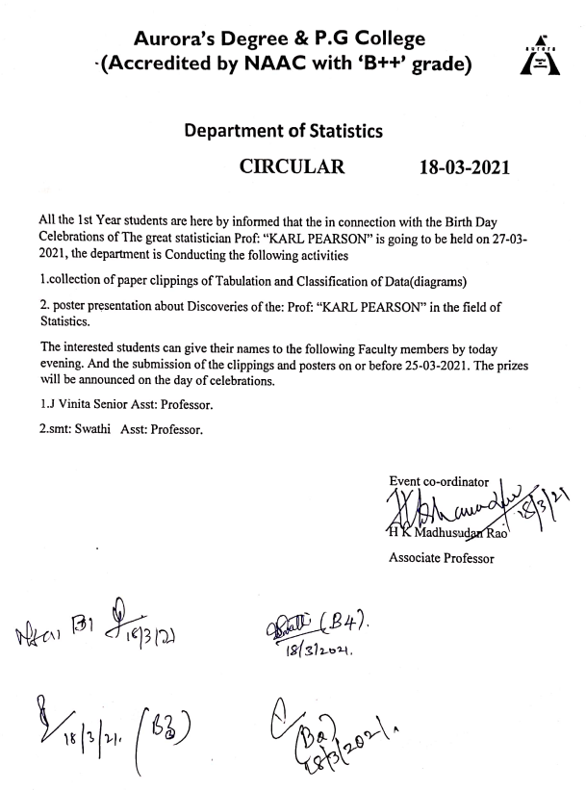

RECEIPTS (IF ANY): NIL
CERTIFICATES (IF ANY): NIL
LETTERS OF COMMUNICATION (IF ANY): NIL

