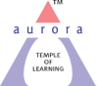
Aurora’s Degree & PG College
(Accredited by NAAC with 'B++' grade)
Chikkadpally, Hyderabad- 500020
Department of Biochemistry

EVENT REPORT

EVENT TITLE | Carl Neuberg Birthday Celebrations
TYPE OF EVENT | Departmental event
FACULTY INCHARGE | G. Sunitha
DEPARTMENT | Biochemistry
DATE | 29/07/2020
VENUE | Online
TARGET AUDIENCE | B.Sc life science students

OBJECTIVE:
- To enlighten students about the role of biochemistry in various diseases.
- To inculcate experimental and creative research skills among students.
BRIEF ABOUT THE EVENT:
Carl Alexander Neuberg (29 July 1877 – 30 May 1956) was an early pioneer in biochemistry, and he is often referred to as the "father of modern biochemistry". His notable contribution to science includes the discovery of the carboxylase and the elucidation of alcoholic fermentation which he showed to be a process of successive enzymatic steps, an understanding that became crucial as to how metabolic pathways would be investigated by later researchers. The department of Biochemistry has celebrated his birthday on 29/07/2020.As a part of the celebrations quiz – Medical Lab Technology and PowerPoint presentation with the theme ‘Biochemistry behind hypertension/diabetes/cancer’ were conducted.
OUTCOME:
The event was successful with the participation of students from life science streams. The students gained the knowledge about the biochemical mechanisms behind the hypertension/diabetes/cancer.

PHOTOGRAPHS:
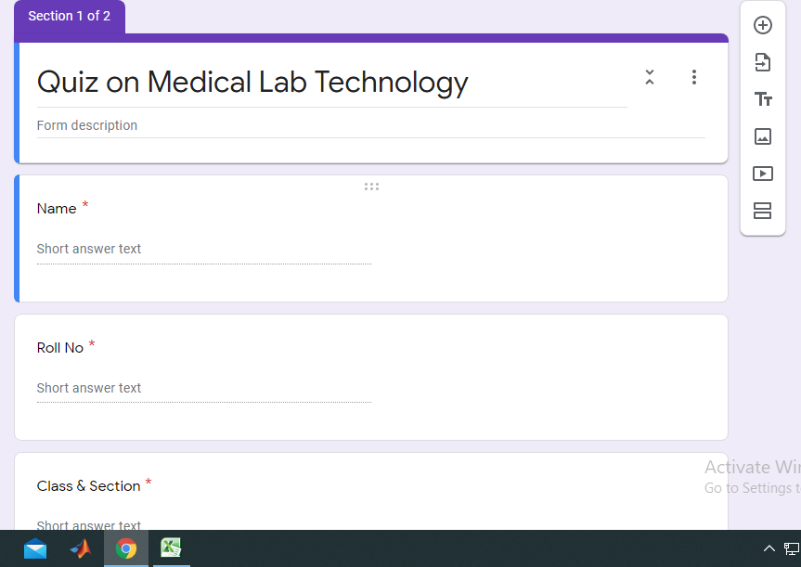

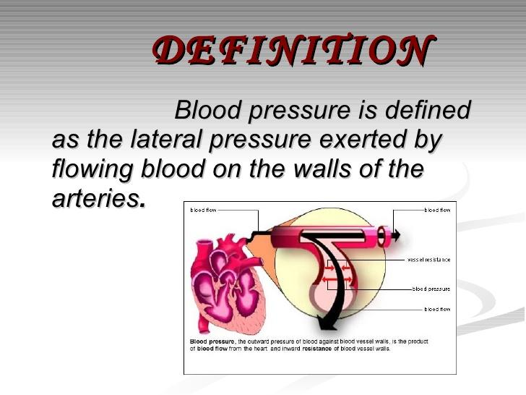

DETAILED REPORT
List of the participants-quiz:
S.No | Name of the student | Class
1 | Ambati Sai Vivek | Mibic3
2 | Deepthi Cheruvu | Btbic3B
3 | Jivanage Anirudh | BTBIC 3A
4 | Afreen Begum | Bt.Bi.C (3B)
5 | Guntagari Anusha | Bt.bi.c 3B
6 | Rounak Singh | Bt. Bi. C 1A
7 | Mohapatra Achyutananda | Btbic-2A
8 | Palleni Sruthi | MIBIC1
9 | S Varsha | Bt.bi.c 1A
10 | Mohammed AlBohisi | BtBiC 1B
11 | Raqshan Aleem | Mi. Bi. C
12 | Marepally sravani | Btbic2A
13 | Chandana | Btbic.1A
14 | Malkapuram chandana | Bt.bi.c 2(A)

List of the participants-Power Point Presentation:
S.No | Name of the student | Class
1 | Afreen Begum | Bt.bi.c 3B
2 | Chinnagalla Shivani | Bt.bi.c 3B
3 | Rounak Singh | Btbic.1A
4 | Mohammed Albohisi | BtBiC 1B
5 | Addagatla BabyUjwala | BtBiC 1B
6 | S. Varsha | Bt.bi.c 1A
7 | Vaagdevi | Bt.bi.c 1A

Photographs:

