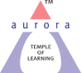
Aurora’s Degree & PG College
(Accredited by NAAC with 'B++' grade)
Chikkadpally, Hyderabad 500020
Department of Biotechnology

EVENT REPORT

NAME OF THE EVENT | National Science Day Celebration
TYPE OF EVENT | Departmental event
FACULTY INCHARGE | Dr.B.Leelamani
DEPARTMENT | Biotechnology
DATE | February 28, 2021
VENUE | Google Meet
TARGET AUDIENCE | 1st year Students & Faculty

OBJECTIVE:
To bring awareness among the students on Science along with getting the basic understanding of the concepts involved in Science.
BRIEF ABOUT THE EVENT:
Science encompasses the systematic study of the structure and behavior of the physical and natural world through observation and experiment, and technology is the application of scientific knowledge for practical purposes. The development of technology along with the advancement in Science helps to bring in a revolution in various fields such as medicine, agriculture, education, information and technology, and many more.
Students involved in Power point presentation:
- Thotapalli Varun – BtBiC 1st Year
- Thandle Vinayak -- BtBiC 1st Year
- Swain Reshma – BtBiC II A
- Samvika -- BtBiC II A
- Adnan Aziz Karani-- BtBiC II B
- Korthivada Pravallika -- BtBiC III B
- K.Rachana -- BtBiC III A
Student Volunteer:
- Korthivada Pravallika -- BtBiC III B
OUTCOME:
All the participants gained knowledge on innovative scientific ideas in day to day life.
PHOTOGRAPHS:
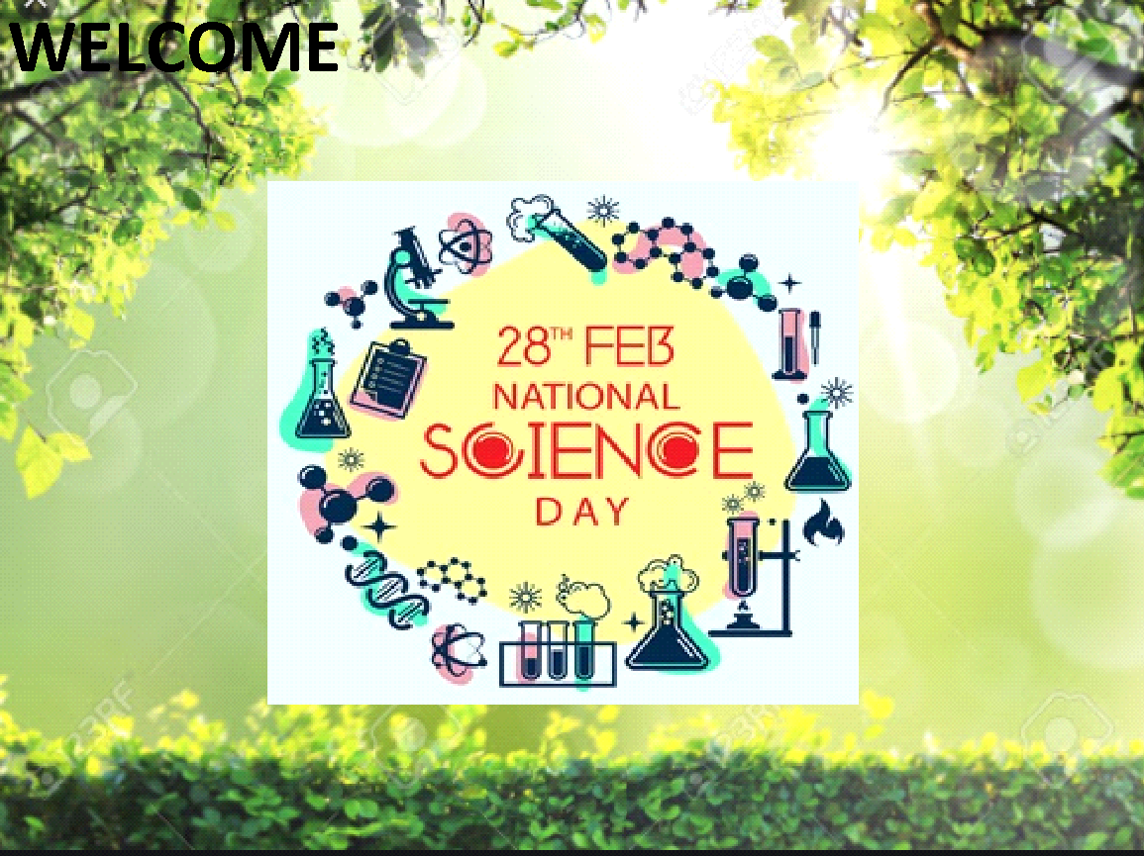

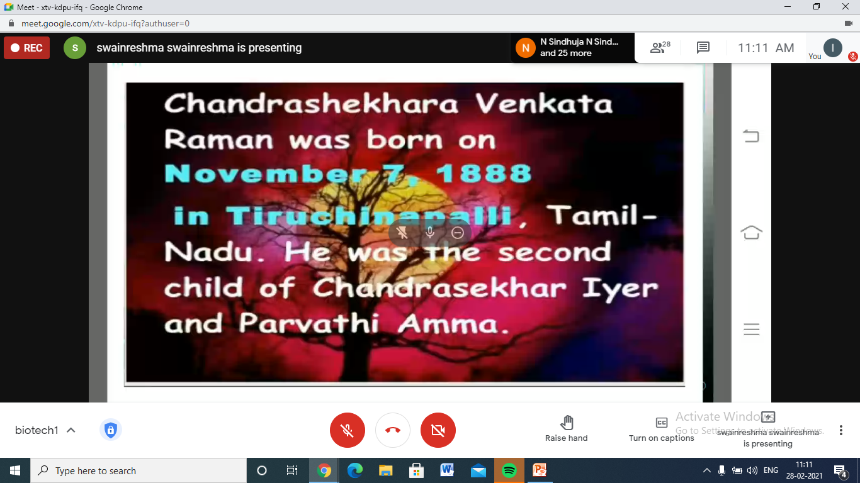

DETAILED REPORT
National Science Day is celebrated on 28th February every year in commomeration and in the honor of Sir, C.V.Raman and his contributions. This year Department of Biotechnology has organised National Science Day event to bring awareness among the students on Science along with getting the basic understanding of the concepts involved in Science. The target audience was 1st year Students & Faculty members along with 2nd and 3rd year students. Korthivada Pravallika from BtBiC III B was student volunteer for the complete session and she has hosted the session in National Science Day Celebration event.
Korthivada Pravallika started the session with introduction to the National Science Day which is celebrated in commomeration and in the honor of Sir, C.V.Raman and highlighted his contributions. Students presented their science ppt’s for 1hour. The session was interesting and students were happy to present their views. The target audience was gained knowledge on innovative scientific ideas in day to day life. At the end of the session vote of thanks was given by student volunteer thanking our Principal Sir and Vice principal sir for their support. All presentees were appreciated for their active participation.
Best presentation for the National Science Day celebration was given to 2 students.
1st best presentation was given to Korthivada Pravallika from BtBiC III B.
2nd best presentation was given to K.Rachana from BtBiC II B.

Details of the Students participated in presentation:
- Thotapalli Varun:
Thotapalli Varun from BtBiC 1st Year bearing Roll number 1051-20-488-015 has presented PPT on “Brocoli”. He has highlighted the importance, production and uses of Brocoli in medicinal field for treating various diseases.

- Thandle Vinayak:
Thandle Vinayak from BtBiC 1st Year bearing Roll number 1051-20-488-045 has presented PPT on “Transgenic Lettuce”. His presentation mainly involved in its genetic resources, types of Lettuce and technology involved in its production.

- Swain Reshma:
Swain Reshma from BtBiC II A has presented PPT on importance of National Science Day Celebration and commomerated in the honor of Sir, C.V.Raman and his contributions.

- Samvika:
Samvika from BtBiC II A has presented PPT on Discovery of Sir, C.V.Raman and applications.

- Adnan Aziz Karani:
Adnan Aziz Karani from BtBiC II B has presented PPT on Early life education of of Sir, C.V.Raman, contributions and publications.

- Korthivada Pravallika:
Korthivada Pravallika from BtBiC III B has presented PPT on “Typical Fermentor Structure”, types of fermentors, components and its importance in Science fieid.

- K.Rachana:
K.Rachana from BtBiC II B has presented PPT on “Vertical Farming”, hydroponics, working and its importance in vertical farming.

Student Volunteer:
- Korthivada Pravallika from BtBiC III B has hosted the session in National Science Day Celebration event.

List of the participants:
Name of the student | Mail id | Contact no.
kodari usha | kodariusha20@adc.edu.in | 7674963314
Mohammed AlBohisi | mohammedaaalbohisi19@adc.edu.in | 9063790065
sadineni shreyas | sadinenishreyas20@adc.edu.in | 8886786850
C DIVYA TEJA | cdivyateja20@adc.edu.in | 9502972363
palcham lokesh kumar goud | palchamlokeshkumargoud20@adc.edu.in | 8179631224
K.K SAI SUNDARESAN | kksaiundaresan20@adc.edu.in | 7702462475
KANUDLA GANESHBABU | kanudlaganeshbabu20@adc.edu.in | 6302691279
T.varun | thotapallivarun20@adc.edu.in | 7569147839
P.jalaja dixit | jalajadikshit.7801@gmail.com | 9000991441
Tandle Vinayak | tandlevinayak20@adc.edu.in | 7893239994
Adnan Aziz Karani | Karaniadnan19@adc.edu.in | 8087628092
Suvarna P | suvarnap@adc.edu.in | 9100000574
K. Rachana | krachana18@adc.edu.in | 9989909687
EGALA CHINMAYE SAIPRIYA | egalachinmayesaipriya20@adc.edu.in | 7013477246
K.nitisha | Kawalinitisha20@adc.edu.in | 98668 64031
CHANDU DASARI | dchandu20@adc.edu.in | 7382464918
Vadlamudi Sri Sai Sripada Vallabh Choudary | vadlamudisrisaisripadavallabhchoudary20@adc.edu.in | 9347134011
Gourav upadhyay | gouravupadhyay20@adc.edu.in | 9618695500
Snigdha priya talamarla | talamarlasnigdhapriya18@adc.edu.in | 7893494752
PIDUGU RAMU | piduguramu20@adc.edu.in | 9182172934
SANIKA MANILAL PATIL | Sanikamanilalpatil20@adc.edu.in | 9515757491
GAJA JEEVAN SAI | gajajeevansai20@adc.edu.in | 9492327097
Korthiwada pravalika | korthiwadapravalika.g21@gmail.com | 9392988895
G.Swapna | gantaswapna18@adc.edu.in | 9063702399
vasudevan | vasudevanr@adc.edu.in | 9100001639
S. Reshma | swainreshma19@adc.edu.in | 8919858083
DAMAGATLA.AKSHAY KUMAR REDDY | bittuakshay224@gmail.com | 9963609190

PHOTOGRAPHS:

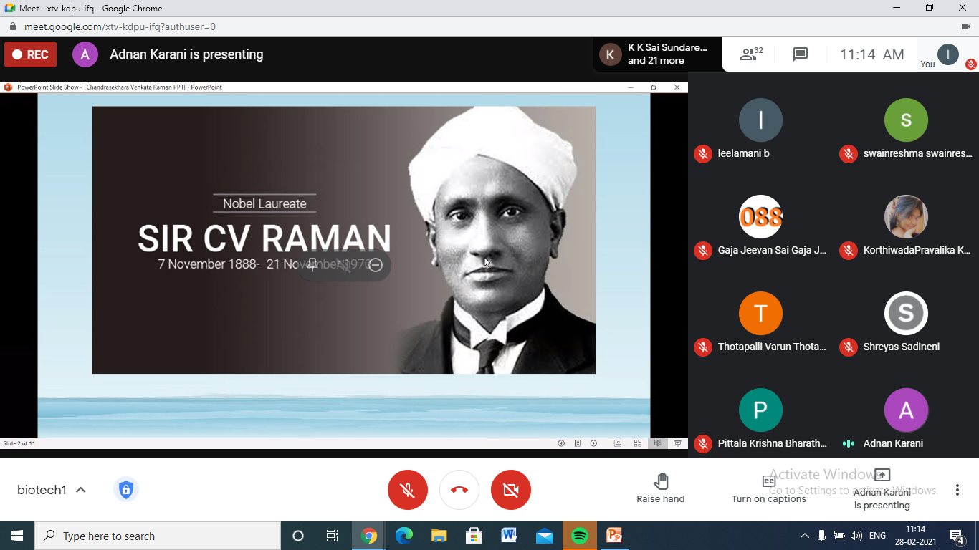

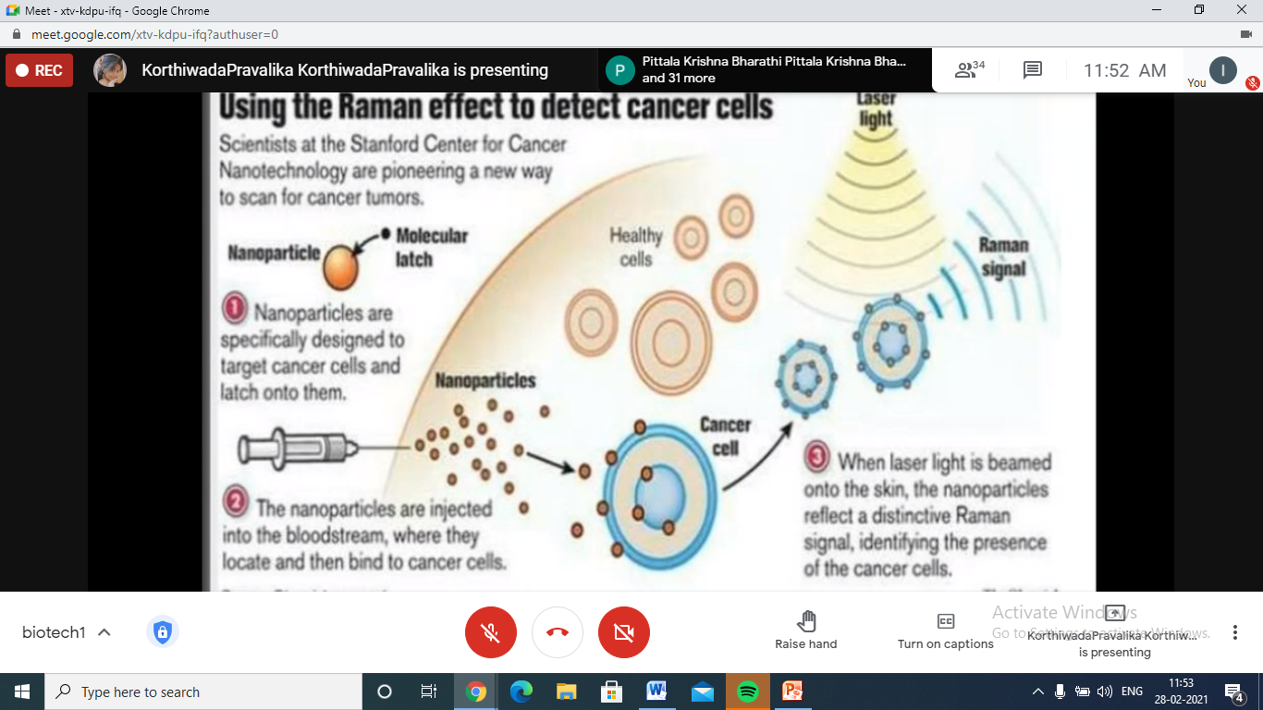

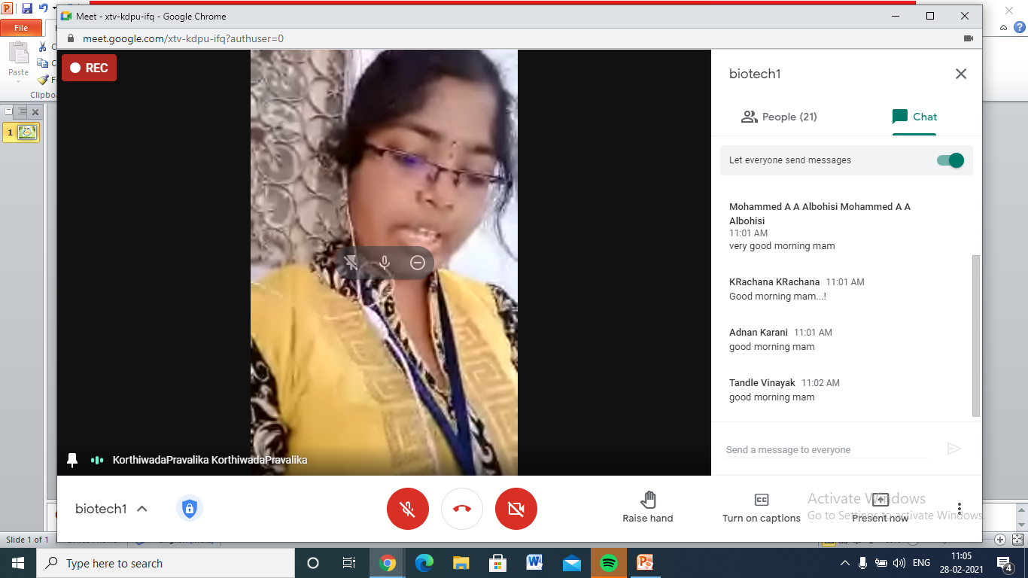

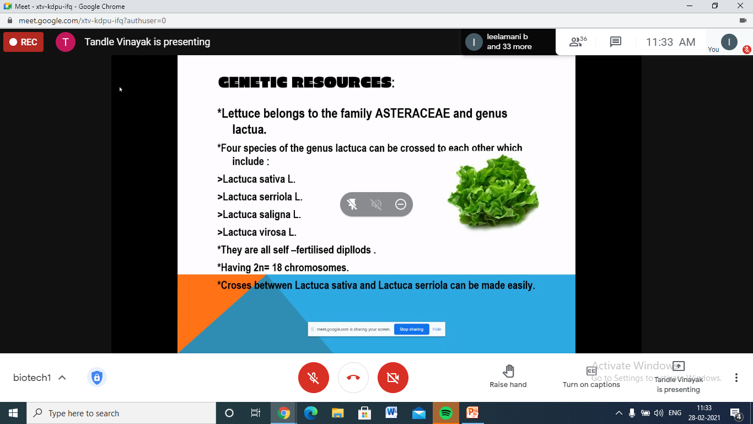

Google meet recording link:
https://drive.google.com/file/d/1cUozM1oOParM2r7PCNyl7pmfXDporttw/view?usp=sharing

OUTCOME:
All the participants gained knowledge on innovative scientific ideas in day to day life.

