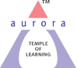
Aurora’s Degree & PG College
(ACCREDITED BY NAAC WITH 'B++' GRADE)
Chikkadpally, Hyderabad 500020

EVENT / ACTIVITY SHORT REPORT

NAME OF THE EVENT / ACTIVITY | Prof. R.A Fisher Birthday Event
TYPE OR TITLE OF EVENT / ACTIVITY | Prof. R.A Fisher Birthday Event
FACULTY INCHARGE | Rajya Lakshmi
DEPARTMENT/CELL/COMMITTEE/CLUB | Statistics
DATE | 17/2/2021
VENUE | Aurora’s Degree & PG College
TARGET AUDIENCE | B.Sc (MSCs/MSDs I Year Students)

OBJECTIVE:
To enlighten the students about the contributions of Prof. R.A. Fisher in the field of Statistics. . Motivating and inspiring the students regarding his studies.
BRIEF ABOUT THE EVENT:
The event was conducted on occasion of the 131st birthday of Prof. R.A. Fisher on 17th February 2021. The event was conducted to inspire the students about the life and achievements of Prof .R.A.Fisher.
On this occasion, The Department of Statistics conducted online quiz competition on BASIC STATISTICS to the MSCS/MSDS Degree first year students. The students actively participated in the quiz competition.
Pranathi Deshpande ,Alekhya T of MSDs , V.Ajay kumar& Dinesh Kotthapelli of MSCs 1A students scored highest marks in online quiz competions on basic statistics
The session began with an introduction of Prof R.A. Fisher by Rajya Lakshmi working as Assistant Professor, Department of Statistic, followed by Power Point presentation, given by K.Swetha Rai & Divya Patil captains of MSCs II year students, on contributions & achievements of Prof.R.A Fisher in the field of statistics for all the sections of first year MSCS/MSDSstudents. The students interacted with the first year students and gave the suggestions and importance of statistics in various fields. H.K Madhusudhan Rao, faculty of Department of Statistics gave a note on the importance of statistics to the students.
OUTCOME:
The students were enlightened on the contributions & achievements of Prof R.A Fisher and the importance of statistics in various fields.
PHOTOGRAPH:
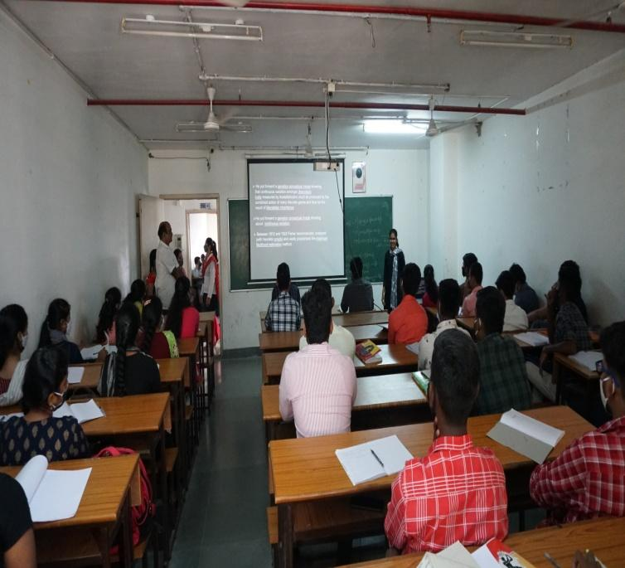

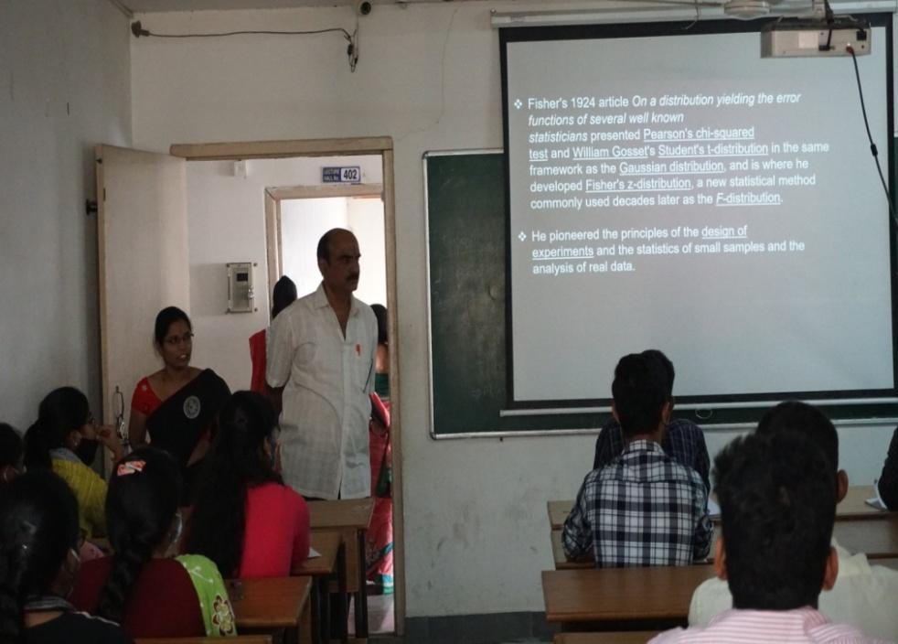

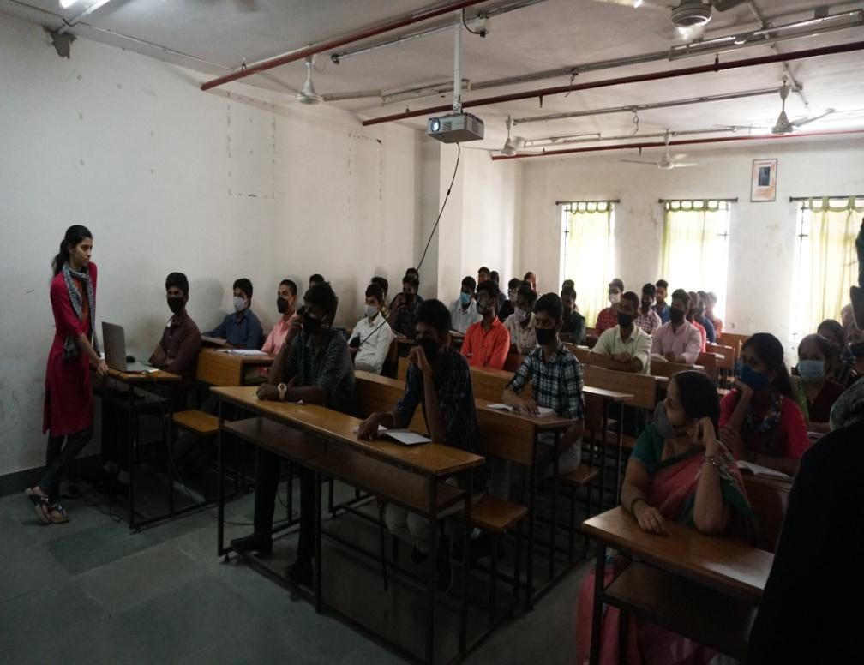

Aurora’s Degree & PG College
(ACCREDITED BY NAAC WITH 'B++' GRADE)
Chikkadpally,Hyderabad 500020

EVENT / ACTIVITY DETAILED REPORT

NAME OF THE EVENT / ACTIVITY | Prof. R.A Fisher Birthday Event
TYPE OR TITLE OF EVENT / ACTIVITY | Prof. R.A Fisher Birthday Event
FACULTY INCHARGE | Rajya Lakshmi
DEPARTMENT/CELL/COMMITTEE/CLUB | Statistics
DATE | 17/2/2021
VENUE | Aurora’s Degree & PG College
TARGET AUDIENCE | B.Sc (MSCs/MSDs I Year Students)

- PROGRAM SCHEDULE:
The event scheduled on 17th February 2021, Wednesday at 3:00 p.m .
The following is the following schedule.
- Inaugural address by Rajya Lakshmi
- PowerPoint Presentation by the students

- LIST OF FACULTY COORDINATORS (DEPARTMENT)
Rajya Lakshmi (Statistics)
- LIST OF THE STUDENT COORDINATORS (NAME , ROLL NO, CLASS & SECTION)
- K.Swetha Rai 1051-19-467-001 MSCs 2A
- Divya Patil 1051-19-467-051 MSCs 2B
- LIST OF THE PARTICIPANTS (NAME , ROLL NO, CLASS & SECTION, NO OF GIRLS, BOYS, CASTE )

Roll Number | Name | Class & Section
1051-20-467-006 | Pooja Jangid | MSCS 1A
1051-20-467-008 | Madhavaram Keyuri | MSCS 1A
1051-20-467-033 | Akku Tanishq | MSCS 1A
1051-20-467-036 | Padmawar Nithin | MSCS 1A
1051-20-467-042 | Andol Rohith | MSCS 1A
1051-20-467-046 | Seela Sai Amruth | MSCS 1A
1051-20-467-047 | Dhanish Madella | MSCS 1A
1051-20-467-056 | Bodducherla Sreeja | MSCS 1A
1051-20-467-101 | Kondapally Saketh Ram | MSCS 1B
1051-20-467-106 | Sirna Saketh | MSCS 1B
1051-20-467-123 | V. Sunil Kumar | MSCS 1B
1051-20-467-125 | Aditya Raj Singh | MSCS 1B
1051-20-467-137 | Kotthur Abhinav Sai | MSCS 1B
1051-20-539-002 | Gigijerla Jahnavi | MSDS 1
1051-20-539-004 | CH Pooja Suvarchala | MSDS 1
1051-20-539-009 | Mantri Ravi Teja | MSDS 1
1051-20-539-010 | Palle Santhosh Reddy | MSDS 1
1051-20-539-014 | Thallapelli Akash Goud | MSDS 1
1051-20-539-016 | Chittam Ranjith Kumar Reddy | MSDS 1
1051-20-539-020 | Payasam Jaya Prakash Reddy | MSDS 1
1051-20-539-022 | Yeddanapudi Lalitha Nityasree | MSDS 1
1051-20-539-023 | Kolimi Kavitha | MSDS 1
1051-20-539-025 | Tata Karuna | MSDS 1
1051-20-539-026 | P Vanshika | MSDS 1
1051-20-539-027 | Madhav Mitesh Trivedi | MSDS 1
1051-20-539-030 | MD Mohtashim Maqsood | MSDS 1
1051-20-539-037 | Pathan Sayeed Basha Khan | MSDS 1
1051-20-539-038 | Rangam Parthiv | MSDS 1
1051-20-539-039 | Cheemala Vyshnavi | MSDS 1
1051-20-539-043 | Mangali Ganesh | MSDS 1
1051-20-467-065 | Mohammed Althaf Qureshi | MSCS 1A
1051-20-467-069 | Sawant Sai Neetesh | MSCS 1B
1051-20-467-070 | Namal Lingraj Ramu | MSCS 1B
1051-20-467-071 | Bokka Rakesh Reddy | MSCS 1B
1051-20-467-072 | A Trinath | MSCS 1B
1051-20-467-073 | Thummeti Aravind Reddy | MSCS 1B
1051-20-467-074 | Mohammad Shadul | MSCS 1B
1051-20-467-075 | Jalli Venkatesh | MSCS 1B
1051-20-467-076 | Kotta Sai Sharath Chandra | MSCS 1B
1051-20-467-077 | Birre Venkat Kiran | MSCS 1B
1051-20-467-078 | Nimmala Saideep | MSCS 1B
1051-20-467-079 | Pentala Dheeraj | MSCS 1B
1051-20-467-080 | Joshi Prateek Jayathirtha | MSCS 1B
1051-20-467-081 | Mondra Rakesh | MSCS 1B
1051-20-467-082 | Chitturi Bhaskar | MSCS 1B
1051-20-467-083 | Bijjam Kishore Reddy | MSCS 1B
1051-20-467-084 | Panchaguda Praveen | MSCS 1B
1051-20-467-085 | Rajula Dinesh | MSCS 1B
1051-20-467-086 | Gaadhiraju Lakshmi Venkata Sivasantosh | MSCS 1B
1051-20-467-087 | Srirangam Kashyap Bharadwaj | MSCS 1B
1051-20-467-088 | Dondapati Karthik Kumar | MSCS 1B
1051-20-467-089 | Gopanaboina Kathyesh Yadav | MSCS 1B
1051-20-467-090 | Mohammed Yahiya | MSCS 1B
1051-20-467-091 | Mazin Ajaz | MSCS 1B
1051-20-467-092 | Mohib Ahmed | MSCS 1B
1051-20-467-093 | Deshmukh Srivani | MSCS 1B
1051-20-467-094 | Vasala Supriya | MSCS 1B
1051-20-467-095 | Vallapu Anjali | MSCS 1B
1051-20-467-096 | B Sri Anjani | MSCS 1B
1051-20-467-097 | Tigala Arun | MSCS 1B
1051-20-467-098 | Poloju Sai Kiran | MSCS 1B
1051-20-467-099 | Purmishetty Srujan | MSCS 1B
1051-20-467-102 | Chevella Sai Nikhil | MSCS 1B
1051-20-467-103 | Deshaipeta Vamshi Krishna | MSCS 1B
1051-20-467-104 | Katta Balaji Rao | MSCS 1B
1051-20-467-105 | Mella Naveen Kumar | MSCS 1B
1051-20-467-107 | S Sudharshan | MSCS 1B
1051-20-467-108 | Bondi Abhishek | MSCS 1B
1051-20-467-109 | Nakka Nithin Yadav | MSCS 1B
1051-20-467-110 | Arkathala Likhith | MSCS 1B
1051-20-467-111 | Sunkari Shreya | MSCS 1B
1051-20-467-112 | Salve Pragnya | MSCS 1B
1051-20-467-113 | B Shivani | MSCS 1B
1051-20-467-114 | Tula Bhavani | MSCS 1B
1051-20-467-115 | Paras Rupani | MSCS 1B

- PARAGRAPH ABOUT THE PROCEEDINGS (TILL THE END OF THE EVENT)

Objective: To enlighten the students about the contributions of Prof. R.A. Fisher in the field of Statistics . Motivating and inspiring the students regarding his studies.
Date: 17-2-2021
Brief about the event :
The event was conducted on occasion of the 131st birthday of Prof. R.A. Fisher on 17th February 2021. The event was conducted to inspire the students about the life and achievements of Prof .R.A.Fisher.
On this occasion, The Department of Statistics conducted online quiz competition on BASIC STATISTICS to the MSCS/MSDS Degree first year students. The students actively participated in the quiz competition.
Pranathi Deshpande ,Alekhya T of MSDs , V.Ajay kumar& Dinesh Kotthapelli of MSCs 1A students scored highest marks in online quiz competions on basic statistics
The session began with an introduction of Prof R.A. Fisher by Rajya Lakshmi working as
Assistant Professor, Department of Statistic, followed by Power Point presentation, given by K.Swetha Rai & Divya Patil captains of MSCs II year students, on contributions & achievements of Prof.R.A Fisher in the field of statistics for all the sections of first year MSCS/MSDSstudents. The students interacted with the first year students and gave the suggestions and importance of statistics in various fields. H.K Madhusudhan Rao, faculty of Department of Statistics gave a note on the importance of statistics to the students.
OUTCOME: The students were enlightened on the contributions & achievements of Prof R.A Fisher and the importance of statistics in various fields.

- INCOME AND EXPENDITURE : NIL
- EVENT PHOTOS ( MIN 2 MAX 4):
p
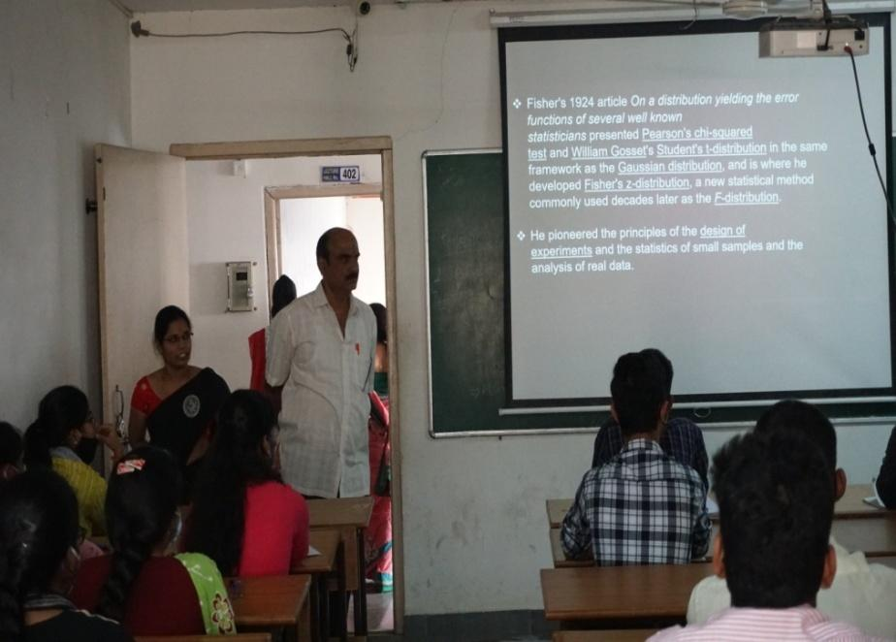
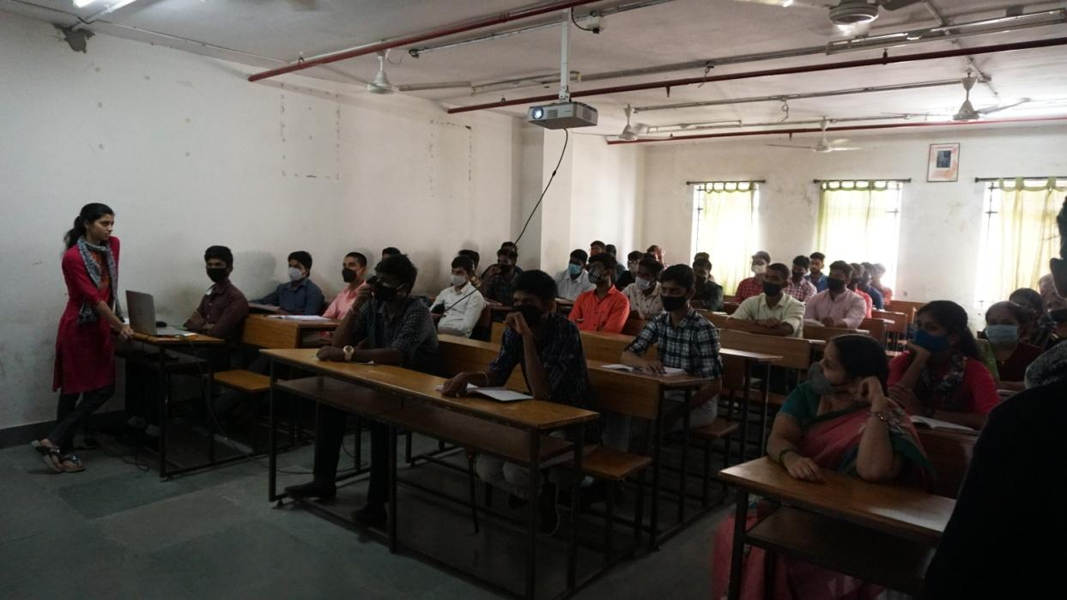
- GUEST PROFILE (IF ANY): NIL
- FEED BACK IF ANY: NIL
- ATTACHMENTS:
EVENT/ACTIVITY PROPOSAL:

EVENT PROPOSAL
for

Prof. R.A. Fisher Birthday Celebration

Event/Activity Name:Prof. R.A. FisherBirthday Celebration

Event/Activity Title: Prof. R.A. Fisher Birthday Celebration
Faculty coordinators: D. Rajya Lakshmi
Date: 17-02-2021
Venue: Aurora’s Degree and PG College
Target audience:Students
Platform: Online /offline
Level: College
Student Volunteer’s: K.SwethaRai (MSCs 2A) , Divya Patil (MSCs 2B)
Objective: To enlighten the students in statistics .
Proposed activities:
- Quiz Competition

Budget: Nil
Coordinator IQAC Coordinator Principal
Rajya Lakshmi Dr. Ravi kiran Dr. ViswanadhamBulusu

EVENT / ACTIVITY NOTICE:

rajyalakshmi d <rajyalakshmid@adc.edu.in> | Tue, Feb 16, 11:37 AM (9 days ago)
to mscs1a, mscs1b, msds1

Good Morning Students,

The Department of Statistics is celebrating Prof Ronald Aylmer Fisher Birthday , Father of Modern Statistics on 17-2-2021. On this occasion , The Department is conducting an online quiz on basic statistics to the students on 17-2-2021 at 10.30 a.m . The link will be provided tomorrow . All the students must participate in quiz competitions.

Thank You,
Rajya Lakshmi
Assistant Professor,
Department of Statistics

RECEIPTS (IF ANY): NIL
CERTIFICATES (IF ANY): NIL
LETTERS OF COMMUNICATION (IF ANY):NIL

