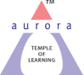
Aurora’s Degree & PG College
(ACCREDITED BY NAAC WITH 'B++' GRADE)
Chikkadpally, Hyderabad 500020

EVENT / ACTIVITY DETAILED REPORT

NAME OF THE EVENT / ACTIVITY | MARTYRS DAY
TYPE OR TITLE OF EVENT / ACTIVITY | MARTYRS DAY
FACULTY INCHARGE | Ms. MADHURI PUTREVU
DEPARTMENT/CELL/COMMITTEE/CLUB | EVENTS
DATE | 30.01.2021
VENUE | GOOGLE MEET
TARGET AUDIENCE | STUDENTS

- PROGRAM SCHEDULE – Timings 10am-11am

- LIST OF FACULTY COORDINATORS (DEPARTMENT) –
Madhuri Putrevu , Department of Computer Applications
- LIST OF THE STUDENT COORDINATORS (NAME, ROLL NO, CLASS & SECTION) - NIL
- LIST OF THE PARTICIPANTS (NAME, ROLL NO, CLASS & SECTION, NO OF GIRLS, BOYS, CASTE )
Excel Sheet attached
- PARAGRAPH ABOUT THE PROCEEDINGS (TILL THE END OF THE EVENT)
The objective of the webinar is to make students aware about the Martyrs of freedom struggle and in Wars with China and Pakistan.
As January 30th is, the day on which Mohan Das Karam Chand Gandhi was assassinated. He lived up to the ideals. Martyrdom is attained only when one is courageous, dedicated, determined, and loves the cause. We all these qualities in Gandhiji. He has shown great courage when Noakhali is burning due to religious riots, he went into the house of a person who was leading the attacks on Hindus. One should hold the courage to go such place and he said, “I will sit here until the communal riots are end”. Mahatma Gandhi conversed with the man and see that communal riots were stopped. It needs a great dedication for cause, great courage, inner strength and determination. Willingness to dies for one cause only when have a will to live for cause. This the learning from Gandhi’s life. Speaker also narrated the shayari of Akbar Ilahabadi about the purpose of life. The second martyr the speaker quotes about Khudi Ram Bose, a 15-year boy from Bengal who showed his bravery by speaking against the then British officer Kings Ford. He was hanged in Muzaffarabad in a public place. Speaker narrated the story of two sons of Guru Gobind Singh. A story narrated about Maqbool Sherwani who is a 19-year boy is who misled the Pakistani army by guiding them to the wrong path without giving a scope to reach Srinagar Airport to occupy the entire Kashmir valley. He was shot dead after two days as Pakistani army pumped 14 bullets into his body and nailed his toes and fingers.
Speaker narrated about Major Shaitan Singh too. These are all the stories of unsung heroes who have sacrificed their lives for their love towards their mother land. Speaker also highlighted that Martyrdom does not mean to sacrifice life but to show the strength, dedication, courage to face the situation.
This story inspired the students a lot. Several students participated in discussion with the speaker and shared their views.
- Photographs :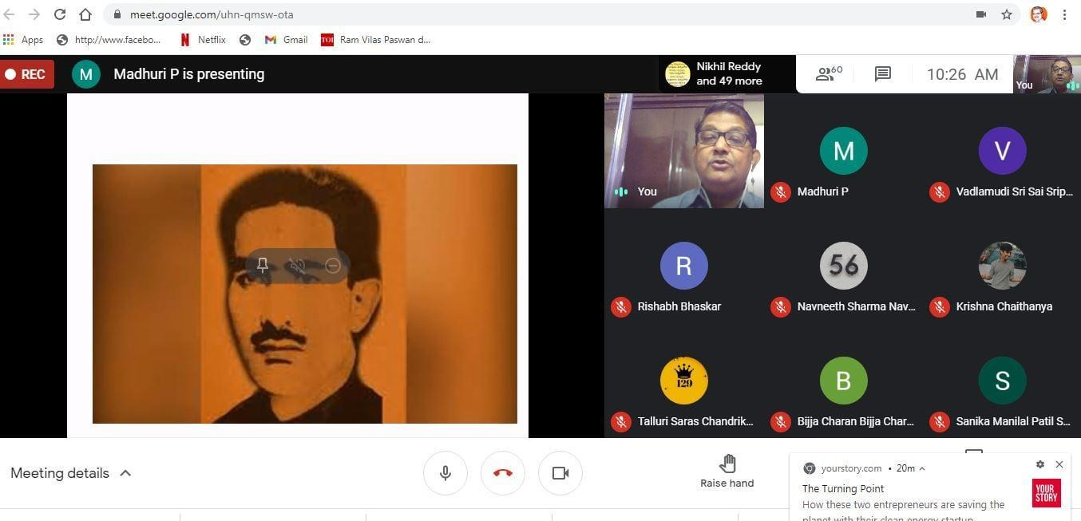
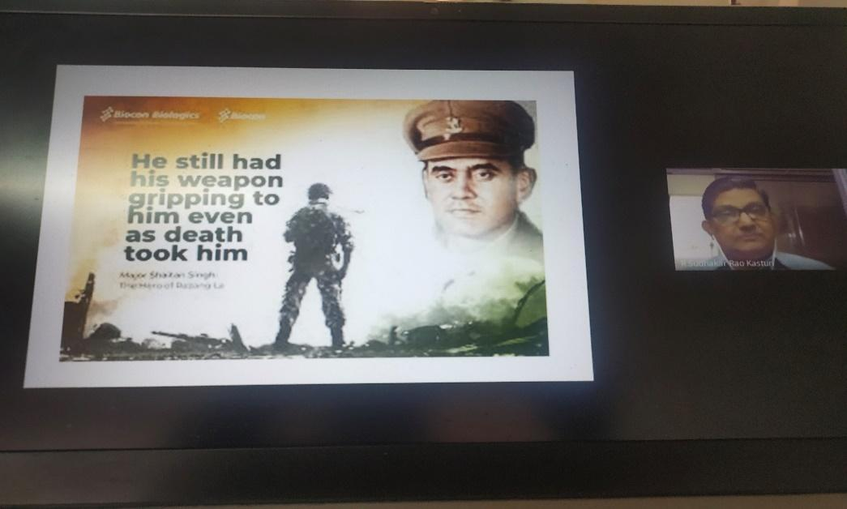
- INCOME AND EXPENDITURE - Nil

