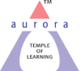
Aurora’s Degree & PG College
(Accredited by NAAC with 'B++' grade)
Chikkadpally, Hyderabad- 500020
Department of Computer Science

EVENT REPORT

EVENT TITLE | Data Privacy Day
TYPE OF EVENT | Department
FACULTY INCHARGE | Syeda Nausheen
DEPARTMENT | Computer Science
DATE | 28-01-2021
VENUE | Online (Google Platform)
TARGET AUDIENCE | First year students

OBJECTIVE: The objective is to raise awareness and promote privacy and data protection best practices among individuals, particularly in the context of safeguarding their personal information online and in social networking.

BRIEF ABOUT THE EVENT: Every January 28th International Data Privacy Day is celebrated by Department of Computer Science to empower individuals and business to respect privacy, safeguard data and enable trust as Millions of people are unaware of and uninformed about how their personal information is being used, collected or shared in our digital society. This year we have celebrated Data Privacy Day by conducting online session for first year students highlighting every Act related to privacy. Session started at 2:00 PM. Total of 140 students have actively attended the session and it continued for 1 hr followed by Question and Answer session at the end.
OUTCOME: Students actively attended the event and gained knowledge with deeper insights into protection of data.

PHOTOGRAPH:
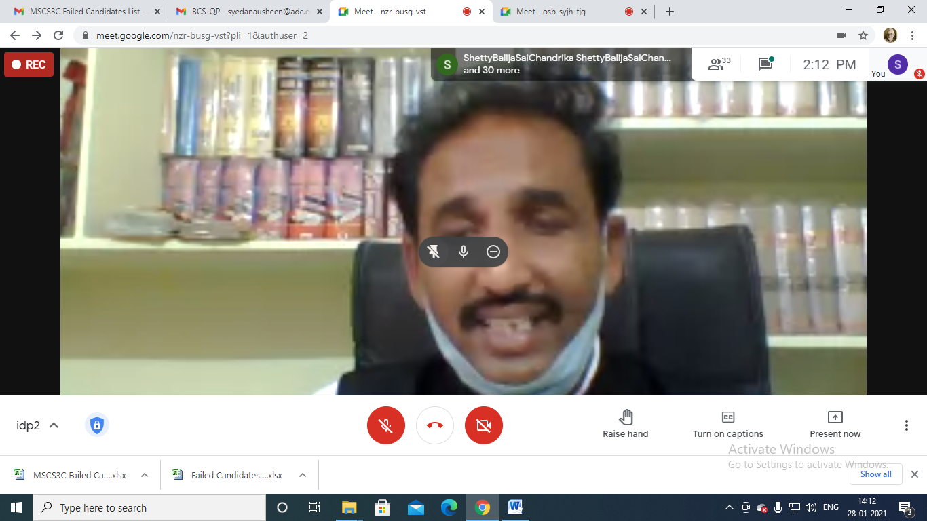

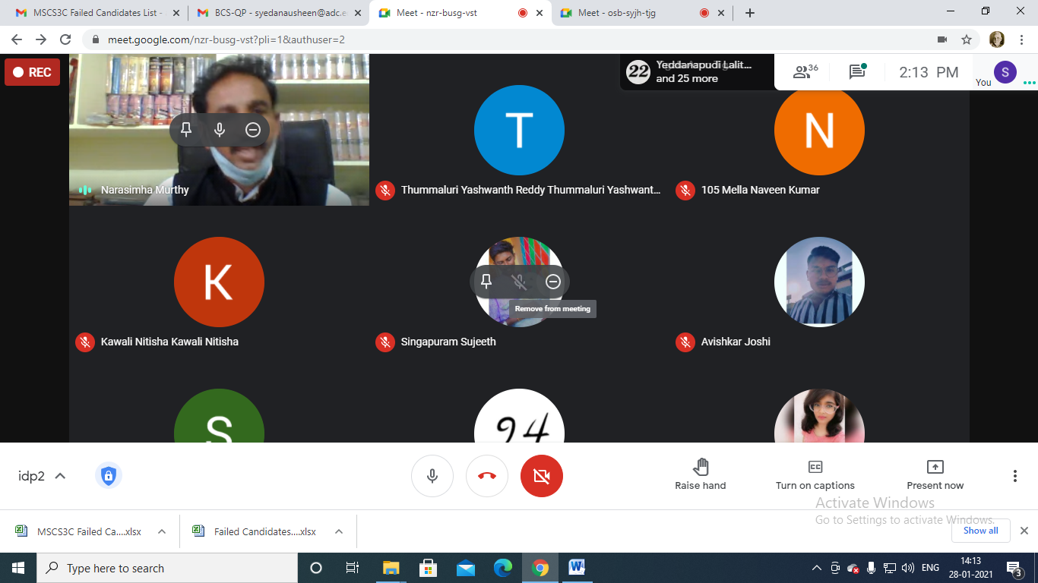

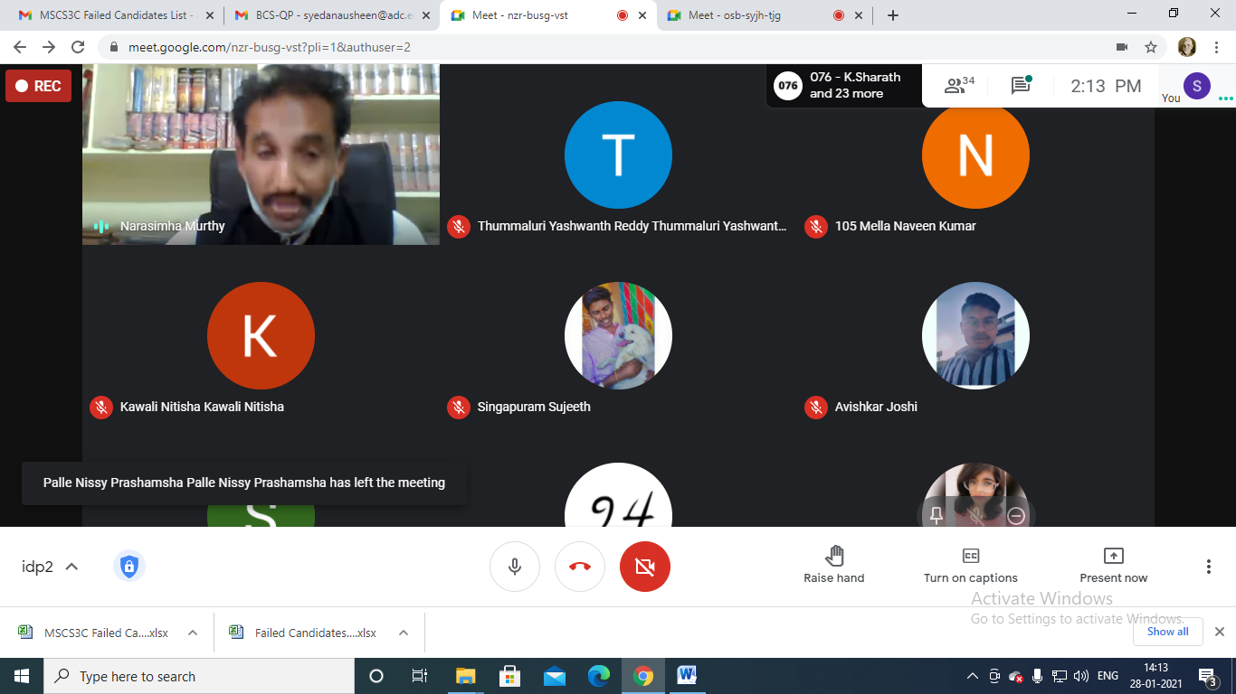

DETAILED REPORT
List of the participants:
Name of the participant | Group
Alekhya Bulusu | MSDS
Pathan Sayeed basha khan | MSDS
Abdul Azharuddin | MSDS
S. Rahul | MSDS
Gubba srilekha | MSDS
Ranjith Kumar Reddy | MSDS
Jaya Prakash Reddy | MSDS
Palle Santhosh Reddy | MSDS
Mahankali Vishal | MSDS
Alekhya Anand Tumma | MSDS
Dudekula Kalyan Babu | MSDS
Karuna Tata | MSDS
Thallapelli Akash Goud | MSDS
Kalwa Ashritha | MSDS
Shanigarapu yugender | MSDS
Anapuram sanjay | MSDS
Y Lalitha Nityasree | MSDS
Rangam Parthiv | MSDS
Ch.vyshnavi | MSDS
Mannan | MSDS
G.jahnavi | MSDS
Mantri Ravi Teja | MSDS
Chattipelli Rajashekar Reddy | MSDS
Sai Ram Reddy | MSCS
Padal Architha | MSCS
V.Ajay kumar | MSCS
Sunkari Shreya | MSCS
Akash mehtra | MSCS
B.savya | MSCS
B.shravana kumari | MSCS
Baddula Sravani | MSCS
kashyap bharadwaj | MSCS
Pooja jangid | MSCS
Adhu Shiva Pavan | MSCS
B.naga teja | MSCS
Arun Teja Chari | MSCS
sai pradeep reddy | MSCS
P Navaneetha | MSCS
Tula Bhavani | MSCS
Manav Halnure | MSCS
R Hasitha | MSCS
Mahesh mahi | MSCS
Vudiga sanjay | MSCS
G.prasanna sravani | MSCS
K. ragini | MSCS
K.shruthi | MSCS
Sai Adithya | MSCS
G. Anunya reddy | MSCS
B. Kishore Reddy | MSCS
P. Nithin | MSCS
M.Dhanish | MSCS
A.likhith | MSCS
N.saideep | MSCS
Mohit kumar | MSCS
P.Praveen | MSCS
S.Saketh | MSCS
S.pragnya | MSCS
Mohammed Althaf. | MSCS
Prateek Joshi | MSCS
Amar Das | MSCS
Sandhya choudhary | MSCS
P.Vaishnavi | MSCS
Jay Kumar Pandey | MSCS
Sunkari Shreya | MSCS
Swathi kumari | MSCS
Paras Rupani | MSCS
D veerender Kumar | MSCS
Purmishetty Srujan | MSCS
D Karthik Kumar | MSCS
Appagalla Vasavi | MSCS
S Sudharshan | MSCS
Poloju Sai Kiran | MSCS
Arkathala Likhith | MSCS
kashyap bharadwaj | MSCS
A.Tanishq | MSCS
R.mahesh | MSCS
P.Bhanu Teja | MSCS
G.Nayan Raj Yadav | MSCS
Vudiga sanjay | MSCS
Jalli Venkatesh | MSCS
G Aarthi Goud | MSCS
Goutham Raj Dharmi | MSCS
S Sudharshan | MSCS
G. Anunya | MSCS
Manav Halnure | MSCS
S.saketh | MSCS
V.Ajay kumar | MSCS
Badrinadh | MSCS
Jala sanjay | MSCS
Namal Lingraj | MSCS
A Trinath | MSCS
B. Sri Anjani | MSCS
Chevella Sai Nikhil | MSCS
R.Bhavani | MSCS
J.Manikanta | MSCS
S.sai neetesh | MSCS
Nagaram durga prasad | MSCS
Rahul Birader | MSCS
Bhaskar | MSCS
S.Sujeeth | MSCS
Avishkar Joshi | MSCS
C. Mounika yadav | BBA1B
P.Vaishnavi | MSCS
A Trinath | MSCS
G. Sanjay | MSCS
B.suchithra | MSCS
Sale Nagalaxmi | MSCS
S. Priyanka | B. Com application
Tigala Arun | MSCS
J.Manikanta | MSCS
P vidhya | MSCS
Rohith Andol | MSCS
K.sharath | MSCS
Avishkar Joshi | MSCS
P Sri sai Abhinav | MSCS
Nayakuni Karthik | MSCS
Karan Raj | MSCS

PHOTOGRAPH:

