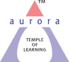
Aurora’s Degree & PG College
(Accredited By NAAC with 'B++' grade)
Chikkadpally, Hyderabad- 500020
Department of Microbiology

EVENT REPORT

EVENT TITLE | Louis Pasteur Birthday celebration
TYPE OF EVENT | Departmental Event
FACULTY INCHARGE | Manjusha
DEPARTMENT | Microbiology
DATE | 27th December 2020
VENUE | Google meet
TARGET AUDIENCE | UG Students

OBJECTIVE:
To emphasize on the discoveries of Louis Pasteur on the occasion of his birth anniversary and to provide a complete session to illustrate his findings
BRIEF ABOUT THE EVENT:
The event was organized on google meet with an intention of disclosing the role of Louis Pasteur as the father of Microbiology and confirmed his role in microbiology
OUTCOME:
- Discoveries in medical microbiology
- Studies on anthrax disease
- Fermentation and germ theory of diseases
- Spontaneous generation
Detailed report
The event was organized on the occasion of Louis Pasteur birth day with the intent of recollecting his valuable contributions towards the development of bacteriology and medical microbiology. Louis Pasteur is one of the prominent scientists in the field of microbiology, who is called as the Father of Microbiology. Pasteur performed several experiments to disprove spontaneous generation. Some of his findings have been into immunology. He is remembered for his remarkable breakthroughs in the causes and prevention of diseases, and his discoveries have saved many live.
The event scheduled on the 27th December 2020 was organized on google meet. The online event commenced at 9AM comprising of talks in accordance with Louis Pasteur extensive work. The session included oral and poster presentation by the students.
Faculty coordinator
S.No | Name of the faculty | Department
1 | Manjusha | Microbiology

List of Student Coordinators
S.No | Name of the student | Roll No | Section
1 | Vidhi S Vasa | 105118459025 | MiGC3A
2 | G.Poojitha | 105118459066 | MiGC3B
3 | Raqshan Aleem | 105118471003 | MiBiC3

List of participants
S.No | Name of the student | Roll No | Section
1 | Purke Gayatri | 1051-18-471-006 | MiBiC3
2 | Boreddy Shalini | 1051-18-471-024 | MiBiC3
3 | Marupakula Yamini Goud | 1051-18-471-016 | MiBiC3
4 | Chethurvedula Lakshmi Kameswari Mani | 1051-18-459-022 | MiGC3A
5 | John Wesley | 1051-18-459-027 | MiGC3A
6 | Odnala Arundhati Ramani | 1051-18-459-040 | MiGC3A
7 | Valluri Supriya | 1051-18-459-024 | MiGC3A
8 | Mannem Rahul Reddy | 1051-18-459-014 | MiGC3A
9 | D.fathima | 1051-19-459-062 | MiGC2A
10 | Jerome Elliot Joshua Chiluka | MiGC1
11 | lokesh | MiGC1
12 | Namitha Yadav | MiGC1
13 | Sravani Sriyah Sree | MiGC1
14 | Sai Sundaresan | MiGC1
15 | Bandari varsha | MiGC1
16 | Vadla Gnaneshwari | MiBiC1
17 | Meerala arun kumar | MiBiC1
18 | Jarugumalli Jhansi | MiBiC1
19 | Kandula ganesh babu | MiBiC1
20 | Lakshmi priya | MiGC1
21 | vagdevi | MiGC1
22 | Valluri Shravan | MiGC1
23 | Shreyas | MiBiC1

Event link
https://drive.google.com/file/d/1TfxJMumdpIdrfLJ_aOTdt4pf23iaKWvV/view?usp=sharing

PHOTOGRAPHS
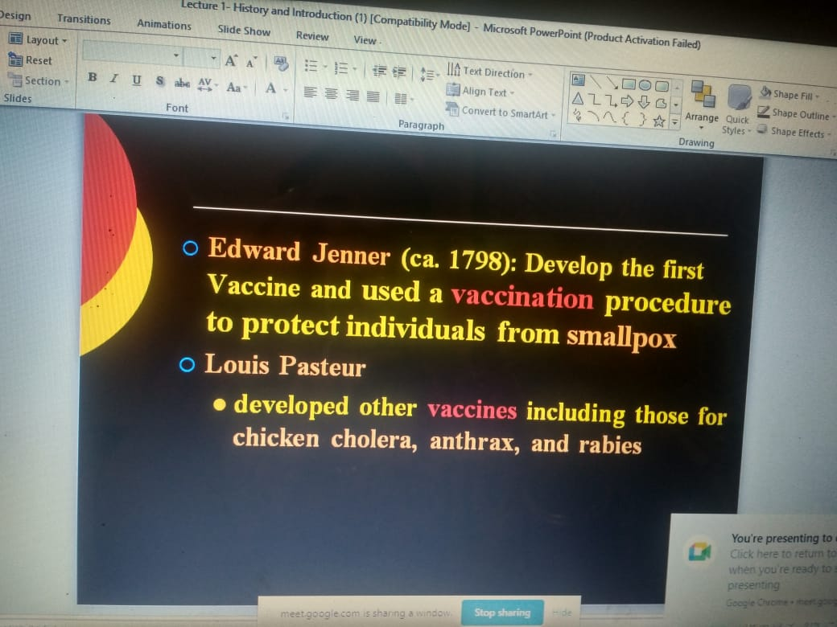

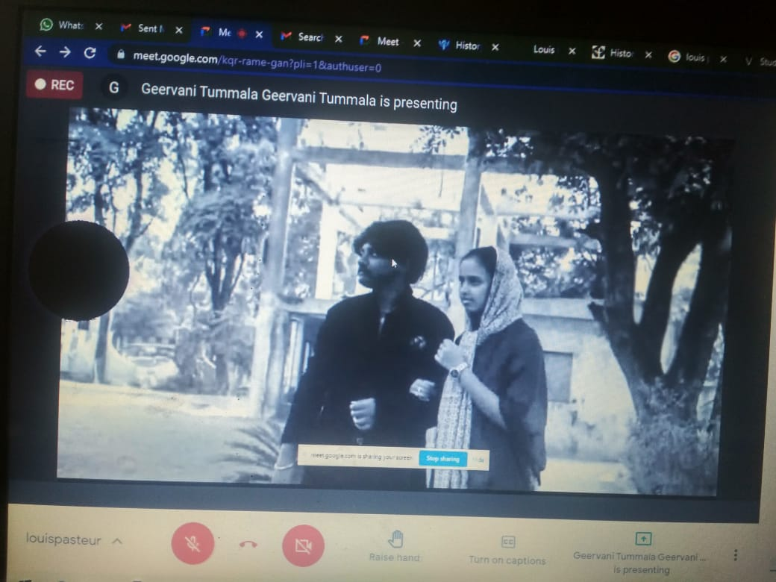

Event proposal
