Aurora’s Degree & PG College
(Accredited by NAAC with 'B++' grade)
Chikkadpally,Hyderabad- 500020

EVENT REPORT

EVENT TITLE | Kalidasa Jayanthi
TYPE OF EVENT | Class
FACULTY INCHARGE | M. Kalyani
DEPARTMENT | Languages
DATE | 28thJuly, 2020
VENUE | Online
TARGET AUDIENCE | UG Students

OBJECTIVE:
To enlighten the students about the great poet Kalidasa, his life and works in Sanskrit Literature.
To enable the students know and understand the richness and importance of the style and few facts about the works of Kalidasa.
BRIEF ABOUT THE EVENT:
KalidasaJayanthi is celebrated to increase the awareness about the great poet Kalidasa and richness imbibed in the works by him. The life of Kalidasa and the works and his style of writing are focused and presented to enable the students know and understand the grammatical aspects, his style in writing which enables the students to understand the richness and beauty in sahitya of Sanskrit language.
Through Power point presentations the greatness of Kalidasa was presented. Kalidasa is an immortal poet and playwright who is an incomparable genius whose works have won worldwide fame.
The facts that in modern times the translations of Kalidasa’s works in many Indian and foreign languages have spread his fame all over the world. His title “Kavikulaguru” ie preceptor of all poets is appropriate to his stature was well presented for a better understanding of the students.
OUTCOME:
The KalidasaJayanthi has enriched the participants in understanding and knowing about the richness in the Sahitya and Sanskrit language and also the beauty in the employment of the prosody.

PHOTOGRAPH

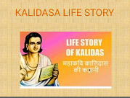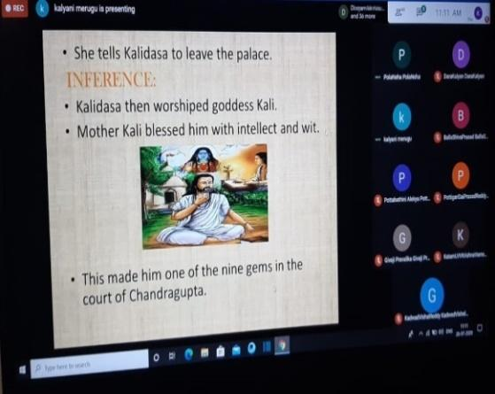

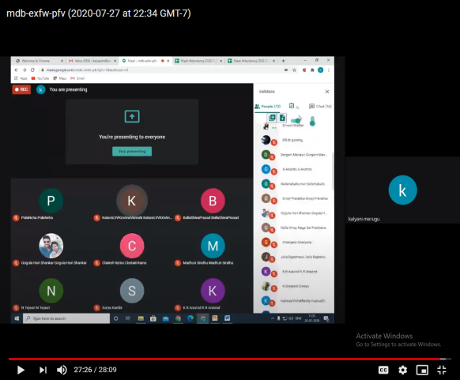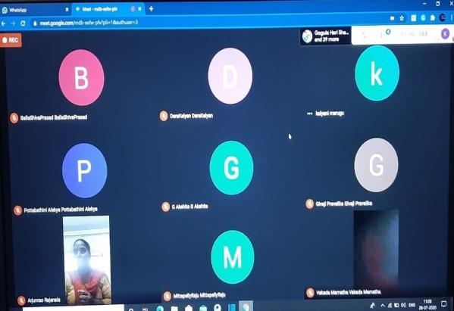

DETAILED REPORT
KalidasaJayanthi was celebrated to enrich, enlighten and enable the students to understand and know about Kalidasa the great poet of Sanskrit Sahitya. Students were enlightened and aware about the works of Kalidasa and few facts about him and in detail about the works by him. Students also understood about the beauty of his works and the beauty in the employment of the prosody in his works.
Kalidasa has made a distinct and glorious contribution in Sanskrit Literature. His word power is unique. In few words, he is capable of bringing out the entire meaning intended. His works are an intellect treat to thinkers and common readers.
Through Power point presentations the greatness of Kalidasa was presented. Kalidasa is an immortal poet and playwright who is an incomparable genius whose works have won worldwide fame. He wrote his plays and poetry largely based around Hindu mythology and philosophy. His name Kalidasa literally means Kali’s servant.
In the works of Kalidasa the beauty of nature is depicted with a precise elegance of metaphors that would be difficult to match in any of the literatures.
The facts that in modern times the translations of Kalidasa’s works in many Indian and foreign languages have spread his fame all over the world. His title “Kavikulaguru” ie preceptor of all poets is appropriate to his stature was well presented for a better understanding of the students.

- List of the Student Coordinators :

NAME | ROLL NO | CLASS & SECTION
P. Neha | 1051-18-402-124 | B.Com Computers – 3C
N. Tejasri | 1051-18-402-238 | B.Com Computers – 3D
K. Aravind | 1051-19-467-119 | MSCs – 2C

Number Of Students Participated in the Event :69
- List of Girl participants :

S.NO | Name Of the Student
1 | Annamaraju Vishnu Priya
2 | Bhargavi Aishu
3 | chandramaalika
4 | Sara Keerthi
5 | SistlaSailaja
6 | ThatikondaSreeja
7 | VakadaMamatha
8 | VankayalaShivanni
9 | Varsha Reddy
10 | VuddhamariSahithi
11 | YashikaYashika
12 | PottabathiniAlekya
13 | PrathivadibhayankaraPravallika
14 | Putti Manju
15 | RushikaNanasoPatil
16 | PogakuVijusha
17 | pokalaakhila
18 | Surya Kanthi
19 | MoktalaKavyaSree
20 | N Tejasri
21 | NagamallaNivya Sri
22 | manishaarolla
23 | MadhuriSindhu
24 | MangilpallyKavya
25 | ManginiSamanvitha
26 | KonderiKeerthika
27 | PolaNehaPolaNeha
28 | JellaRajeshwari
29 | K Sreeya K Sreeya
30 | KaleruSudershani
31 | GivajiPravalika
32 | GSanjanaGSanjana
33 | DurgamManasvi
34 | G Akshita

- List of Boy participants :

S.NO | Name Of the Student
1 | AlwalaShashankGoud
2 | Anuj Singh Thakur
3 | B.Srujan
4 | BallaShivaPrasad
5 | Bazaru Dharma Teja
6 | D.raviteja
7 | DaraKalyan
8 | Dharamkar Krishna
9 | Dinesh Drafter
10 | shivharbiradar
11 | SriramShivakumar
12 | UdthaGyaneshwar
13 | UppunuthulaNikhil
14 | vamshinath
15 | VeeraSubhan
16 | PottigariSaiPrasadReddy
17 | saikiran
18 | SaikiranMekala
19 | Sanjay Mende
20 | PeddiDeekshith
21 | MynamRaviTeja
22 | P.pruthviraj9989 Patti
23 | Mohit Kumar Akkala
24 | Mohit Kumar Choudhary
25 | KundeShivaKumar
26 | MadikondaSai Deepak
27 | MandulaHemanth
28 | KatamLVVKrishnaVamshi
29 | KonkiSaiKumar
30 | K R Aravind
31 | KadwadVishalReddy
32 | kalyankumar
33 | GellerlaSaiKumar
34 | GogulaHari Shankar
35 | GollaVinay Naga SaiPrabhakar

Budget plan - Nil

Photographs :

