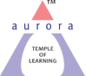
Aurora’s Degree & PG College
(ACCREDITED BY NAAC WITH 'B++' GRADE)
Chikkadpally, Hyderabad 500020

DETAILED REPORT

NAME OF THE EVENT / ACTIVITY | BATHUKAMMA CELEBRATIONS 2020
TYPE OR TITLE OF EVENT / ACTIVITY | BATHUKAMMA CELEBRATIONS 2020
FACULTY INCHARGE | SANDHYA RANI G
DEPARTMENT/CELL/COMMITTEE/CLUB | CULTURAL COMMITTEE
DATE | 23/10/2020
VENUE | SEMINAR HALL,BLOCK VI,RTC X ROADS
TARGET AUDIENCE | TEACHING AND NON-TEACHING FEMALE STAFF

- PROGRAM SCHEDULE

S.NO | SCHEDULED PROGRAMME
1. | Making OF Bathukamma by Non-teaching staff.
2. | Presenting Bathukamma in Seminar Hall, Block VI.
3. | Pooja on Bathukamma by Dr.Om Prakash Sir
4. | Performing bathukamma dance with bathukamma songs by all teaching and non-teaching female staff.
5. | Garba dance by teaching female staff
6. | End of event

- LIST OF FACULTY COORDINATORS (DEPARTMENT)

S.NO | FACULTY COORDINATOR
1 | SANDHYA RANI G

- LIST OF THE STUDENT COORDINATORS: NILL
- LIST OF THE PARTICIPANTS: ALL TEACHING AND NON-TEACHING FEMALE STAFF MEMBERS.

- PARAGRAPH ABOUT THE PROCEEDINGS : Bathukamma festival is the main festival, celebrated all over Telangana state. Since students are not attending classes and are not allowed to go to college, the Cultural committee has decided to celebrate the bathukamma event with teaching and non-teaching female staff. As it was planned suddenly, the convenor had taken permission from the Principal sir in the morning and the same was informed to all the members as well as teaching staff. In the afternoon at 03:00 p.m everyone gathered in the seminar hall, RTC block and celebrated the festival along with the non-teaching staff. All female teaching and non-teaching staff have actively participated in the event. Non-teaching staff have rejoiced by singing bathukamma songs as well. The event ended up at 04:30 p.m.

- INCOME AND EXPENDITURE: NILL
- EVENT PHOTOS:
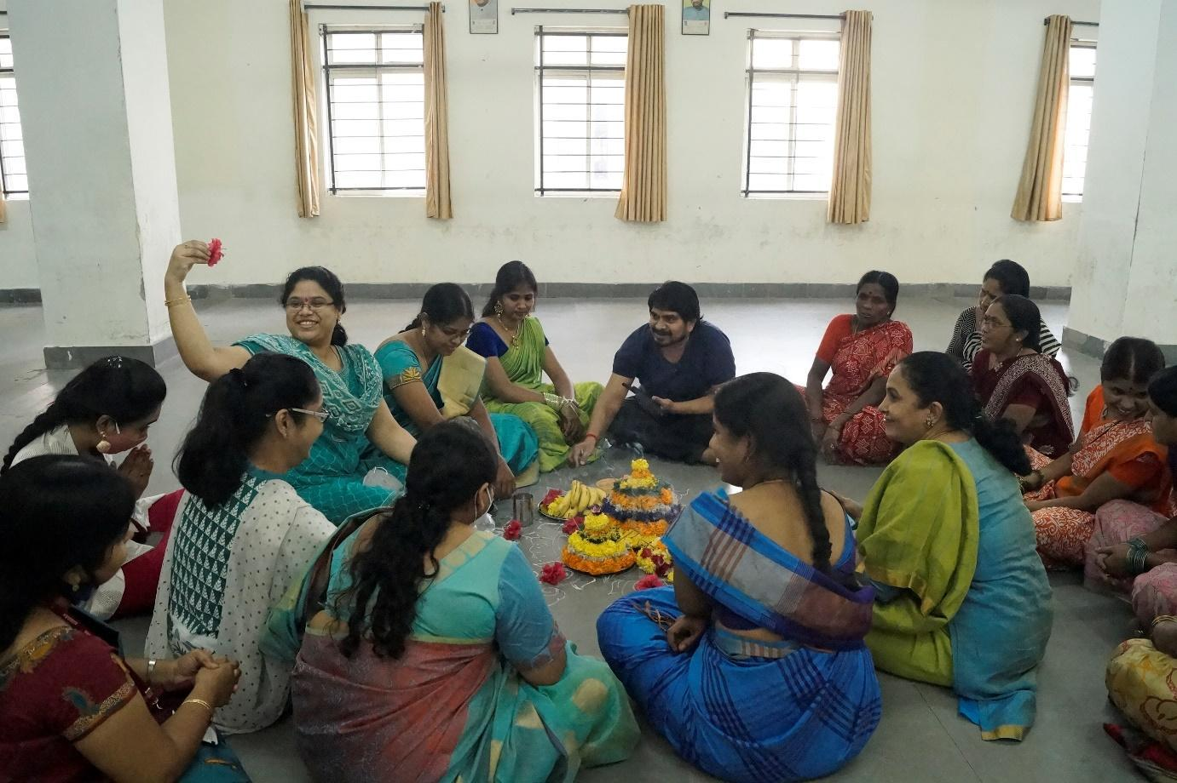

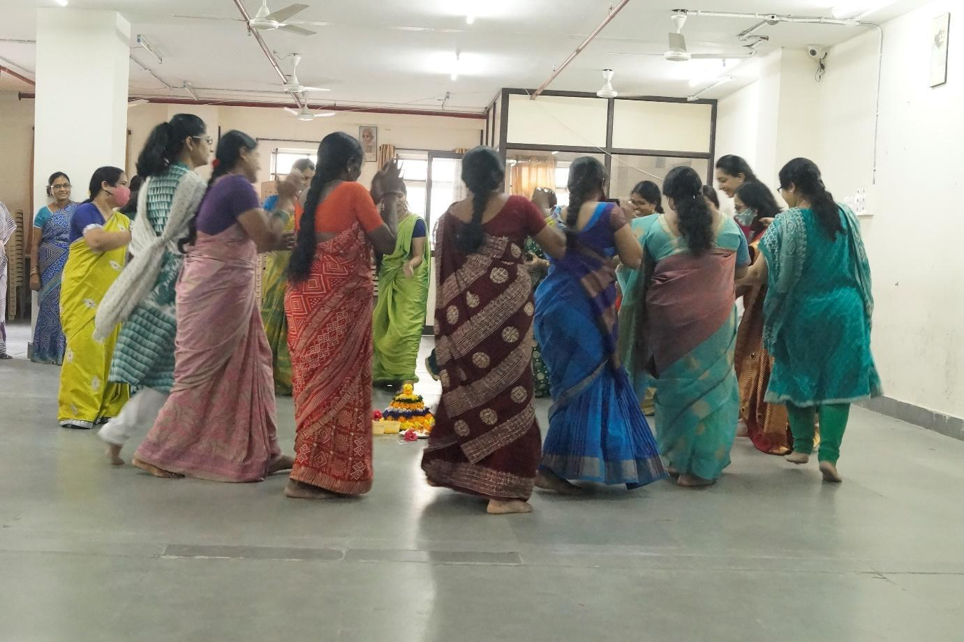
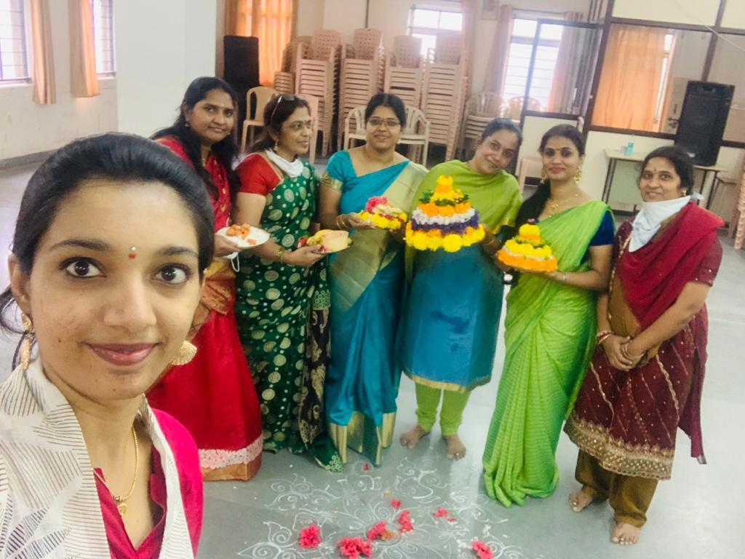

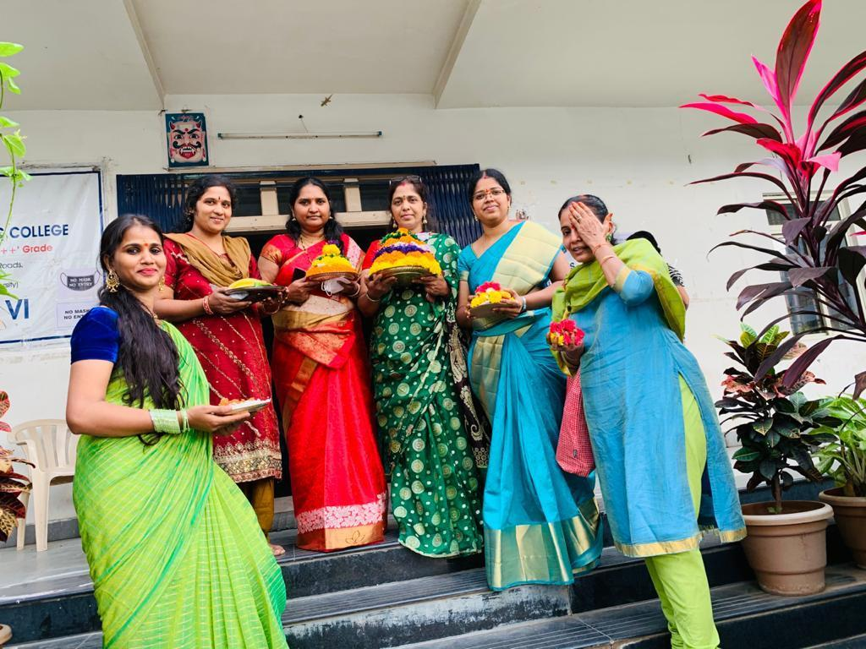

- GUEST PROFILE (IF ANY): NONE
- FEED BACK IF ANY: NONE
- ATTACHMENTS:
EVENT/ACTIVITY PROPOSAL
EVENT / ACTIVITY NOTICE
RECEIPTS - NONE
CERTIFICATES - NONE
LETTERS OF COMMUNICATION - NONE

