Aurora’s Degree and PG College 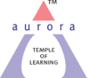
(ACCREDITED BY NAAC WITH ‘B++’ GRADE)
Chikkadpally, Hyderabad 500020
EVENT PROPOSAL
for

Jaya Prakash Narayan’s Birthday Celebration

Event/Activity Name: Jaya Prakash Narayan’s Birthday Celebration

Event/Activity Title: Jaya Prakash Narayan’s Birthday Celebration
Cell / Committee/Club Convener/facilitator: NA
Faculty coordinators: Bhavana Parthireddy
Date: 11-10-2020
Time: 11:00 A.M
Venue: Aurora’s Degree and PG College
Target audience: Faculty & Students
Platform: Online - Google Meet
Level: Institution
Student Volunteers: Hriday Basa
Objective: To remember “Lok Nayak” Jaya Prakash Narayan’s contributions to a free and independent India through his ideals.
Proposed activities:
- Speech
- PPT presentation
- Essay writing competition
Guest/Speaker details: NA
Budget: NA
Faculty Coordinator IQAC Coordinator Principal
Bhavana Parthireddy Dr. Ravi kiran Dr. Viswanadham Bulusu

Aurora’s Degree & PG College
(ACCREDITED BY NAAC WITH 'B++' GRADE)
Chikkadpally, Hyderabad 500020

EVENT / ACTIVITY SHORT REPORT

NAME OF THE EVENT / ACTIVITY | Jaya Prakash Narayan’s Birthday Celebration
TYPE OR TITLE OF EVENT / ACTIVITY | Jaya Prakash Narayan’s Birthday Celebration
FACULTY INCHARGE | Bhavana Parthireddy
DEPARTMENT/CELL/COMMITTEE/CLUB | Department of English
DATE | 11-10-2020
VENUE | Aurora’s Degree and PG College
TARGET AUDIENCE | Faculty & Students

OBJECTIVE: To remember “Lok Nayak” Jaya Prakash Narayan’s contributions to a free and independent India through his ideals.

BRIEF ABOUT THE EVENT: On the Occasion of “Lok Nayak” Jaya Prakash Narayan’s birthday, an excerpt from the short movie that Prakash Jha directed was shown in which Chetan Pandit played the role of JP, was shown to remember and revisit his political and social contribution to the society.
This event was conducted online through google meet, anchor Kainaat Khoja welcomed everyone and Hriday Basa made a speech . A ppt was presented which depicted the life of Jaya Prakash Narayan and his contributions to a free and independent India through his ideals. At the end Rishitej made a vote of thanks.
On the same day we had an essay writing competition where 2 students participated and the students who scored more 80% and above were given participation certificates.
Feedback from the participants was positive; the session was highly informative. The responses received were encouraging and satisfactory.

OUTCOME: Students have learnt about the contributions of Jayaprakash Narayan to Independent India.

PHOTOGRAPH:
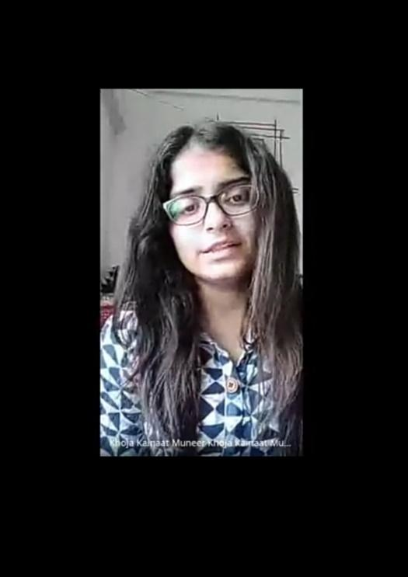
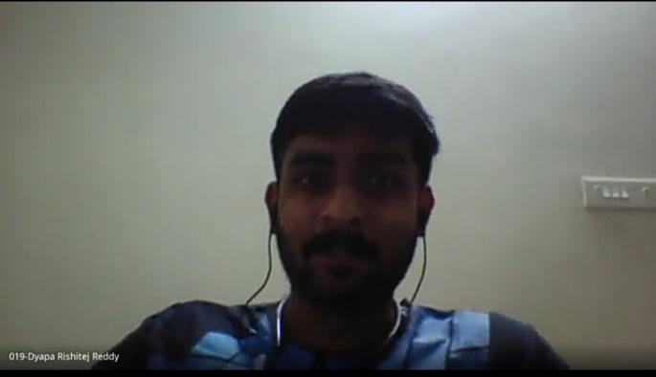
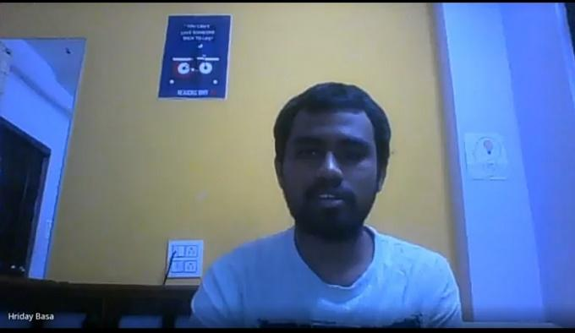

Aurora’s Degree & PG College
(ACCREDITED BY NAAC WITH 'B++' GRADE)
Chikkadpally, Hyderabad 500020

JAYA PRAKASH NARAYAN’S BIRTHDAY CELEBRATION DETAILED REPORT

Name Of The Event/ Activity | Jaya Prakash Narayan’s Birthday Celebration
Type Or Title Of Event / Activity | Jaya Prakash Narayan’s Birthday Celebration
Faculty Incharge | Bhavana Parthireddy
Department/Cell/Committee/Club | Department of English
Date | 11-10-2020
Venue | Aurora’s Degree and PG College
Target Audience | Faculty & Students

- Program Schedule: Jaya Prakash Narayan’s Birthday Celebrations was conducted for Degree and PG college students on 11/10/2020 through google meet
- List Of Coordinators: Bhavana Parthireddy, Department of English
- List Of The Student Coordinators:

S. No. | NAME | ROLL NO | CLASS & SECTION
1 | Kainaat Khoja | 1051-19-459-059 | MiGC 2B
2 | Hriday Basa | 1051-18-468-077 | MPCs 3B
3 | Rishitej | 1051-18-467-019 | MSCs3A

- List Of The Participants (NAME , ROLL NO, CLASS & SECTION, NO OF GIRLS, BOYS, CASTE):
- Paragraph About The Proceedings (TILL THE END OF THE EVENT): On the Occasion of “Lok Nayak” Jaya Prakash Narayan’s birthday, an excerpt from the short movie that Prakash Jha directed was shown in which Chetan Pandit played the role of JP, was shown to remember and revisit his political and social contribution to the society.
This event was conducted online through google meet, anchor Kainaat Khoja welcomed everyone and Hriday Basa made a speech . A ppt was presented which depicted the life of Jaya Prakash Narayan and his contributions to a free and independent India through his ideals. At the end Rishitej made a vote of thanks.
On the same day we had an essay writing competition where 2 students participated in the essay competition.
Feedback from the participants was positive; the session was highly informative. The responses received were encouraging and satisfactory.

- Income And Expenditure: NA
- Event Photos ( MIN 2 MAX 4): 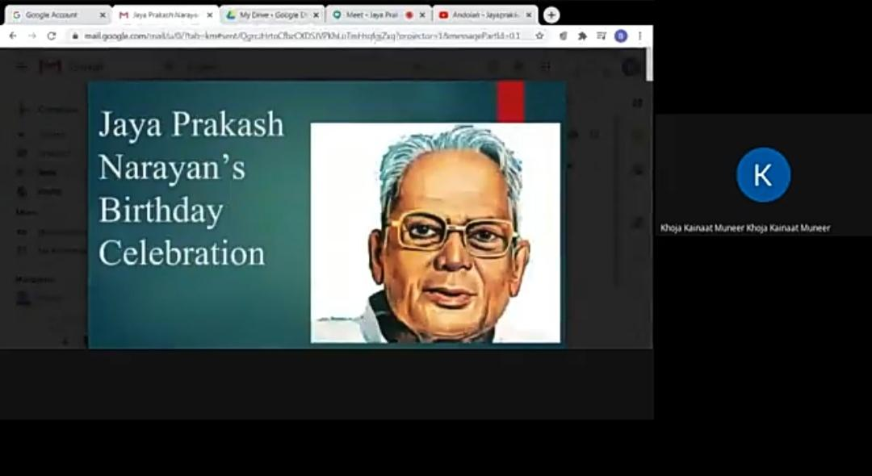

- Guest Profile (IF ANY): NA
- Feed Back If Any: NA
- Attachments:
EVENT/ACTIVITY PROPOSAL:
EVENT / ACTIVITY NOTICE:
Greetings!
The Department of English is celebrating the birthday of Shri. Loknayak Jaya Prakash Narayan through google meet on 11-10-2020 at 12 Noon. An essay writing competition is being conducted on his political ideas on 11-10-2020 in google form. The competition link will be enabled at 2:00 P.M. and disabled at 3:00 P.M
Google meet link: https://meet.google.com/fdo-agps-tsa
Competition link: https://forms.gle/CLVWCHPMFMMke3mz6
RECEIPTS (IF ANY): NA
CERTIFICATES (IF ANY):
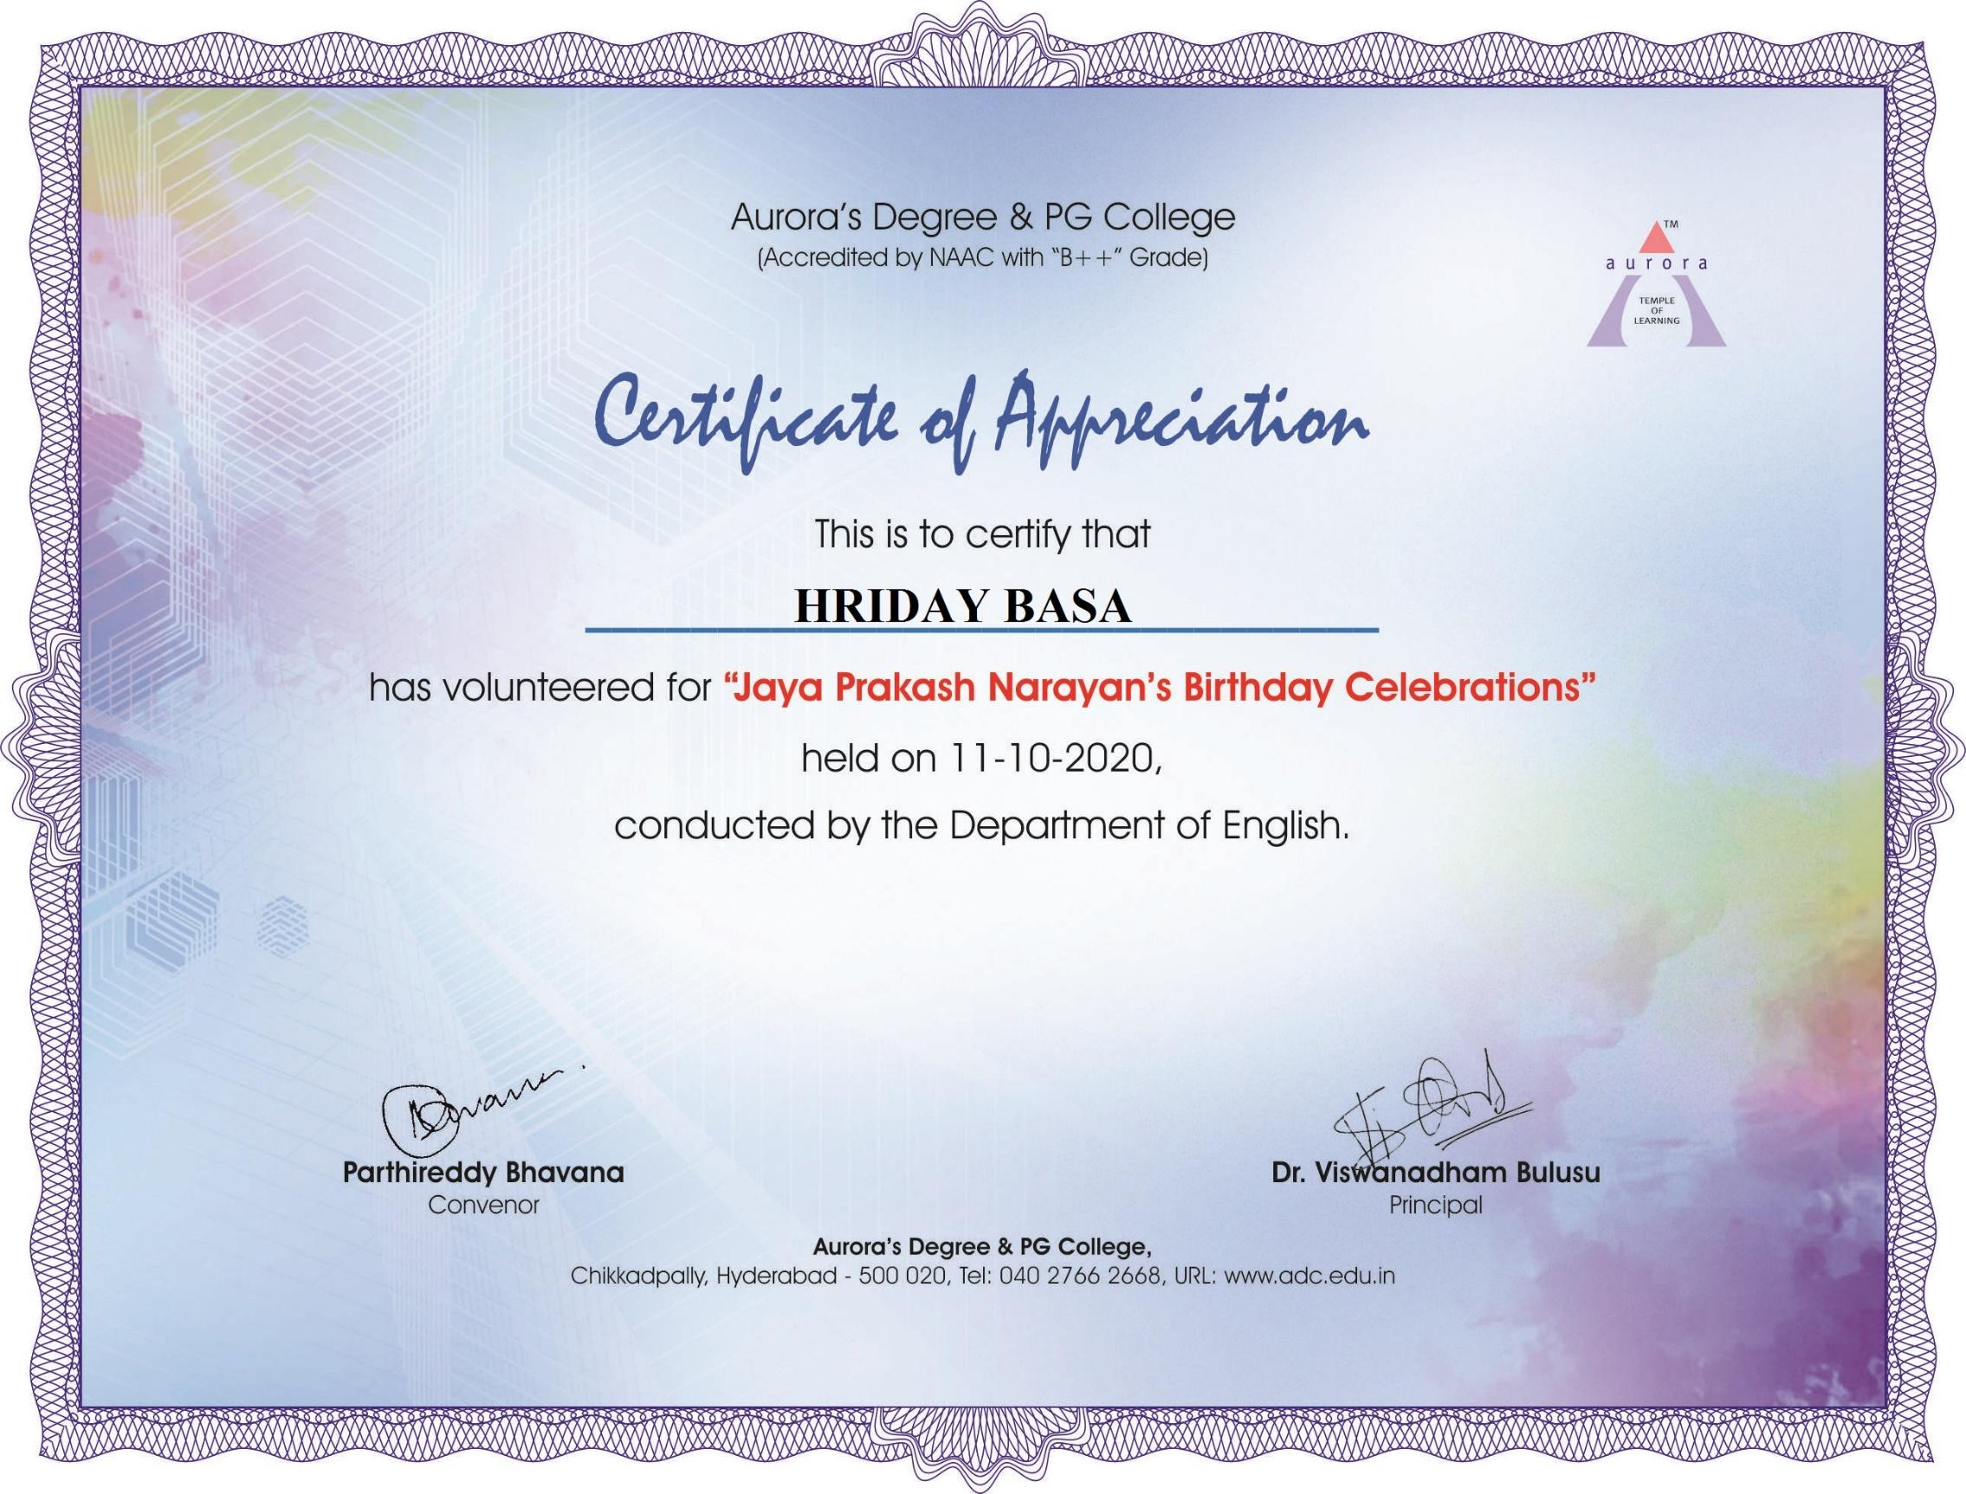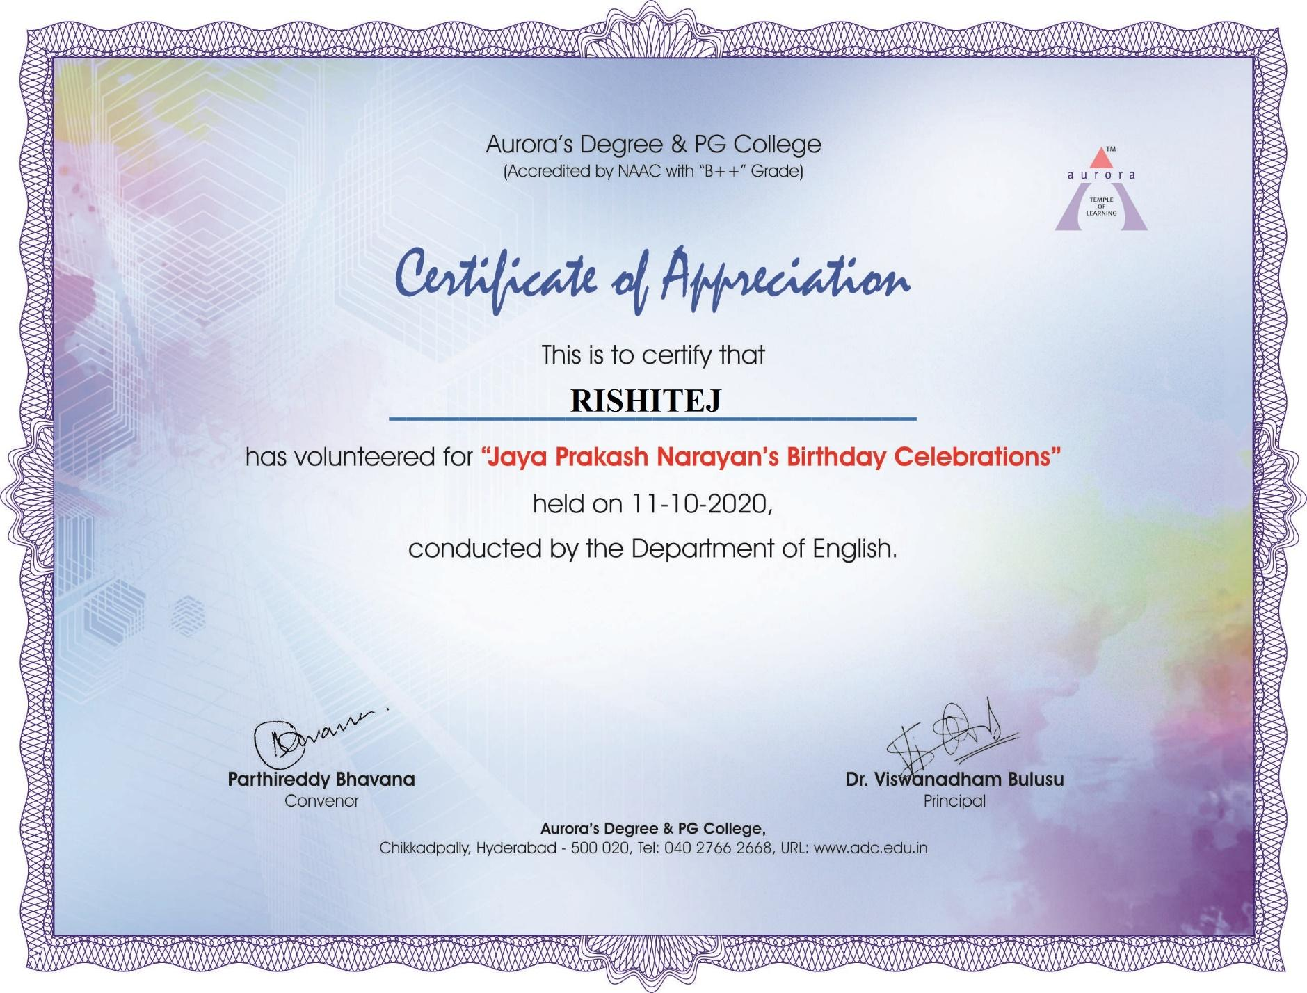
LETTERS OF COMMUNICATION (IF ANY): NA

