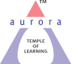
Aurora’s Degree & PG College
(ACCREDITED BY NAAC WITH 'B++' GRADE)
Chikkadpally, Hyderabad 500020

EVENT / ACTIVITY DETAILED REPORT

NAME OF THE EVENT / ACTIVITY | R.K.Narayan’s Birthday Celebrations
TYPE OR TITLE OF EVENT / ACTIVITY | R.K.Narayan’s Birthday Celebrations
FACULTY INCHARGE | E.Ankitha
DEPARTMENT/CELL/COMMITTEE/CLUB | English
DATE | 10-10-2020
VENUE | Google meet
TARGET AUDIENCE | Students

- PROGRAM SCHEDULE:
R.K.Narayan’s Birthday Celebrations was conducted for Degree and PG college students on 10/10/2020 through google meet .
S.No | FACULTY COORDINATORS | DEPARTMENT
1. | E.Ankitha | English
2.LIST OF FACULTY COORDINATORS (DEPARTMENT)

3.LIST OF THE STUDENT COORDINATORS
S.NO | NAME | ROLL NO | CLASS | SECTION
1 | KainaatKhoja | 105119459059 | B.Sc (Mi.Bi.C’S) | -
2 | KunduruSudhanshu | 105118468089 | B.Sc (M.P.C’S) | B
3 | B.Hriday | 105118468077 | B.Sc (M.P.C’S) | B
4 | Rishitej | 105118467019 | B.Sc (M.S.C’S) | A

- LIST OF THE PARTICIPANTS (NAME , ROLL NO, CLASS & SECTION, NO OF GIRLS, BOYS, CASTE )
S.No | Name | Email-id
1 | K.R.Aravind | kraravind19@adc.edu.in
2 | JanagamNithish | janagamnithish19@adc.edu.in
3 | P.M.M.Maharshi | pottigarimanikantamanomaharshi18@adc.edu.in
4 | DYAPA RISHITEJ REDDY | dyaparishitejreddy18@adc.edu.in
5 | Nitesh Raj J | jniteshraj@adc.edu.in
6 | Somarajusrinath | somarajusrinath19@adc.edu.in
7 | CH PAVAN KALYAN | challapavankalyan18@adc.edu.in
8 | Bacchasaimamatha | bacchasaimamatha19@adc.edu.in
9 | Esha Thakur | eshathakur19@adc.edu.in
10 | Rounak Singh | rounaksingh19@adc.edu.in
11 | AyushChhabra | ayushchhabra19@adc.edu.in
12 | C A AkhileshYadav | caakhileshyadav19@adc.edu.in
13 | Udaykiran | palsaudaykiran19@adc.edu.in
14 | V keerthisree | vkeerthisree@adc.edu.in
15 | Raqshanaleem | raqshanaleem18@adc.edu.in
16 | SudhanshuKunduru | kundurusudhanshu18@adc.edu.in
17 | Sony Biradar | bsony18@adc.edu.in
18 | G VISHAL KUMAR | gandlavishalkumar19@adc.edu.in
19 | KethiriRanadheer | kethiriranadheer18@adc.edu.in
20 | Job Jeevan | gaddamjobjeevan@adc.edu.in
21 | ShaliniBoreddy | boreddyshalini18@adc.edu.in
22 | Pagadalasainikhil | pagadalasainikhil18@adc.edu.in
23 | Snehalatha | sandrasnehalatha18@adc.edu.in
24 | A.Manisha | avulamanisha18@adc.edu.in
25 | A.Vishnupriya | annamarajuvishnupriya19@adc.edu.in
26 | Ram Prasad | akuthotaramprasad@adc.edu.in
27 | BaddulaTejasvi | baddulatejasvi@adc.edu.in
28 | SHIFA KHAN | shifakhan19@adc.edu.in
29 | DIVYANSHU BASUTKAR | divyanshubasutkar19@adc.edu.in
30 | MEGHA KIRTHI RELEKAR | meghakirthirelekar19@adc.edu.in
31 | Saichandrika | shettybalijasaichandrika18@adc.edu.in
32 | T.swethareddy | tswetha18@adc.edu.in
33 | K. Rachana | krachana18@adc.edu.in
34 | aparnasingh | aparnasingh18@adc.edu.in
35 | Soniyasunka | sunkasoniyaanil19@adc.edu.in
36 | Chpooja | chpooja@adc.edu.in
37 | Peddagolla Rani | peddagollarani18@adc.edu.in
38 | Savyabalusani | balusanisavya19@adc.edu.in
39 | Keyura | edekeyura18@adc.edu.in
40 | BUDUMA TARUN | budumatarun19@adc.edu.in
41 | Sharma muskan | sharmamuskan18@adc.edu.in
42 | Bhudharamsrinavya | bhudharamsrinavya19@adc.edu.in
43 | Mousumisamanta | mousumisamanta19@adc.edu.in
44 | A. Akshaya | amarabadaakshaya19@adc.edu.in
45 | Kishore | gundlakishorkumar18@adc.edu.in
46 | NakkaAvinash | nakkaavinash18@adc.edu.in
47 | ErukullaSaikumar | erukullasaikumar19@adc.edu.in
48 | Ragampreethi | ragampreethi18@adc.edu.in
49 | Arbaaz khan | arbaazkhan18@adc.edu.in
50 | PolaNeha | polaneha18@adc.edu.in
51 | G.ruchika | gudiniyaruchika19@adc.edu.in
52 | Pranathi | talapranathi19@adc.edu.in
53 | SirraSukanya | sirrasukanya19@adc.edu.in

- PARAGRAPH ABOUT THE PROCEEDINGS (TILL THE END OF THE EVENT)
On 111th birth anniversary of R.K.Narayan, we revisit the timeless works of him and that timeless place called Malgudi. We can find something of us in little boys and their friends, snake charmers and sweet vendors, astrologers and guides who inhabit this town.
This event was conducted online through google meet, anchorKainaatKhoja welcomed everyone and KunduruSudhanshumade a speech . A ppt was presented which depicted the life of author and his great works. On this occasion a small chapter from the story of “Swamy and his friends” was shown in the form of cartoon show. At the end Rishitej made a vote of thanks.
On the following day we had a quiz where 53 students participated and the students who scored more 80% and above were given participation certificates.
Feedback from the participants was positive; the session was highly informative. The responses received were encouraging and satisfactory.

- INCOME AND EXPENDITURE
- EVENT PHOTOS ( MIN 2 MAX 4)
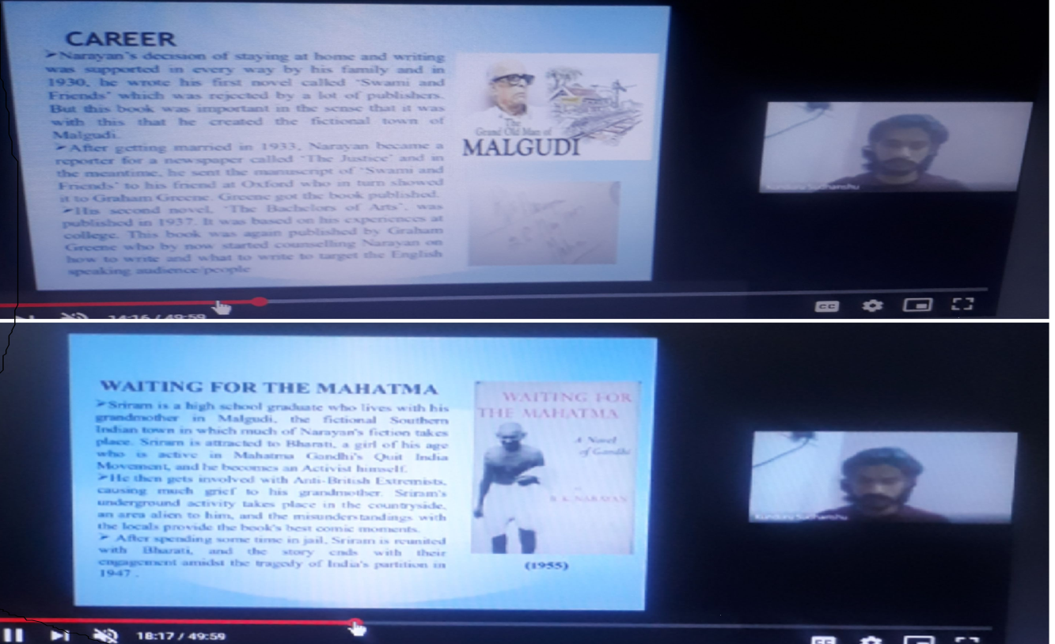

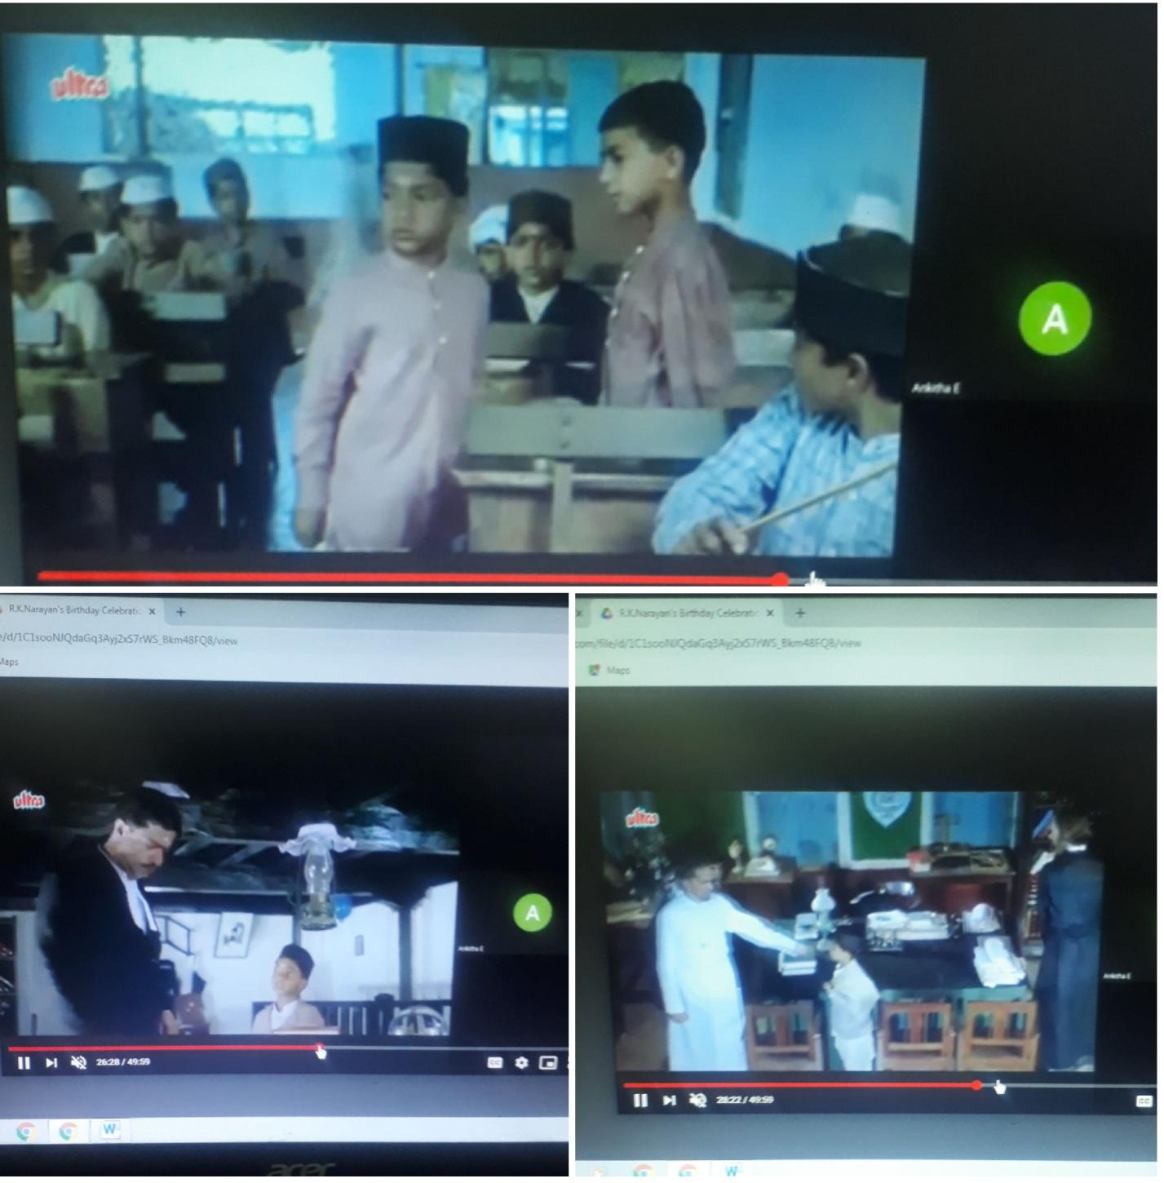

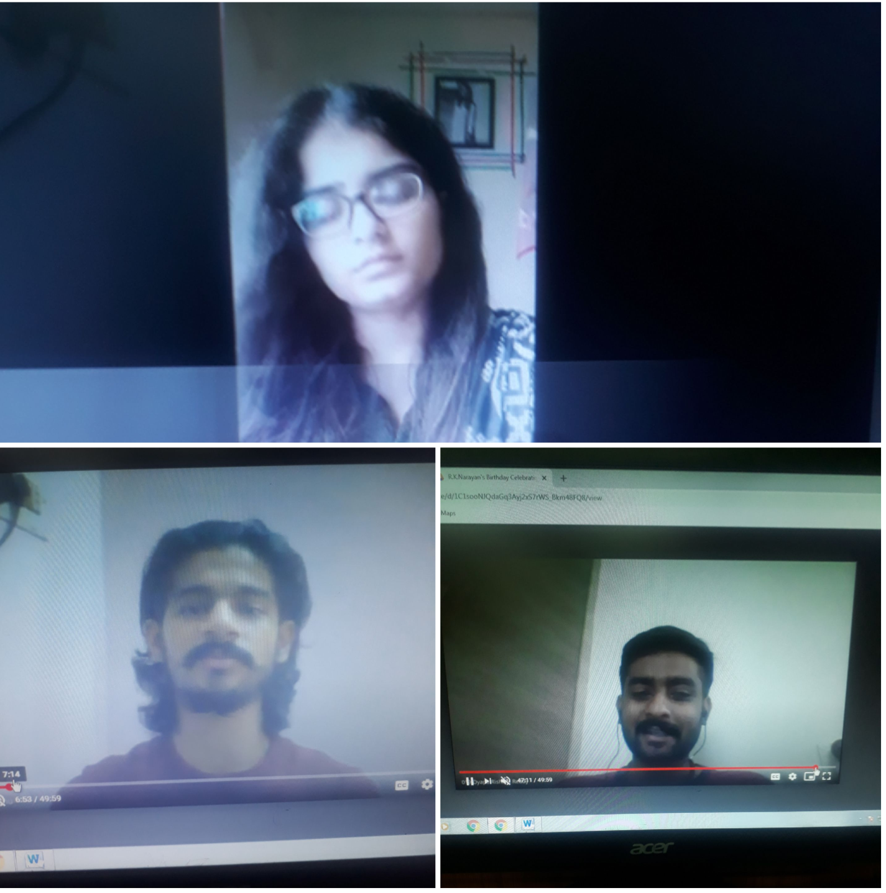

- GUEST PROFILE (IF ANY)
- FEED BACK IF ANY
- ATTACHMENTS:
EVENT/ACTIVITY PROPOSAL
EVENT / ACTIVITY NOTICE
RECEIPTS (IF ANY)
CERTIFICATES (IF ANY)
LETTERS OF COMMUNICATION (IF ANY)

Aurora’s Degree & PG College
(ACCREDITED BY NAAC WITH 'B++' GRADE)
Chikkadpally,Hyderabad 500020

EVENT / ACTIVITY DETAILED REPORT

NAME OF THE EVENT / ACTIVITY | R.K.Narayan’s Birthday Celebrations
TYPE OR TITLE OF EVENT / ACTIVITY | R.K.Narayan’s Birthday Celebrations
FACULTY INCHARGE | E.Ankitha
DEPARTMENT/CELL/COMMITTEE/CLUB | English
DATE | 10-10-2020
VENUE | Google meet
TARGET AUDIENCE | Students

OBJECTIVE:
- To pay tribute to the Great Indian author.
- To make the students aware about the writings of R.K.Narayan.

BREIF ABOUT THE EVENT:
On 111th birth anniversary of R.K.Narayan, we revisit the timeless works of him and that timeless place called Malgudi. We can find something of us in little boys and their friends, snake charmers and sweet vendors, astrologers and guides who inhabit this town.
This event was conducted online through google meet, anchor KainaatKhoja welcomed everyone and KunduruSudhanshu made a speech . A ppt was presented which depicted the life of author and his great works. On this occasion a small chapter from the story of “Swamy and his friends” was shown in the form of cartoon show. At the end Rishitej made a vote of thanks.
On the following day we had a quiz where 53 students participated and the students who scored more 80% and above were given participation certificates.
Feedback from the participants was positive; the session was highly informative. The responses received were encouraging and satisfactory.
OUTCOME:
- Students have learnt more about the writings of R.K.Narayan and his style of writing.
- Students have also learnt that all the works of him go around the same village, Malgudi a small country side in Southern India(Malgudi is there in the mind of the writer).

EVENT PHOTOS

