Aurora’s Degree & PG College 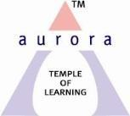
(ACCREDITED BY NAAC WITH 'B++' GRADE)
Chikkadpally, Hyderabad 500020

Event Name: Department Event
Event Title: Hindi Diwas
Cell Convener: K.Sujatha
Faculty coordinator: Dr.Shivhar Biradar
Date& Venue: 14 - 21 Sept, 2020, Aurora’s Degree &PG College.
Target audience: UG Students
Level: College Level
Budget: Nil
Objective:
It is a platform for students to showcase their talent in their national language and the main aim of the event is to encourage the students to develop their motherhood and for their growth as an Indian.
Proposed activities:
Through Online Will Conduct Virtual Competitions Like Shayari, Elocution and Poetry Recitation.

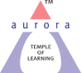
Aurora’s Degree & PG College
(ACCREDITED BY NAAC WITH 'B++' GRADE)
Chikkadpally,Hyderabad 500020

EVENT / ACTIVITY SHORT REPORT

NAME OF THE EVENT / ACTIVITY | Hindi Diwas 2020
TYPE OR TITLE OF EVENT / ACTIVITY | HINDI DIWAS
FACULTY INCHARGE | Dr. Shivhar Biradar
DEPARTMENT/CELL/COMMITTEE/CLUB | Language Department
DATE | 14-18th September 2020
VENUE | Google Meet
TARGET AUDIENCE | Students of all 3 years

OBJECTIVE:
Being one of the most diverse nations in the world, India is a place where numerous traditions, customs, religions and languages flourish among all the languages. Hindi is considered the chief as well as the widely spoken in India.
The main aim of the event was to create awareness among the students about the Hindi Language.

BRIEF ABOUT THE EVENT:
Aurora Degree & PG College Organized Virtual activity on Hindi Diwas from 14th September to 18th September at Google meets. The event started with the prayer song. The convener of the event Dr.Shivhar Biradar (Hindi faculty) from department of languages gave an introduction speech about the importance of Hindi Language, Hindi our official language was given its authority on 14th Sept 1949.

- Welcome video to create awareness among students about Hindi Language.
- To make the online programme more interactive and engaging several competitions and activities were organized like online poem recitation, Poster

- Making competition, elocution, Speech Competition wherein students participated with full zeal and enthusiasm.
OUTCOME:
Students will get to know about importance of Hindi and they will gain knowledge about Hindi Language.
PHOTOGRAPH:

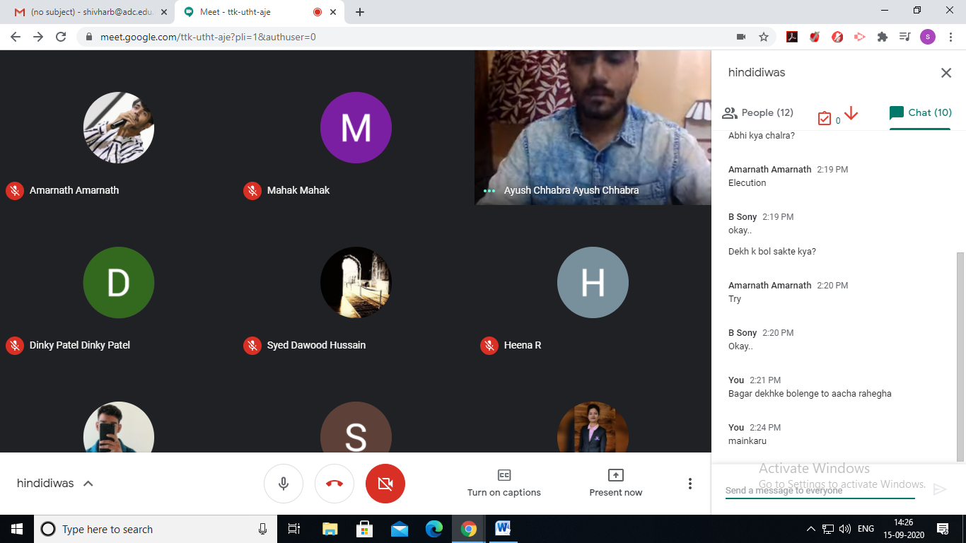

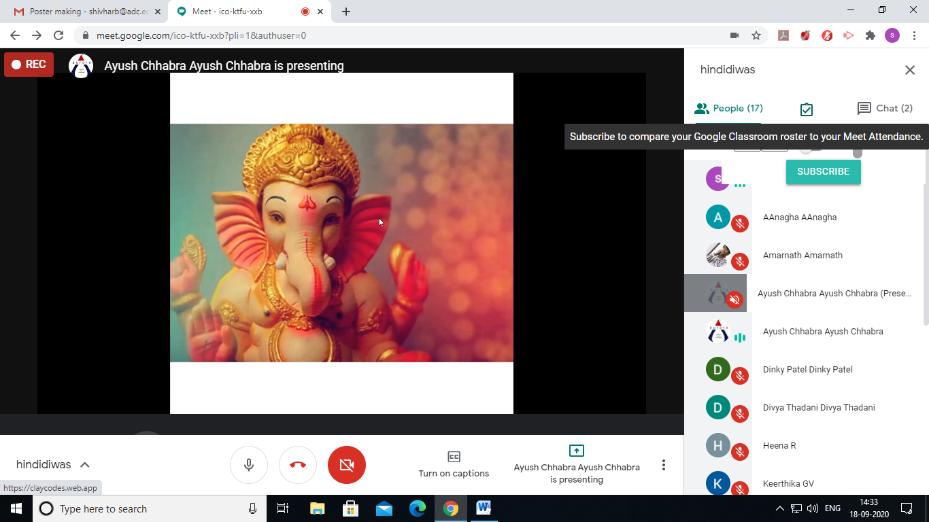

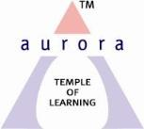
Aurora’s Degree & PG College
ACCREDITED BY NAAC WITH ‘B++’ GRADE
Chikkadpally, Hyderabad 500020
NAME OF THE EVENT : | Hindi Diwas
FACULTY INCHARGE | Dr. Shivhar Biradar
DEPARTMENT | Languages
DATE | 14-18th September 2020
VENUE | Google Meet
TARGET AUDIENCE | Students of all 3 years
SPEAKER | Dr. Shivhar Biradar

Objective:
Being one of the most diverse nations in the world, India is a place where numerous traditions, customs, religions and languages flourish among all the languages. Hindi is considered the chief as well as the widely spoken in India.
The main aim of the event was to create awareness among the students about the Hindi Language.
- Faculty Coordinator :
Dr. Shivhar Biradar

- Student Coordinators:
- Amarnath – 1051-18-402-163 (B.Com Computers 3 ‘C’)
- Ayush Chhabra – 1051-19-401-151 (B.Com Generals 2 ‘C’)

- Elocution
Girls :
- Mahek gupta MiGC 2 B – 1051-19-459-064
- Sony Biradar B.Com Generals 3 C – 1051-18-401-156
- Dinky Patel MiGC 2 B – 1051-19-459-063
- Siddala Akshitha B.Com Honors 2B – 1051-19-407-101
Boys:
- Ayush Chhabra B.Com Generals 2 C – 1051-19-401-151

- Poetry Recitation
Girls :
- Pragati Oza B.Com Generals 2 C – 1051-19-401-163
Boys :
- Ayush Chhabra B.Com Generals 2 C – 1 051-19-401-151
- Syed Dawood Hussain BBA – 1051-19-684-080
- Amarnath B.Com Computers – 1051-18-402-163
- Anirudh Sharma B.Com Computers 3C – 1051-18-402-166

- Poster Making
Boys :
Vinod Shrirame MIGC 2 B – 1051-19-459-056
Girls :
GV Keerthika BBA 3A – 1051-18-684-014

- Speech Competition
Boys :
Ayush Chhabra B.Com 2 C – 1051-19-401-151

Brief about the event: Aurora Degree & PG College Organized Virtual activity on Hindi Diwas from 14th September to 18th September at Google meet. The event started with the prayer song. The convener of the event Dr. Shivhar Biradar (Hindi faculty) from department of languages gave an introduction speech about the importance of Hindi Language, Hindi our official language was given its authority on 14th Sept 1949.

- Welcome video to create awareness among students about Hindi Language.
- To make the online program more interactive and engaging several competitions and activities were organized like online poem recitation, Poster making competition, elocution, Speech Competition wherein students participated with full zeal and enthusiasm.

Faculty Volunteer Dr. Shivhar Biradar also shared a poem which instilled patriotism in everyone.
- Welcome Song by Anirudh of B.Com Computers 3 C
- Prayer Song by Rahul Das of B.Com Generals 1 C
- Shayaari Recited by Ayush Chhabra, Syed Dawood, Amar Agarwal, Pragati Oza and many Others .
- Speeches were given by the Students on Hindi Bhasha ka Udbhav aur Vikas by Sony, Dinky & Ayush chhabra.
- Ayush Chhabra of B.Com Generals 1C delivered a speech virtually about the dismal state of Hindi Language usage in our country. He stressed the point that somebody who speaks authentic Hindi language is not the one who is left behind in the society instead is the one who deeps down inside in taking ahead the uniqueness of this beautiful language.

In the concluding lines of his speech, he urged the youth of India to come forward and join hands in promoting Hindi language and stay connected for the progress of this language.

- Vote of Thanks by Dr. Shivhar Biradar
Hindi diwas is a platform for students to showcase their talent in their National Language and to encourage the students to develop their motherhood and for their growth as an Indian.
The session was concluded with a collective realization of the importance of Hindi language and the resolve to respect it.

Certificates were distributed.

OUTCOME:
Students will get to know about importance of Hindi and they will gain knowledge about Hindi Language.
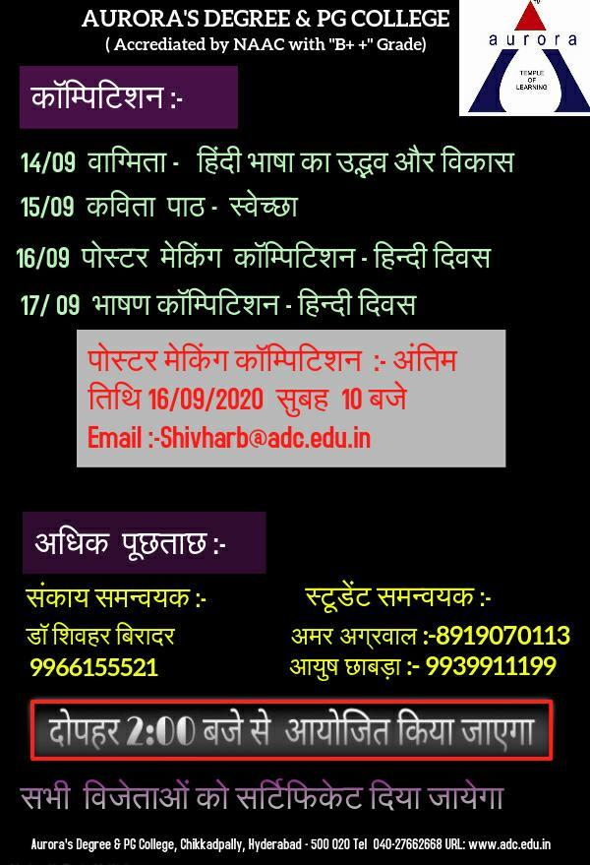

PHOTOS:

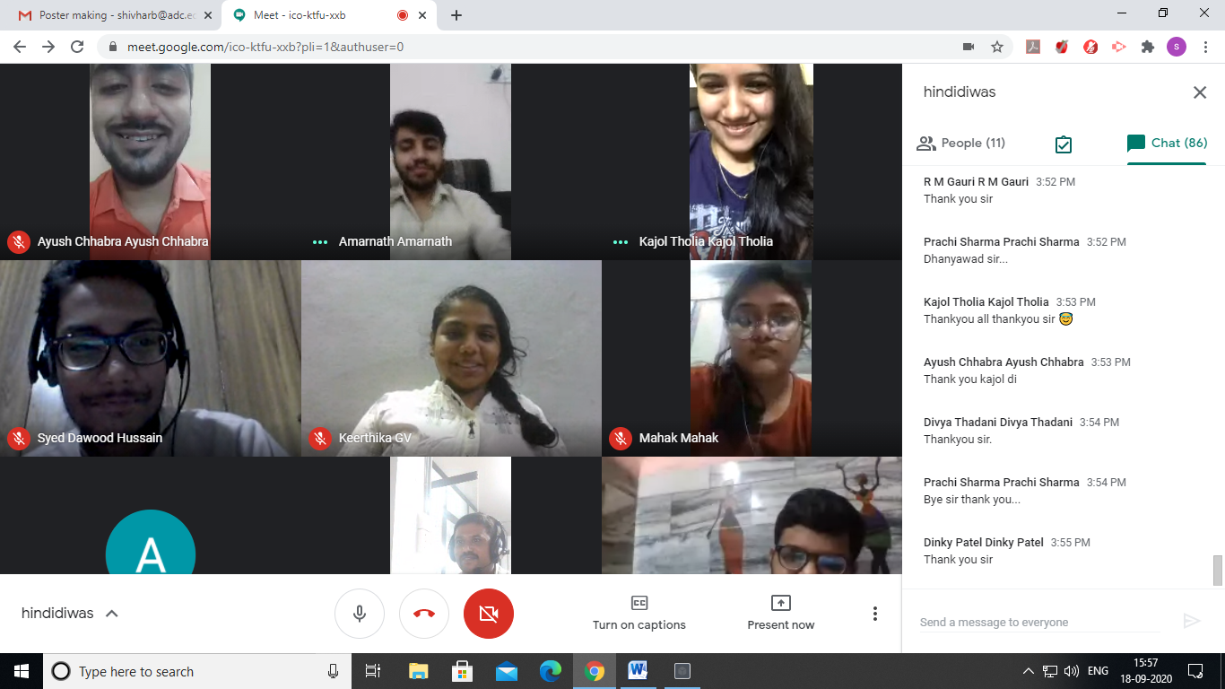

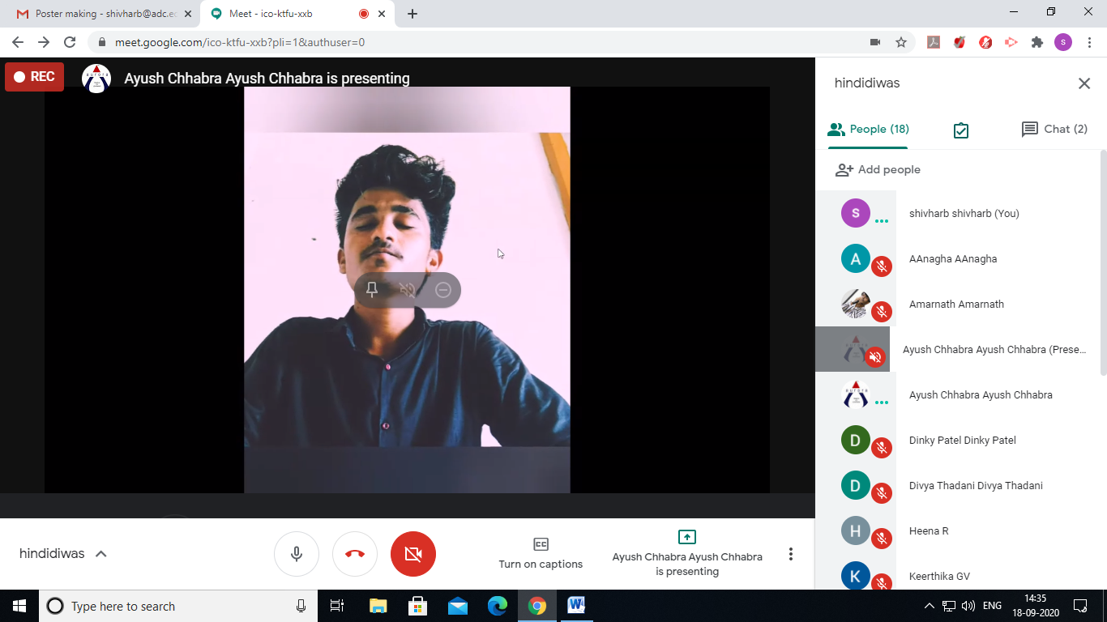

STUDENTS ATTENDED
BOYS:
- Ayush Chhabra
- Syed Dawood Hussain
- Amarnath
- Anirudh Sharma
- Vinod Shrirame
- Ayush Modi
- Rishabh Agarwal
- Abhinash das
- Kunal yadav
- Jigar jain
- Mayur Jain
- Ashish
- Das Rahul
- Sudhanshu vyas
- Varun yadav
- Moses paul

- Arpit mehashwari
- Aman Singh
- Stephen
- Aniketh singh Thakur
- K jaydeep
GIRLS
- Dipishi Agarwal
- Rishika sarda
- Shivani henkare
- Bhargavi
- Pragati Oza
- Mahek gupta
- Sony Biradar
- Dinky Patel
- Siddala Akshitha
- GV Keerthika
- Shruti Agarwal
- Shaik Shabana
- Anjali khatri
- Shefali vyas
- Sejal baliga
- Zareena shaik
- Preethi Ash
- Shifa khan

