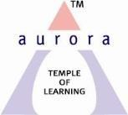
Aurora’s Degree & PG College
Chikkadpally, Hyderabad 500020

NAME OF THE EVENT : | World AIDS Day
FACULTY INCHARGE | P Vanamala
DEPARTMENT | MICROBIOLOGY
DATE | 1st December 2018
VENUE | Delight Foundation
TARGET AUDIENCE | HIV Sufferers

Objective:
To encourage the students and motivate them in having social awareness and inculcate social wellbeing among them.
OUTCOME:
The event was celebrated by the Delight Foundation which takes care of HIV victims. Students collected money and bought fruits and refreshments for them. Students had interaction and fun with all the victims and became a reason for smiles on the victim’s faces.
Photographs
