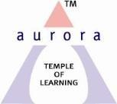
Aurora’s Degree & PG College
Chikkadpally, Hyderabad 500020
NAME OF THE EVENT : | WORLD SCIENCE DAY
FACULTY INCHARGE | Hafeeza Shamoona
DEPARTMENT | Dept of Chemistry
DATE | 12th-November -2018(Monday)
VENUE | Auroras Auditorium
TARGET AUDIENCE | UG - BSc students and PG students
SPEAKER | -

Objective:
To develop scientific attitude among students, to arouse the interests to study Science ,to develop interdisciplinary connections ,to develop skills in scientific investigations ,to become aware of the contribution of Scientists in the world, to pose questions and design experiments or investigations to answer them.
The session was from 10.00am -1.00 pm. It has a poster presentation competition on “Nobel laureates in science and their work”.
The session was with Under Graduate and Postgraduate students who has presented the work of their favorite nobel laureate in science.
OUTCOME:
Students could examine issues such as the impact of scientific advancement on work, recreation, communication, economic systems, health and environmental sustainability and some of them want to pursue careers in Science

Photo graphs
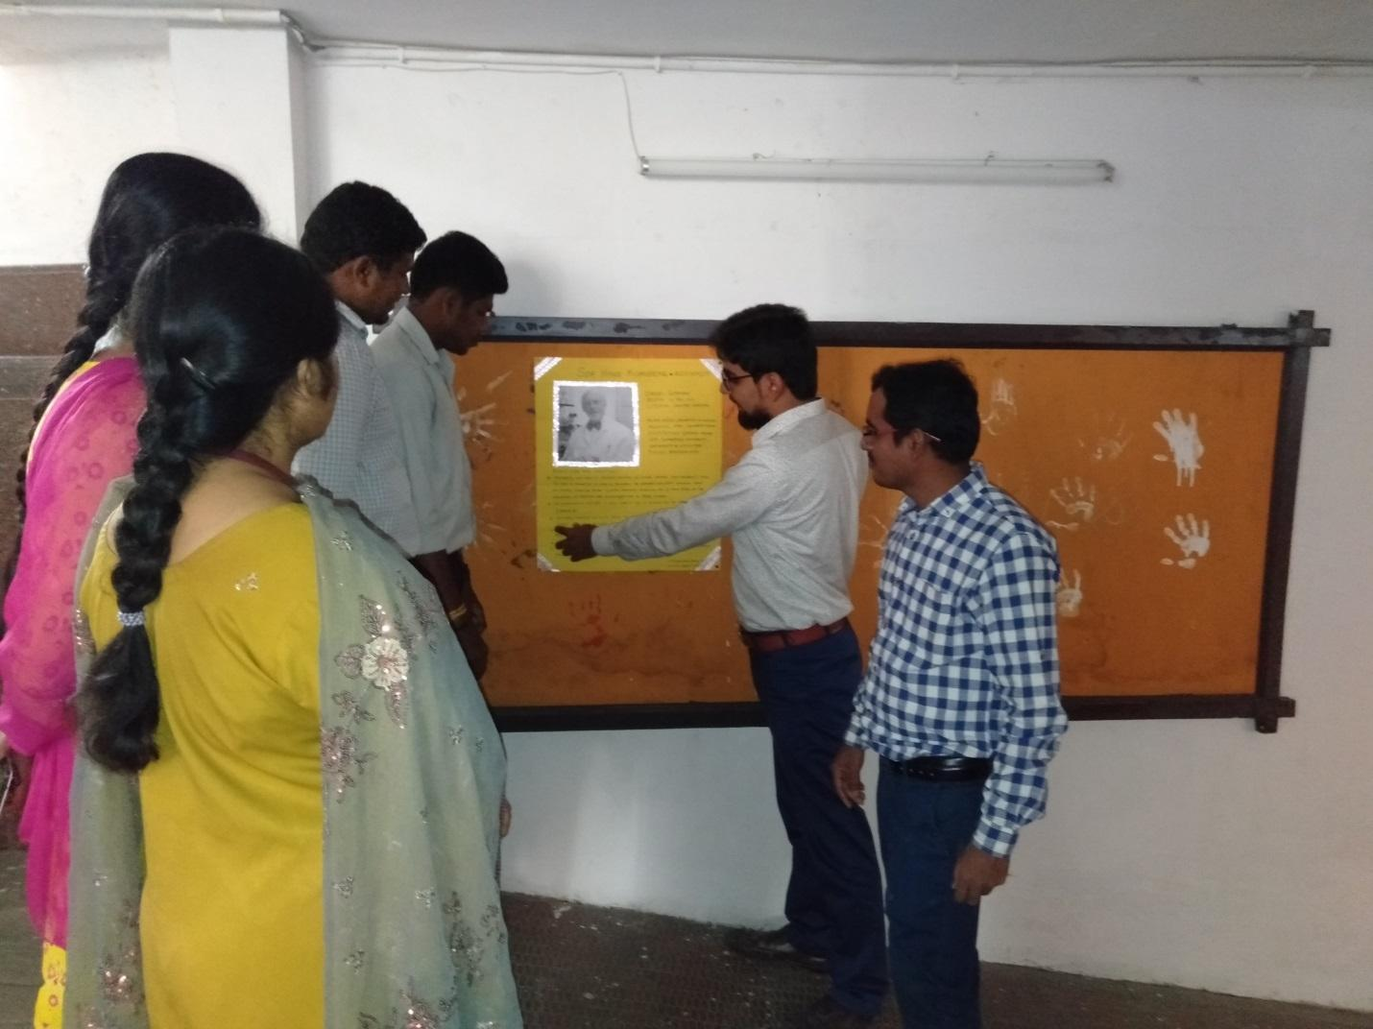
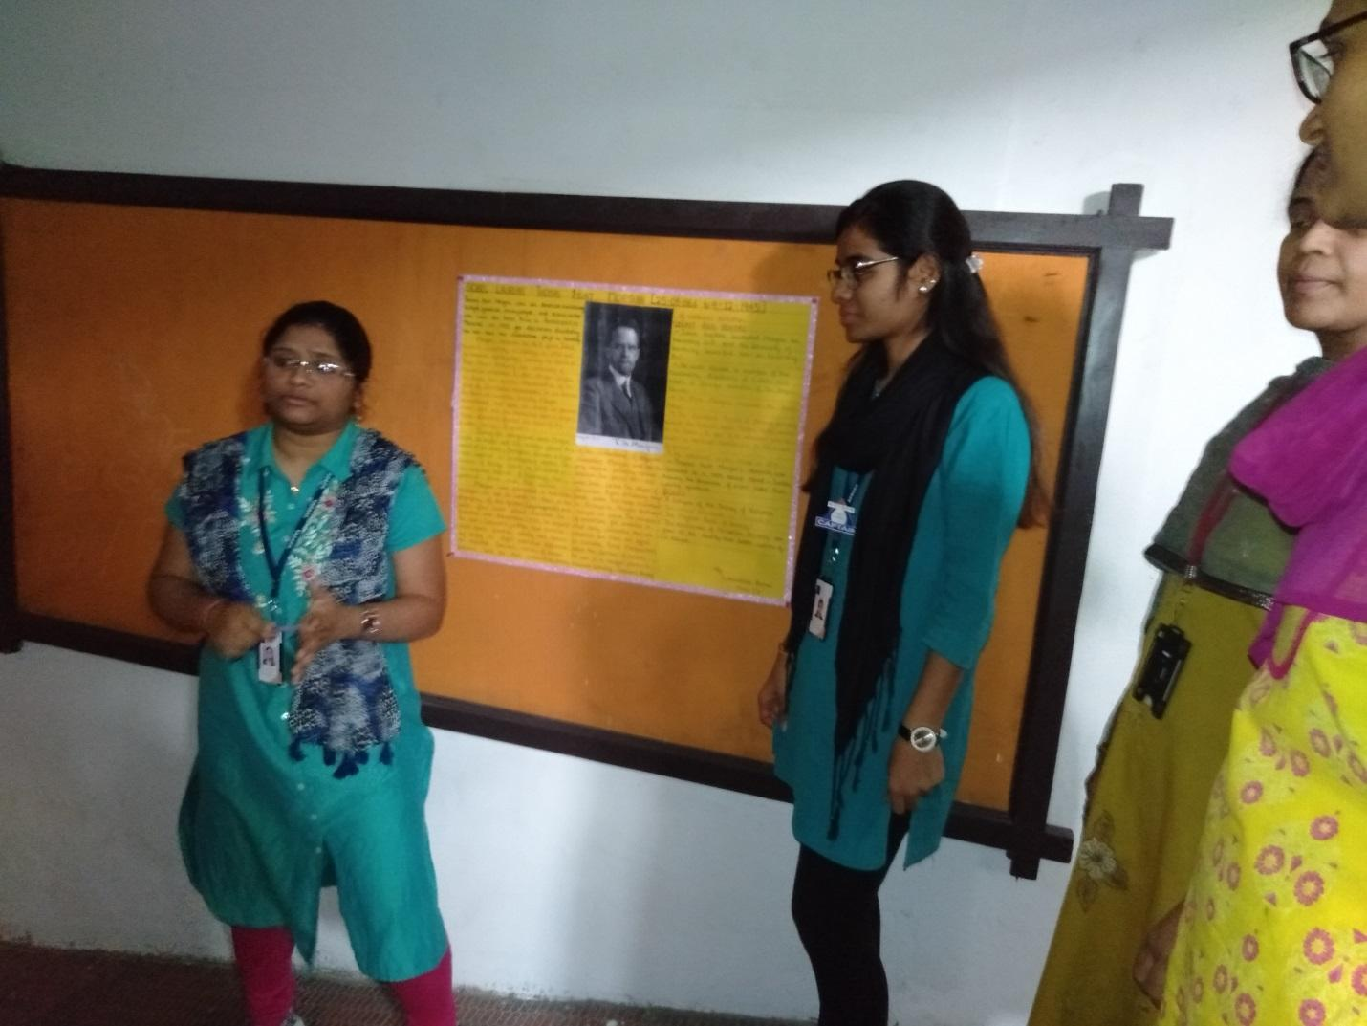

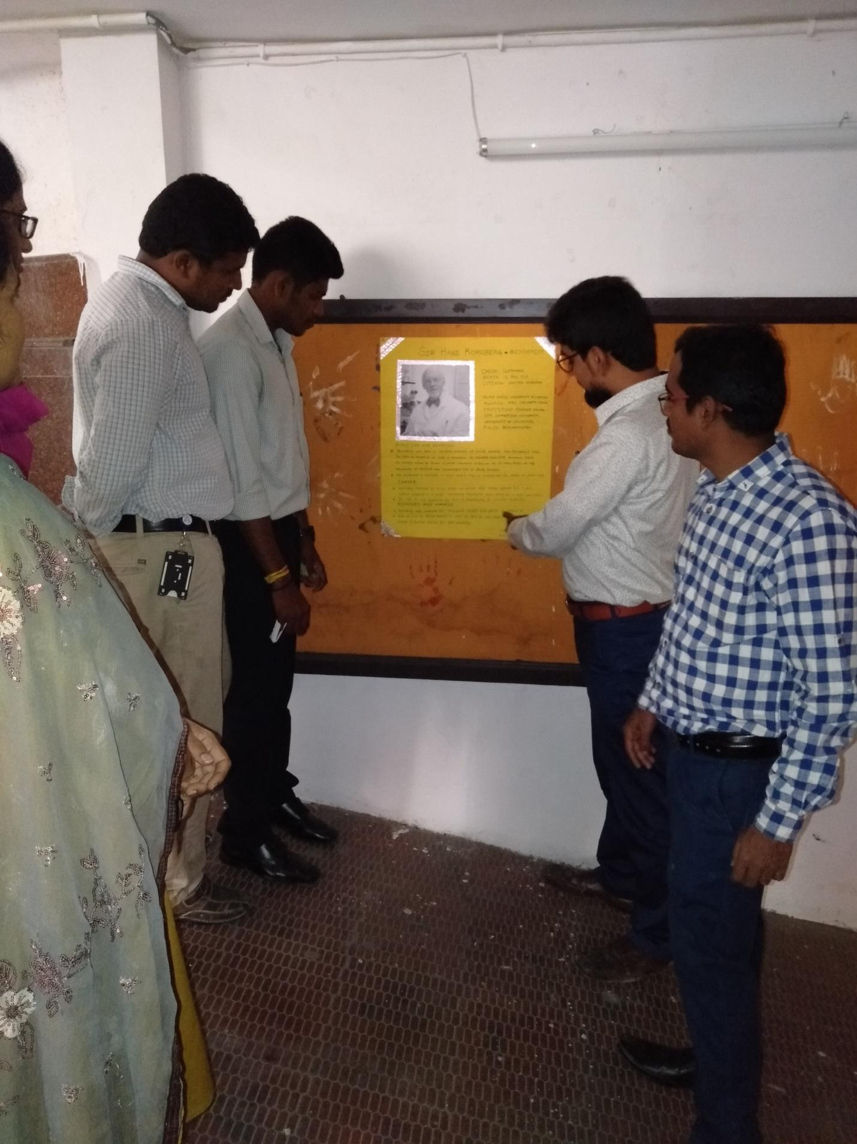

DETAILED REPORT:
LIST OF THE STUDENT COORDINATORS
Sno. | ROLL NO | NAME | CLASS | SECTION
1 | 1051-17-503-057 | Mohammad Abdul Qavi | M.Sc –Final (organic chemistry) | -
2 | 1051-18-459-025 | Vidhi S Vasa | MiG.C 1 | A

LIST OF THE PARTICIPANTS
Sno. | ROLL NO | NAME | CLASS | SECTION
1 | 1051-18-459-015 | Nandini Kallala | MiG.C 1 | A
2 | 1051-18-459-024 | Valluri Supriya | MiG.C 1 | A
3 | 1051-18-459-025 | Vidhi S Vasa | MiG.C 1 | A
4 | 1051-18-459-030 | Metla Sai Pavan Kalyan | MiG.C 1 | A
5 | 1051-18-459-031 | Mahankali Sai Priya | MiG.C 1 | A
6 | 1051-18-459-040 | Odnala Arundhati Ramani | MiG.C 1 | A
7 | 1051-18-488-058 | Korthiwada Pravalika | Bt.Bi.C 1 | B
8 | 1051-18-488-060 | Mohammed Shoeb Ahmed | Bt.Bi.C 1 | B
9 | 1051-18-488-078 | N Richard Stallin | Bt.Bi.C 1 | B
10 | 1051-17-503-005 | Guda Venkatesh | M.Sc –Final (organic chemistry)
11 | 1051-17-503-007 | Padakanti Chandra Shekar | M.Sc –Final (organic chemistry)
12 | 1051-17-503-051 | S Geetha Reddy | M.Sc –Final (organic chemistry)
13 | 1051-17-503-057 | Mohammad Abdul Qavi | M.Sc –Final (organic chemistry)
14 | 1051-17-503-064 | Dhanavath Eshwar Naik | M.Sc –Final (organic chemistry)
15 | 1051-17-503-066 | Agurlla Rekha | M.Sc –Final (organic chemistry)
16 | 1051-17-503-067 | Masagoni Bhargavi | M.Sc –Final (organic chemistry)
17 | 1051-17-503-069 | Godala Sravan | M.Sc –Final (organic chemistry)

