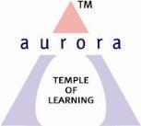
Aurora’s Degree & PG College
Chikkadpally, Hyderabad -500020
Report
On
Outreach Program
On the occasion of “Transistor Invention Day”

NAME OF THE EVENT : Outreach Program On the occasion of “Transistor Invention Day”
FACULTY INCHARGE :P Archana & G Sunanda

DEPARTMENT : Physics
DATE : 15th December, 2018
VENUE: Andhra Vidyalaya High School, Chikkadpally
TARGET AUDIENCE: Andhra Vidyalaya High School, Chikkadpally.
OBJECTIVE: To aware students about various career options in the field of Physics and Electronics
- To make students understand the basic components of physics and electronics.
- To make students to know the importance of invention of transistor in the field of electronics
OUTCOME : Students will gain knowledge about working of various physics and electronics basic components.

- Students will gain knowledge on latest inventions in electronics
- Students will be motivated to take up their career in the field of physics and electronics

NAME OF THE EVENT | Outreach Program  On the occasion of “Transistor Invention Day”
FACULTY INCHARGE | P Archana & G Sunanda
DEPARTMENT | Physics
DATE | 15th December, 2018
VENUE | Andhra Vidyalaya High School, Chikkadpally.
TARGET AUDIENCE | X Class Students
OBJECTIVE: | - To aware students about various career options in the field of Physics and Electronics  - To make students understand the basic components of physics and electronics.  - To make students know the importance of the invention of the transistor in the field of electronics.
OUTCOME | - Students will gain knowledge about the working of various physics and electronics basic components.  - Students will gain knowledge on latest inventions in electronics  - Students will be motivated to take up their career in the field of physics and electronics
PHOTOGRAPH | 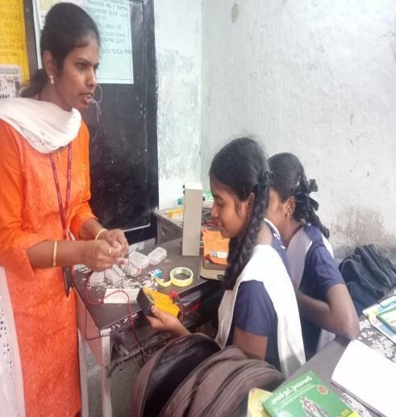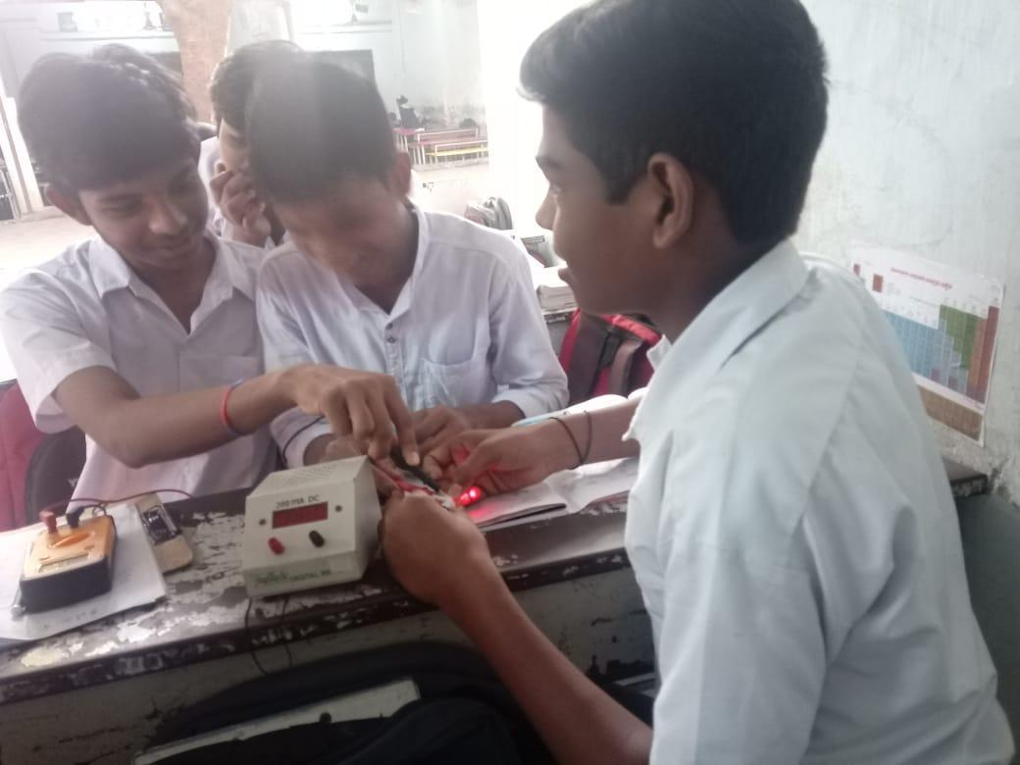  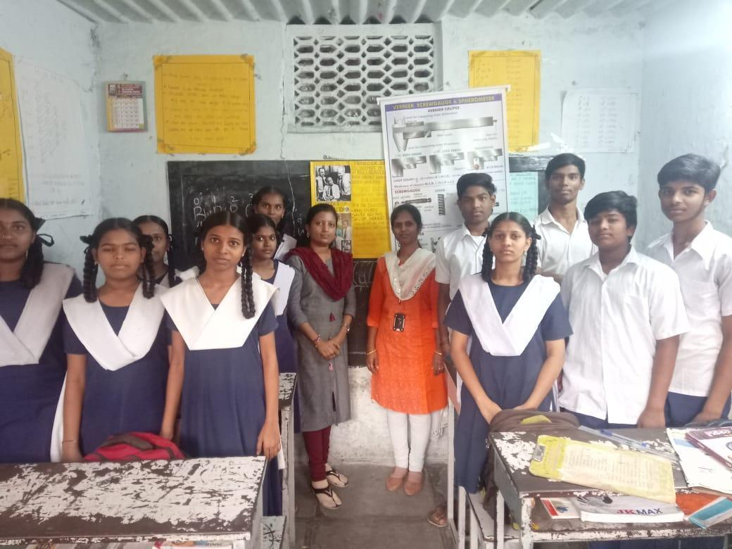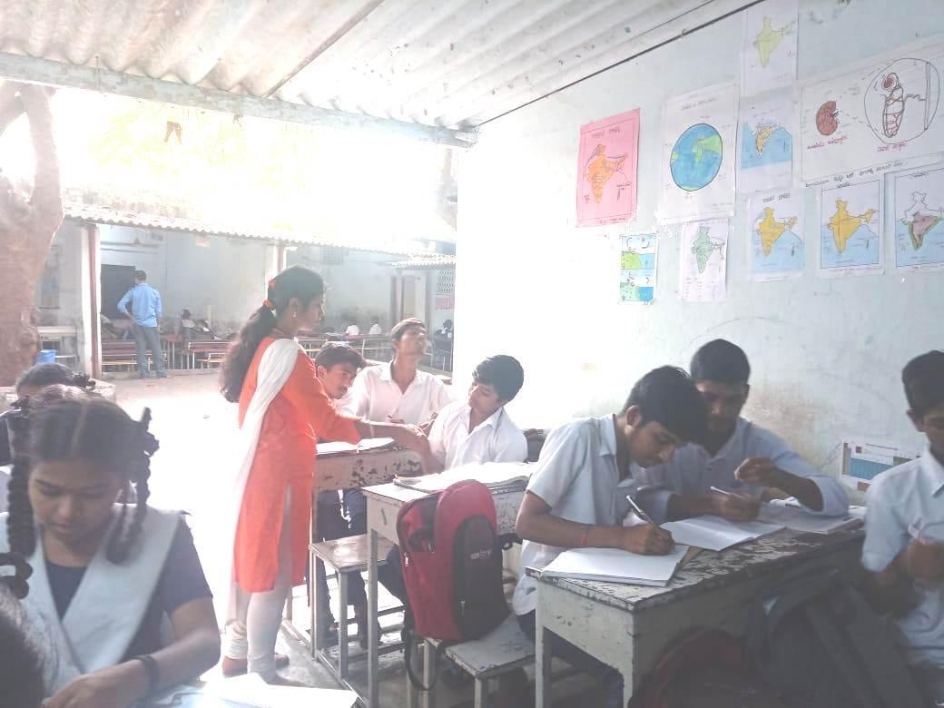

Report
On
Outreach Program
On the occasion of “Transistor Invention Day”

Date : 15-12-2018,
Venue : Andhra Vidyalaya High School, Chikkadapally.
Target Audience : X Class students

Introduction of the Event:
The transistor was probably the most important invention of the 20th century. Three great scientists Shockley, Bardeen and Brattain are responsible for the invention of the first transistor and it was announced on 16th December 1947.
The invention of transistor has brought a revolutionary change in the field of electronics. Today there is no electronic gadget that does not use a component from the transistor family. Hence every year 16th December is celebrated as Transistor’s Birthday all over the world and the scientists are remembered on this occasion.
Methodology:
Department of Physics, Aurora’s Degree and PG College conducts this event with great enthusiasm every year.
Faculty members P Archana and G Sunanda conducted an outreach program in,
Andhra Vidyalaya High School ,Chikkadpally. They interacted with X grade students and explained about Invention of Transistor and its applications .They also demonstrated few basic components of electronics and Physics such as resistors, LEDS , different types of transistors, Prism, Vernier calipers and screw gauge. Few concepts like Dispersion of light through Prism, and measuring diameter & thickness of wire by using Vernier calipers, screw gauge and colouring coding of resistors were explained.
Students were very enthusiastic and participated actively and are very happy with the session.
Following is the list of students:
s.no | Name of the student | Grade
1. | Sangeetha | X
2. | G. Sirisha | X
3. | S .Hari prasad | X
4. | U.Sravani | X
5. | M. Renuka | X
6 | D .Bindu | X
7 | U.Ram | X
8 | P. Durga Prasad | X
9 | P .Uday kiran | X
10 | D .Anusha | X

Faculty Coordinator:
P Archana & G Sunanda, Department of Physics

